Lab 2

1)
To run the example, the commands executed were:
- gcc -pthread -o thread thread.c
- ./thread

After multiple runs of the program, the aspect that is most apparent is the fact that, although the threads are created sequentially, they do not execute in the order they were created, in the bottom figure, an example of a run is present.

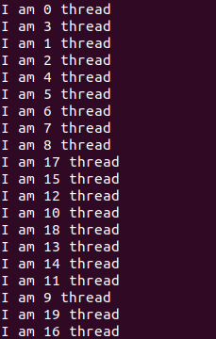
Fig 1. Execution of thread.c

As we can see in the image, threads are executed in an apparently “random way”, not following the order of creation.

2)
To run the example after the changes needed to measure the execution time for different numbers of threads, the commands executed were:
- gcc -pthread tmeas.c -o thread thread.c
- ./thread <Number of threads>

The execution times of multiple runs are present in the results.txt file (program automatically appends the time of each execution to the file)

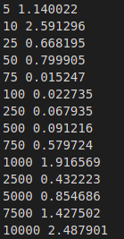

Fig 2. Results.txt

Many things can affect an execution time, from system load to memory usage só it is hard to explain why the execution times variate so much.

3 and 4)
To run the vectors program without any changes, the following commands were executed:
- gcc -pthread tmeas.c -o vectors vectors.c
- ./vectors

To run it after the changes, these were the ones used:
- gcc -pthread tmeas.c -o vectors vectors.c
- ./vectors <Number of threads> <Size of vectors>

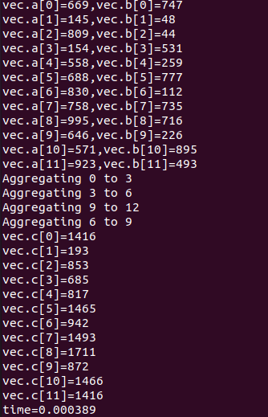
Fig 3. Execution of vectors.c
As we can see in the console output of vectors.c, in the case of vector size being 12 and number of threads 4, everything works fine and in a paralel way (as well as in other cases). We can also see a message where each thread mentions the indexes of the vectors that they are aggregating.

Like in the other program, the results of the executions are printed to a file “results_vector.txt” that contains the data of each run in the format <number of threads> <vector size> <time of the execution>.
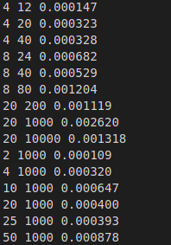

Fig 4. results_vector.txt
As we can see in the last 6 runs, for the same vector size, the run that has the lowest execution time is the one that uses only 2 threads, but the time finds a local minimum at the 25 threads mark. This shows that in this case, more threads is not always the better choice.

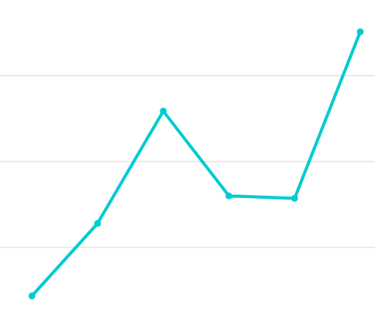
Fig 5. Graph representation of last 6 values (2,4,10,20,25,50) (not to scale)

Tiago Araújo Castro

