Lab 2

2)

To run the example, the commands executed were:
1. gcc -pthread -o mutex pthread_mutex.c
2. ./mutex

In the example, without the use of mutexes, the final value is pretty much random, because the threads access and alter the same memory block (‘global_var’) at the same time, often overwriting any changes the other thread made.
In the example with mutexes, the final value is 0 (as it should be), because each thread’s critical section is enclosed by the mutex, entering it only when the other thread has set it free. This use of mutexes in critical sections is essential to the successful use of threads.

3)

To run the example, the commands executed were:
1. gcc -pthread -o cond pthread_cond.c
2. ./cond

To run the supermarket code, the commands executed were:
1. gcc -pthread -o supermarket supermarket.c
2. ./supermarket <Number of customers> <Number of baskets> <Max time spent in the supermarket>

To specify the inputs of the program, follow the format specified above, either runing the program without any parameters or with the 3 of them. If parameters are not specified, the values used will be 5 customers, 2 baskets and 10 seconds as the max time spent in the supermarket by each customer..

In the next page, the output of a default run is specified.

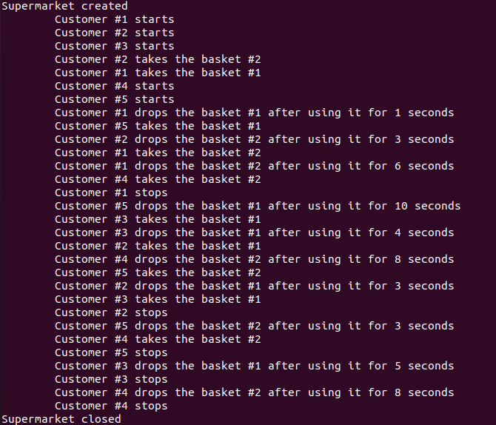
Fig 1. Output of default run

