Lab 4

2)

To run de example, the following commands were used:
- gcc -pthread -o example -fopenmp example.c
- ./example

Impressions after analysing the code and the result (not making the commented changes):
- In the firstprivate case the variable ‘a’ behaves like a private variable, except that it is initialized to the outside value (0).
- In the private case, the private directive declares ‘a’ to have a separate copy in the memory of each thread. Such private variables are initialized as they would be in a main program, being that the value after the threads execution remains as before.
- In the lastprivate case, ‘a’ is preserved as in the last iteration of the last thread parallel loop.
- In the shared case, ‘a’ is preserved as in the last iteration of the parallel loop.
- In the no data-sharing case, ‘a’ is perserved as the highest value achieved since it is the value of the last access.

After the change nr.1 from the comments:
The mentioned before behaviour for the lastprivate case is confirmed.

After the change nr.2 from the comments:
By disabling the locks, the value of a is not guaranteed to be that of the last printed value, because threads don’t block each other from accessing the shared varable ‘a’. Previously, with the locks, threads always had their iterations sequentially, but after removing the lock, they are not guaranteed to behave this way.

Commenting on remark 3 from the comments:
Already mentioned previously.

Answering question 4 from the comments:
Any data declared outside the region will be shared: any thread using the variable ‘a’ will access the same memory location associated with it.

4)

To run the written program, the following commands were used:
- gcc -pthread -o program -fopenmp program.c
- ./program

In program.c, a) is incremented instead than multiplied by 0.5

Outputs of the different strategies:
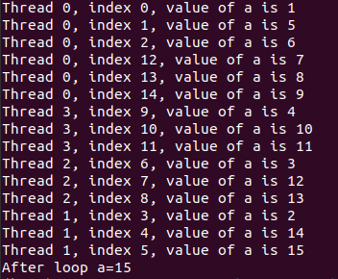
a)

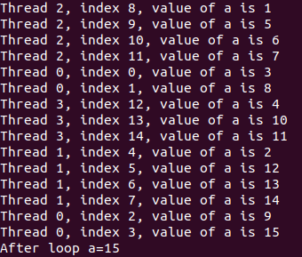
b)

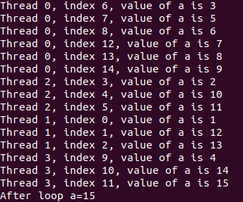
c)

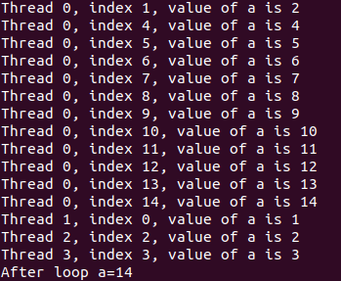
d)

5)

Execution times for each strategy:
a) 0.201ms
b) 0,141ms
c) 1,249ms
d) 0,902ms

As we can see, the static option offers a better execution time compared to the dynamic option, since a) has a better execution time and c) and b) than d). When looking at the chunk size, being default vs 3. The winner seems to be the default, since b) has a better execution time than a) and d) a better execution time than c).

Tiago Castro

