Lab 6

2)

A hostfile was created to circunvent the unavailability of enough slots. It is named hostfile and contains “localhost slots=7”
To run de example, the following commands were used:
- mpicc examplempi.c -o empi
- mpirun --hostfile hostfile -np 7 --display-map ./empi

3)

A hostfile was created to circunvent the unavailability of enough slots. It is named hostfile and contains “localhost slots=21”
To run de example, the following commands were used:
- mpicc propagate.c -o empi
- mpirun --hostfile hostfile -np 21 --display-map ./empi

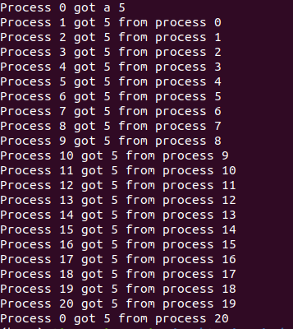

fig 1. Output of propagate.c

The program is set to send the number through all the processes and asking a new number until a negative number is set to be sent.

4)

A hostfile was created to circunvent the unavailability of enough slots. It is named hostfile and contains “localhost slots=21”
To run de example, the following commands were used:
- mpicc propagateNB.c -o empi
- mpirun --hostfile hostfile -np 21 --display-map ./empi

Works the same way as the propagate.c program but with non blocking calls.

