Lab 7

2)

To run de example, the following commands were used:
- mpicc program.c -o empi
- mpirun -np 6 --display-map ./empi

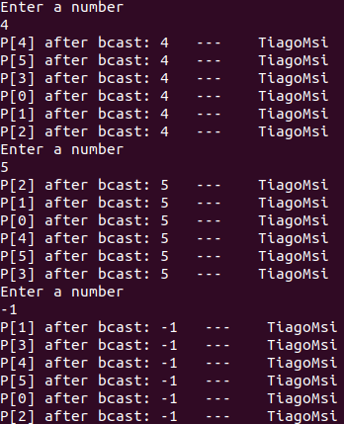

Fig1. Output of program.c (finishes after the negative value input)

3)

To run de example, the following commands were used:
- mpicc type.c -o empi
- mpirun -np 6 --display-map ./empi

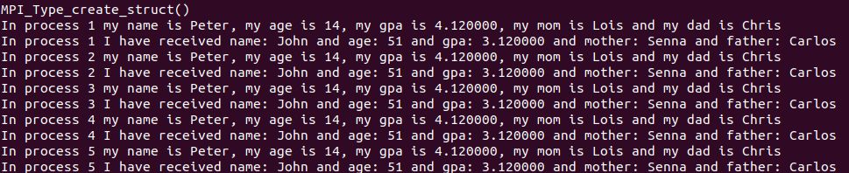
Fig2. Output of type.c after data changes

Data is now structured like this:

typedef struct {
char name[20];
int age;
float gpa;
char father[20];
char mother[20];
} Data;

The time it takes to send the data is 0.000005s.

4)

To run de example, the following commands were used:
- mpicc pack.c -o empi
- mpirun -np 2 --display-map ./empi
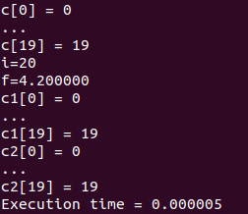

Fig3. Output of pack.c with previous data structure

The time it takes to send the data is around 0.000005s as well. However, the time in type.c are for multiple send, só, we can deduce that the pack option is not as good. For type.c considering a single send, the time averages around 0.000001s.

Tiago Araújo Castro

