Project

1)
A hostfile was created to circunvent the unavailability of slots and contains “localhost slots=10”
Commands to run the program
• mpicc 1.c -o empi
• mpirun --hostfile hostfile -np 10 --display-map ./empi

The lift is in a 6 floor building and starts at the second floor and can take up to 5 people. All of this is editable above.The lift, if it has someone at the floor it is in, will grab the people there as long as they want to go the same way as the person who first contacted the elevator. In the case of the elevator arriving its destination, it will let any people there waiting for it decide the next stop. If there is no one there, it will go to the spot where the first person that "presses the button" says. For example, if the elevator is in 2 and is going to 4, but in 3 finds someone going to 5, it will drop off the first person at 4 and continue to 5 grabing anyone else in the way that is going the same way.

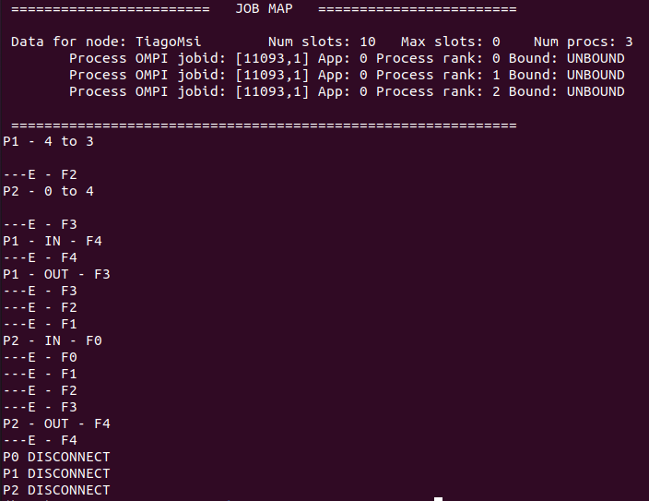
Img 1. Execution of ex1 with 3 processes (2 clients)
2)

Commands to run the program:
• gcc -g -Wall tmeas.c -o 2 2.c -lpthread
• ./2 <number of subintervals of integration>

Integration interval can be edited in the macros A and B. Outputs the result, time to calculate the result and the values calculated by each thread.
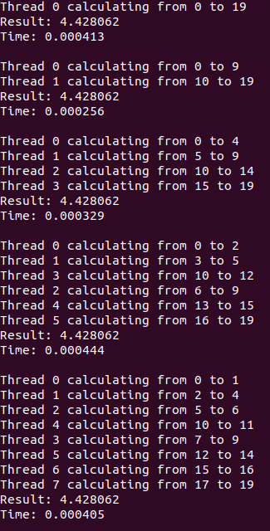

Img2. Execution of ex2 with 20 subintervals

3)

Commands to run the program:
• gcc -g -Wall tmeas.c -o 3 3.c -lpthread -lm
• ./3 <value of x> <limit of somatory (n)>

Outputs the result, time to calculate the result and the values calculated by each thread.

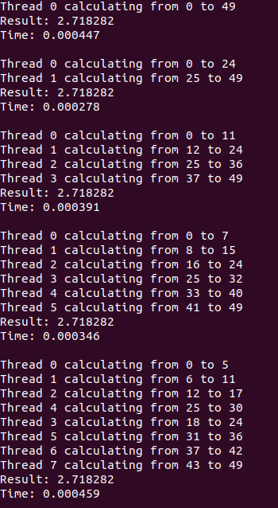

Img3. Execution of ex3 with x=1 and 50 as n

4)

Commands to run the program:
• gcc -g -Wall -o 4 4.c -lpthread -lm
• ./4 <number of elements of the sum>

Number of processes is editable in the macro P. Outputs the values calculated by each thread as well as the final sum, ln value and result.
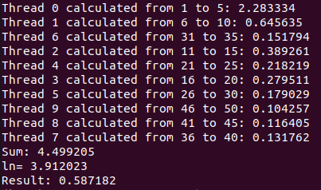

Img4. Execution of ex4 with n=50 and 10 processes

5)

Commands to run the program:
• gcc -o 5 -fopenmp 5.c
• ./5 <number of lines in system and x variables>

Number of threads is editable in the macro THREADS. Outputs the system lines with the substituted values.
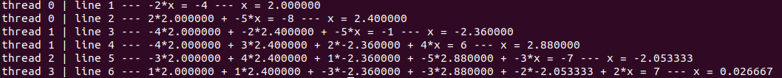
Img5. Execution of ex5 with 6 system equations and 4 threads

6)

Commands to run the program:
• gcc -o 6 -fopenmp 6.c
• ./6 <number of natural numbers>

Number of threads is editable in the macro THREADS. Outputs the prime numbers until the desired number limit.

Img6. Execution of ex6 until number 125 and 4 threads

Tiago Araújo Castro

