Homework 2 – Marine Chemistry
Total 50 points
Due date: Tuesday 11/04/2025 at 10:45 am (before I leave the classroom)

Rules:
- Group assignment: 3-4 students (feel free to form new groups)
- Individual assignments will not be accepted
- All answers must be handwritten. Typed and digital assignments will not be accepted
- Extensions will not be granted, except under unusual circumstances or examples covered in the section on Missed Class Policy and University Sanctioned Absences on Syllabus
- If you do use generative AI, include a brief (one sentence) description of how you used the tool followed by a list of the prompts used (bullet points) used in each question
- IF THE GROUP FAILS TO SOLVE THE GROUP ACCOUNTABILITY EXERCISE, THE ENTIRE GROUP WILL RECEIVE A TOTAL OF 0 POINTS ON THE ENTIRE HOMEWORK ASSIGNMENT

Remember: All questions are supposed to be answered in the context of our classes. Even questions based on reading materials. Meaning, you will need fundamental knowledge presented in class together with the content presented here or reading materials.

- Based on the sentence “Water is familiar, abundant, and odd” (10 pts):
  - What do you think it is meant by “familiar, abundant, and odd”? (2 pts)
  - What is the water molecule characteristic responsible for its “odd” and especial properties? (3 pts)
  - What are the properties of water that result from this “odd”? (5 pts)

- Using the north-south temperature distribution below, answer the following questions. Remember: Negative values indicate the Southern Hemisphere Latitudes (10 pts).

  - Define what is a thermocline? (5 pts)
  - Is the thermocline more prominent (or strong) at 50°S, 0°, or 40°N? (3 pts)
  - Based on the ice cube experiment we performed in class and your answers so far, in which region surface waters can reach the deep zones more easily, higher or lower latitudes? (2 pts)

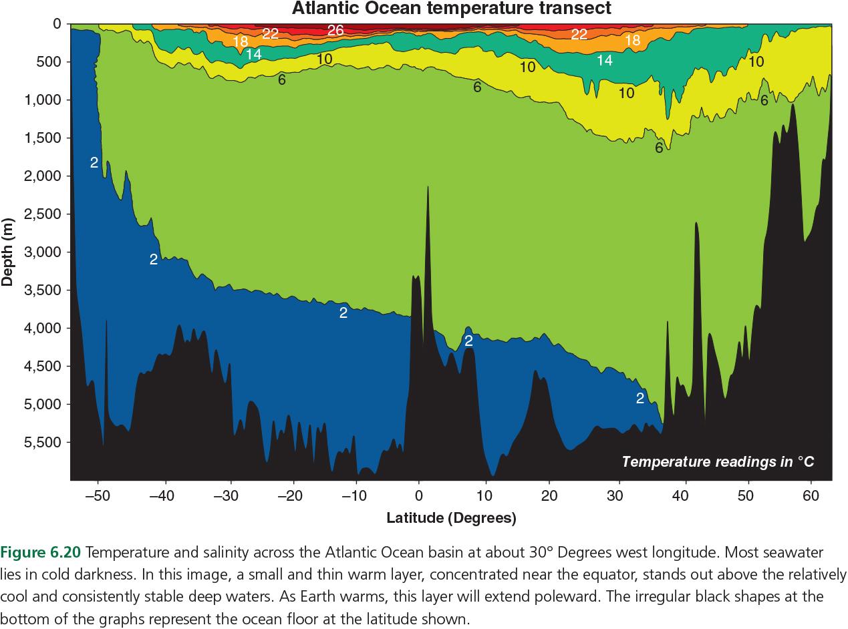

- Why is the water’s high heat capacity important for local weather and global climate (10 pts).

- Based on your knowledge of gases in the ocean (10 pts):
  - What are the major gases dissolved in the oceans? (5 pts)
  - Is the amount of dissolved gases the same at the surface and the deep ocean? (3 pts)
  - Which gas is more abundant if we consider both regions at the same time? (2 pts)

- Based on Giltz & Taylorf (2017) and our classes answer (10 pts + up to 10 extra points for perfect answers):
  - Describe how a change in ocean pH can affect some marine organisms like corals? (2 pts + 2 extra pts)

  - Why are larval crustaceans (such as blue crab zoea) more susceptible to ocean acidification than juveniles and adults? (2 pts + 2 extra pts)

  - What scientific evidence from the article convinced you that these organisms were affected by ocean acidification? (2 pts + 2 extra pts)

  - Should anthropogenic CO₂ be considered a marine pollutant? Why? (2 pts + 2 extra pts)

  - If yes, of what kind (chronic or acute) and why (2 pts + 2 extra pts)

- [MANDATORY] Group Accountability Exercise: In a short paragraph or a statement, describe the role of each group member during the homework assignment.

ANY work done will be rewarded with a grade. Students with larger workloads will be rewarded extra points. Students with NO CONTRIBUTION to the group activity won’t receive any points.

Example 1: All group members equally contributed to the homework assignment.

Example 2: Jane Doe answered questions 1 and 2, while John Doe, Jim Doe, and Carry Doe equally contributed to questions 3, 4, and 5.

Example 3: Everyone contributed except John Doe.

In example 2 Jane Doe will receive extra 5 points. In example 3, John Doe will fail the assignment (0 pts).

IF THE GROUP FAILS TO SOLVE THE GROUP ACCOUNTABILITY EXERCISE, THE ENTIRE GROUP WILL RECEIVE A TOTAL OF 0 POINTS ON THE ENTIRE HOMEWORK ASSIGNMENT

