Homework 3 – Physical Oceanography
Total 50 points
Due date: Tuesday 11/25/2025 at 10:45 am (before I leave the classroom)

Rules:
- Group assignment: 3-4 students (feel free to form new groups)
- Individual assignments will not be accepted
- All answers must be handwritten. Typed and digital assignments will not be
accepted
- Extensions will not be granted, except under unusual circumstances or examples
covered in the section on Missed Class Policy and University Sanctioned Absences
on Syllabus
- If you do use generative AI, include a brief (one sentence) description of how you
used the tool followed by a list of the prompts used (bullet points) used in each
question
- IF THE GROUP FAILS TO SOLVE THE GROUP ACCOUNTABILITY
EXERCISE, THE ENTIRE GROUP WILL RECEIVE A TOTAL OF 0 POINTS
ON THE ENTIRE HOMEWORK ASSIGNMENT

Remember: All questions are supposed to be answered in the context of our classes. Even
questions based on reading materials. Meaning, you will need fundamental knowledge
presented in class together with the content presented here or reading materials.

- Briefly explain how and where deep waters form and how that process influences global circulation? (10 pts)

- Answer the following questions about ocean Gyres (10 pts)
  - What are the main forces (apparent and real) involved in the spin-up of oceanic gyres by the winds? (7 pts)
  - Describe the chain of events of how winds accelerates the ocean gyres in the Northern Hemisphere. You can create your own schematic figure to aid your explanation. (3 pts).

- What is coastal upwelling? How does it form? What is its relation to local weather and fisheries (10 pts)

- Consider a surface gravity waves with wavelength of 100 m (please indicate your reasoning in each item) (10 pts)
  - What is its propagation speed in the deep ocean (3 pts)?

  - Once it reaches regions with local depth of approximately 5 m, these waves become shallow water waves. What are the new propagation speeds over this depth (3 pts)?

  - Explain why they slow down or speed up (2 pts).

  - Why shallow water waves tend to align with local topography and become parallel to the coastlines (2 pts)?

- The University of Hawaii’s keeps the record of all available tidal data from around the globe at https://uhslc.soest.hawaii.edu/stations. Recording tides consists of measuring the sea level height at a fixed point over time. Below you will find graphs showing the tidal gauge observations and tidal predictions from Salalah, Oman and Kanton, Kiribati. Based on the data displayed, answer (10 pts)
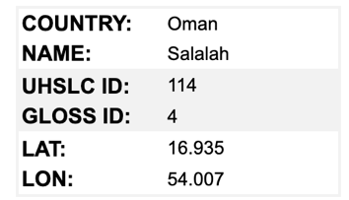

Salalah, Oman
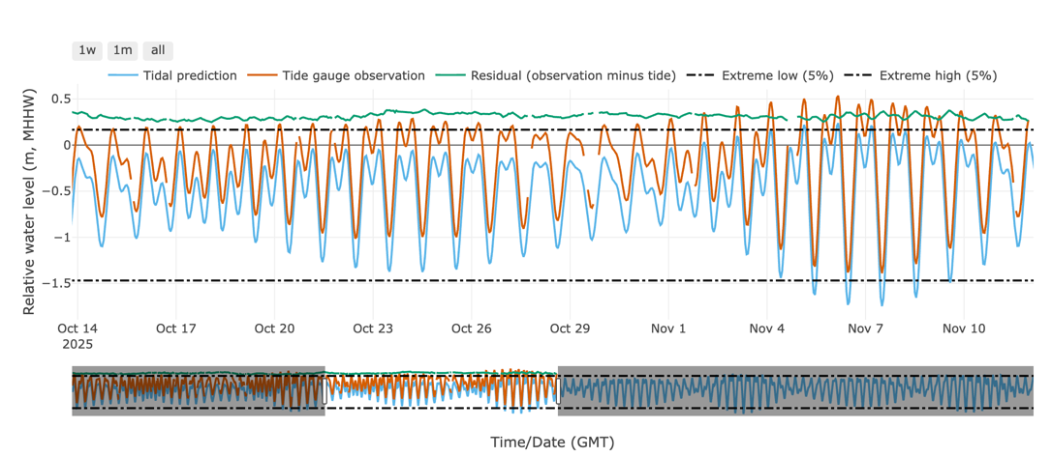

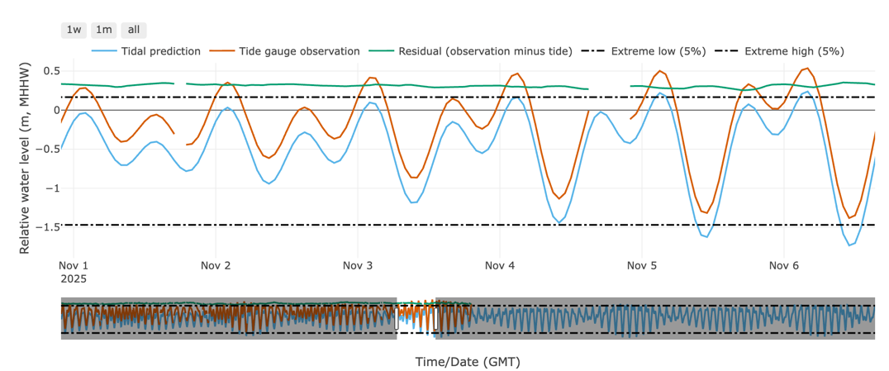

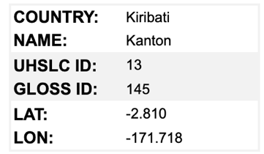
Kanton, Kiribati

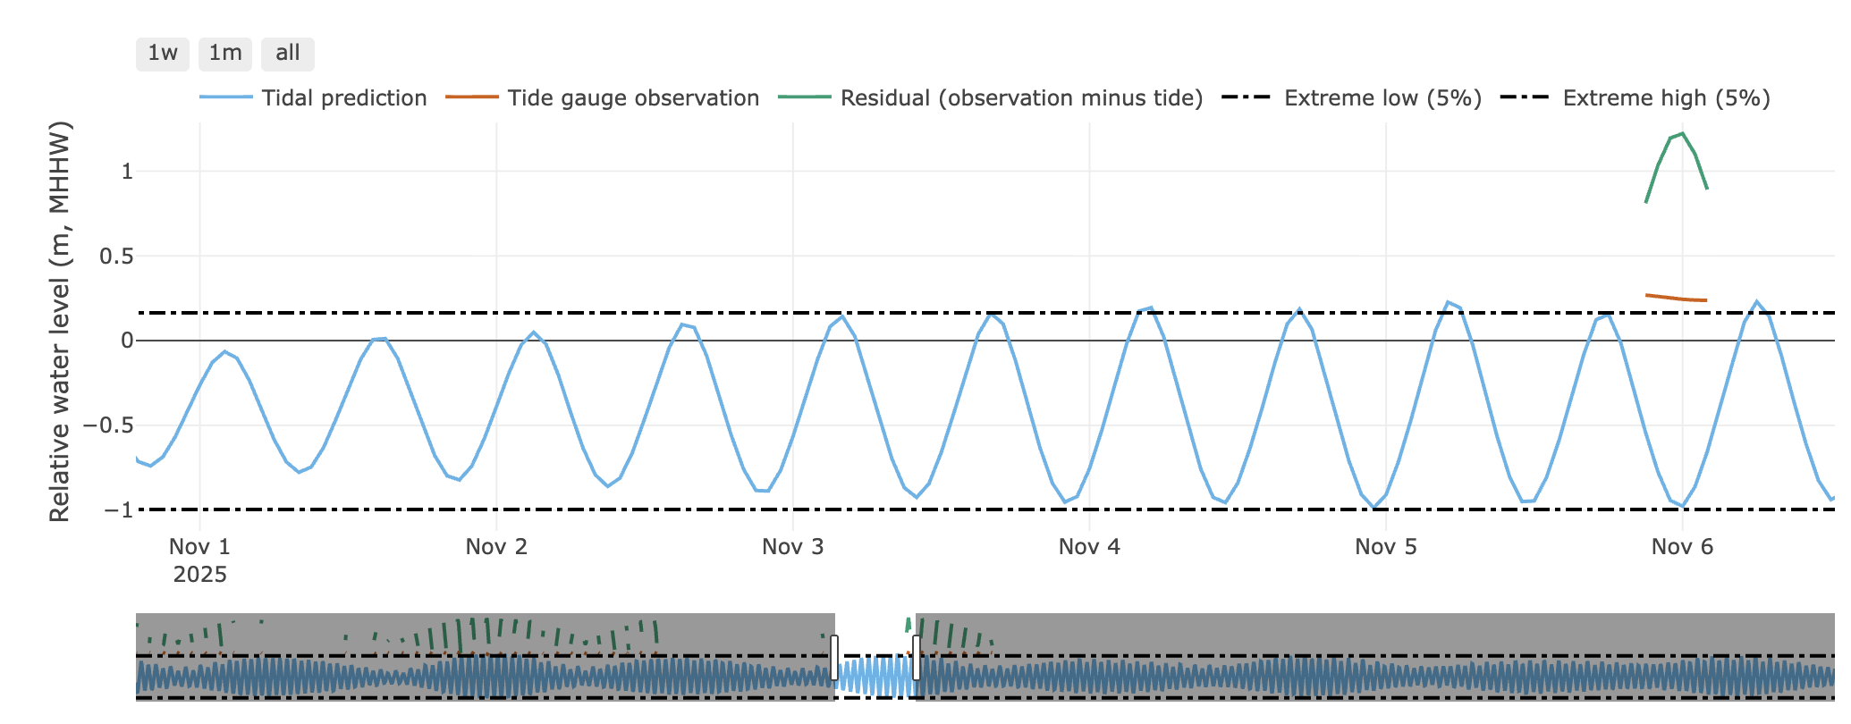

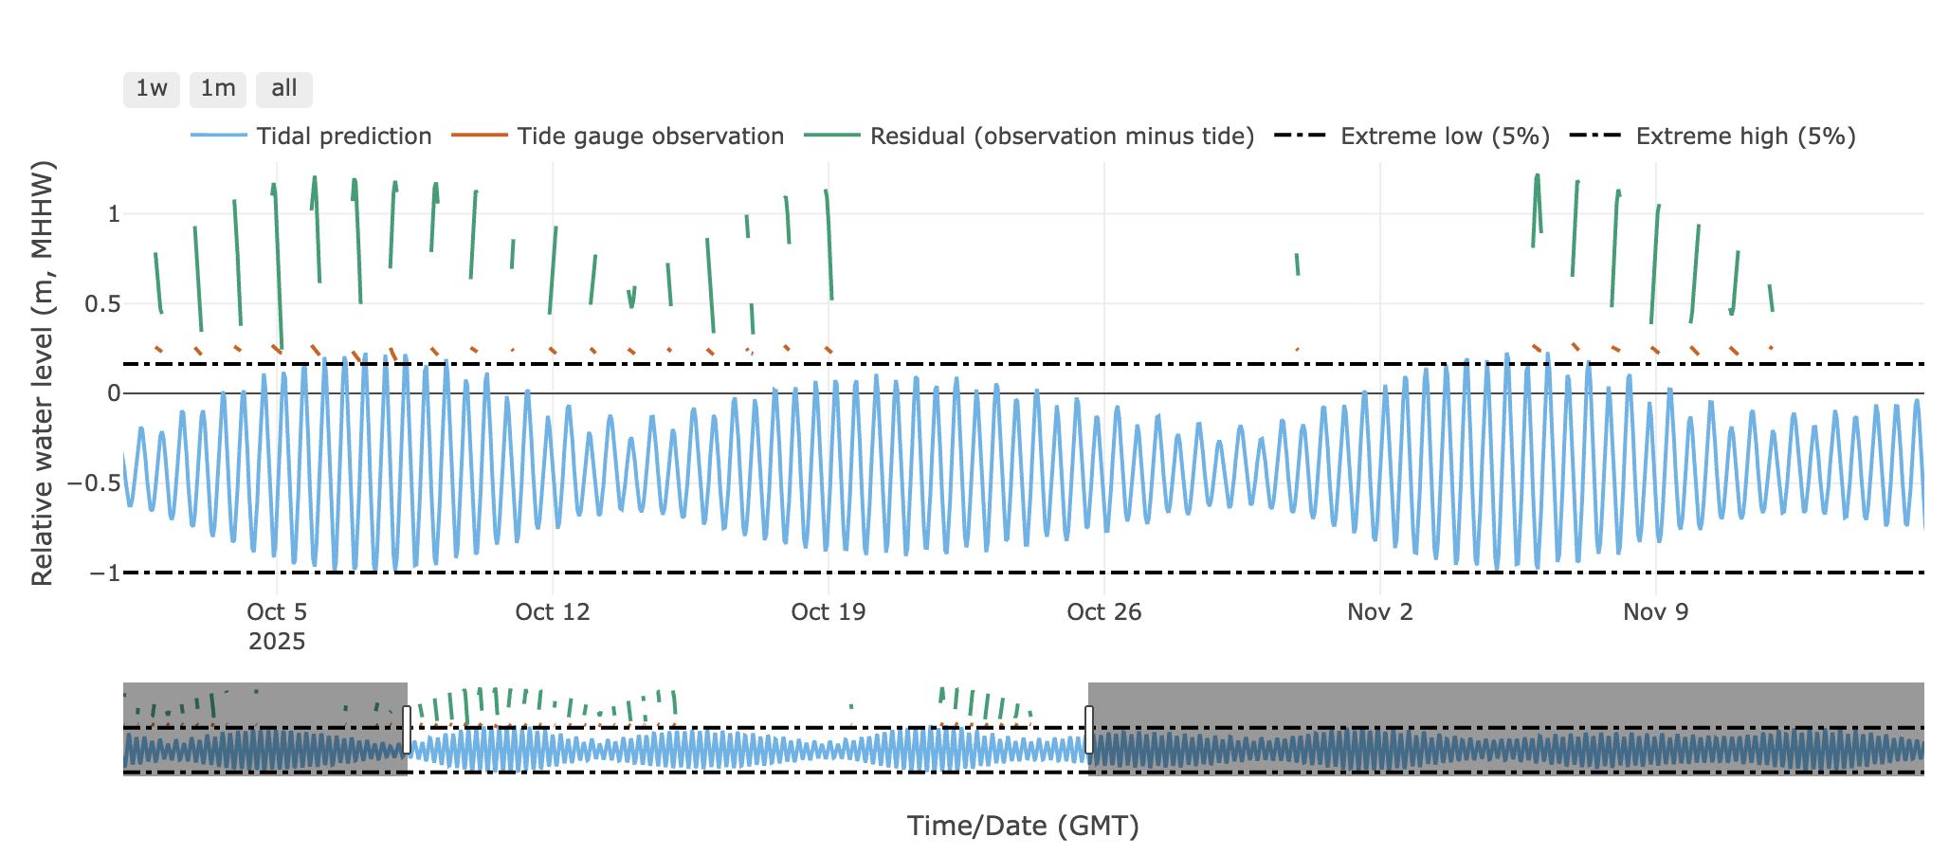

- Determine if the tide is diurnal, semi-diurnal or mixed in each location (4 pts).
- What is the tidal amplitude of the spring tide in each location? (2 pts)
- What is the tidal amplitude of the neap tide in each location? (2 pts)
- Which ocean are these two tidal gauges are located? (2 pts)

- [EXTRA EXERCISE] Based on the article by Levang (2018), the video at https://youtu.be/CCmTY0PKGDs, and classes (extra 10 pts):
  - What are the two types of “oceanic roads” (circulation) discussed in the article? (3 extra points)
  - Based on the video, do you think the “oceanic roads” from the article accurately describe the ocean circulation seen in the video? If not, why? (7 extra pts)

- [MANDATORY] Group Accountability Exercise: In a short paragraph or a statement, describe the role of each group member during the homework assignment.

ANY work done will be rewarded with a grade. Students with larger workloads will be rewarded extra points. Students with NO CONTRIBUTION to the group activity won’t receive any points.

Example 1: All group members equally contributed to the homework assignment.

Example 2: Jane Doe answered questions 1 and 2, while John Doe, Jim Doe, and Carry Doe equally contributed to questions 3, 4, and 5.

Example 3: Everyone contributed except John Doe.

In example 2 Jane Doe will receive extra 5 points. In example 3, John Doe will fail the assignment (0 pts).

IF THE GROUP FAILS TO SOLVE THE GROUP ACCOUNTABILITY EXERCISE, THE ENTIRE GROUP WILL RECEIVE A TOTAL OF 0 POINTS ON THE ENTIRE HOMEWORK ASSIGNMENT

