Homework 2 – Marine Chemistry
Total 10 points
Due date: Tuesday 07/12/2022 at 2 pm (class time)

- What is meant by the statement “Water is familiar, abundant, and odd”?
  - What is the water molecules’ characteristic responsible for its “odd” and especial properties?
  - What are the “odd” properties of water? (2 Pts).

- Using the north-south temperature distribution below, identify the thermocline (or pycnocline) and the deep zones at 50S, 0, and 40N. Negative values indicate the South Atlantic.
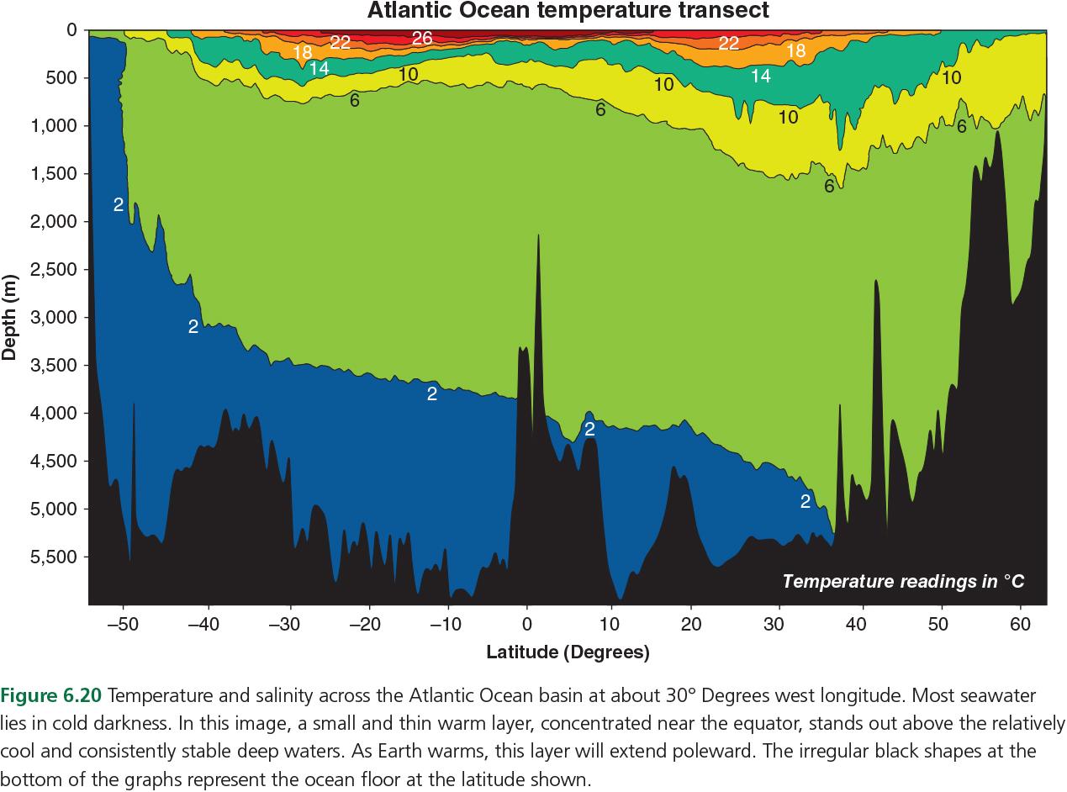
  - Is the thermocline more prominent in lower or higher latitudes?
  - Based on the ice cube experiment video and your answers so far, in which region surface waters can reach the deep zones, higher or lower latitudes? (2 Pts).

- Why is the water’s high heat capacity important for local weather and global climate (2 pts)

- What are the major gases dissolved in the oceans? Are the amount of dissolved gases the same at the surface and the deep ocean? Which gas is more abundant in both regions? (2 pts)

- Based on the discussion of Giltz & Taylorf (2017) (2 pts):
  - Describe how a change in ocean pH can affect some marine organisms? Ex: corals

  - Why are larval crustaceans (such as blue crab zoea) more susceptible to ocean acidification than juveniles and adults?

  - What scientific evidence convinced you that these organisms were affected by ocean acidification?

  - Should anthropogenic CO2 be considered a marine pollutant?

  - If yes, of what kind (chronic or acute) and why.

