Bug #1: Unhandled exception when clicking the collapsed to selected button

Environment: Production

OS: Windows 10 - 64-bit

SOFTWARE VERSION:   
Version: 9.0 64   
Bit Build: 412.45223   
Edition: Premium Trials   
SERIAL Number: Trial

PRIORITY: Low

**Steps to reproduce  
  
1 - Click on Visual MODFLOW Flex 9.0.exe  
2- Click on Start Trial Version  
3- Click on** Colapse to Selected button **(screen 1)  
4- See the error message in the screen 2**

Colapse to Selected -> Error message  
  
When user clicks the button Colapse to Selected, the Error message " Unhandled exception has ocurred in your application." appears

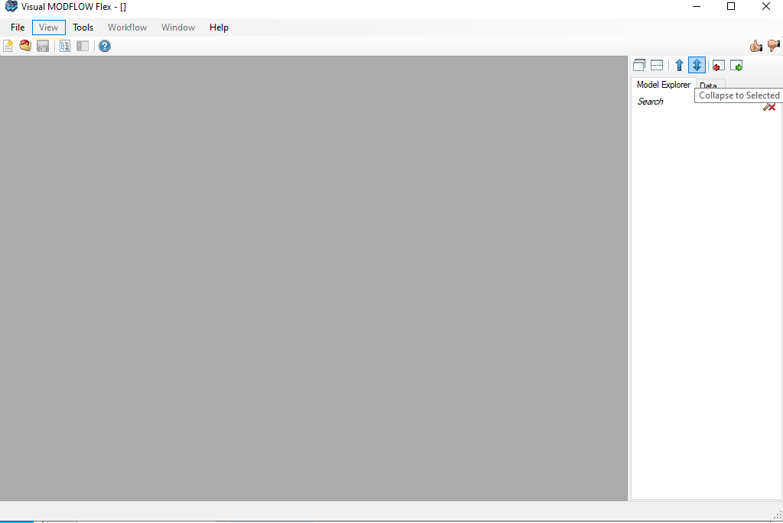

Screen 1

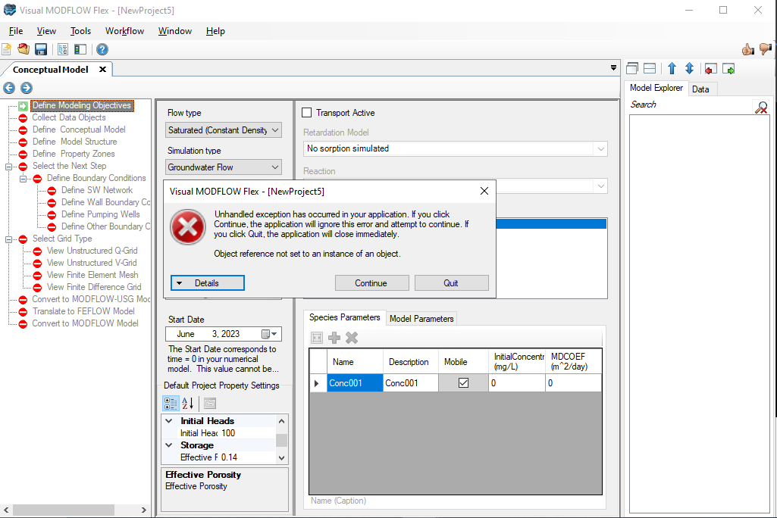

Screen 2