**Bug #1: Unhandled exception when clicking the “Collapse to selected” button**

Environment: Production

OS: Windows 10 - 64-bit

SOFTWARE VERSION: 9.0 64 Bit   
Build: 412.45223   
Edition: Premium Trial   
Serial Number: TRIAL   
  
Priority: Low

Steps to reproduce:  
1 - Click on vmodflex.exe  
2- Click on Start Trial Version  
3- Click on the “Collapse to Selected” button (screen 1)  
4- See the error message in screen 2

Collapse to Selected -> Error message  
  
When the user clicks the button “Collapse to Selected”, the following Error message appears:  
   
"Unhandled exception has occurred in your application. If you click Continue, the application will ignore this error and attempt to continue. If you click Quit, the application will close immediately.  
Object reference not set to an instance of an object."

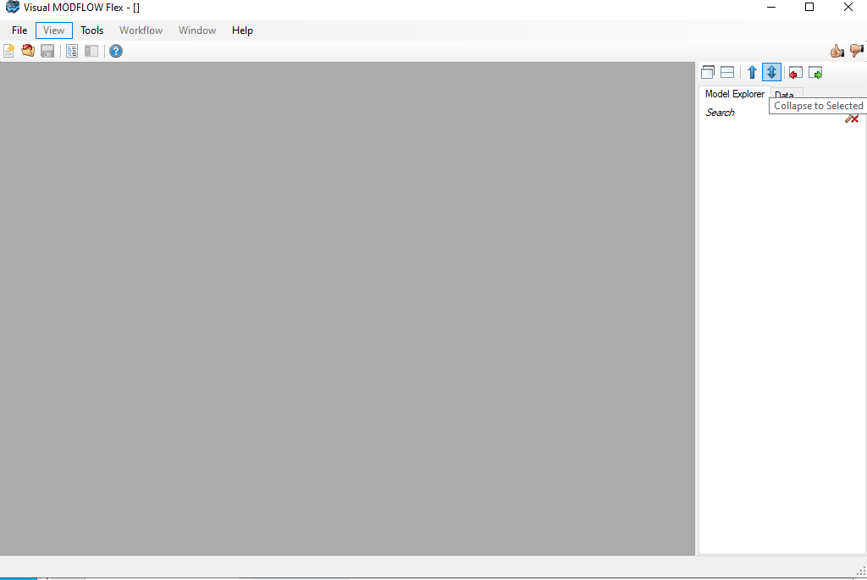Screen 1

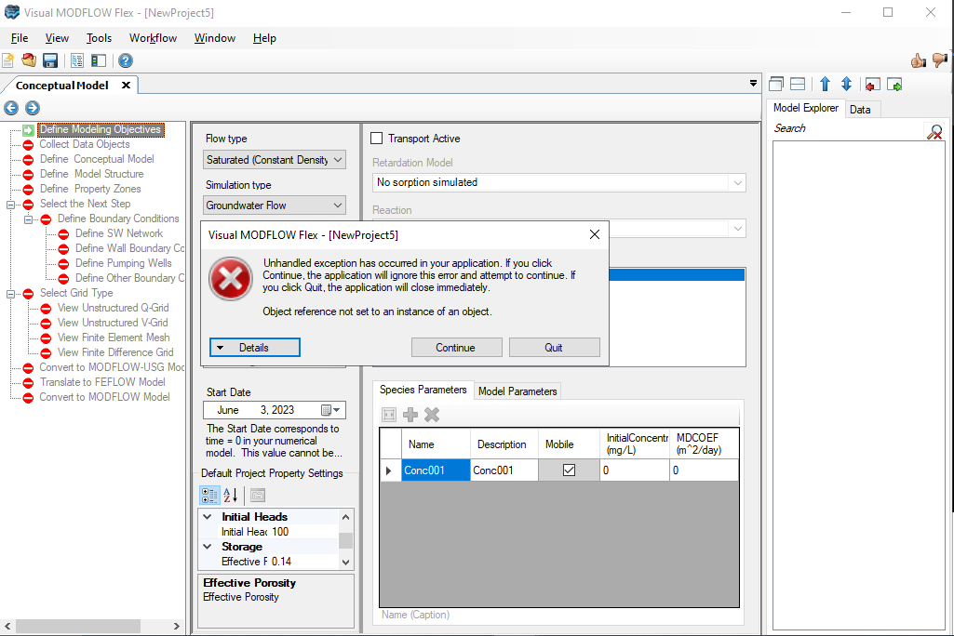Screen 2