Bug #2: Unhandled exception when selecting the “New Calibration Dashboard” from the drop-down menu.

Environment: Production

OS: Windows 10 - 64-bit

SOFTWARE VERSION: 9.0 64 Bit   
Build: 412.45223   
Edition: Premium Trial   
Serial Number: TRIAL   
  
Priority: Low

Steps to reproduce:  
1 - Click on vmodflex.exe  
2- Click on Start Trial Version  
3- Click on the Click on File->New Project from the drop-down menu (screen 1)  
4- Enter a name for the New Project (screen 2)  
5- Click on the OK button  
6- Select option any of the two Modeling Scenarios (screen3)  
7- Click on the Window->Calibration Dashboard option from the drop-down menu (screen 4)  
8- See the error message on screen 5

New Calibration Dashboard -> Error message  
  
When the user selects “New Calibration Dashboard” from drop-down menu, the following Error message appears:  
   
"Unhandled exception has occurred in your application. If you click Continue, the application will ignore this error and attempt to continue. If you click Quit, the application will close immediately.  
Object reference not set to an instance of an object."

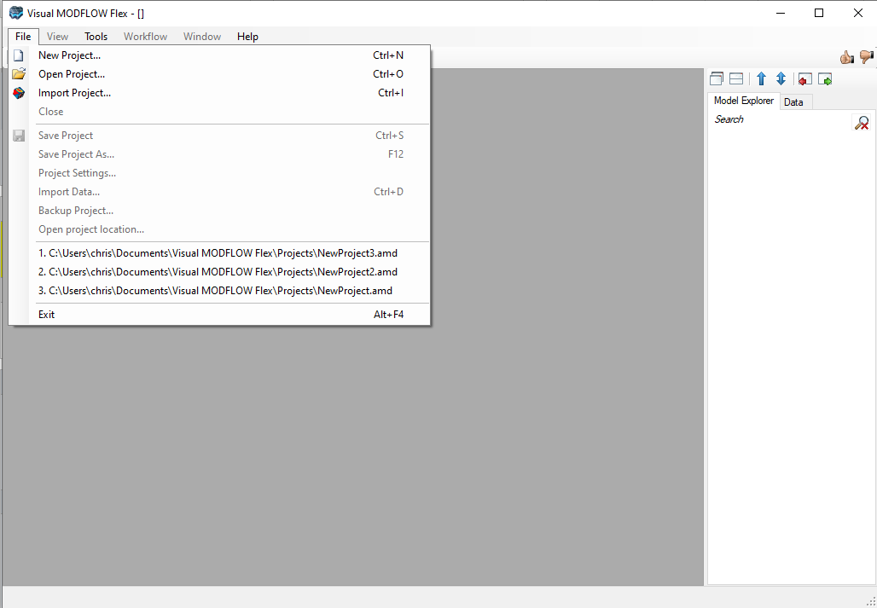Screen 1

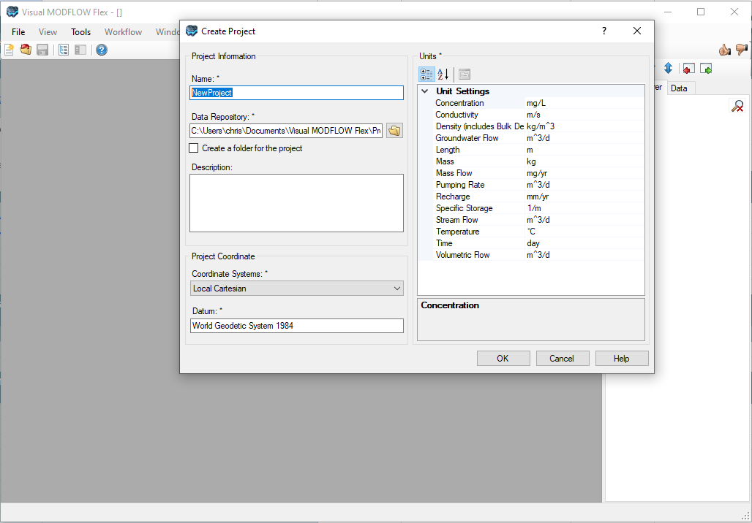Screen 2

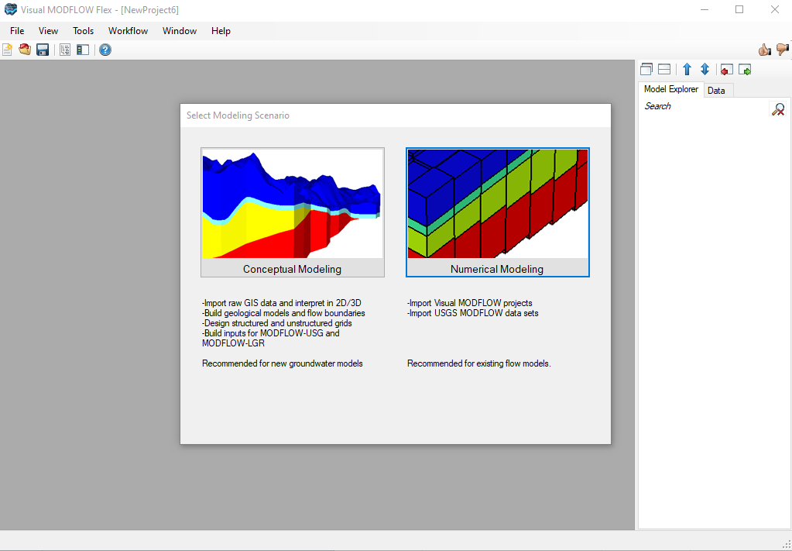Screen 3

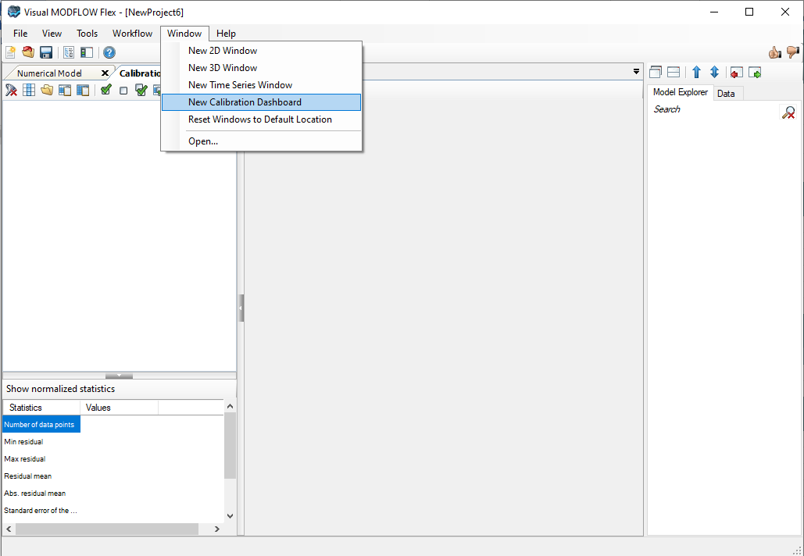Screen 4

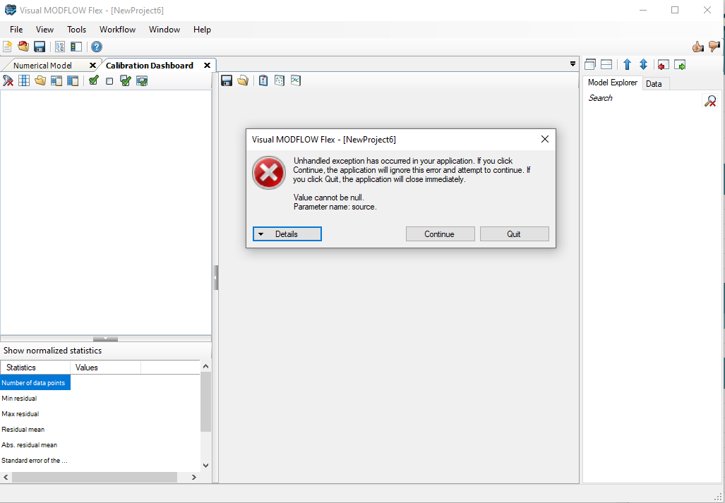Screen 5