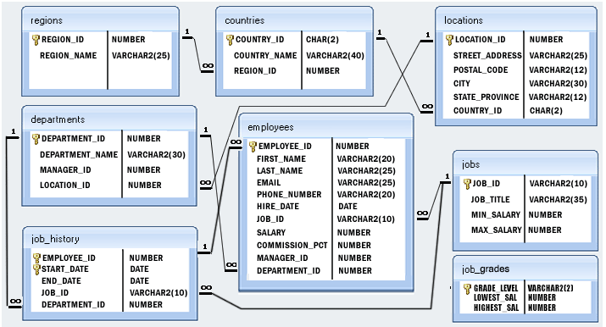

select count(*) from employees;

select sum(salary) from employees;

select departament_id,count(*) from employees group by departament_id;

select departament_name,count(*) from employees e, departaments d where e.departament_id=d.departament_id group by departament_name;

select departament_name,sum(salary) from employees e, departaments d where e.departament_id=d.departament_id group by departament_name;

select first_name, last_name, job_title from employees e, jobs j where e.job_id=j.job_id;

select first_name, last_name, job_title from employees e
join jobs j on e.job_id=j.job_id;

select first_name, last_name, job_title from employees natural join jobs ordet by first_name;

select departament_name,count(*) as quantidade from employees e, departaments d, (select max(quantidade) as maior from (select departament_name,count(*) as quantidade from employees e, departaments d where e.departament_id=d.departament_id group by departament_name)
) f where f.quantidade = maior and e.departament_id=d.departament_id group by departament_name

select max(quantidade) from (select departament_name,count(*) as quantidade from employees e, departaments d where e.departament_id=d.departament_id group by departament_name)

select departament_name,count(*) as quantidade from employees e, departaments d where e.departament_id=d.departament_id group by departament_name having count(*) = (select max(quantidade) from (select departament_name,count(*) as quantidade from employees e, departaments d where e.departament_id=d.departament_id group by departament_name))

select a.first_name, a.last_name, b.first_name, b.last_name from employees a, employees b where a.manager_id=b.employee_id

select country_name from employees e
join departaments d on e.departament_id=d.departament_id
join locations l on d.location_id = l.location_id
join countries c on l.country_id=c.country_id

select country_name from employees
natural join departaments
natural join locations l
natural join countries c

select country_name,count(*) from employees
natural join departaments
natural join locations l
natural join countries c group by country_name
having count(*) = (select max(quantidade) from (select country_name,count(*) as quantidade from employees
natural join departaments
natural join locations l
natural join countries c group by country_name))

select employee_nome,count(distinct departament_id) from job_history j, employees e where e.employee_id=j.employee_id group by employee_nome

select e.first_name, e.last_name from employees e (3) where not exists

(select departament_id from departments (1,2,3,4) not in

(select departament_id from job_history j where j.employee_id= e.employee_id)) (1,2,3,4)

select min(start_date) from job_history

select first_name, last_name from employee a, DateDiff ( start_date, data_atual ,DP_DAY )
(select employee_id from job_history where start_date= (select min(start_date) from job_history)) b where a.empployee_id=b.employee_id

select employee_id, max(DateDiff ( start_date, end_date,DP_DAY )) as maior_periodo from job_history group by employee_id having

elect employee_id, max(DateDiff ( start_date, end_date,DP_DAY )) as maior_periodo from job_history group by employee_id having max(DateDiff ( start_date, end_date,DP_DAY )) =(
Select max(maior_periodo) from (select employee_id, max(DateDiff ( start_date, end_date,DP_DAY )) as maior_periodo from job_history group by employee_id))

