### **Setup Tips**

### **SQL Server (Engine and Management Studio)**

### **Visual Studio**

### **SQL Management Studio**

### Start by installing the [SQL Server Management Studio](https://learn.microsoft.com/en-us/sql/ssms/download-sql-server-management-studio-ssms?view=sql-server-ver16#download-ssms)[1]. It's faster and you can jump to the first task while installing the database server.

### **SQL Server Express**

When it's finished, proceed to install the SQL Server 2019 Express.

**Important**, follow [this tutorial](https://diadem.in/blog/sql-server-2019-express-installation)[2] step by step. **Follow the images to the letter** (after *SQL Server Features installation*). In particular, the *Feature Selection* and ***Mixed Mode Authentication***.

**Do not forget your username and password.**

You can proceed to the first question while the database server is being installed, provided you already have the IEETA database credentials.

|  |  |
| --- | --- |
| SQL Server feature selection | SQL-2019-Express-installation-database-engine-configuration |

**Known Problems**

It is still possible if you installed it and forgot to enable mix mode. Use the following instructions:

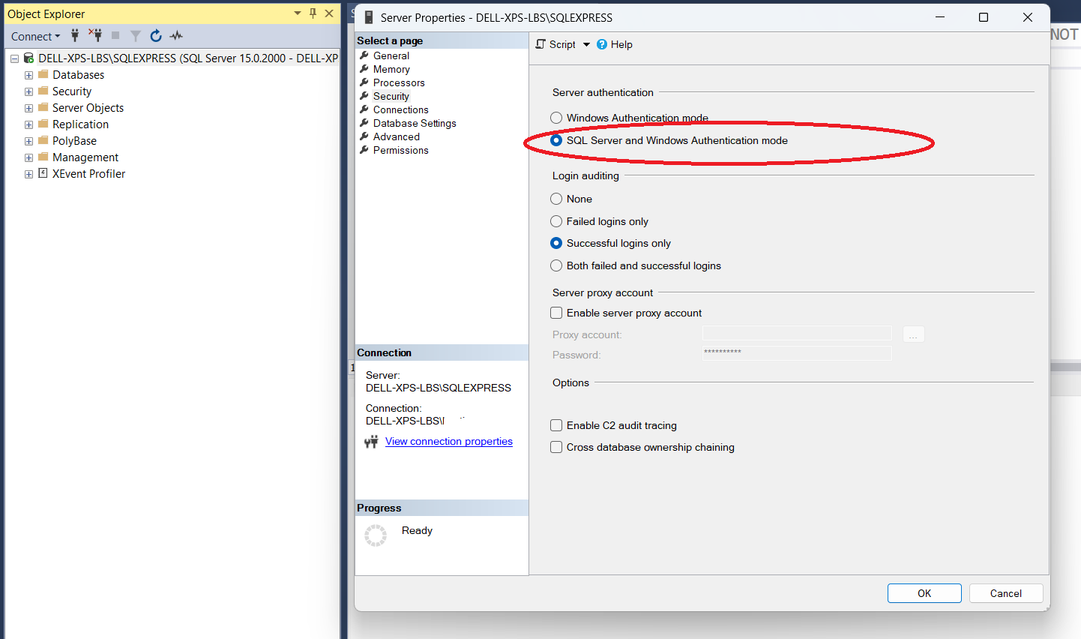

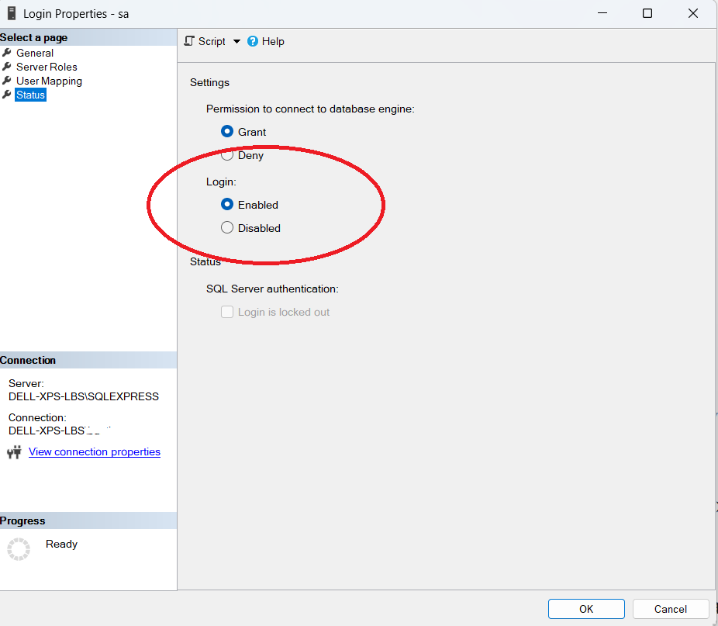

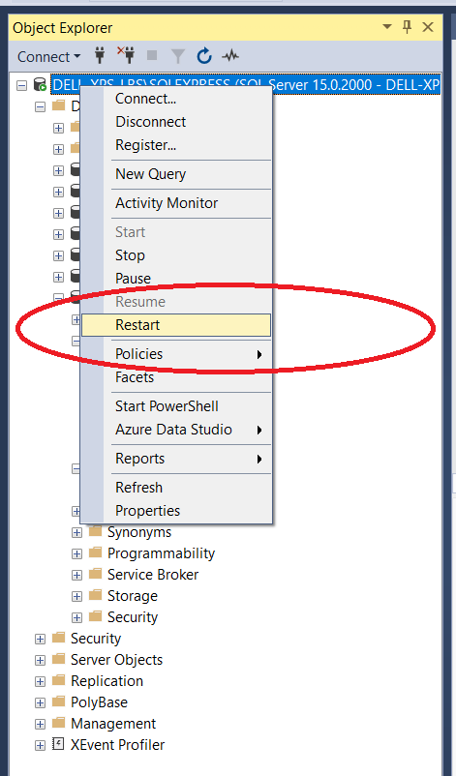

### **Visual Studio**

Setup – Only requests “.Net desktop development” Module

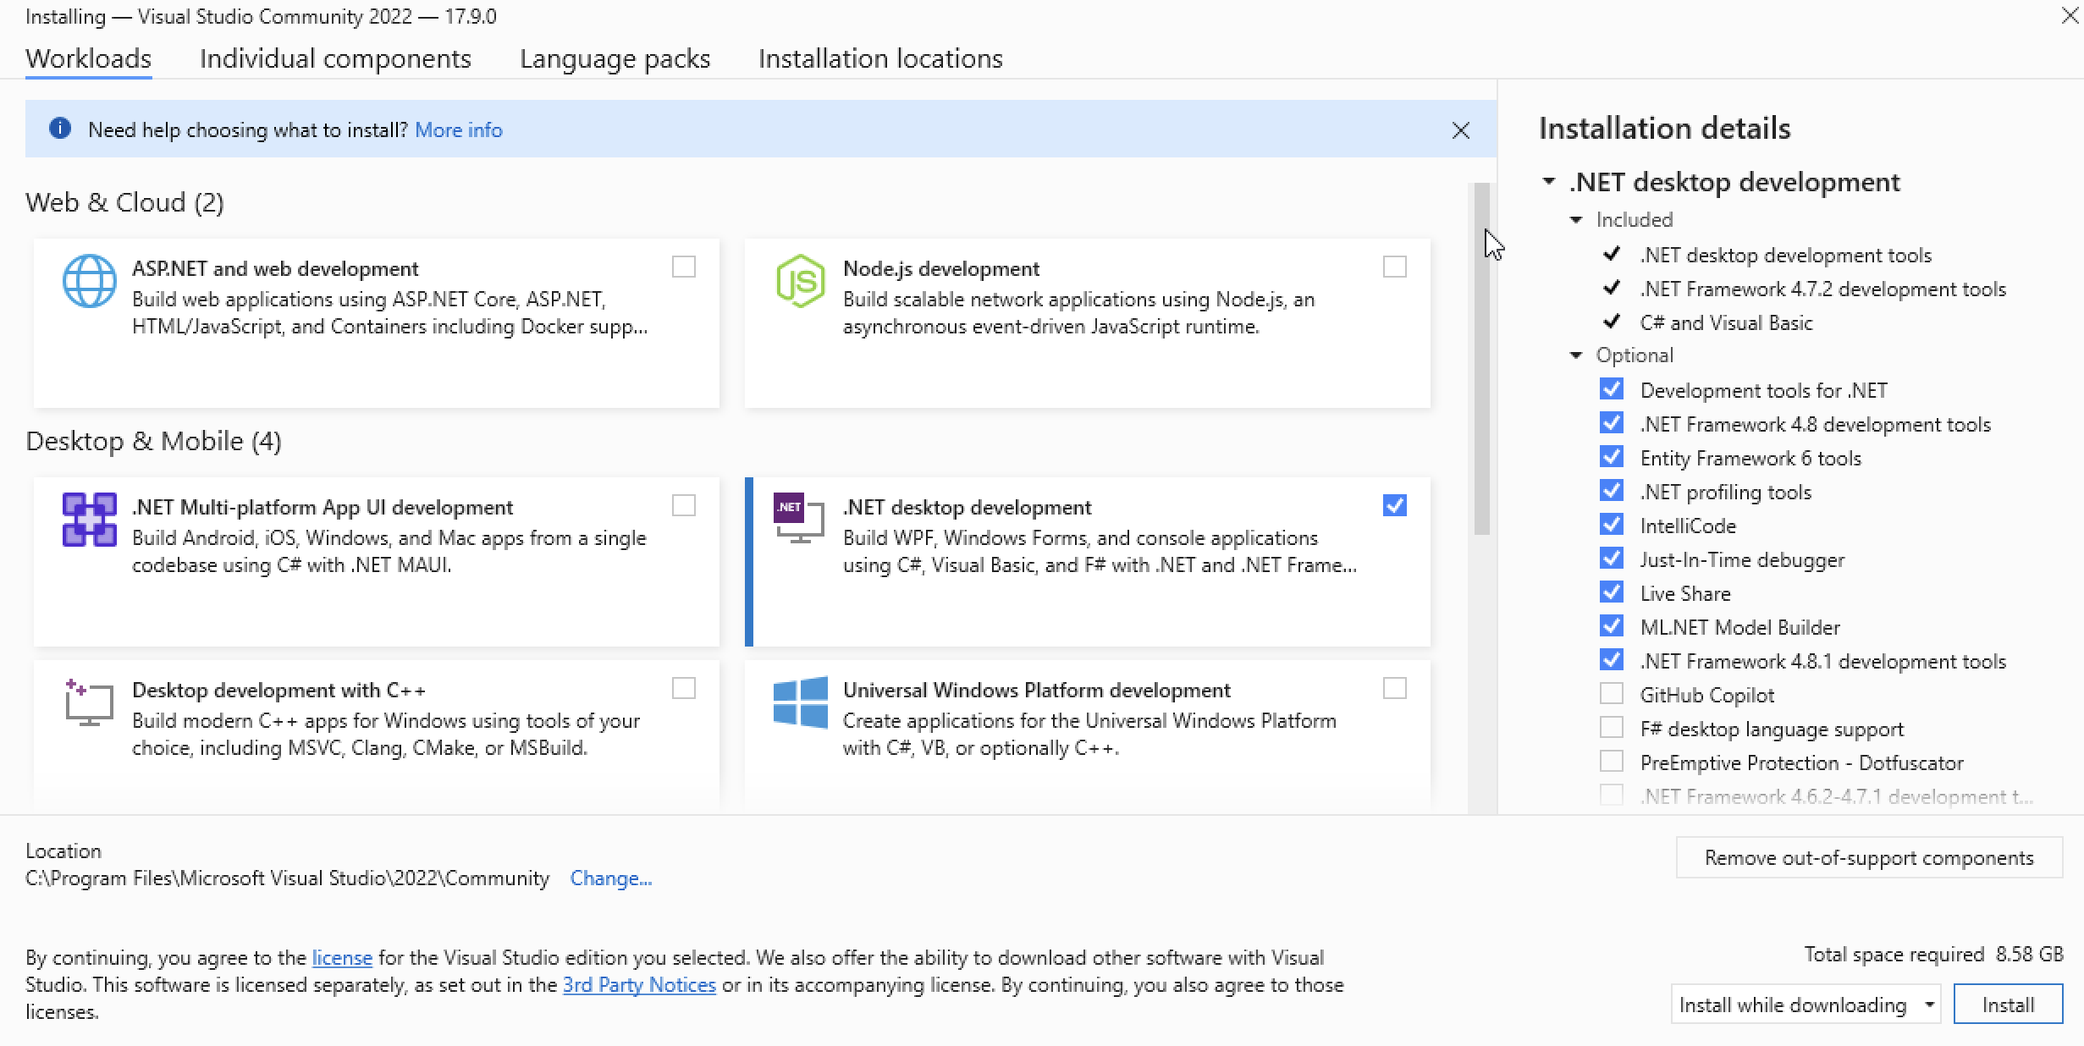

New Project – Windows Forms App C#

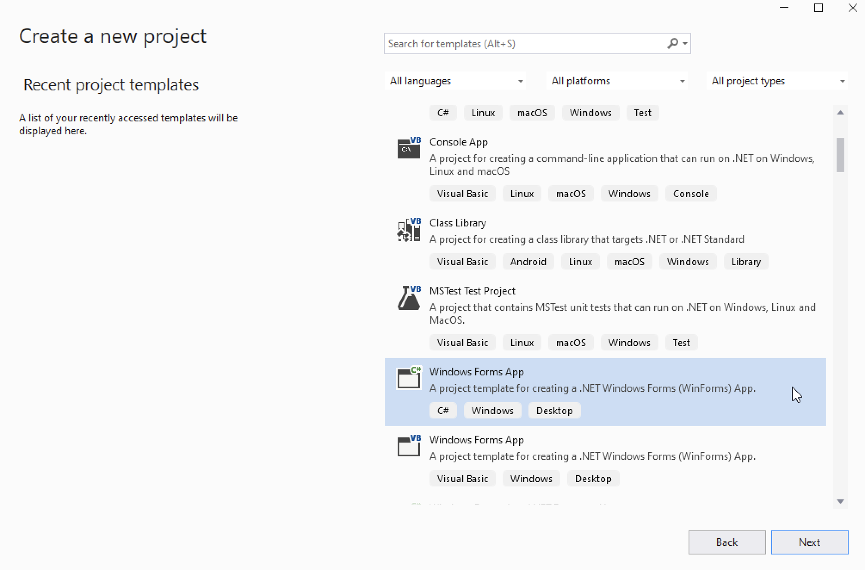

1. <https://learn.microsoft.com/en-us/ssms/download-sql-server-management-studio-ssms?view=sql-server-ver16#download-ssms>
2. <https://diadem.in/blog/sql-server-2019-express-installation>