Setup Tips

SQL Server (Engine and Management Studio)

Visual Studio

SQL Management Studio

Start by installing the SQL Server Management Studio. It's faster and you can jump to the first task while installing the database server.

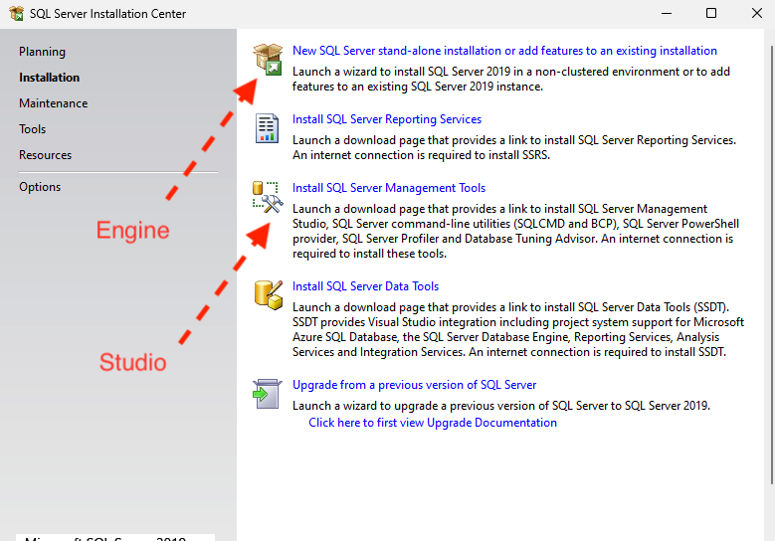

SQL Server Express

When it's finished, proceed to install the SQL Server 2019 Express.

Important, follow this tutorial step by step. Follow the images to the letter (after SQL Server Features installation). In particular, the Feature Selection and Mixed Mode Authentication.
Do not forget your username and password.
You can proceed to the first question while the database server is being installed, provided you already have the IEETA database credentials.

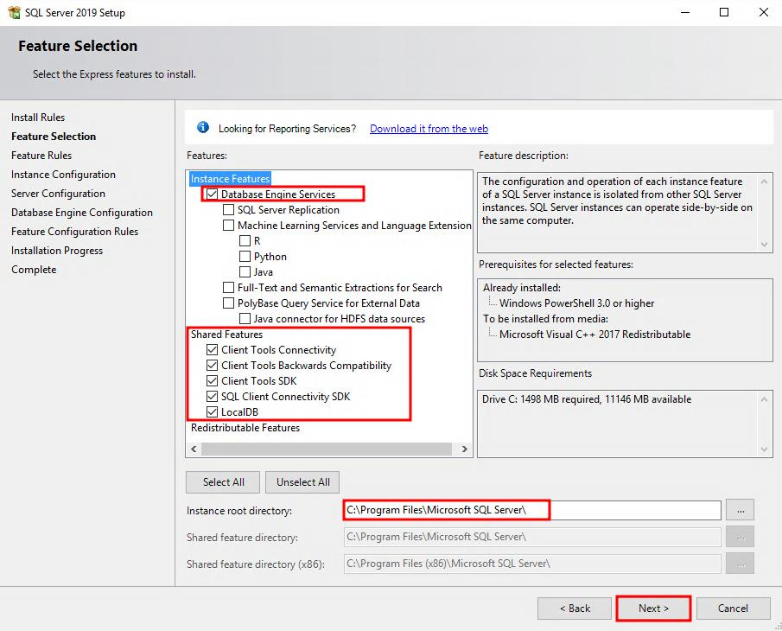 | 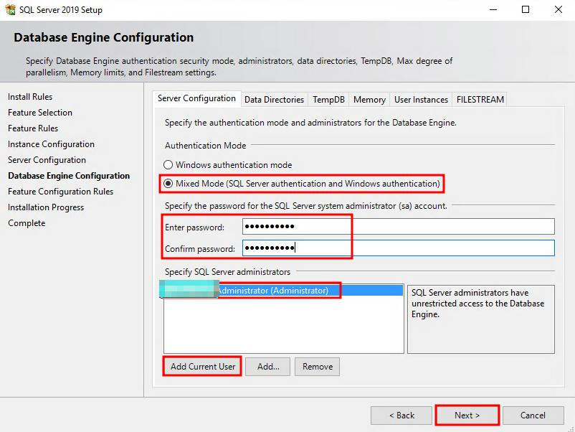

Known Problems
It is still possible if you installed it and forgot to enable mix mode. Use the following instructions:
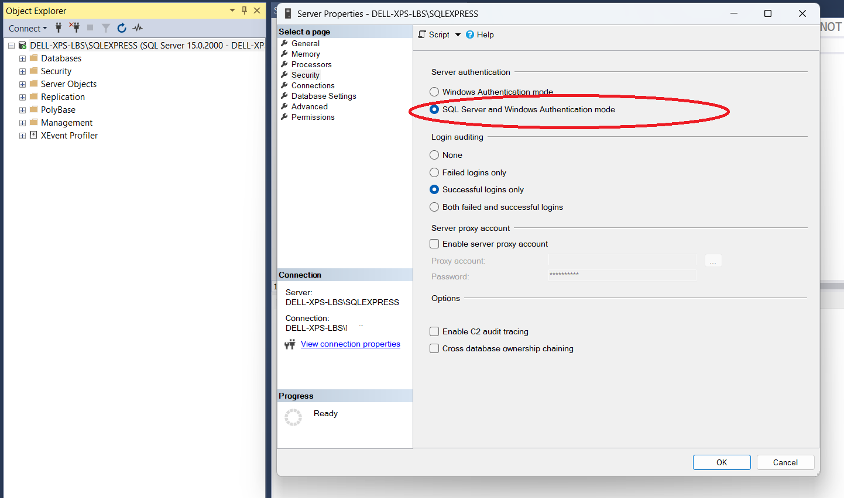
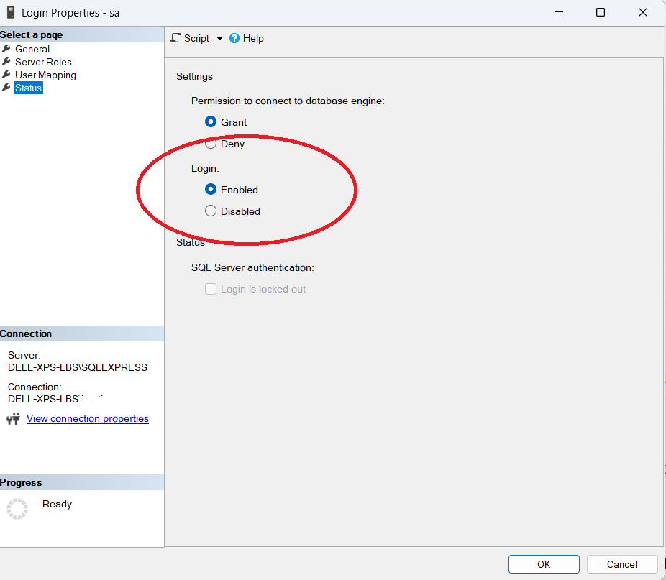
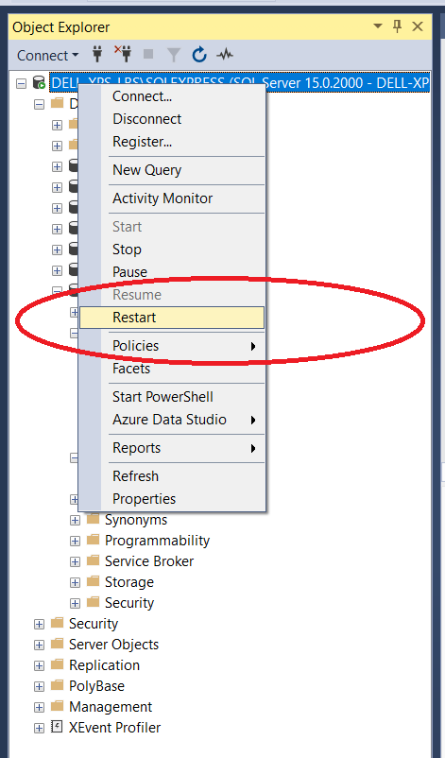

Visual Studio

Setup – Only requests “.Net desktop development” Module
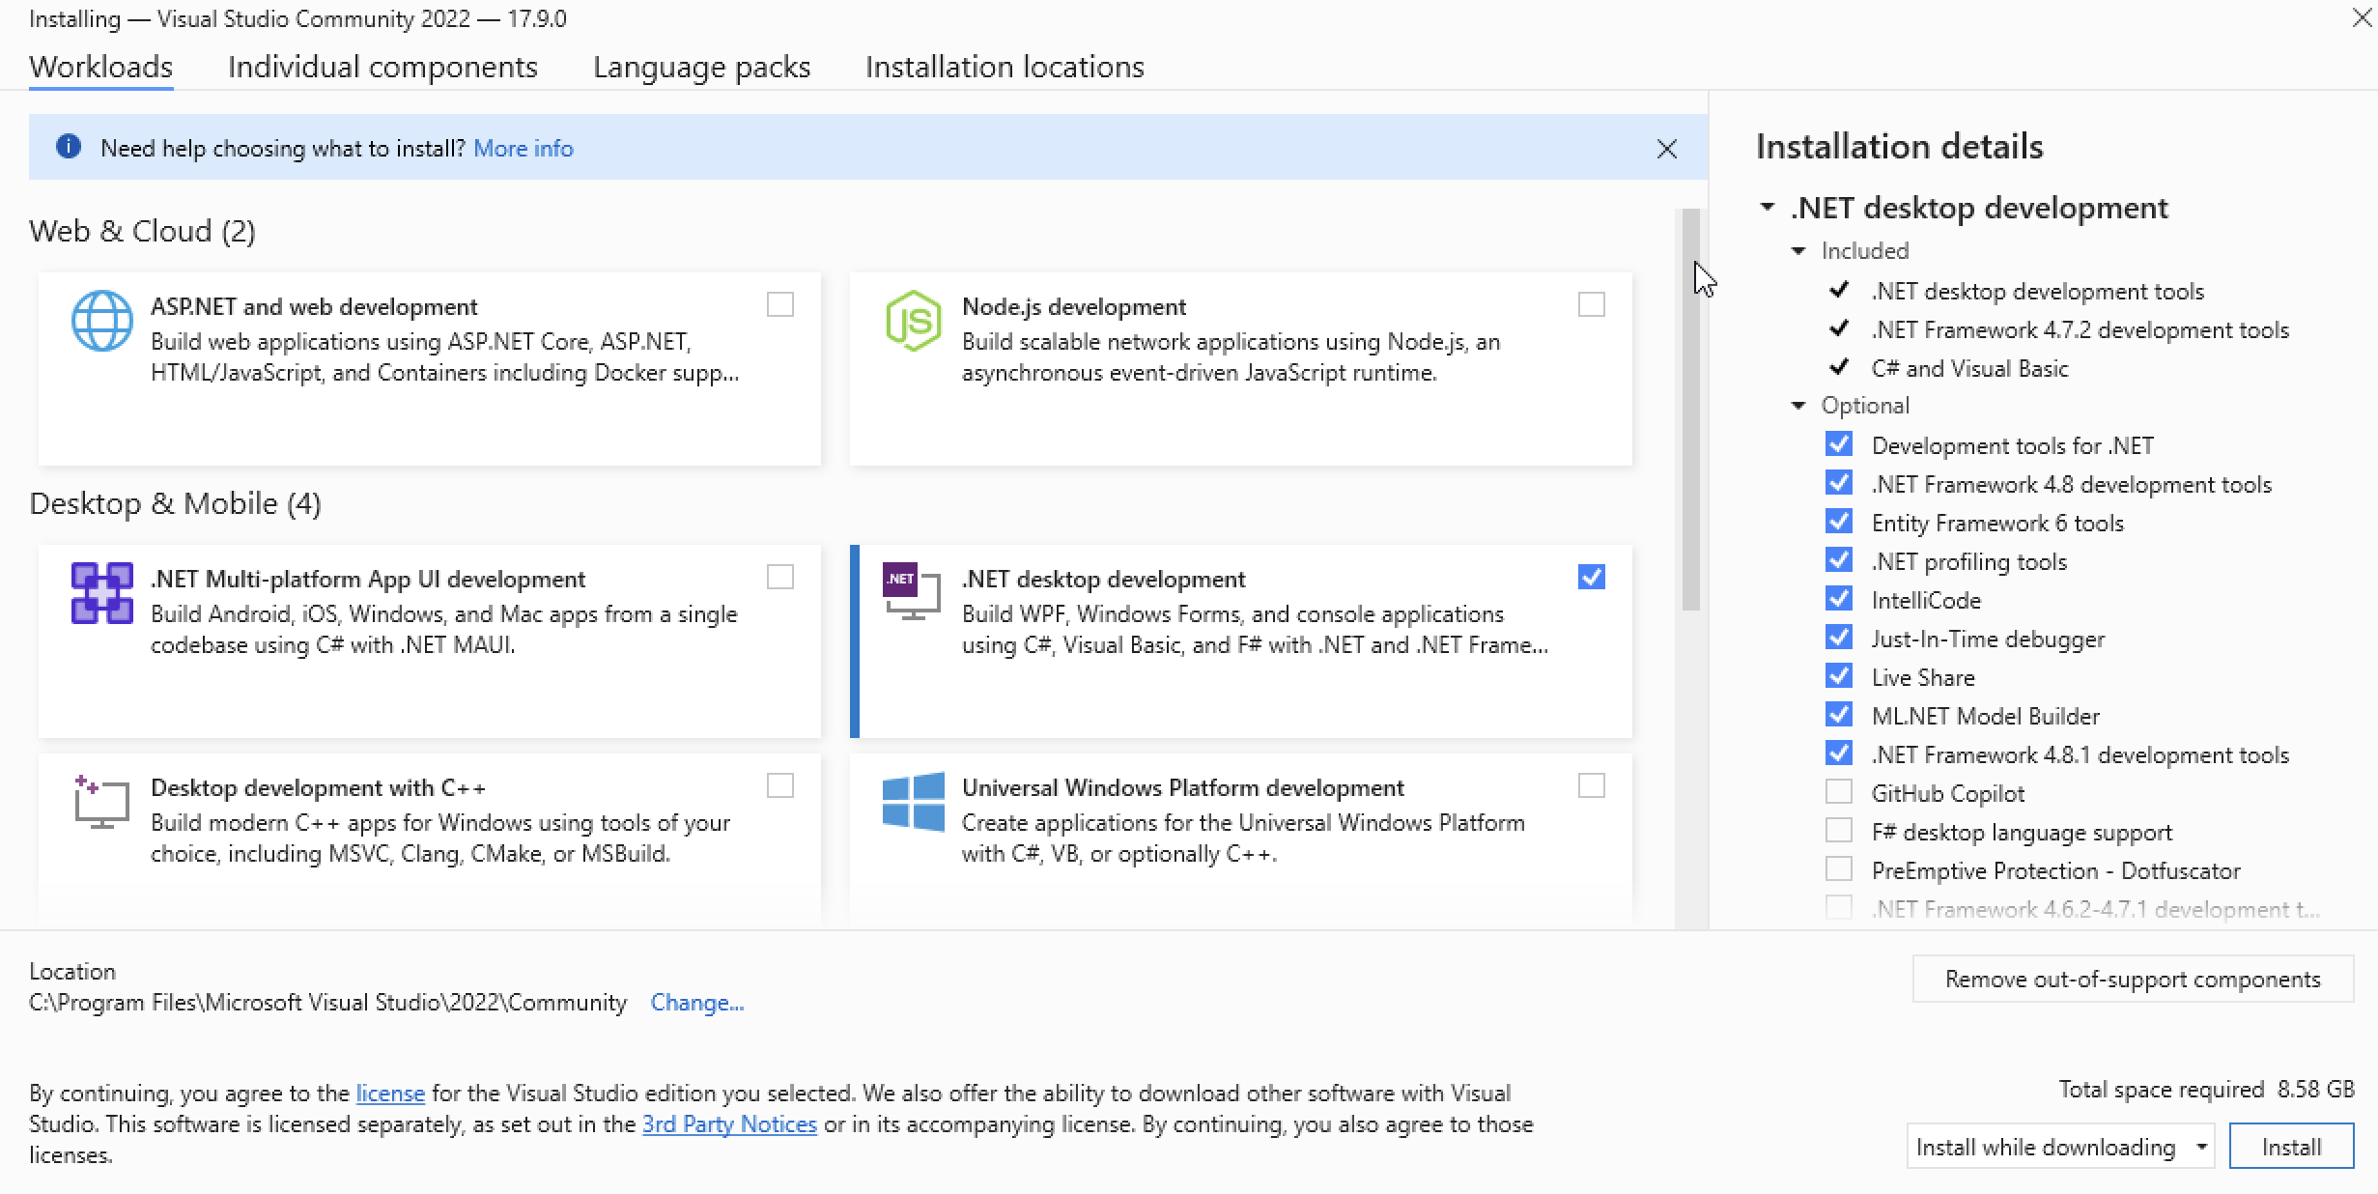

New Project – Windows Forms App C#
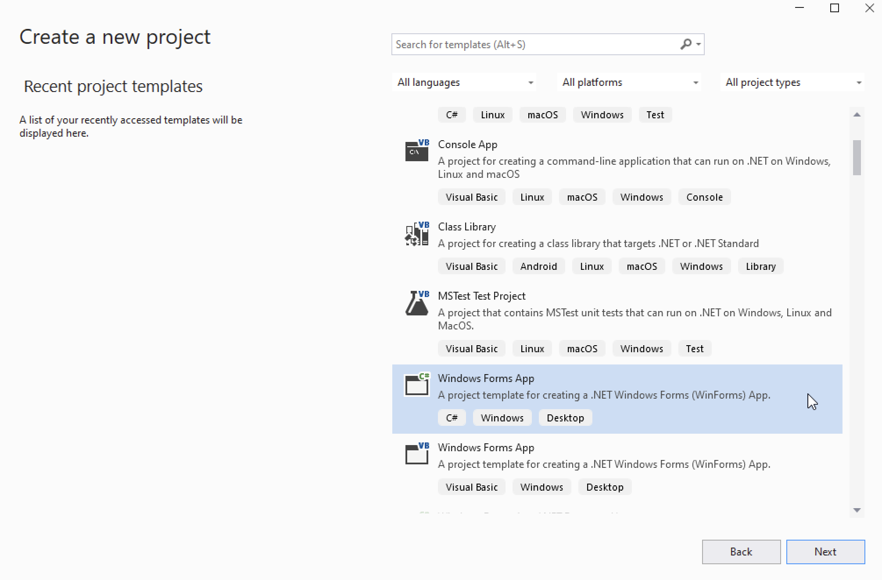

https://learn.microsoft.com/en-us/ssms/download-sql-server-management-studio-ssms?view=sql-server-ver16#download-ssms
https://diadem.in/blog/sql-server-2019-express-installation

