A Smart Delivery Optimization System for Last-Mile Couriers in Medellín
Santiago González Granada
MSc Analytics and Data Science, EAFIT University, Medellín, Colombia
Advisor: Juan Carlos Monroy Osorio
Abstract
Small last-mile courier companies in Medellín operate under a combination of constraints that most commercial routing tools fail to address: steep topographic gradients that affect vehicle capacity, plate-based traffic restrictions that limit circulation windows, narrow margins that preclude enterprise software adoption, and manual processes that propagate errors downstream. This research presents a deployable end-to-end intelligent logistics system that integrates three components — automated package measurement via ArUco markers and computer vision, a Vehicle Routing Problem (VRP) optimizer incorporating real traffic, topographic slope, heterogeneous fleet selection, cargo time windows, and pico y placa restrictions, and a three-dimensional bin packing algorithm that sequences loading by delivery order. The system is validated on a historical dataset of 139,192 delivery records collected between May 2020 and March 2026, and tested in a real operational run that processed 200 deliveries distributed across 9 routes. Results demonstrate that the system computes physically executable routes in under 30 seconds per cluster, correctly identifies slope-restricted stops, and runs on standard hardware without cloud infrastructure — making intelligent logistics accessible to small courier operators who would otherwise lack access to such tools.
Keywords: last-mile delivery, vehicle routing problem, 3D bin packing, computer vision, ArUco markers, Medellín, topographic constraints, small courier companies.

1. Introduction
The accelerating demands of urban commerce have placed growing pressure on last-mile courier companies to deliver faster, more efficiently, and at lower cost. In cities such as Medellín, this pressure is compounded by steep terrain, pico y placa traffic restrictions, and a fragmented ecosystem of small couriers that lack routing software, rely on driver intuition, and have no systematic way to optimize how packages are loaded into their vehicles. The result is wasted vehicle space, unnecessary trips, and operational costs that erode already thin margins.
Recent advancements in artificial intelligence offer new opportunities to address these inefficiencies through combinatorial optimization and computer vision. Constraint-based VRP solvers and 3D bin packing algorithms have demonstrated their capacity to compute efficient routes and maximize cargo utilization in real-world urban conditions [1,2]. However, despite the maturity of these technologies, their adoption among small last-mile couriers remains virtually nonexistent. Most operators still rely on manual route planning, informal loading practices, and driver experience — reactive approaches that are poorly suited for the operational complexity of Medellín.
The central problem is not the absence of predictive accuracy, but the absence of a practical, end-to-end system that connects package measurement, route planning, and cargo loading into a single intelligent workflow accessible to small couriers. This research presents a deployable logistics system designed specifically for the operational reality of small courier companies in Medellín. The contributions of this work are threefold: (i) an automated package measurement module based on ArUco markers and OpenCV; (ii) a VRP optimizer incorporating real-world Medellín constraints, including topographic slope, heterogeneous fleet selection, cargo time windows, and pico y placa restrictions, validated against the Google Maps Distance Matrix API; and (iii) a 3D bin packing algorithm that sequences cargo loading according to delivery order. The system is validated on a historical dataset of approximately 139,000 delivery records and on a real operational run processing 200 deliveries.
2. Related Work
The Vehicle Routing Problem and its rich variants have been extensively studied in the operations research literature. Classical formulations minimize total distance subject to vehicle capacity constraints, while rich VRP variants incorporate time windows, multiple depots, heterogeneous fleets, and dynamic traffic conditions [1]. The NP-hard nature of the problem has driven the development of metaheuristic and learning-based approaches, with Google OR-Tools emerging as a widely adopted open-source solver that combines construction heuristics with guided local search.
The seminal work of Bruni et al. [1] serves as the primary methodological reference for this research. The authors demonstrated that machine learning heuristics can solve complex stochastic bin packing problems up to 75 times faster than exact solvers while maintaining solution quality within a 5% optimality gap, making real-time optimization feasible for small operators. Their integration of machine learning with combinatorial optimization in the context of third-party logistics and last-mile delivery established a template for applying these techniques to courier-scale problems. Giuffrida et al. [2] extended this line of research by showing that combining route optimization with vehicle consolidation strategies reduces operational costs by up to 67% compared to single-vehicle approaches in urban delivery settings. Both studies emphasize the importance of adapting optimization tools to the specific operational context in which they are deployed.
In the context of three-dimensional bin packing, the literature has evolved from simple first-fit decreasing heuristics to sophisticated metaheuristics that incorporate stability, weight distribution, and unloading sequence constraints. Computer vision approaches to automated package measurement have also matured, with ArUco markers [3] providing a low-cost, robust solution for spatial reference in controlled environments. However, few studies have integrated these three components — measurement, routing, and packing — into a single deployable system tailored for small courier operations.
3. Methodology
3.1 System Architecture
The proposed system is structured as a three-layer architecture built around a FastAPI backend that coordinates three independent but interconnected modules: the computer vision measurement engine, the vehicle routing optimizer, and the three-dimensional cargo loading optimizer. The application exposes a three-page web interface — registration, measurement, and optimization — accessible through any standard browser, with all processing running locally on standard hardware without cloud infrastructure.
3.2 Automated Package Measurement
The measurement module implements a real-time computer vision pipeline using OpenCV and ArUco marker detection. A printed 5 × 5 cm ArUco marker is placed alongside each package in the camera's field of view. The detector converts each frame to grayscale, identifies the marker using the DICT_4X4_50 dictionary, and computes a pixels-per-centimeter scale factor by dividing the marker's pixel dimensions by its known physical size. A Canny edge detector combined with morphological operations identifies the package contour, and dimensional measurements are derived using the spatial reference. Measurements are considered valid only after five consecutive stable frames, preventing errors from camera movement or partial marker occlusion.
3.3 Vehicle Routing Optimizer
The routing module implements a multi-vehicle VRP pipeline with automatic geographic clustering. Given a set of confirmed packages, the system computes total weight and volume, applies a cost-efficiency heuristic to select the appropriate fleet configuration from a catalog of four vehicle types (Renault Kangoo, Renault Trafic, Nissan NV350, Chevrolet NPR), and groups deliveries into geographic clusters using a custom K-means algorithm operating on latitude-longitude coordinates with Haversine distance as the metric.
For each cluster, the system fetches a real-time distance matrix from the Google Maps Distance Matrix API using the planned departure timestamp, ensuring that travel times reflect actual traffic conditions rather than free-flow estimates. A hybrid cost matrix combines travel time with a topographic penalty: slopes above 18% incur 1,800 seconds of additional cost, slopes between 12% and 18% incur 900 seconds, and slopes between 7% and 12% incur 300 seconds. This penalty structure discourages routing fully loaded vehicles up steep gradients when flatter alternatives exist.
A physics-based module evaluates whether each vehicle can physically climb to every assigned stop under its current payload. Given a vehicle's tare weight, horsepower, drivetrain efficiency, and the slope between two stops, the module computes the required traction power — including gravitational and rolling resistance components — and compares it against the available wheel power. Stops flagged as non-viable trigger a nearest-corner snapping algorithm that reassigns the delivery point to the closest accessible location.
Medellín's pico y placa restriction is encoded as a rule-based class that maps weekdays to restricted plate digits and defines two daily restriction windows (06:00–08:30 and 17:30–20:00). The optimizer filters ineligible vehicles before the OR-Tools solver runs, and automatically advances the departure time if the planned start falls within a restriction window. The VRP is solved with PATH_CHEAPEST_ARC as the construction heuristic and GUIDED_LOCAL_SEARCH for improvement, with a 30-second time limit per cluster.

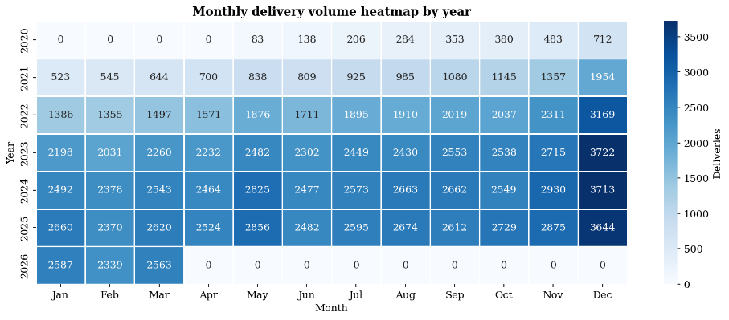
3.4 Three-Dimensional Bin Packing
The packing module implements a free-space heuristic that places packages inside the vehicle's cargo bay in reverse delivery order, ensuring the first stop is always accessible at the cargo door. The algorithm maintains a dynamic list of free spaces that gets split and pruned after each placement, evaluates six possible box orientations per package (unless the cargo is fragile), and computes a support ratio to ensure structural stability. The final output includes the exact XYZ coordinates of every package, the vehicle's center of mass, and a loading efficiency metric expressed as the percentage of cargo volume occupied.
4. Dataset and Experimental Setup
The dataset used in this study contains 139,192 delivery records spanning May 2020 to March 2026, reflecting the operational patterns of a last-mile courier company serving Medellín and its metropolitan area. Each record captures 19 fields including package identifier, timestamp, geocoded destination, elevation above sea level, cargo type, box dimensions, weight, volume, density, and delivery status. Destinations are distributed across 35 real neighborhoods of Medellín, weighted by commercial activity — El Poblado, Laureles, and Envigado receive the highest volumes, consistent with urban commercial density patterns.
The dataset reflects the natural maturation of a growing courier operation: missing value rates for the neighborhood field decline from 25.92% in 2020 to 1.00% in 2026, while weight outliers detected by the interquartile range method show a parallel downward trend. This structured data-quality variation provides a realistic stress test for the preprocessing pipeline — outlier detection, missing value imputation, and coordinate validation — ensuring the system is robust to the noisier conditions of early-stage operations.
Figure 1 illustrates the monthly delivery volume across the full observation period. Two patterns emerge clearly from the visualization: a sigmoidal year-over-year growth pattern, with annual volume rising from 2,639 deliveries in 2020 (reflecting the operational disruption of the COVID-19 pandemic) to over 32,000 annual deliveries by 2025, and a recurring seasonal peak concentrated in November and December, consistent with Black Friday and Christmas commercial cycles. May shows a secondary peak attributable to Mother's Day, one of the most commercially significant dates in the Colombian retail calendar. These patterns have direct operational implications for fleet planning, staffing, and route capacity provisioning.

Figure 1. Monthly delivery volume heatmap by year (2020–2026).
5. Results
5.1 Operational Run: 200 Deliveries Across 9 Routes
In a real operational run, the proposed system processed 200 registered packages with a combined weight of 1,488 kg and a total volume of 6.70 m³. The system autonomously determined that 9 routes were required to cover all deliveries and grouped the packages into 9 geographic clusters using the K-means algorithm. All 9 routes were assigned to the most cost-efficient option— as the total payload per cluster (100–165 kg) fell comfortably within the units with 650 kg weight capacity and 2.33 m³ volume limit.
Figure 2 presents the multi-route output overlaid on the Medellín metropolitan area. The K-means clustering produced geographically coherent zones, with each route covering a distinct sector of the city — minimizing inter-cluster route crossings and reducing total deadhead distance. The collective operation covered 496 km across all routes, using real traffic times obtained from the Google Maps Distance Matrix API.
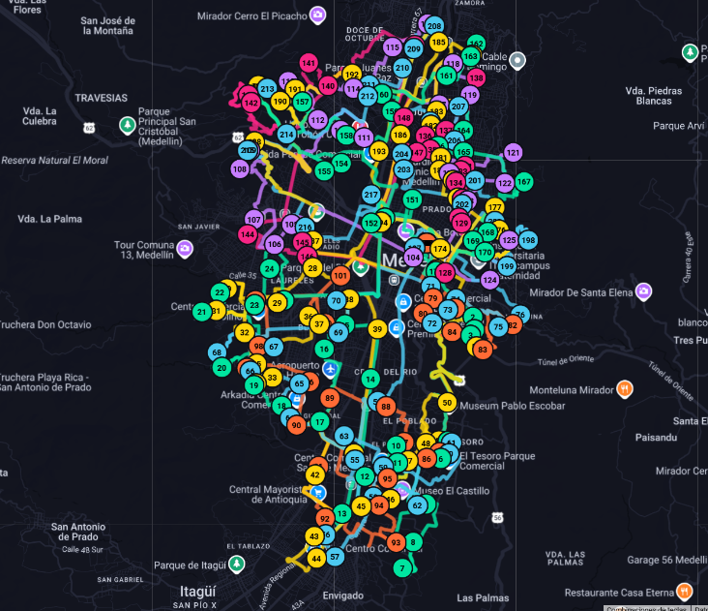Figure 2. Multi-route output across the Medellín metropolitan area. Each color represents one of the 9 routes computed by the system.
5.2 Scalability: When the Required Fleet Is Not Available
An important consideration for small courier operators is that the number of routes computed by the system may exceed their available fleet on any given day. For a small company, operating 9 vehicles simultaneously is uncommon — most small couriers own between one and four vehicles. The system addresses this constraint in two ways. First, when the available fleet is smaller than the optimal number of routes, the operator can configure the system to compute routes sequentially across multiple days or dispatch waves — splitting the delivery volume into tranches that each fit within the available fleet, while preserving the cluster geography and topographic constraints. Second, the system can be reconfigured to operate with a single vehicle per day by increasing each cluster's capacity threshold, producing longer individual routes at the cost of extended driver working hours. In both cases, the optimizer's elasticity ensures that the output adapts to the operator's real capacity rather than assuming an idealized fleet.
5.3 Topographic Slope Analysis
Of the 200 stops processed, the system classified 163 as normal slope (below 7%), 27 as moderate (7–12%), 28 as high (12–18%), and 12 as very high (above 18%). No stops required redirection to an alternate drop point, indicating that all deliveries were physically reachable by a fully loaded Renault Kangoo under its 110 HP engine rating. Stops flagged as high or very high slope — concentrated in the hillside neighborhoods of Robledo and Manrique — received additional time penalties in the OR-Tools cost matrix, resulting in sequencing adjustments that ensured vehicles approached these stops with lighter loads.
5.4 Cargo Loading Efficiency
The 3D bin packing algorithm processed each route's assigned packages independently, computing the optimal spatial arrangement inside the vehicle's cargo bay. Average cargo volume utilization across the 9 routes was 19.81%, with individual efficiencies ranging from 17.18% to 22.41%. While this figure appears low in absolute terms, it reflects a deliberate operational constraint: the bin packing algorithm prioritizes delivery sequence compliance over raw volume maximization. Packages are loaded in reverse delivery order so the first stop is always accessible at the cargo door, which necessarily creates air gaps between packages rather than stacks that would obstruct efficient unloading.
5.5 System Response Time
The complete optimization pipeline — from fetching the distance matrix to producing the final route and loading plan — completed in under 30 seconds per cluster. The FastAPI backend exposed the optimization endpoint synchronously and responded to the frontend within the expected operational threshold for a daily pre-departure planning tool.
6. Discussion
6.1 Algorithmic Elasticity and Fleet Selection
One of the most significant findings of this research is the behavioral flexibility of the optimization pipeline. The system does not impose a fixed routing strategy — it reads the scale of each day's delivery set and adapts accordingly. For large delivery volumes, the system autonomously determines that multiple geographic clusters are necessary; for smaller delivery sets, it produces a single continuous route with no clustering. No parameter was changed between configurations — the algorithm calculates the appropriate structure dynamically. Clustering is not always optimal: for small delivery sets, a single continuous route may be mathematically superior to an artificially imposed geographic partition.
Fleet selection follows the same principle. The operational run deployed Kangoo units not because other vehicles were unavailable, but because the K-means clustering distributed payloads into manageable chunks within the Kangoo's capacity. Deploying a larger vehicle such as the NV350 or NPR for a cluster of 150 kg would consume more fuel and incur a higher per-kilometer cost without any operational benefit. Regarding pico y placa compliance, the departure timestamp fell outside the afternoon restriction window, allowing all routes to proceed without restriction; had the planned departure fallen within a restricted window, the optimizer would have advanced the start time automatically and filtered ineligible plate digits before computing the solution.
6.2 Topographic Constraint Significance
The slope distribution observed in the operational run — with 40 out of 200 stops presenting moderate to very high gradients — reflects Medellín's urban geography: commercial density is concentrated in the valley floor, while residential demand extends into hillside communes where street gradients routinely exceed 10%. The fact that no stop required redirection does not mean the topographic constraint is irrelevant; it means the selected vehicle's engine power was sufficient for the payloads assigned. In scenarios with heavier packages or larger vehicles near their weight limit, the physics module would flag stops as non-viable and trigger nearest-corner reassignment. This type of physical reasoning is absent from conventional routing tools available to small couriers.
6.3 Loading Efficiency Interpretation
The 19.81% average loading efficiency invites reflection on the nature of last-mile courier operations. The binding constraint is almost never volume — it is stop count and time. Each route carried 21–24 packages, representing a full day's work for a single driver navigating Medellín's traffic. The vehicle could physically carry more packages by volume, but the driver could not deliver more stops within a reasonable working window. Distributing 200 deliveries across 9 parallel routes completes the operation in approximately 3 hours of driving per route, while a single larger vehicle would require sequential routing extending well beyond operational hours.
6.4 Cost of Real-Time Data
A critical limitation must be acknowledged: the Google Maps Distance Matrix API, which provides the real traffic times that make the system's routing decisions meaningful, comes at a significant financial cost. The operational run consumed approximately COP 300,000 in API credits in a single day. For a small courier operating on thin margins, this cost structure is not immediately sustainable on a scale. Future iterations could mitigate this by implementing a caching layer that reuses distance matrix results for frequently repeated origin-destination pairs, or by falling back to open-source routing engines such as OpenRouteService for runs where real-time traffic data is less critical.
7. Conclusions and Future Work
This research presented an end-to-end intelligent logistics system designed for the operational reality of small last-mile courier companies in Medellín. The system integrates computer vision-based package measurement, constrained vehicle route optimization, and three-dimensional bin packing into a single deployable web application running on standard hardware without cloud infrastructure. Validated on a dataset of 139,192 historical delivery records and tested in an operational run of 200 deliveries, the system computes physically executable routes that respect topographic, temporal, and regulatory constraints that conventional GPS navigators systematically ignore.
Many of the losses that small courier companies absorb every day — extra fuel, failed deliveries, overtime — are not bad luck. They are the predictable consequence of making complex decisions without the right information. The proposed system does not eliminate complexity; it makes complexity visible, measurable, and actionable before the van leaves the warehouse. It demonstrates that intelligent logistics tools can be built, validated, and deployed without enterprise infrastructure, and that the benefits of optimization are within reach for small operators who need them most.
Future work will focus on three directions: (i) replacing ArUco-based measurement with LiDAR-enabled smartphones and machine learning models for contactless, markerless package dimensioning; (ii) developing a caching strategy to reduce dependence on the Google Maps API for cost-sustainable operation at scale; and (iii) extending the VRP formulation to handle stochastic demand and same-day delivery windows, integrating ideas from recent machine-learning-based heuristics for bin packing and routing [1].
References
[1] Bruni, M. E., Fadda, E., Fedorov, S., & Perboli, G. (2023). A machine learning optimization approach for last-mile delivery and third-party logistics. Computers & Operations Research, 157, 106262.
[2] Giuffrida, N., Fajardo-Calderin, J., Masegosa, A. D., Werner, F., Steudter, M., & Pilla, F. (2022). Optimization and machine learning applied to last-mile logistics: A review. Sustainability, 14(9), 5329.
[3] Garrido-Jurado, S., Muñoz-Salinas, R., Madrid-Cuevas, F. J., & Marín-Jiménez, M. J. (2014). Automatic generation and detection of highly reliable fiducial markers under occlusion. Pattern Recognition, 47(6), 2280–2292.
[4] Gonzalez-Calderon, C. A., Posada-Henao, J. J., Granada-Muñoz, C. A., Moreno-Palacio, D. P., & Arcila-Mena, G. (2022). Cargo bikes in Medellín: a possibility for sustainable urban freight transportation. Transportation, 49(5), 1351–1369.
[5] Zheng, Y., Capra, L., Wolfson, O., & Yang, H. (2014). Urban computing: Concepts, methodologies, and applications. ACM Transactions on Intelligent Systems and Technology, 5(3), 1–55.
[6] Sinnott, R. W. (1984). Virtues of the Haversine. Sky and Telescope, 68(2), 158.
[7] Perboli, G., Rosano, M., Saint-Guillain, M., & Rizzo, P. (2018). Simulation–optimisation framework for city logistics: an application on multimodal last-mile delivery. IET Intelligent Transport Systems, 12(4), 262–269.
[8] Montecinos, J., Ouhimmou, M., Chauhan, S., & Paquet, M. (2021). Horizontal collaborative transportation planning for small and medium-sized enterprises. Transportation Research Part E, 149, 102314.

