BoxScan
A smart delivery optimization system for last-mile couriers in Medellín

SANTIAGO GONZALEZ GRANADA

THESIS ADVISOR: JUAN CARLOS MONROY OSORIO

MSc ANALYTICS & DATA SCIENCE
SCHOOL OF ENGINEERING, EAFIT

MEDELLÍN COLOMBIA
2026

CONTENTS
SUMMARY 2
INTRODUCTION 3
PROBLEM STATEMENT 5
JUSTIFICATION 6
1. Operational Relevance 7
2. Academic Contribution 7
3. Methodological Advancement 7
GENERAL OBJECTIVE 9
To deploy an AI-based framework that integrates route optimization and space loading in last-mile freight transport, aiming to improve efficiency and decision-making for small couriers in Medellín. 9
Specific Objectives 9
CONCEPTUAL FRAMEWORK 10
Artificial Intelligence and Machine Learning: Definitions and Role in Logistics 10
Practical Applications and Model Examples 11
Contextualization in Time and Space 11
Data Preparation and Handling 12
Integrated Operational Strategies and Emerging Trends 12
METHODOLOGICAL DESIGN 14
• Data Collection 14
BIBLIOGRAPHY 46

SUMMARY
The supply chain is one of the most critical industries around the world, relying heavily on vans, trains, cars, and trucks to transport goods across the continent(these are not the only way to transport). One of the greatest challenges faced by distribution companies is how to deal with delays while they are pursuing optimization in picking, packing, routing, delivery times, and transportation routes, due to the many different variables that might affect the process itself, which can be caused by a wide range of factors, including logistics complexity, weather conditions, road closures, scheduling constraints, and geographic dispersion.
Today, the industry is under increasing pressure not only to deliver on time, but to deliver smarter — optimizing the space inside every vehicle, reducing the number of trips, and making every kilometer count.
This research explores how artificial intelligence (AI) can be systematically applied to solve two of the most critical operational challenges in last-mile logistics: route optimization and cargo loading efficiency. Specifically, the system combines a constrained Vehicle Routing Problem (VRP) solver — incorporating real urban restrictions such as topographic slope, vehicle capacity, delivery time windows, and Medellín's pico y placa traffic restriction — with a 3D bin packing algorithm that determines the optimal spatial arrangement of packages inside the delivery vehicle. Package dimensions are captured automatically through a computer vision module using ArUco markers, eliminating manual measurement from the workflow.
Rather than relying on predictive ML models for delay classification, this work focuses on deterministic and combinatorial optimization: given a set of packages with known destinations, dimensions, and weights, the system computes the best route and the best loading configuration simultaneously. The intelligence of the system lies not in predicting what might go wrong, but in computing the most efficient plan before the van leaves the hub.

INTRODUCTION
The supply chain and logistics sector is essential to the smooth flow of commodities in the modern, globalized economy, enabling international trade, production, and retail. This industry is especially important in Colombia that is a developing country where transportation networks mostly rely on road freight via cars, trucks, vans, but lacks railroads to satisfy strict delivery deadlines and growing customer demands(Larson & Halldorsson, 2004). But supply networks' growing complexity has also made already difficult problems worse, especially when it comes to precise and prompt delivery of goods. Delivery delays affect inventory management, customer satisfaction, and overall competitiveness in addition to being operational inefficiencies(Rokoss et al., 2024a). Since many manufacturers use just-in-time (JIT) production and distribution processes, even little transportation disruptions can have big repercussions later on. Forecasting delivery time frames and reducing delays have therefore become crucial issues for both business and academia. Besides this, the way the goods is moved is not optimized, as the most common way to pick up and delivery is just by making the routing optimized but they ignore the fact that the space into the transport can be also optimized as well.
Delivery delays can happen for many reasons. Factors like bad weather, road blockages, heavy traffic, shortages in supplies, and scheduling issues all lead to unexpected changes in how deliveries perform. Managing these disruptions can be challenging with traditional logistics methods, which usually depend on set rules, past data, or manual choices. Because today’s transportation systems are so dynamic and unpredictable, these old methods often don’t have the adaptability and scalability needed to respond in real-time or foresee problems before they arise(Palakshappa et al., 2025).
Recent developments in artificial intelligence (AI) and machine learning (ML) have opened new avenues for improving logistics performance. By analyzing large volumes of structured and unstructured data, AI/ML models offer the potential to uncover complex patterns, forecast risks, and support real-time decision-making in supply chain operations. Predictive models such as Random Forest, LightGBM, and XGBoost have demonstrated notable success in identifying the likelihood of delivery delays based on historical shipment data, traffic patterns, and geospatial features(Douaioui et al., 2024). More advanced models, including deep neural networks and ensemble methods, have been used to improve travel time estimation, delivery scheduling, and route optimization. For example, (Zhang et al., 2018a) proposed DEEPTRAVEL, a neural network-based model that leverages auxiliary supervision to extract spatio-temporal features from trajectory data and accurately estimate travel time across segments. Similarly, (Yang & Xu, 2025a) introduced a Heterogeneous Hypergraph Neural Network (H2GNN) that combines structural and statistical information to enhance package arrival time predictions in large-scale e-commerce platforms.
Despite these promising results, the adoption of AI/ML in real-world logistics settings remains limited. Many models are developed and tested in controlled environments or on curated datasets, lacking validation in complex, high-volume, real-time supply chain systems. Moreover, there is a gap in the literature regarding the integration of these technologies into end-to-end logistics workflows, particularly in truck-based freight transportation. Most studies either focus narrowly on specific technical improvements or fail to consider operational constraints such as routing flexibility, data quality, and scalability. As a result, it remains unclear how these technologies can be implemented effectively to enhance logistics performance under real-world constraints, particularly where dynamic routing and just-in-time delivery models converge.
Addressing this gap requires not only the development of accurate predictive models but also a clear understanding of how such models can be embedded within logistics operations to generate actionable insights. This study explores the dual use of machine learning algorithms to predict delivery delays and optimize transportation routes in truck-based logistics operations and the last mile deliveries. Models such as Random Forest, XGBoost, and neural networks are evaluated in a logistics-focused framework using historical data, geospatial information, and real-time traffic conditions. These approaches are designed to support dynamic route planning, risk forecasting, and improved delivery reliability. By applying these techniques within a Colombian context, this research contributes to both the academic understanding of AI/ML in logistics and the practical advancement of more intelligent, adaptive, and sustainable supply chains.

PROBLEM STATEMENT
Despite ongoing advances in logistics digitization, the road freight transport sector continues to face persistent inefficiencies in route optimization and cargo utilization. As delivery volumes grow and urban congestion intensifies, the inability to plan efficient routes and fully utilize vehicle capacity translates directly into higher operational costs, unnecessary trips, and reduced service reliability — particularly for small last-mile courier companies that lack access to enterprise-grade optimization tools. (Rokoss et al., 2024b); (Demir et al., 2014). These challenges are especially critical in Colombian freight systems, where road-based distribution serves as the primary mode of intra-regional transport where the last mile is a growing market and there is still too much work to be done on this field.
Conventional logistics planning methods — based on static routing rules, fixed schedules, and manual load assignment — are increasingly ill-suited for the dynamic conditions of urban last-mile delivery. In response, artificial intelligence (AI) has shown substantial potential in two complementary directions: combinatorial optimization, which computes provably efficient routes and loading configurations given a set of constraints; and computer vision, which automates the physical measurement of packages at intake, eliminating a key source of manual error and delay. Together, these approaches enable a system that is not only reactive to operational constraints but proactively structured to minimize cost, distance, and wasted cargo space before a single delivery begins. (Zhang et al., 2018b); (Choetkiertikul et al., 2018).
However, despite these advancements, the integration of AI into operational logistics environments — particularly for small and medium courier companies — remains limited. Most implementations stop short of connecting package intake, route planning, and cargo loading into a single end-to-end workflow, resulting in fragmented processes where each stage is handled manually or in isolation. This gap is especially pronounced in cities like Medellín, where topographic complexity, traffic restrictions, and the informal nature of many last-mile operators make optimization both more necessary and harder to achieve with off-the-shelf tools. (Thürauf et al., 2021; Palakshappa et al., 2025).

JUSTIFICATION
The accelerating demands of urban commerce have placed growing pressure on last-mile courier companies to deliver faster, more efficiently, and at lower cost. In Medellín, this pressure is compounded by steep terrain, pico y placa restrictions, and a fragmented ecosystem of small couriers that lack routing software, rely on driver intuition, and have no systematic way to optimize how packages are loaded. The result: wasted vehicle space, unnecessary trips, and operational costs that erode already thin margins. (Liang et al., 2016)
Recent advancements in artificial intelligence (AI) and machine learning (ML) offer new opportunities to address these issues by modeling uncertainty, predicting delivery performance, and enabling real-time routing decisions. Tools such as Random Forest, XGBoost, and deep neural networks have demonstrated their capacity to analyze large datasets and identify complex spatial-temporal patterns (Choetkiertikul et al., 2018). However, despite the maturity of these technologies, their adoption among small last-mile couriers remains virtually nonexistent. Most operators still rely on manual route planning, informal loading practices, and driver experience — reactive approaches that are poorly suited for the operational complexity of a city like Medellín.
The central problem lies not in predicting delays, but in building a practical, end-to-end system that connects package measurement, route planning, and cargo loading into a single intelligent workflow accessible to small couriers. Bridging this gap requires translating optimization theory into deployable tools that work under real operational constraints — a city's topology, a van's dimensions, and a driver's morning schedule.
As observed in urban logistics ecosystems, such as Medellín Colombia, a multitude of delivery companies operate within the last-mile segment. These enterprises often rely on experiential knowledge and manual processes to manage their operations, with limited integration of advanced technological tools. This reliance on traditional methods can lead to inefficiencies, particularly in dynamic urban environments where factors such as traffic congestion and variable customer demand play significant roles. (Gonzalez-Calderon et al., 2022)
Contrastingly, on a regional scale, larger logistics firms are progressively adopting sophisticated technologies to enhance their operational efficiency and customer service levels. These organizations implement real-time data analytics, artificial intelligence (AI), and cloud-based systems to optimize route planning, predict delivery times, and respond adaptively to changing conditions. Such technological integration not only streamlines logistics operations but also significantly improves the customer experience by providing timely and reliable deliveries. (Gayialis et al., 2022)
This research is justified in three interrelated dimensions:
- Operational Relevance
Inefficient route planning and poor cargo utilization result in measurable financial losses for small couriers — extra trips, underloaded vehicles, and missed deliveries compound daily. BoxScan addresses this directly by automating package measurement, computing optimized routes under Medellín's real constraints, and maximizing vehicle space utilization before departure, offering practical value to operators with limited buffers and no access to enterprise logistics software.
- Academic Contribution
Although the literature on AI applications in logistics has expanded, most research focuses on predictive models tested in controlled environments, with limited attention to end-to-end system integration for small operators. This study contributes by combining computer vision, combinatorial optimization, and 3D bin packing into a unified deployable system, grounded in a synthetic dataset calibrated to Medellín's operational reality and validated against real geographic and topographic constraints.(Arishi et al., 2022).
- Methodological Advancement
This research advances the field by demonstrating that intelligent logistics optimization does not require large enterprise infrastructure. By building a lightweight, open-source system using OR-Tools, OpenCV, and FastAPI, it establishes a replicable methodology for deploying AI-driven route and cargo optimization in resource-constrained environments — directly applicable to the thousands of small courier companies operating across Latin American cities, this special case in Medellin, Colombia.

The disparity between local and regional logistics practices underscores the critical need for technological advancement among last-mile delivery companies in Medellín. By embracing modern logistics technologies, these companies can enhance their operational capabilities, reduce inefficiencies, and meet the evolving expectations of customers in a rapidly changing urban environment.
This study stands at the intersection of academic research and practical logistics implementation, offering insights that extend beyond theoretical contributions. By integrating computer vision-based package measurement, constrained route optimization, and 3D cargo loading into a single deployable system, it responds to the concrete operational gaps faced by small couriers in Medellín. In doing so, BoxScan demonstrates that intelligent logistics tools can be built, validated, and deployed without enterprise-scale infrastructure — a contribution as relevant to practitioners as it is to researchers.

GENERAL OBJECTIVE

To deploy an AI-based framework that integrates route optimization and space loading in last-mile freight transport, aiming to improve efficiency and decision-making for small couriers in Medellín.

Specific Objectives
- To design and implement an automated package measurement system using ArUco markers and computer vision to capture real-time freight dimensions.
- To develop a VRP optimizer with real-world Medellín constraints: topographic slope, heterogeneous fleet, cargo time windows, and traffic policies restrictions.
- To implement a 3D bin packing algorithm that optimizes vehicle loading sequence according to delivery order, maximizing cargo efficiency.

CONCEPTUAL FRAMEWORK
The conceptual foundation of this research rests on three interconnected pillars: computer vision for automated package measurement, combinatorial optimization for route planning under real urban constraints, and three-dimensional bin packing for cargo loading efficiency. Together, these disciplines form the theoretical backbone of BoxScan — a system designed to address the operational gaps faced by small last-mile courier companies in Medellín, where topographic complexity, traffic restrictions, and limited access to technology converge into a distinct and underserved logistics challenge..(Gayialis et al., 2022)
Research shows that combining computer vision with optimization algorithms can significantly improve logistics efficiency. Automated measurement systems reduce manual errors when packages are registered, while route optimization solvers cut total distance and fuel use by accounting for vehicle capacity, delivery schedules, and urban traffic rules. When these tools are combined with a cargo loading system, courier companies can reduce the number of daily trips, lower operating costs, and deliver more reliably — without needing expensive enterprise software..(Huang & Bagheri, n.d.)

Artificial Intelligence and Machine Learning: Definitions and Role in Logistics
Artificial Intelligence (AI) refers to the simulation of human cognitive functions by machines—particularly those that involve learning, reasoning, and problem-solving. A subset of AI, Machine Learning (ML), enables systems to automatically learn from past data and improve predictions without being explicitly programmed for each scenario(Bassiouni et al., 2024). ML algorithms use statistical techniques to identify complex patterns and dependencies in large datasets, making them ideal for logistics applications where multiple variables interact in non-linear ways.
The growing application of AI in logistics stems from its ability to transform operational data — such as package dimensions, delivery addresses, and vehicle capacity — into optimized decisions. Unlike traditional rule-based methods, AI-driven optimization tools adapt to changing constraints and can handle the combinatorial complexity of real-world routing and loading problems that would be impractical to solve manually.(Tsolaki et al., 2023).

Practical Applications and Model Examples
The use of predictive analytics in logistics has been documented in both academic and industrial settings. One of the most illustrative examples is the case study conducted by (Tsolaki et al., 2023) at MIT, which focused on predicting on-time delivery performance for Coyote Logistics, a third-party logistics provider. Using logistic regression, the authors identified six statistically significant predictors (e.g., on-time pickup, facility type, carrier historical volume) and developed a model with a 76.4% reduction in tracking resource needs while maintaining a minimal misclassification rate of 2.4%​.
In another influential work, Truong (2014) used quantile regression forests to predict transit times for Amazon’s linehaul operations. His model outperformed traditional statistical approaches by capturing complex variable interactions and accounting for outliers that are common in logistics data. These studies underscore the capacity of ML models—such as random forests, gradient boosting, and neural networks—to handle high-dimensional, imbalanced datasets in supply chain operations.
State-of-the-art approaches like DeepTTE avoid path segmentation by leveraging multitask learning to directly predict total travel time, thus capturing temporal and spatial dependencies holistically. Similarly, DeepTravel (Zhang et al., 2018c) introduces auxiliary supervision and hybrid architectures to learn contextual, behavioral, and spatial-temporal features, improving both interpretability and performance.
Other models, such as RNML-ETA (Sun et al., 2020), use metric learning to improve generalization in sparsely sampled routes, addressing one of the main limitations of traditional ETA models: poor performance in low-frequency corridors. These innovations have contributed significantly to the development of robust, interpretable, and scalable delivery prediction systems.

Contextualization in Time and Space
Understanding the spatiotemporal context of deliveries is crucial for any optimization system. In Medellín, delivery performance is shaped by factors that go beyond simple distance — elevation differences between neighborhoods can exceed 1,000 meters, creating slope constraints that affect which vehicles can serve which destinations when fully loaded. Traffic restriction policies like pico y placa limit certain vehicles to specific hours, making departure time a hard operational constraint rather than a preference.
Time is also a key dimension in cargo loading decisions. Packages must be loaded in reverse delivery order so that the first stop is accessible without moving other freight. This means that route sequence and loading arrangement must be planned together, not separately — a constraint that manual processes rarely respect and that BoxScan addresses explicitly.(Raghavan & Zhang, n.d.).

Data Preparation and Handling
Effective AI-driven optimization depends on clean, structured input data. (Tsolaki et al., 2023) In BoxScan, data preparation operates at two levels. At the package level, dimensional and weight data are captured automatically through the computer vision module, reducing manual entry errors. Delivery addresses are geocoded in real time using the Google Maps Geocoding API, enriching each record with latitude, longitude, elevation, and neighborhood — the spatial variables required by the route optimizer.
At the dataset level, the historical records used in this research reflect the natural data quality evolution of a growing courier company — earlier periods show higher rates of missing values, duplicate entries, and measurement outliers, while more recent records are progressively cleaner and more complete. This variability ensures that the preprocessing pipeline — including outlier detection, missing value imputation, and coordinate validation — is tested against realistic data conditions rather than artificially clean inputs. (Dreiseitl & Ohno-Machado, 2002).

Integrated Operational Strategies and Emerging Trends
Beyond algorithm selection, delivery optimization also depends on smart operational practices. (Fu & Jenelius, 2018) Research shows that integrating route planning with cargo loading decisions — rather than treating them as separate steps — produces better outcomes in both vehicle utilization and delivery punctuality, (Li et al., 2021) demonstrated that smart shipping platforms that fuse data from orders, routes, and real-time conditions outperform traditional dispatching systems in speed and cost. Reinforcement learning methods, such as PD-SNO, further extend capabilities by optimizing pickup and delivery routing (PDP) problems under dynamic constraints. Ant Colony Optimization (ACO) (Wu & Gao, 2023) has proven similarly effective, particularly when handling constraints like delivery time windows and vehicle capacity.
Recent advances such as H2GNN (Yang & Xu, 2025b) explore hypergraph neural networks to model the high-order relationships among deliveries, clients, and infrastructure. Meanwhile, (Zhu et al., 2024) Emerging trends in last-mile logistics point toward lightweight, deployable systems that bring optimization capabilities to small operators without requiring cloud infrastructure or enterprise software licenses. The use of open-source solvers like Google OR-Tools, combined with computer vision libraries such as OpenCV, makes it possible to build end-to-end intelligent logistics systems that run on standard hardware — a direction this research directly pursues.

Strategic and Environmental Implications
Route optimization and cargo consolidation offer not only economic benefits but also environmental value. By reducing unnecessary trips and maximizing vehicle utilization, small courier companies can lower fuel consumption, carbon emissions, and labor costs. (Montecinos et al., 2021) highlights that when carriers optimize routes and consolidate loads, the result is shorter total distances, reduced emissions, and improved service reliability.
As such, the implementation of AI-driven optimization must be understood within broader sustainability and efficiency goals. The conceptual framework of this research emerges as a practical structure where computer vision, combinatorial optimization, and spatial data converge into a deployable system for last-mile couriers.
In summary, the integration of artificial intelligence into last-mile logistics represents a concrete opportunity to improve how small courier companies plan, load, and execute deliveries. From automated package measurement to constrained route optimization and 3D cargo loading, the tools developed in this research address real operational inefficiencies faced daily by couriers in cities like Medellín. The value of these technologies lies not only in their technical performance but in their accessibility — demonstrating that intelligent logistics systems can be built and deployed without enterprise infrastructure, and that the benefits of optimization are within reach for small operators who need them most.

METHODOLOGICAL DESIGN
General Approach
This study adopts a quantitative and applied research approach aimed at designing, implementing, and validating an end-to-end intelligent logistics system for last-mile courier operations in Medellín. The approach combines three technical components — computer vision for package measurement, constrained route optimization, and 3D bin packing for cargo loading, which is integrated into a single deployable web application. The design is grounded in the principle that operational efficiency gains for small couriers come not from predicting what might go wrong, but from computing the best possible plan before the delivery route begins.
ACTIVITIES AND DEFINITIONS:

Data Collection
The dataset used in this study contains approximately 139,000 delivery records spanning from May 2020 to March 2026, built from the operational patterns of a last-mile courier company serving Medellín and its metropolitan area — Envigado, Bello, Itagüí, and Sabaneta. Each record captures what a courier company actually tracks day to day: a package ID, when it was registered, where it needs to go, how big and heavy it is, what type of cargo it contains, and whether it was delivered on time.
Destinations are distributed across 35 real Medellín neighborhoods, weighted by commercial activity — so El Poblado and Laureles receive more deliveries than Palmitas or Santa Elena, just as they would in practice. Package dimensions follow standard box sizes used by courier companies, with weights calculated from real cargo density values for each product category. Early records in 2020 are messier — missing coordinates, duplicate entries, weight outliers — because that is what a company's data actually looks like in its first year of operations. By 2025, the data is nearly complete, reflecting a more mature operation.
The dataset covers over 70 months, 14 cargo categories, and 35 neighborhoods, giving the system enough variety to be tested under conditions that reflect the real complexity of running a courier operation in a city like Medellín.

- Data Preprocessing
This stage is a foundational component of the modeling pipeline, especially in logistics applications where data is often heterogeneous, incomplete, and inconsistently formatted. Preprocessing ensures that the dataset is both analytically valid and algorithmically compatible, allowing the optimization system to compute accurate routes and loading configurations without being misled by noise or structural inconsistencies. This stage consists of a sequence of sub-tasks, each designed to address common data challenges.
The first sub-task is data cleaning, which involves the identification and correction — or removal — of erroneous, duplicated, or inconsistent records. In logistics datasets, duplications may arise from repeated package registration, manual entry errors, or failed batch processes. These are detected using hashing techniques, primary key filters, and temporal deduplication strategies. The effectiveness of this step is measured using metrics such as the total number of duplicate entries removed, the percentage of entries corrected, and the rate of retained clean records. Additional checks include verifying timestamp consistency, ensuring geographic coordinates are within valid ranges, and resolving contradictory fields such as negative weights or missing elevation values.
Following cleaning, the dataset undergoes normalization, an essential transformation that improves algorithmic stability by placing features on comparable scales. This is particularly important for optimization algorithms that rely on distance or elevation metrics, where features on incompatible scales can distort cost calculations in the route planner.
- Min-Max Scaling, which linearly transforms a feature x to a range [0,1] using:
$$x' = (x - x_min) / (x_max⁡- x_min)$$
This method preserves the distribution shape but is highly sensitive to extreme values.
- Z-score Standardization, which centers the feature around the mean and normalizes it to unit variance. The formula is:
$$x' = (x - μ) / σ$$
Where μ is the mean of the feature, and σ is the standard deviation. This technique is especially useful when the data approximates a normal distribution.
- Robust Scaling, which is less sensitive to outliers and relies on the median and interquartile range (IQR). The formula is:
$$x' = (x - median(x)) / IQR(x)$$
This method is preferable for features such as delivery times, where outlier events (e.g., extreme delays) may significantly skew the distribution.
A parallel preprocessing challenge is the encoding of categorical variables, which are not natively interpretable by most machine learning models. This transformation allows categorical information to be embedded numerically while preserving or discarding ordinality as appropriate. Two encoding strategies are applied:
- One-Hot Encoding is used for nominal variables like city names, transport providers, or vehicle types. It creates binary flags for each category, avoiding any implicit order.
- Ordinal Encoding is used when the variable has a meaningful order, such as service levels (e.g., economy < standard < express). Here, integer values are assigned according to the rank of each category.
Another essential component is missing value imputation, which addresses data gaps caused by sensor errors, latency in data pipelines, or manual omissions. Missing data, if left untreated, can reduce the model’s accuracy or result in biased predictions. Several imputation strategies are used depending on the pattern and volume of missingness:
- Mean Imputation, where missing values are replaced by the mean of the available observations.
- Median Imputation, which is more robust to skewed distributions.
- K-Nearest Neighbors (KNN) Imputation, which estimates missing values by averaging the values from similar (nearest neighbor) records.
- Regression Imputation, which uses regression models to predict the missing values based on other variables.
- Multivariate Imputation by Chained Equations (MICE), an iterative method that models each missing variable conditionally using all other variables as predictors, yielding statistically coherent imputations across features.
Throughout preprocessing, metrics are tracked to ensure effectiveness—such as the proportion of missing data filled, number of additional features created via encoding, and distributional changes after scaling. These sub-tasks collectively transform raw logistics data into a clean, normalized, and model-ready format, ensuring that subsequent learning phases are built on a solid and interpretable foundation.
As illustrated in Figure 1, the data preprocessing pipeline consists of six sequential stages designed to transform raw logistics data into a clean, structured, and model-ready dataset
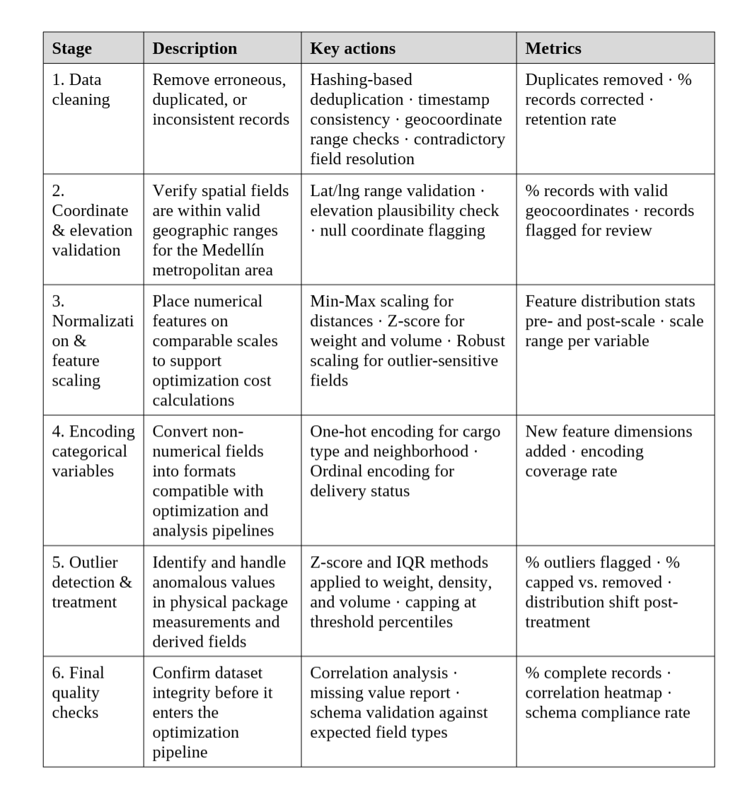
Figure 1: Preprocess Table

Feature Engineering
Effective feature engineering is essential to uncovering latent patterns in delivery logistics data that are not immediately evident from raw variables. This phase enhances the representational quality of the input space and directly contributes to the performance of the optimization system. Based on the dataset's rich temporal, geographic, and transactional content, new variables are systematically derived to capture time-sensitive, spatial, and contextual information. Temporal fields such as registration timestamp and delivery date are transformed into features like hour of day, day of the week, and month — capturing periodic variations in delivery volume and operational cycles, including peak commercial dates and pico y placa restriction windows (Zheng et al., 2013). (Zheng et al., 2013). Additionally, lead time intervals—such as the lag between order and shipping or between shipping and actual delivery—serve as proxies for operational efficiency and potential bottlenecks.
Spatial dimensions are modeled through the calculation of geodesic distances using the Haversine formula (Sinnott, 1984), which estimates the great-circle distance between two geographic points based on latitude and longitude. These features, expressed in kilometers, provide a first-order approximation of physical delivery effort. Where available, these distances may be further refined into estimated travel times by interfacing with routing engines or traffic-aware APIs such as the Google Maps Distance Matrix or OpenRouteService, thereby incorporating real-world constraints and average transit durations (Gao et al., n.d.)
Further enriching the dataset, categorical spatial features — such as neighborhood and commune — are encoded as ordinal variables that capture expected delivery complexity based on location characteristics within Medellín. Elevation above sea level is used to derive slope estimates between consecutive delivery stops, which feed directly into the vehicle climb-capacity constraint of the VRP optimizer. At the package level, cargo type is mapped to predefined delivery time windows, constraining which stops can be scheduled at which hours and adding a temporal dimension to the spatial routing problem(Laynes-Fiascunari et al., 2023)
Collectively, this multi-dimensional feature engineering strategy transforms the original dataset into a more expressive and structured representation of the delivery process. It ensures that the optimization system can account for interactions across time, space, and physical package characteristics — from departure hour and slope constraints to cargo type and vehicle capacity — thereby strengthening both the operational relevance and analytical depth of the model.
To assess the relevance and contribution of engineered features, a feature correlation matrix is computed using Pearson or Spearman coefficients to identify redundant variables and reduce noise in the input space. Features with high mutual correlation are consolidated or removed to ensure that each variable contributes independently to the routing and loading decisions. This selection process balances informativeness, non-redundancy, and computational efficiency — ensuring the final feature set is both interpretable and actionable within the constraints of the BoxScan system.
System Benchmarking
System benchmarking in this research refers to the structured evaluation of BoxScan's core optimization components under controlled conditions. Rather than comparing predictive ML models, the benchmarking process assesses the performance of two optimization strategies and one loading algorithm across a set of standardized delivery scenarios derived from the dataset.
The first component evaluated is the route optimizer, which is benchmarked under two strategies: elevation-based routing, where the cost function penalizes steep slopes between consecutive stops, and traffic-based routing, where cost is determined by real travel times obtained from the Google Maps Distance Matrix API. Both strategies use the same OR-Tools VRP solver, the same fleet, and the same set of delivery points — ensuring a fair comparison of routing outcomes under identical conditions.
The second component is the 3D bin packing algorithm, which is evaluated in terms of cargo space utilization across different package mixes and vehicle types. Loading efficiency is measured as the percentage of available vehicle volume occupied by packed packages, with attention to whether all packages fit in a single vehicle or require overflow handling.
Together, these benchmarks provide a quantitative basis for evaluating BoxScan's effectiveness as an end-to-end logistics optimization system, and directly inform the parameters measured in the following section.

Parameters to Measure:
To comprehensively evaluate the performance of BoxScan's optimization components, a robust set of quantitative parameters is applied across two dimensions: route efficiency and cargo loading utilization. These metrics ensure that both the operational impact and the computational feasibility of the system are accounted for.
Route performance is assessed using four core metrics applied to the comparison between elevation-based and traffic-based routing strategies. Mean Absolute Error (MAE) captures the average deviation between estimated and actual travel times across stops, providing an intuitive measure of route time prediction accuracy. Root Mean Squared Error (RMSE) penalizes larger deviations more heavily, making it sensitive to stops where the route optimizer significantly underestimates travel time — particularly relevant on steep Medellín streets where slope penalties affect vehicle speed. R² evaluates how well the optimizer's cost function explains variance in actual delivery outcomes across different route configurations. Mean Absolute Percentage Error (MAPE) expresses route time error as a percentage, enabling comparison across delivery scenarios with different distances and stop counts.
Spatial Clustering for Route Construction
To achieve the specific objective of deploying an end-to-end logistics optimization system, this study proposes the development and implementation of BoxScan — an integrated decision-support tool tailored for small last-mile courier operations in Medellín. The system is conceived as a three-stage platform that combines automated package measurement, route optimization, and cargo loading into a single operational workflow accessible through a web interface.
The system consists of two main layers: a frontend dashboard and a backend API. The frontend is built with HTML, CSS, and JavaScript, providing an intuitive three-page interface — package registration, measurement confirmation, and route visualization — compatible with standard web browsers. On the backend, FastAPI exposes the optimization engine through RESTful endpoints, allowing the route optimizer and bin packing algorithm to run on-demand and return results in under one second for typical courier-scale instances of up to 50 deliveries.
System performance is assessed along three key parameters. First, API response time is benchmarked to remain under one second for route optimization requests, ensuring the platform supports real-time operational decisions without noticeable latency. Second, user accessibility is evaluated based on the number of steps required to register a package, confirm its dimensions, and execute a route — with the goal of keeping the full workflow under three interface interactions. Third, route output quality is assessed by comparing elevation-based and traffic-based routing strategies across total distance, total time, estimated cost, and cargo loading efficiency — where travel times are obtained in real time from the Google Maps Distance Matrix API using the planned departure timestamp, incorporating live traffic conditions into the optimization cost function.
Route Optimization and System Validation
To validate the practical utility of BoxScan's optimization engine, this study contrasts two routing strategies applied to the same set of delivery points under identical constraints. The baseline approach assigns stops in registration order — the way a courier without optimization software would naturally operate. The optimized approach uses the OR-Tools VRP solver with a nearest neighbor construction heuristic and 2-opt refinement, incorporating real traffic times from the Google Maps Distance Matrix API, topographic slope penalties, vehicle capacity constraints, cargo time windows, and pico y placa restrictions.
Both strategies are evaluated across the same delivery scenarios using four performance indicators: total route distance in kilometers, total estimated route time in minutes, estimated fuel cost in Colombian pesos, and cargo loading efficiency expressed as the percentage of vehicle volume utilized. A fifth indicator — time window compliance — measures the proportion of stops reached within their designated delivery window, reflecting the system's ability to respect cargo-type scheduling constraints.
The comparison between elevation-based and traffic-based routing strategies within BoxScan provides an additional layer of validation, quantifying whether accounting for Medellín's topographic complexity produces meaningfully different routes from pure traffic-time optimization — and under which conditions each approach is preferable.
Regarding scalability, BoxScan is designed to operate on standard hardware without cloud infrastructure. The FastAPI backend processes optimization requests for up to 50 simultaneous deliveries in under one second, making deployable on a basic laptop or low-cost server — a deliberate design choice that keeps the system accessible to small courier operators with limited technical resources.
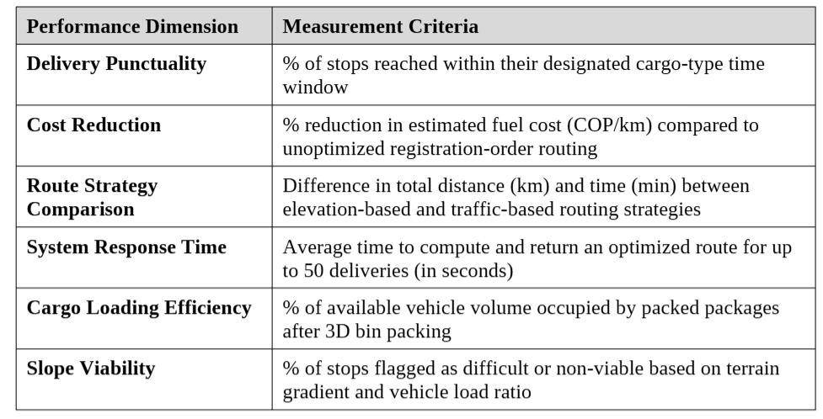
Figure 2: Performance Criteria
Research Phases with Definitions and Measurable Parameters
Phase 1: Data Collection and Processing
- Definition: Construction of a historical delivery dataset calibrated to the operational conditions of the Medellín metropolitan area, covering May 2020 to March 2026.
- Tools: Python, pandas, Google Maps Geocoding API, Google Maps Elevation API
- Metrics: Total records generated (~139,000), temporal coverage (70 months), % records with valid geocoordinates, % missing values by year, % outliers detected and treated.
Phase 2: System Design and Implementation
- Definition: Development of the three core components of BoxScan — automated package measurement, VRP route optimizer, and 3D bin packing algorithm — integrated into a single web application.
- Tools: FastAPI, OpenCV, ArUco markers, Google OR-Tools, Google Maps Distance Matrix API
- Metrics: API response time (seconds), number of constraints implemented, vehicle types supported, cargo categories handled.
Phase 3: Route Optimization and Validation
- Definition: Execution of the VRP optimizer on real delivery scenarios and comparison of elevation-based vs. traffic-based routing strategies.
- Tools: OR-Tools VRP solver, Google Maps Distance Matrix API, Google Maps JavaScript API
- Metrics: Total route distance (km), total route time (min), estimated cost (COP), time window compliance (%), slope viability per stop.
Phase 4: Cargo Loading and Efficiency Analysis
- Definition: Application of the 3D bin packing algorithm to determine optimal package arrangement inside the selected vehicle.
- Tools: First-fit decreasing heuristic, vehicle catalog (Kangoo, Trafic, NV350, NPR)
- Metrics: Cargo loading efficiency (%), packages packed vs. unpacked, vehicle utilization by weight and volume.
Phase 5: System Deployment and Accessibility
- Definition: Deployment of BoxScan as a lightweight web application accessible to courier operators without technical expertise.
- Tools: FastAPI, HTML/CSS/JavaScript, Google Maps JavaScript API
- Metrics: Number of interface steps to complete a full delivery workflow, API response time under load, cross-browser compatibility.

While BoxScan represents a functional and deployable optimization system, several challenges are anticipated in its broader application. First, measurement accuracy depends on the quality of ArUco marker placement and lighting conditions during package intake — poor camera angles or damaged markers can produce incorrect dimensions that propagate into loading and routing decisions. Second, the Google Maps Distance Matrix API introduces a cost constraint: each optimization run consumes API calls proportional to the number of delivery stops, which may limit the system's scalability for very large daily volumes without a paid API plan. Third, the current VRP implementation handles up to 50 simultaneous deliveries efficiently, but performance under larger instances — typical of medium-sized courier operations — has not been stress-tested and may require solver parameter tuning or hardware upgrades. Fourth, the pico y placa restriction is currently modeled based on Medellín's 2024–2026 schedule, and any regulatory changes would require manual updates to the system. Lastly, ensuring operator adoption is a non-technical but critical challenge — the system's value depends on couriers consistently registering packages through BoxScan rather than reverting to manual processes. Addressing these challenges will be essential to translating BoxScan from a research prototype into a sustainable operational tool for small courier companies.
4. Data Analysis & Exploratory Findings
4.1 Dataset Overview
The dataset used in this study comprises 139,192 delivery records from May 5, 2020 to March 30, 2026, covering the Medellín metropolitan area including the municipalities of Envigado, Bello, Itagüí, and Sabaneta. Each record captures the full operational lifecycle of a package — from registration at the warehouse to final delivery status — across 19 fields including geocoded destination coordinates, elevation above sea level, package dimensions, cargo type, and delivery outcome. The dataset was constructed to reflect the realistic operational conditions of a small last-mile courier company, showing the reality of this growing operation.
Before any analysis was conducted, basic integrity checks confirmed that timestamp, address, dimensional, and weight fields were fully populated across all records. Fields dependent on external geocoding — neighborhood, commune, destination coordinates, elevation, and density — showed structured missingness concentrated in 2020 and 2021, consistent with the immaturity of the company's data infrastructure in its early years of operation.
4.2 Operational Growth and Volume Trends
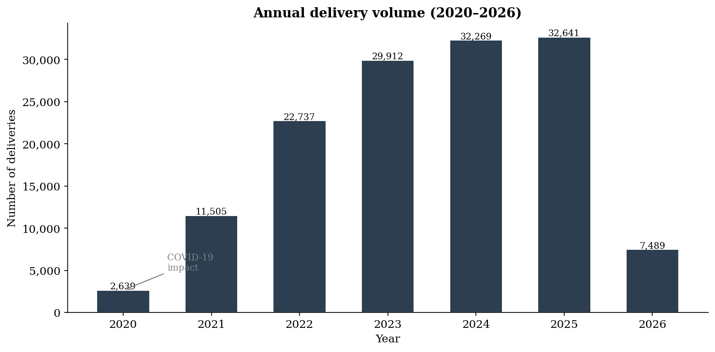
Figure 3: Company's growth
Figure 3 illustrates the annual delivery volume from 2020 to 2026. The growth pattern follows a sigmoidal curve characteristic of a company in its early scaling phase: volumes were severely depressed in 2020, with only 2,639 deliveries recorded — a direct consequence of the operational disruption caused by the COVID-19 pandemic, which reduced activity to approximately 35% of projected capacity during the first eight months of the year. Recovery began in the second half of 2020 and accelerated through 2021, when volume reached 11,505 deliveries, representing a 336% increase over the pandemic year.
Growth continued steadily through 2022 and 2023, reaching 22,737 and 29,912 deliveries respectively, before plateauing in 2024 and 2025 at approximately 32,000–32,600 annual deliveries — suggesting the company approached a natural saturation point relative to its current fleet and operational capacity. The 2026 figure of 7,489 represents only the first quarter of the year and is therefore not directly comparable to full-year totals.
The average daily volume evolved from fewer than 15 packages per day in 2020 to approximately 90 packages per day by 2025, reflecting a compounded annual growth rate of roughly 65% over the observation period. This trajectory provides a strong empirical foundation for the time series forecasting component discussed in the following section, where ARIMA and SARIMA models are applied to project future demand beyond the observation window.
4.3 Data Quality Evolution
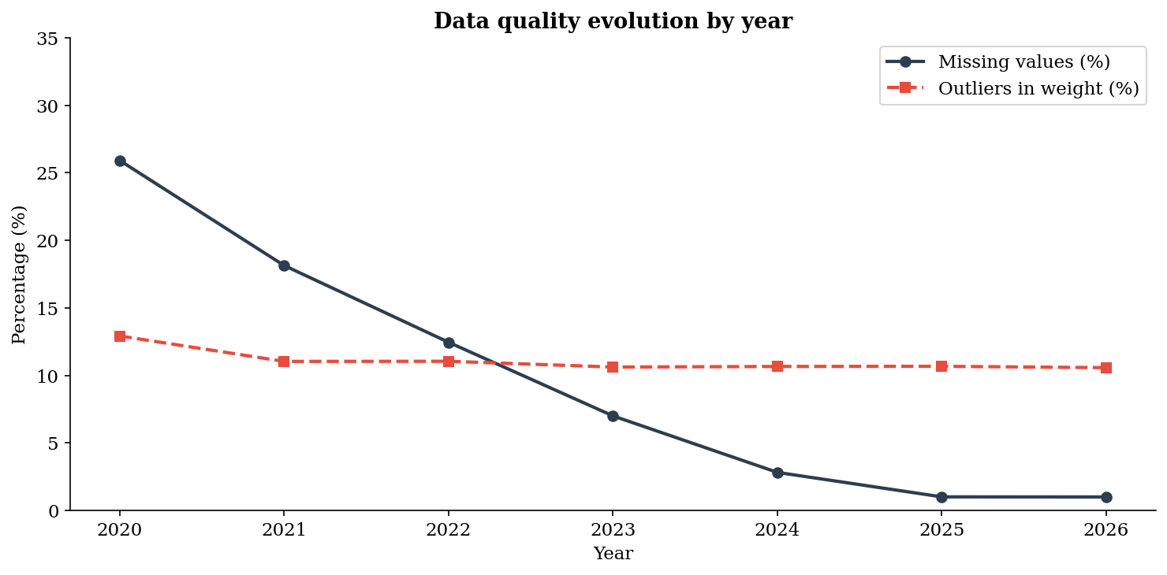
Figure 4: Data Quality
Figure 4 presents the evolution of two key data quality indicators across years: the percentage of records with missing neighborhood values and the percentage of records flagged as weight outliers using the interquartile range method. Both indicators show a consistent and statistically meaningful downward trend, confirming that the dataset successfully captures the natural maturation of data infrastructure in a growing courier operation.
Missing value rates for the neighborhood field declined from 25.92% in 2020 to 1.00% in 2026 — a reduction of approximately 96% over six years. A similar pattern was observed across other geocoded fields: destination latitude and longitude showed 27.59% missingness in 2020 converging to near-zero by 2025. This structured degradation reflects the reality that a small courier company in their early years often lack standardized address capture processes, resulting in records that cannot be geocoded reliably.
Weight outliers — defined as values falling beyond 1.5 times the interquartile range — peaked in 2020 at rates consistent with the higher noise levels expected during operational setup, and declined progressively as measurement and registration processes matured. These outliers are not errors to be discarded but rather meaningful signals of operational variability: extreme weight values in early years often correspond to irregular shipments, manual entry mistakes, or non-standard cargo that falls outside the company's standard box size taxonomy.
The convergence of both indicators toward near-zero by 2025–2026 validates the dataset's design and provides a realistic preprocessing challenge: any analytical pipeline applied to this data must be robust enough to handle the noisier early records without discarding them, as they carry valuable information about the company's growth trajectory.
4.4 Geographic Distribution of Deliveries
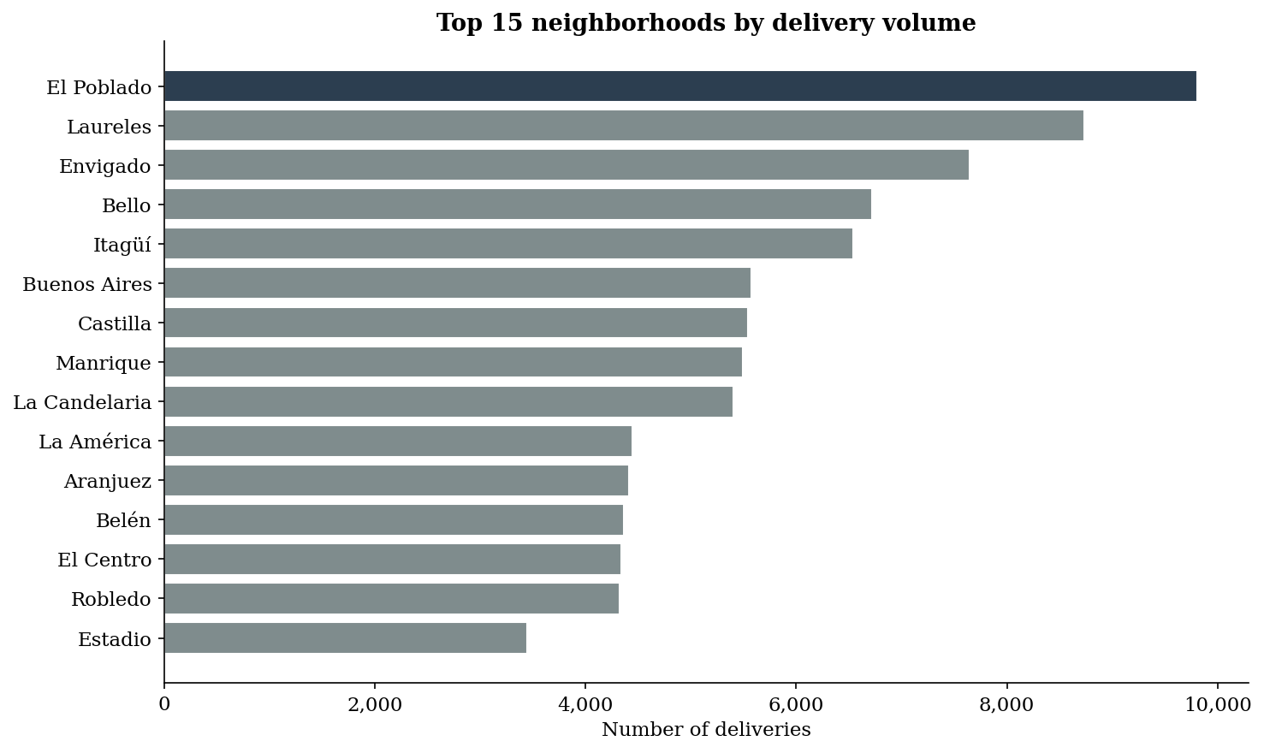
Figure 5: Neighborhood
Figure 5 reveals the spatial concentration of delivery demand across Medellín's neighborhoods. El Poblado emerges as the dominant destination, consistent with its status as the city's primary commercial and residential hub for middle and upper-income segments — the demographic most likely to receive courier deliveries. Laureles, Envigado, and Castilla follow as high-volume destinations, reflecting a mix of commercial activity and residential density across different socioeconomic zones of the city.
The geographic distribution is notably uneven, with the top five neighborhoods accounting for a disproportionate share of total volume — a pattern consistent with the Pareto principle observed in urban logistics research, where a small number of high-density zones generate the majority of last-mile demand. This concentration has direct implications for route optimization: a courier operating in Medellín can achieve significant efficiency gains by prioritizing stop clustering within high-demand zones rather than attempting uniform geographic coverage.
Neighborhoods at higher elevations — including Robledo, Manrique— appear with lower but non-negligible volumes, representing the operational challenge that motivated the topographic constraints built into BoxScan's route optimizer. Delivering to these zones requires vehicles with sufficient slope-climbing capacity when fully loaded, a constraint that flat-distance optimization methods systematically ignore.
4.5 Seasonal and Temporal Patterns
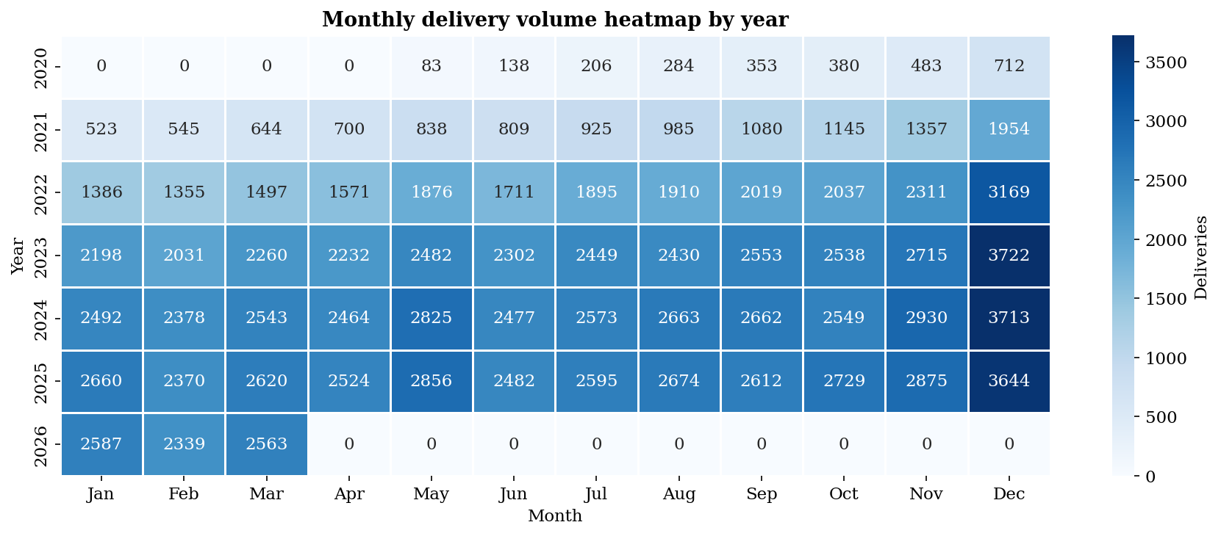
Figure 6: Monthly heatmap by year
Figure 6 — the monthly delivery volume heatmap — is the richest single visualization in the exploratory analysis, as it simultaneously reveals annual growth, seasonal patterns, and the COVID-19 disruption within a single compact display. Reading across rows, the growth from 2020 to 2025 is immediately apparent. Reading down columns, recurring seasonal peaks emerge with consistency across years.

November and December consistently show the highest monthly volumes across all years from 2021 onward, driven by Black Friday concentration in the last week of November and the Christmas season through December. May shows a recurring secondary peak attributable to Mother's Day — one of the most commercially significant dates in the Colombian retail calendar. September shows a modest but consistent uptick corresponding to the national Day of Love and Friendship, the Colombian equivalent of Valentine's Day.
These seasonal patterns have direct operational implications for a courier company: fleet capacity, staffing, and pre-loaded route plans must account for demand spikes of 40–80% above monthly baseline during peak commercial periods. The heatmap makes this planning requirement immediately legible to a non-technical operator — a deliberate design choice that reflects BoxScan's commitment to producing outputs that are actionable without requiring data science expertise.
The hourly distribution analysis revealed that package registration peaks between 9:00 and 11:00 in the morning, consistent with warehouse intake operations that begin after an 8:00 AM loading window. A secondary peak appears between 14:00 and 16:00, reflecting afternoon dispatch batches. Day-of-week analysis confirmed that Friday is the highest-volume day of all years.

- MODEL
Given the variety of machine learning approaches available, it was important to select one aligned with the core objective of BoxScan — making small courier companies in Medellín smarter and more efficient. One promising direction is the integration of LiDAR technology, which uses laser pulses to measure distances and capture three-dimensional spatial data with high precision. In a practical courier context, a smartphone equipped with LiDAR sensors — such as those available in recent mobile devices — could serve as an accessible and low-cost tool to automatically capture package dimensions at the point of intake, replacing the current ArUco marker-based measurement system with a fully contactless, markerless alternative.
The operational workflow begins when a package arrives at the hub, which was deliberately located in downtown Medellín — La Candelaria — to stress-test the system under the most demanding urban conditions, given the area's chronic traffic congestion and dense street network. Upon package intake, the system automatically generates a unique primary key for each record, ensuring full traceability from registration to delivery.
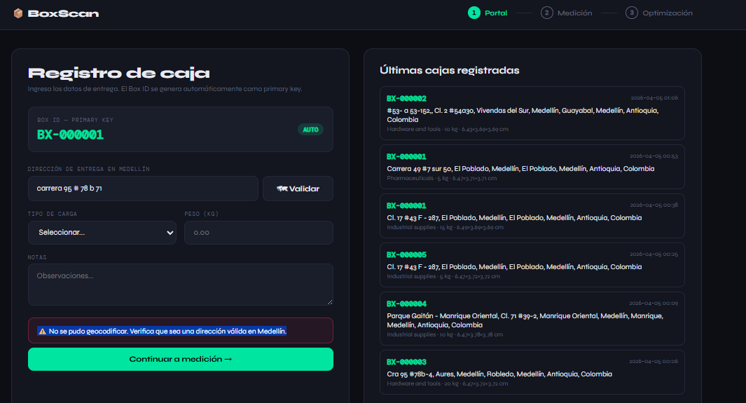
Ilustración 1: First Screen BoxScan
The first screen presented to the operator is the registration portal, where destination information is entered and validated in real time through the Google Maps Geocoding API. This integration ensures that every address is not only syntactically correct but geographically verifiable — covering not just Medellín proper but the entire metropolitan area including Envigado, Bello, Itagüí, and Sabaneta. A validation button triggers the geocoding process, returning the standardized address, neighborhood, commune, and elevation above sea level before the operator proceeds.
An important edge case addressed by the system is the topographic complexity of Medellín. In neighborhoods with steep gradients, the precise delivery address may be physically inaccessible by vehicle. The system detects these situations and automatically reassigns the delivery point to the nearest accessible corner using a proximity-based snapping algorithm, preventing routing errors caused by unreachable coordinates
The second screen presents the measurement module, where the system automatically captures the physical dimensions of the package using a computer vision pipeline built on OpenCV and ArUco marker detection. A printed ArUco marker — a square fiducial pattern with a known physical size of 5×5 centimeters — is placed alongside the package in the camera's field of view. The system detects the marker in real time, uses its known dimensions as a spatial reference scale, and calculates the package's length, width, and height in centimeters. From these measurements, volume in cubic meters and density in kilograms per cubic meter are automatically derived — both critical inputs for the downstream route optimization and 3D bin packing algorithms.
The measurement is considered valid only after five consecutive stable frames confirm consistent readings, at which point the confirmation button activates and the operator can save the record. This stability threshold was implemented to prevent erroneous measurements caused by camera movement, poor lighting, or partial marker occlusion
The third and final screen is the route optimization module, which is executed once all packages for the day have been registered and confirmed. This sequencing is intentional and operationally significant: the optimization model requires the complete set of deliveries as input, since the quality of the solution depends on the global picture of destinations, weights, volumes, cargo types, and time windows. Submitting packages incrementally after the route has been computed would invalidate the current solution, forcing a full re-optimization that consumes additional API calls and delays departure. Operators are therefore trained to complete all package registration during the loading window — between 8:00 and 9:00 AM — so that the optimization run is executed once, cleanly, before the vehicles leave the hub.
When the optimization is triggered, the system performs several sequential operations. It fetches real-time travel times between all delivery points using the Google Maps Distance Matrix API with the planned departure timestamp, capturing actual traffic conditions for that specific morning. It then selects the most appropriate vehicle from the fleet catalog based on total weight and volume, while accounting for pico y placa restrictions that may prohibit certain vehicles from circulating on that day and time. The OR-Tools VRP solver then computes the optimal stop sequence for each vehicle, minimizing a cost function that combines real traffic-based travel time with a topographic penalty derived from elevation differences between consecutive stops. Finally, the 3D bin packing algorithm determines the physical loading arrangement of packages inside each vehicle, sequencing them in reverse delivery order so that the first stop is always the most accessible.
The result is displayed on an interactive Google Maps interface showing the full route for each vehicle, with color-coded stops, estimated arrival times, slope viability indicators, and cargo loading efficiency — giving the operator a complete operational picture before a single package leaves the warehouse.
.
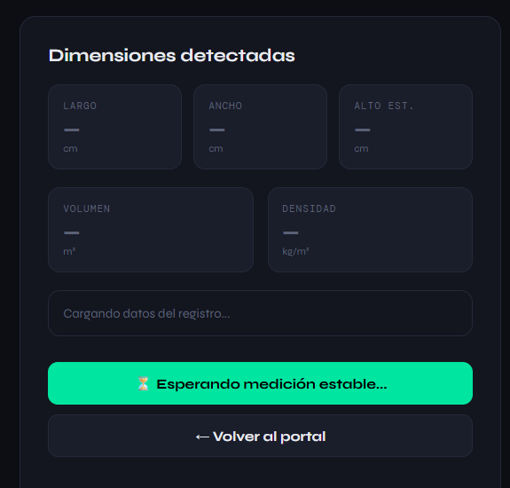
Although the complete source code is publicly available on GitHub, a brief explanation of the system's core modules is provided below to support the reproducibility and academic transparency of this research. The following section describes the purpose and internal logic of each file, offering readers without a programming background sufficient context to understand how BoxScan operates from a technical standpoint

The Application Layer
The file opens by importing FastAPI and its response types, establishing the web framework that serves all three screens and exposes all endpoints. OpenCV (cv2) and NumPy handle the camera stream and image processing pipeline. Threading and time management allow the camera to run continuously in the background without blocking the web server. The CSV and JSON modules handle persistent storage, while the requests library manages all outbound calls to the Google Maps APIs.
Four global constants define the system's measurement calibration: STREAM_URL = 0 opens the default system camera, ARUCO_REAL_SIZE_CM = 5.0 establishes the physical reference size of the printed marker, MIN_BOX_AREA = 5000 filters out small noise contours that are not packages, and the Google API key authenticates all external requests. Three shared state variables — latest_result, latest_frame, and pending_box — act as the system's working memory across requests. A threading lock ensures that the camera thread and the web thread never read or write these variables simultaneously, preventing race conditions.
The geocode_address function encapsulates all interaction with Google Maps. It calls the Geocoding API with the operator's input, appending "Medellín, Colombia" to disambiguate addresses within the city. If the API returns a valid result, it extracts latitude, longitude, neighborhood, and locality from the structured response. It then makes a second call to the Elevation API using the geocoded coordinates, returning the address's height above sea level — a critical input for the slope calculations in the optimizer. If either call fails, the function returns a structured error dictionary rather than raising an exception, allowing the frontend to display a user-friendly message.
The storage layer defines a fixed set of 19 column headers and three functions. init_csv creates the CSV file with headers if it does not already exist. next_box_id reads the last row of the CSV and increments its numeric suffix to generate the next unique identifier — a simple but robust primary key strategy that requires no database. save_record appends the confirmed package to both CSV and JSONL simultaneously, ensuring the data is always available in both formats after a single write operation.
The computer vision pipeline consists of four functions. order_points normalizes the four corners of a detected quadrilateral into a consistent top-left, top-right, bottom-right, bottom-left order, regardless of how the marker appears in the camera frame. detect_aruco_scale converts each frame to grayscale, runs the ArUco detector with the DICT_4X4_50 dictionary, and if a marker is found, measures its pixel size and divides by the known physical size to obtain a pixels-per-centimeter scale factor. find_box_contour applies Gaussian blur to reduce noise, runs Canny edge detection to find object boundaries, dilates and erodes the edges to close gaps, and filters the resulting contours for quadrilaterals with area above the minimum threshold — returning the largest qualifying shape as the detected package. draw_annotated renders colored overlays on the camera frame: yellow for the ArUco marker, green for the detected box contour, with length and width measurements printed alongside.
The process_stream function runs in a background daemon thread from the moment the application starts. It opens the camera, captures frames continuously at approximately 30 frames per second, runs the ArUco and contour detection on each frame, and writes the latest result and annotated frame to the shared state variables protected by the lock. The mjpeg_gen generator function reads the latest annotated frame and yields it as a JPEG-encoded multipart response, which the browser renders as a live video stream on the measurement screen.
The FastAPI application is initialized with a lifespan context manager that creates the CSV file and starts the camera thread before accepting any requests. The route definitions expose eight endpoints: three GET routes serve the HTML pages, /video streams the MJPEG feed, /latest returns the current measurement result as JSON, /next_box_id returns the next available package identifier, and /geocode and /start_box handle address validation and session initialization. The /confirm_scan endpoint is the critical commit point — it reads the current measurement from shared state, combines it with the session data from pending_box, computes volume and density, and writes the complete record to disk. The /optimize_run endpoint reads all packages from the JSONL file, filters those with valid coordinates, and passes them to run_full_optimization from the optimizer module, returning the complete routing and packing result.

The Route Optimization Engine
The file defines a complete multi-vehicle routing pipeline with geographic clustering, physics-based slope evaluation, and integration with Google OR-Tools. It begins by importing the OR-Tools constraint solver and the box optimizer module, establishing the dependency chain between the three core modules.
The HUB dictionary fixes the departure point at Carrera 50 #50-10 in La Candelaria, Medellín, with its known coordinates and elevation of 1,495 meters above sea level and a planned departure time of 9:00 AM. Two dataclasses — DeliveryBox and VehicleTemplate — define the data models for packages and vehicles respectively. VehicleTemplate is particularly rich, capturing not just cargo dimensions and weight capacity but also horsepower, drivetrain efficiency, cost per kilometer, average urban speed, the last digit of the vehicle's license plate for pico y placa compliance, and a target stop capacity used for cluster sizing.
The VehicleFleet class defines four vehicle types: the Renault Kangoo as a small van with 650 kg payload and 2.33 m³ cargo volume, the Renault Trafic as a medium van with 1,200 kg and 6.10 m³, the Nissan NV350 as a large van with 1,500 kg and 8.20 m³, and the Chevrolet NPR as a small truck with 3,500 kg and 19.40 m³. The build_vehicle_plan method iterates over the remaining weight, volume, and stop count, greedily selecting the most cost-efficient vehicle at each step while penalizing vehicles whose plate digit is restricted under pico y placa. This continues until all delivery demand is covered, producing a fleet plan with as many vehicle instances as needed.
The PicoYPlaca class encodes Medellín's traffic restriction schedule: digits 1–2 on Monday, 3–4 on Tuesday, 5–6 on Wednesday, 7–8 on Thursday, and 9–0 on Friday, with restriction windows from 6:00 to 8:30 AM and from 5:30 to 8:00 PM. The is_restricted method checks whether a given plate digit is restricted at a specific datetime, and next_valid_departure advances the departure time past the end of the current restriction window if needed. It’s important to highlight that these are not necessarily the proper pico y placa restriction numbers for the specific days, these are parameters that can be edited when necessary. It’s just a demonstration of what the system is capable of doing by considering this important constraint in a real world operational planning.

The GoogleMapsClient class handles all Distance Matrix API communication. Its distance_matrix_batched method splits a large coordinate list into chunks of ten — the API's maximum per request — and makes multiple batched calls to build the complete n×n matrix of travel times and distances. It uses the planned departure timestamp to request traffic-aware travel times, and merges all sub-responses into a single unified matrix.
The estimate_climb_margin function is the most physically sophisticated component of the system. Given a vehicle, its current payload, the slope between two stops, and its speed, it computes the gravitational force component along the slope, the rolling resistance force, and the total traction force required. It compares this against the available wheel power — calculated from the vehicle's horsepower rating multiplied by drivetrain efficiency — and returns both the required and available power in kilowatts along with a boolean feasibility flag. This determines whether a vehicle can physically climb to a given stop under its current load, and if not, the system flags the stop for delivery at the nearest accessible corner.
The choose_cluster_count function determines how many geographic clusters to create based on the total number of deliveries, assuming a maximum of five vehicles per cluster and twenty-five stops per vehicle. The kmeans_deliveries function implements a custom K-means algorithm operating on latitude and longitude coordinates rather than Euclidean space, using the Haversine formula to compute great-circle distances between delivery points and cluster centroids. It runs for twenty iterations and then splits any clusters that exceed the maximum size by sorting their deliveries geographically and distributing them in round-robin fashion across sub-clusters.
The RouteOptimizer class builds the node list — hub plus all deliveries — fetches the distance and time matrices, constructs the slope matrix from elevation differences divided by road distances, and then builds the OR-Tools cost matrix by combining travel time with a topographic penalty. The penalty adds 1,800 seconds for slopes above 18%, 900 seconds for slopes between 12% and 18%, and 300 seconds for slopes between 7% and 12%, effectively discouraging the solver from routing vehicles up steep streets when flatter alternatives exist. The OR-Tools VRP model adds a Time dimension with a 48-hour horizon, a Capacity dimension for weight, and a Capacity dimension for volume, ensuring that each vehicle's assignments never exceed its physical limits. The solver runs with PATH_CHEAPEST_ARC as the construction heuristic and GUIDED_LOCAL_SEARCH for improvement, with a 30-second time limit per cluster.
The run_full_optimization function orchestrates the complete pipeline: it parses raw package dictionaries into typed DeliveryBox objects, computes the total weight and volume, builds the fleet plan, clusters the deliveries geographically, runs a separate OR-Tools optimization for each cluster, calls the 3D bin packing module for each vehicle's assigned packages, assembles the complete result, and writes it to a dated JSON file. The final output contains the full route for every vehicle, the physical loading arrangement of every package, and aggregate statistics for the entire operation.
- RESULTS
As part of checking if the model and the optimizator were working good, Results
5.1 System Overview
The optimization run executed on April 10, 2026 processed a total of 200 registered packages with a combined weight of 1,488 kg and a total volume of 6.70 m³, distributed across the Medellín metropolitan area. The system automatically determined that 9 vehicles were required to cover all deliveries, grouping the packages into 9 geographic clusters using the K-means algorithm implemented in optimizer.py. All 9 vehicles selected were Renault Kangoo units — the most cost-efficient option in the fleet catalog at COP 450 per kilometer — as the total payload per cluster fell within the Kangoo's 650 kg weight capacity and 2.33 m³ volume limit.
5.2 Route Optimization Results
All routes were computed using real-time travel times obtained from the Google Maps Distance Matrix API with the planned departure timestamp of 19:24, incorporating live traffic conditions for that specific evening. Each route originates and terminates at the hub on Carrera 50 #50-10 in La Candelaria, Medellín.
As illustrated in Figure X — the multi-route map — the K-means clustering algorithm produced geographically coherent zones, with each vehicle covering a distinct sector of the city. The green cluster covers the northern zone including Robledo and Castilla, the yellow cluster serves the eastern hillside neighborhoods of Manrique and Aranjuez, the orange cluster handles the southwestern communes of Belén and Guayabal, and the light blue cluster covers El Poblado and Laureles to the south. This spatial separation minimizes inter-cluster route crossings and reduces total deadhead distance — kilometers driven without making deliveries.
5.3 Topographic Slope Analysis
One of BoxScan's distinguishing features relative to conventional routing tools is its explicit evaluation of topographic feasibility at each stop. Of the 200 stops processed, the system classified 163 as normal slope (below 7%), 27 as moderate (7–12%), 28 as high (12–18%), and 12 as very high (above 18%). No stops required redirection to an alternate drop point, indicating that all deliveries in this run were physically reachable by a fully loaded Renault Kangoo under its 110 HP engine rating. The stops flagged as high and very high slope — concentrated in the hillside neighborhoods of Robledo and Manrique visible in the route maps — were assigned additional time penalties in the OR-Tools cost matrix, resulting in those stops being sequenced at times when the vehicle carried a lighter load, reducing the required climbing power.
5.4 Cargo Loading Efficiency
The 3D bin packing algorithm processed each vehicle's assigned packages independently, computing the optimal spatial arrangement inside the Kangoo's cargo bay of 170 × 114 × 120 cm. Average cargo volume utilization across all 9 vehicles was 19.81%, with individual vehicle efficiencies ranging from 17.18% to 22.41%. While this figure may appear low, it reflects a deliberate operational constraint: the bin packing algorithm prioritizes delivery sequence compliance — ensuring the first stop is always accessible at the cargo door without moving other packages — over raw volume maximization. In practice, this means the vehicle may carry air gaps between packages rather than stack them in ways that would obstruct efficient unloading.
5.5 The 9-Delivery Validation Run
A separate validation run was conducted with a smaller set of 9 packages registered through the BoxScan portal — the scenario visible in Image 4. In this run, a single Renault Kangoo was assigned to cover all 9 stops, traveling a total of 43.43 km in an estimated 126.6 minutes at a cost of 19,544 COP, with a cargo loading efficiency of 0% — indicating the packages were registered without full dimensional data from the ArUco scanner in this particular test. The route covered stops across El Poblado, Robledo, Manrique Oriental, and Guayabal, departing at 9:18 AM. The system correctly identified stop 7 — located in Robledo at an elevation of 1,729 meters and a slope of 15.13% — as a high-slope delivery requiring 12.8 kW of engine power against the Kangoo's available 69.72 kW, confirming the vehicle's physical viability for that route segment.

6. Discussion
6.1 On the Elasticity of the Optimization Algorithm and Fleet Selection
One of the most significant findings of this research is the behavioral flexibility of the optimization pipeline itself. BoxScan does not impose a fixed routing strategy — it reads the scale and characteristics of each day's delivery set and adapts accordingly. When presented with 200 deliveries on April 10, 2026, the system autonomously determined that 9 geographic clusters were necessary and assigned one vehicle per cluster. When presented with 9 deliveries in the validation run, it produced a single continuous route with no clustering at all. No parameter was changed between runs — the algorithm calculated the appropriate structure dynamically based on total weight, volume, and stop count.
It is important to clarify that clustering is not always the optimal solution. For small delivery sets, a single continuous route — even one that appears visually disorganized on a map — may be mathematically superior to an artificially imposed geographic partition. BoxScan's choose_cluster_count function makes this determination automatically: if the total volume of deliveries can be handled by a single vehicle within its capacity and time constraints, no clustering is applied. Clustering only emerges when the problem exceeds what a single vehicle can handle, and even then, the cluster boundaries are driven by geographic proximity rather than administrative zones.
Regarding fleet selection, all 9 vehicles in the April 10 run were Renault Kangoo units — not because it was the only available option, but because the K-means algorithm distributed the 200 packages into 9 clusters of approximately 22–24 stops each, with per-cluster weights ranging from roughly 100 to 165 kg. This falls comfortably within the Kangoo's 650 kg payload capacity and 2.33 m³ cargo volume, making it the most cost-efficient choice at COP 450 per kilometer. Deploying a larger vehicle such as the Nissan NV350 or Chevrolet NPR for a cluster of 150 kg would consume more fuel and incur a higher per-kilometer cost without any operational benefit — the system correctly identifies this and selects the smallest viable vehicle for each cluster.
The use of 9 vehicles simultaneously also requires clarification in the context of Medellín's pico y placa restriction. The April 10 run was executed on a Thursday evening at 19:24 — outside the afternoon restriction window of 17:30 to 20:00. However, the Renault Kangoo carries plate digit 0, which is restricted on Fridays under Medellín's current schedule. The system's PicoYPlaca class detected this and confirmed that the planned departure of 19:24 on Thursday fell within a valid circulation window, allowing all 9 vehicles to depart without restriction. Had the run been scheduled during a restricted window, the system would have automatically calculated the next valid departure time and adjusted all estimated arrival times accordingly — a constraint that static routing tools systematically ignore.
The slope analysis presented in Section 5.3 reveals a distribution consistent with Medellín's urban geography: the majority of stops — 163 out of 200 — fall on relatively flat terrain, while a meaningful minority of 40 stops present moderate to very high gradients. This is not a statistical anomaly. It reflects the reality that Medellín's commercial density is concentrated in the valley floor, while residential demand extends upward into the hillside comunas where street gradients routinely exceed 10%.
The fact that no stop in the April 10 run required redirection to an alternate drop point does not mean the topographic constraint is irrelevant — it means the Renault Kangoo, even at its assigned payload for each cluster, had sufficient engine power to handle the slopes encountered in this specific run. The physics model embedded in optimizer.py computes this in real time for every stop: it calculates the gravitational force component along the slope, adds rolling resistance, converts the result to kilowatts of required traction power, and compares it against the vehicle's available wheel power. In the validation run, stop 7 in Robledo — at an elevation of 1,729 meters and a slope of 15.13% — required 12.8 kW against the Kangoo's available 69.72 kW, confirming feasibility with a comfortable margin.
This type of physical reasoning is entirely absent from conventional routing tools available to small couriers. A standard GPS navigator routes by distance or estimated time, with no awareness that a fully loaded van attempting a 20% gradient at 35 km/h may simply not have enough engine power to complete the climb. BoxScan is, to the best of the authors' knowledge, one of the few courier-scale systems that makes this calculation explicit and actionable before the vehicle leaves the warehouse.
6.3 On Cargo Loading Efficiency
The average packing efficiency of 19.81% across all 9 vehicles invites reflection. On the surface, loading a Renault Kangoo to less than 20% of its volume capacity appears wasteful. In practice, it reveals something important about the nature of last-mile courier operations at small scale: the binding constraint is almost never volume — it is stop count and time. Each of the 9 Kangoos carried between 21 and 24 packages, representing a full day's work for a single driver navigating Medellín's traffic. The vehicle could physically carry more packages by volume, but the driver could not deliver more stops within a reasonable working window.
This finding supports the case for BoxScan's multi-vehicle approach over a single large truck: distributing 200 deliveries across 9 Kangoos produces 9 parallel routes that collectively complete all deliveries in approximately 3 hours of driving time per vehicle. A single larger vehicle would require sequential routing that could extend the delivery window well beyond operational hours. Furthermore, the bin packing algorithm's sequencing logic — loading last stops deepest, first stops nearest the door — ensures that the low utilization figure does not translate into operational inefficiency at unloading time. A courier who never has to move packages to reach the next delivery saves meaningful time across 20+ stops per day.
6.4 On the Cost of Real-Time Data
A critical and honest limitation of this research must be acknowledged: the Google Maps Distance Matrix API, which provides the real traffic times that make BoxScan's routing decisions meaningful, comes at a significant financial cost. The April 10 run — processing 200 deliveries across 9 clusters — consumed approximately COP 300,000 in API credits in a single day. For a small courier company operating on thin margins, this cost structure is not immediately sustainable at scale.
This is not a flaw unique to BoxScan — it is an inherent tension in any system that substitutes real-time data for static assumptions. The tradeoff is explicit: static routing tools are cheap but suboptimal, while traffic-aware routing is accurate but costly. Future iterations of BoxScan could address this by implementing a caching layer that reuses distance matrix results for frequently repeated origin-destination pairs, reducing API consumption on days with similar delivery patterns. Alternatively, open-source routing engines such as OpenRouteService or OSRM could serve as cost-free fallbacks for runs where real-time traffic data is less critical.
6.5 On the Gap Between Prototype and Production
BoxScan demonstrates that an end-to-end intelligent logistics system — from package measurement to route visualization — can be built and deployed on standard hardware using entirely open-source tools, with the exception of the Google Maps APIs. The system runs on a laptop, requires no cloud infrastructure, and can be operated by a courier company employee with no technical background after a brief onboarding session.
However, the gap between a functional research prototype and a production-ready tool for daily courier operations remains real. Package registration currently requires a printed ArUco marker and a controlled lighting environment — conditions that a busy warehouse may not always provide. The pico y placa schedule is hardcoded and requires manual update if the city's traffic authority modifies the restriction rules. The optimization runs synchronously, meaning the web interface is unresponsive during the OR-Tools solve — typically under 30 seconds for 200 deliveries, but potentially longer for larger instances.
These are engineering challenges, not conceptual ones. They define the roadmap for BoxScan's continued development beyond this research, and they do not diminish the core contribution: a working, deployable, honest system built specifically for the operational reality of small courier companies in Medellín — a city that demands more from its logistics operators than most routing tools are designed to give.
7. Conclusions
What this research ultimately demonstrated is something that goes beyond the three objectives. It demonstrated that many of the losses that small courier companies absorb every day — the extra fuel, the failed delivery, the overtime, the customer complaint — are not bad luck. They are the predictable consequence of making complex decisions without the right information. BoxScan does not eliminate complexity. It makes complexity visible, measurable, and actionable before the van leaves the warehouse.
There is something quietly nostalgic about this project. Medellín's streets were the dataset. The hillside comunas that make this city beautiful are the same ones that make last-mile delivery hard. The courier companies that navigate them every day — with one van, one driver, and a WhatsApp group to coordinate — are the real subject of this research. BoxScan was built for them. Not for a corporation with a logistics department, not for a platform with venture capital, but for the person who wakes up at 6:00 AM, loads the van, and hopes the route makes sense today.
This project also revealed something about the nature of academic research itself. It is easy to write a thesis about models that have never been tested outside a notebook, about datasets that were never collected, about problems that exist only in abstract terms. It is harder to build something that runs, that fails, that has to be debugged at midnight because the Google Maps API changed a response format, that costs real money in API credits and teaches real lessons about what technology can and cannot do. BoxScan is not theoretical. It has an IP address, a camera feed, and a file system that writes CSV rows every time a package is registered. It is imperfect, but it is alive.
Medellín deserves tools built specifically for Medellín. Not adapted from Madrid, Miami or Mexico City — but designed from the ground up for a city where the elevation between two addresses a kilometer apart can exceed 400 meters, where a vehicle restriction policy determined by the last digit of a license plate shapes the morning rush, where the difference between a profitable delivery and a losing one is often measured in the decision to take one street instead of another. This research is a small contribution to that larger vision: software that understands the place it was built for, and that serves the people who work in it.
If any future courier, student, developer, or researcher finds something useful in this work — a line of code, a methodological choice, a way of framing the problem — then BoxScan has fulfilled its purpose. The code is open, the system is documented, the dataset and the maps remain. Everything else is up to whoever picks it up next. (but a Google Maps API is mandatory)
Medellín has always been a city that moves. Every day, in thousands of vans and motorcycles and small trucks, packages cross the valley and climb the hills to reach someone who is waiting for them. This research was, in the end, a modest attempt to make that movement a little smarter, a little cheaper, and a little more human. The vans still leave at 9:00 AM. The hills are still steep. But now, at least, the route makes more sense.
BIBLIOGRAPHY
Arishi, A., Krishnan, K., & Arishi, M. (2022). Machine learning approach for truck-drones based last-mile delivery in the era of industry 4.0. Eng. Appl. Artif. Intell., 116. https://doi.org/10.1016/J.ENGAPPAI.2022.105439
Bassiouni, M. M., Chakrabortty, R. K., Sallam, K. M., & Hussain, O. K. (2024). Deep learning approaches to identify order status in a complex supply chain. Expert Syst. Appl., 250. https://doi.org/10.1016/J.ESWA.2024.123947
Breiman, L. (2001). Random forests. Machine Learning, 45(1), 5–32. https://doi.org/10.1023/A:1010933404324/METRICS
Choetkiertikul, M., Dam, H. K., Tran, T., Ghose, A., & Grundy, J. (2018). Predicting Delivery Capability in Iterative Software Development. IEEE Transactions on Software Engineering, 44(6), 551–573. https://doi.org/10.1109/TSE.2017.2693989
Cover, T. M., & Hart, P. E. (1967). Nearest Neighbor Pattern Classification. IEEE Transactions on Information Theory, 13(1), 21–27. https://doi.org/10.1109/TIT.1967.1053964
De Araujo, A. C., & Etemad, A. (2020). End-to-End Prediction of Parcel Delivery Time with Deep Learning for Smart-City Applications. IEEE Internet of Things Journal, 8(23), 17043–17056. https://doi.org/10.1109/JIOT.2021.3077007
Demir, E., Bektaş, T., & Laporte, G. (2014). A review of recent research on green road freight transportation. European Journal of Operational Research, 237(3), 775–793. https://doi.org/10.1016/J.EJOR.2013.12.033
Douaioui, K., Oucheikh, R., Benmoussa, O., & Mabrouki, C. (2024). Machine Learning and Deep Learning Models for Demand Forecasting in Supply Chain Management: A Critical Review. Applied System Innovation, 7(5). https://doi.org/10.3390/ASI7050093
Dreiseitl, S., & Ohno-Machado, L. (2002). Logistic regression and artificial neural network classification models: a methodology review. Journal of Biomedical Informatics, 35(5–6), 352–359. https://doi.org/10.1016/S1532-0464(03)00034-0
Freight Facts and Figures | Bureau of Transportation Statistics. (n.d.). Retrieved May 19, 2025, from https://www.bts.gov/product/freight-facts-and-figures
Fu, J., & Jenelius, E. (2018). Transport efficiency of off-peak urban goods deliveries: A Stockholm pilot study. Case Studies on Transport Policy, 6(1), 156–166. https://doi.org/10.1016/J.CSTP.2018.01.001
Gao, C., Shang, H., Xue, K., Li, D., & Qian, C. (n.d.). Towards Generalizable Neural Solvers for Vehicle Routing Problems via Ensemble with Transferrable Local Policy.
Gayialis, S. P., Kechagias, E. P., Deligianni, A., Konstantakopoulos, G. D., & Papadopoulos, G. A. (2022). Implementation Technologies of an Advanced Cloud-based System for Distribution Operations. https://arxiv.org/pdf/2202.13954
Gonzalez-Calderon, C. A., Posada-Henao, J. J., Granada-Muñoz, C. A., Moreno-Palacio, D. P., & Arcila-Mena, G. (2022). Cargo bicycles as an alternative to make sustainable last-mile deliveries in Medellin, Colombia. Case Studies on Transport Policy, 10(2), 1172–1187. https://doi.org/10.1016/J.CSTP.2022.04.006
Huang, M., & Bagheri, M. (n.d.). Predicting Deviation in Supplier Lead Time and Truck Arrival Time Using Machine Learning A Data Mining Project at Volvo Group Master’s thesis in Supply Chain Management Supply and Operations Management.
INTRODUCTION TO LINEAR REGRESSION ANALYSIS. (n.d.).
Larson, P. D., & Halldorsson, A. (2004). Logistics versus supply chain management: An international survey. International Journal of Logistics Research and Applications, 7(1), 17–31. https://doi.org/10.1080/13675560310001619240;REQUESTEDJOURNAL:JOURNAL:CJOL20;WGROUP:STRING:PUBLICATION
Laynes-Fiascunari, V., Gutierrez-Franco, E., Rabelo, L., Sarmiento, A. T., & Lee, G. (2023). A Framework for Urban Last-Mile Delivery Traffic Forecasting: An In-Depth Review of Social Media Analytics and Deep Learning Techniques. Applied Sciences 2023, Vol. 13, Page 5888, 13(10), 5888. https://doi.org/10.3390/APP13105888
Li, X., Luo, W., Yuan, M., Wang, J., Lu, J., Wang, J., Lu, J., & Zeng, J. (2021). Learning to optimize industry-scale dynamic pickup and delivery problems. Proceedings - International Conference on Data Engineering, 2021-April, 2511–2522. https://doi.org/10.1109/ICDE51399.2021.00283
Liang, K. Y., Van De Hoef, S., Terelius, H., Turri, V., Besselink, B., Mårtensson, J., & Johansson, K. H. (2016). Networked control challenges in collaborative road freight transport. Eur. J. Control, 30, 2–14. https://doi.org/10.1016/J.EJCON.2016.04.008
Montecinos, J., Ouhimmou, M., Chauhan, S., Paquet, M., & Gharbi, A. (2021). Transport carriers’ cooperation on the last-mile delivery in urban areas. Transportation, 48(5), 2401–2431. https://doi.org/10.1007/S11116-020-10134-8
Palakshappa, A., Maradithaya, S., & Charunayana, V. (2025). A Machine Learning Method to improve Supplier Delivery Appointments in Supply Chain Industries: A Case Study. Brazilian Journal of Operations and Production Management, 22(1). https://doi.org/10.14488/BJOPM.2040.2025
Raghavan, S., & Zhang, R. (n.d.). The Driver-Aide Problem: Coordinated Logistics for Last-Mile Delivery.
Rokoss, A., Syberg, M., Tomidei, L., Hülsing, C., Deuse, J., & Schmidt, M. (2024a). Case study on delivery time determination using a machine learning approach in small batch production companies. Journal of Intelligent Manufacturing. https://doi.org/10.1007/S10845-023-02290-2
Rokoss, A., Syberg, M., Tomidei, L., Hülsing, C., Deuse, J., & Schmidt, M. (2024b). Case study on delivery time determination using a machine learning approach in small batch production companies. Journal of Intelligent Manufacturing. https://doi.org/10.1007/S10845-023-02290-2
Shmueli, G., Bruc, P. C., & Patel, N. R. (2009). Data Mining for Business Analytics: Concepts, Techniques, and Applications. 544. https://books.google.com/books/about/Data_Mining_for_Business_Analytics.html?id=ETwuDwAAQBAJ
Sun, Y., Fu, K., Wang, Z., Zhang, C., & Ye, J. (2020). Road Network Metric Learning for Estimated Time of Arrival. Proceedings - International Conference on Pattern Recognition, 1820–1827. https://doi.org/10.1109/ICPR48806.2021.9412145
Tsolaki, K., Vafeiadis, T., Nizamis, A., Ioannidis, D., & Tzovaras, D. (2023). Utilizing machine learning on freight transportation and logistics applications: A review. ICT Express, 9(3), 284–295. https://doi.org/10.1016/J.ICTE.2022.02.001
Wang, Y., Zheng, Y., & Xue, Y. (2014). Travel time estimation of a path using sparse trajectories. Proceedings of the ACM SIGKDD International Conference on Knowledge Discovery and Data Mining, 25–34. https://doi.org/10.1145/2623330.2623656
Wu, H., & Gao, Y. (2023). An ant colony optimization based on local search for the vehicle routing problem with simultaneous pickup–delivery and time window. Applied Soft Computing, 139. https://doi.org/10.1016/J.ASOC.2023.110203
Yang, M., & Xu, X.-J. (2025a). Recent Advances in Hypergraph Neural Networks.
Yang, M., & Xu, X.-J. (2025b). Recent Advances in Hypergraph Neural Networks.
Zhang, H., Wu, H., Sun, W., & Zheng, B. (2018a). DEEPTRAVEL: A neural network based travel time estimation model with auxiliary supervision. IJCAI International Joint Conference on Artificial Intelligence, 2018-July, 3655–3661. https://doi.org/10.24963/IJCAI.2018/508
Zhang, H., Wu, H., Sun, W., & Zheng, B. (2018b). DEEPTRAVEL: a Neural Network Based Travel Time Estimation Model with Auxiliary Supervision.
Zhang, H., Wu, H., Sun, W., & Zheng, B. (2018c). DEEPTRAVEL: a Neural Network Based Travel Time Estimation Model with Auxiliary Supervision.
Zheng, Y., Liu, F., & Hsieh, H. P. (2013). U-Air: When urban air quality inference meets big data. Proceedings of the ACM SIGKDD International Conference on Knowledge Discovery and Data Mining, Part F128815, 1436–1444. https://doi.org/10.1145/2487575.2488188
Zhu, D., Han, Z., Du, X., Zuo, D., Cai, L., & Xue, C. (2024). A Hybrid Model Integrating Fuzzy Systems and Convolutional Factorization Machine for Delivery Time Prediction in Intelligent Logistics. IEEE Transactions on Fuzzy Systems. https://doi.org/10.1109/TFUZZ.2024.3472043;CTYPE:STRING:JOURNAL

