INSTITUTO SUPERIOR DE ENGENHARIA DO PORTO

ENGENHARIA INFORMÁTICA – 1º

**LAPR II**

**REAL ESTATE USA**

**USER MANUAL**

# 

HUGO NOGUEIRA – 1170504

NILSA GIL – 1221792

06/2023

# INTRODUTION

Welcome to the user manual for the "Real Estate USA" management application. This application has been meticulously designed and developed as part of a comprehensive project at the Degree in Informatics Engineering (LEI). Our team has harnessed the knowledge and competencies from several courses—ESOFT, PPROG, MDISC, MATCP, and LAPR2—to bring forth an integrated solution that caters to all aspects of real estate management.

Real Estate USA is a premier company in the United States, with a vast network of real estate agencies spread across the country. Our aim is to simplify and streamline the complex landscape of real estate transactions by providing an accessible, user-friendly platform. The application serves as a one-stop solution for all real estate needs, providing tools for managing property listings, scheduling visits, handling lease or sale transactions, and even analyzing performance at both the individual store and broader network levels.

The manual covers various functionalities and features of our application, starting from simple tasks like user authentication to more complex operations like property listing, visit scheduling, or performance analysis. The instructions in this manual are intended for a diverse group of users, including property owners, real estate agents, clients, store managers, network managers, and the system administrator, providing comprehensive coverage of the application's usage.

Real Estate USA application has been designed with a prime focus on usability, aiming to deliver a seamless experience to all its users. Its underlying technology stack includes Java, IntelliJ IDE or NetBeans, and JavaFX 11, complying with the best practices for requirement identification, OO software analysis and design, and coding conventions. All these components together ensure the application is robust, secure, and efficient.

Whether you're a property owner looking to list your property, a client intending to explore property options, or an employee aiming to perform their tasks more efficiently, this manual will guide you step-by-step. Enjoy the journey of navigating the "Real Estate USA" management application, designed to streamline real estate operations, making them more efficient, transparent, and user-friendly.

We believe that by arming you with the knowledge and tools to navigate this application effectively, we can collectively bring about a transformation in the real estate industry. Our goal is to make real estate transactions as effortless and straightforward as possible, eliminating traditional roadblocks and inefficiencies in the process.

Please read through this manual carefully to fully understand and get the best out of the application. Happy browsing!

# GLOSSARY

* **Agent**: A real estate professional or representative who manages property listings and interacts with clients on behalf of the company.
* **Analysis**: The process of examining data, variables, or other factors to gain insights, make decisions, or solve problems within the system.
* **Appointment**: A scheduled visit or meeting to view a property, arranged between the client and the agent.
* **Booking Request**: A request made by a client to book a property for a specific period of time.
* **Branch**: A physical location or office of the company where real estate agents and employees operate and manage property listings.
* **Client**: An individual or entity seeking to buy, sell, or rent properties through the system.
* **Employee**: A person who works for the company and has specific roles and responsibilities within the system.
* **Legacy System**: An existing and outdated system or software that is being replaced or integrated with the new system.
* **Manager**: A person responsible for overseeing the operations of a branch or a group of employees within the system.
* **Property Listing**: A record or entry in the system that represents a property available for sale or rent, containing relevant details such as location, price, and property features.
* **Property Search**: The process of searching for properties based on specific criteria, such as property type, number of rooms, and price range.
* **Publication**: The act of making property sale announcements or other relevant information available to users through the system.
* **Purchase Order**: An official request made by a client to purchase a property at a specified price.
* **Regression Analysis**: A statistical technique used to determine the relationship between variables and predict values based on historical data.
* **Serialization**: The process of converting an object into a format that can be stored or transmitted and reconstructed later.
* **Store**: A physical location or branch where real estate agents and employees operate and manage property listings.
* **System Administrator**: A person responsible for managing and maintaining the system, including user accounts, permissions, and system configurations.
* **Troubleshooting**: The process of identifying, analyzing, and resolving problems or issues that may arise within the system or its functionalities.
* **User Manual**: A document that provides instructions and information on how to use the system, including its features, functionalities, and troubleshooting guidelines.

# TABLE OF CONTENTS

Índice

INTRODUTION 3

GLOSSARY 5

TABLE OF CONTENTS 7

SYSTEM REQUIREMENTS 8

3. System Requirements 8

3.1 Software Requirements 8

3.2 Installation Procedures 9

3.3 Technical Specifications 9

SYSTEM OVERVIEW 10

FEATURES 13

TROUBLESHOOTING 23

FREQUENTLY ASKED QUESTIONS (FAQs) 26

Attachments 28

# SYSTEM REQUIREMENTS

## 3. System Requirements

In order to ensure that the "Real Estate USA" management application operates effectively and efficiently, it is necessary to comply with certain system requirements. These requirements pertain to both hardware and software components. Below we outline the necessary specifications:

## 3.1 Software Requirements

* Operating System: The application is platform-independent as it's developed in Java. It can run on any operating system capable of running Java Runtime Environment (JRE), such as Windows, etc.
* Java Development Kit (JDK): You will need JDK 11 or higher installed on your machine to run this application. JDK includes JRE, which is required to run Java applications.
* Integrated Development Environment (IDE): The application has been developed using IntelliJ IDE and NetBeans. Although it's not necessary for running the application, it would be beneficial for any further development or troubleshooting purposes.
* JavaFX 11: The graphical user interface of the application is developed in JavaFX 11, which needs to be installed and configured on your system.

## 3.2 Installation Procedures

* Ensure that you have the correct version of Java Development Kit (JDK 11 or higher) installed on your machine. You can check this by typing java -version in your command line or terminal.
* Download and install the latest version of JavaFX 11. Make sure it's correctly configured with your JDK.
* Run the application by executing the Java file. On most systems, this can be done by double-clicking the file. Alternatively, you can use the command java -jar filename.jar from your terminal or command line.
* The application should now be running. You can log in with your user credentials and start using the application.

## 3.3 Technical Specifications

* Authentication: The application uses an authentication system requiring a password of seven alphanumeric characters, including three capital letters and two digits.
* Data Persistence: The application uses object serialization for data persistence between two runs of the application.
* Documentation: The source code is documented using Javadoc.
* Unit Testing: The application's unit tests are implemented using the JUnit 5 framework.
* Coverage Report: The JaCoCo plugin is used for generating the coverage report.

# SYSTEM OVERVIEW

Real Estate USA is a company that manages the business of real estate properties in the United States.

The company needs an application to handle the lease and sale of properties and various related operations. The application allows buyers to access available properties, agents to publish advertisements, and employees to manage the business.

Users can register, schedule visits, make purchase/lease orders, and more.

The system includes features for administrators, agents, clients, store managers, and network managers.

The application is developed in Java using IntelliJ IDE or NetBeans, with a graphical interface in JavaFX 11.

Authentication requires a password with specific criteria.

The application supports the English language.

The system is designed to meet the needs of a real estate agency, allowing agents, clients, store managers, network managers and administrators to perform various tasks related to buying, selling and scheduling visits to real estate properties.

Features by Function:

**Agent**:

* View available property information.
* Register announcement for the sale or rent of real estate.
* View announcement requests made to the agent.
* Schedule and respond to approval of property visits.
* Record visits and provide business opinions.
* Accept or decline requests to purchase properties.
* List booking power for properties managed by them.
* Respond to users who have scheduled visits via email.

**Client**:

* Search properties available for sale or lease.
* Sending property announcements to agents.
* Schedule visits to properties of interest.
* Receive notifications of confirmation or rejection of visit acceptance.
* Send messages to agents to schedule visits.
* Read responses to visit requests and accept or reject them.

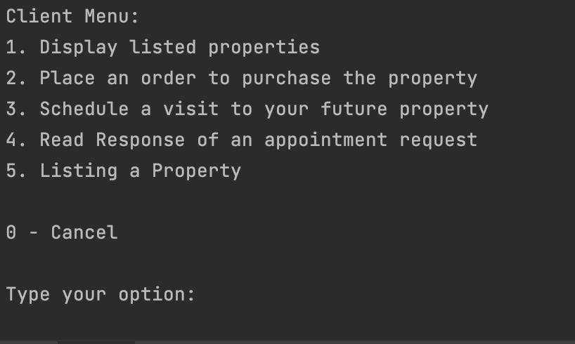

**Store manager**:

* Analyze the business carried out by the store.
* Compare the sales values ​​of the properties with the predicted values.
* Access information about the employees who work in the store.
* Manage teams of agents.

**Unregistered user**:

* Display listed properties
* Register as client

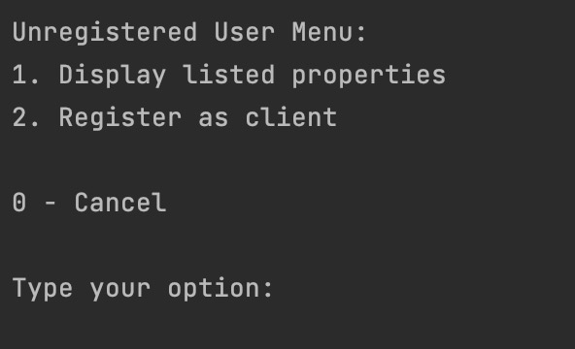

**Network Manager**:

* List all properties available in all stores in the network.
* Split the stores into two subsets with the closest number of properties.
* List all staffs in each store.
* Analyze the trades carried out across the network.

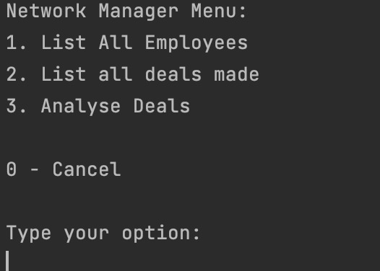

**Administrator**:

* Import information from a legacy system into the new system.
* Configure property classification options.
* Specify states, districts or cities.

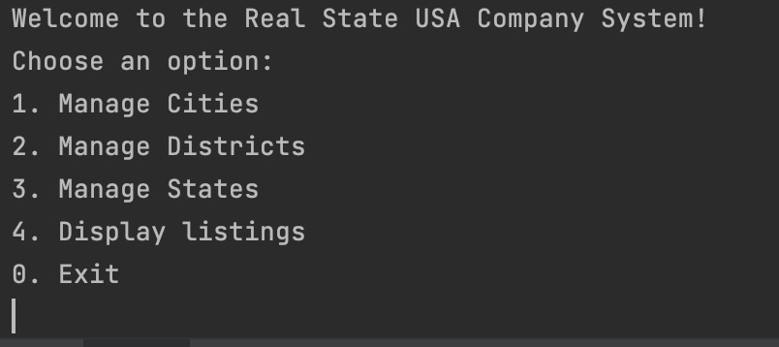

* Configure email services for sending notifications.

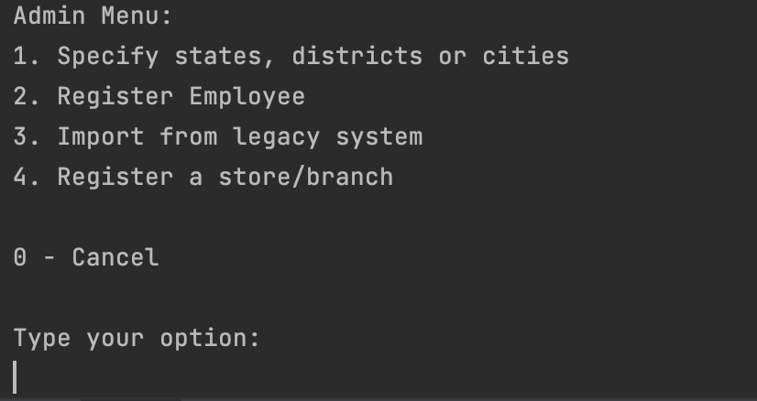

These functionalities allow system users to interact efficiently and carry out their activities related to real estate properties. Each role has access to specific features and plays an important role in real estate management and transactions.

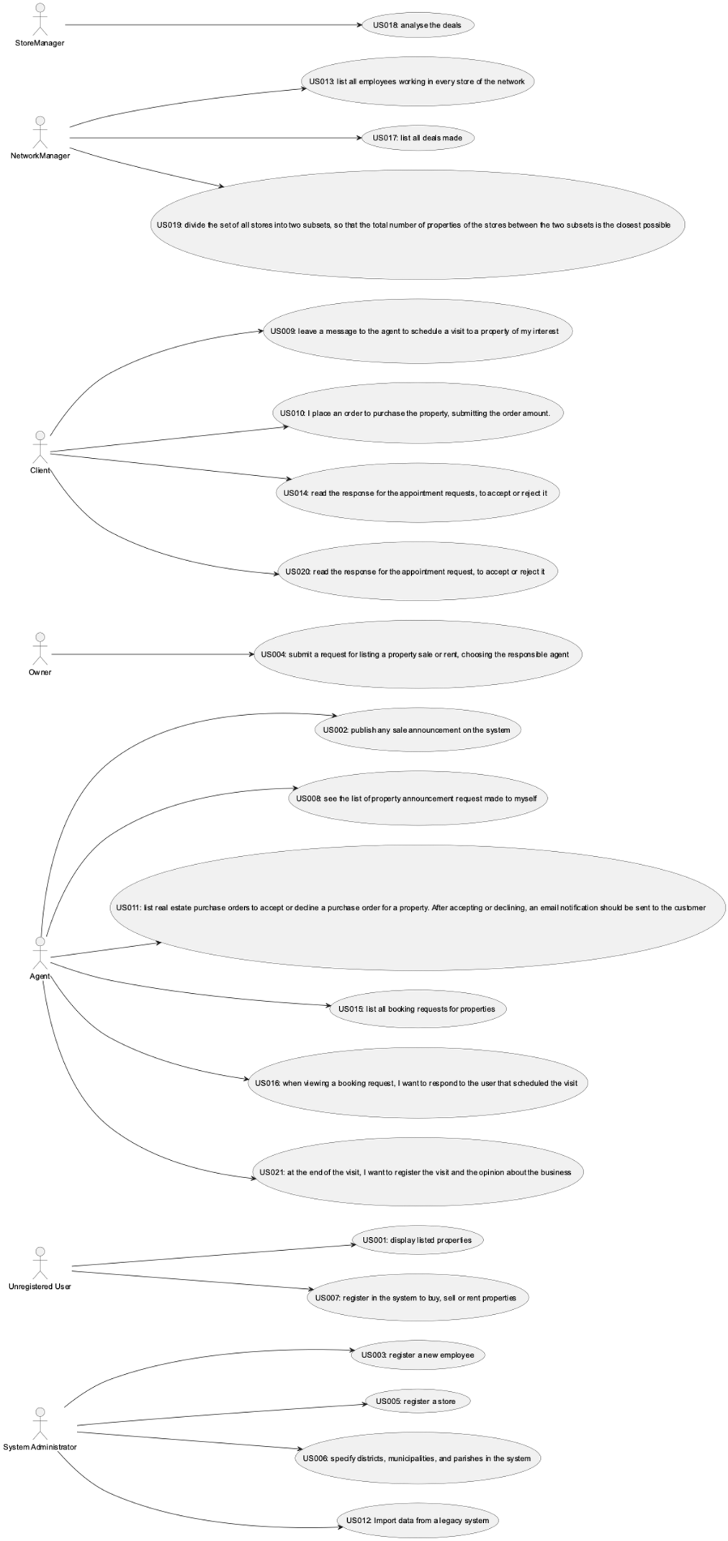

# FEATURES

* **Menu Login:**

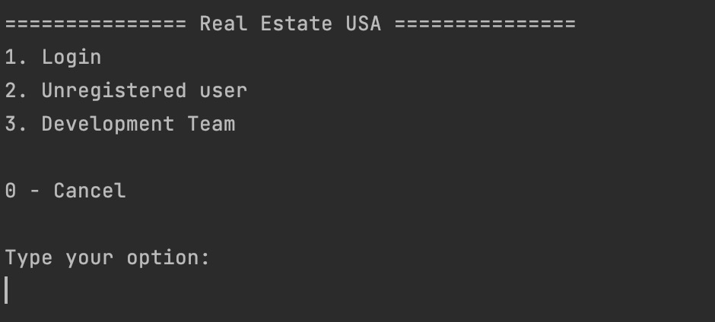

1. **Property Listing Display:**
   * Feature: Provide a professional display of listed properties.
   * Description: Unregistered users can access a visually appealing and informative presentation of available properties for lease or sale. This feature showcases properties with detailed descriptions, pricing information, and contact details to attract potential clients.
   * Steps:
     1. Open the app
     2. Choose the option "unregistered user”, then select the option "Display..."



* + 1. Then select the search criteria (example: see by type of business)

1. **Sale Announcement Publication:**
   * Feature: Enable agents to publish official sale announcements.
   * Description: Agents can publish announcements for sale or lease of real estate, notifying customers when the announcement is published.
   * Steps:
     1. Log in as an agent.
     2. Access the sale ad publishing option.

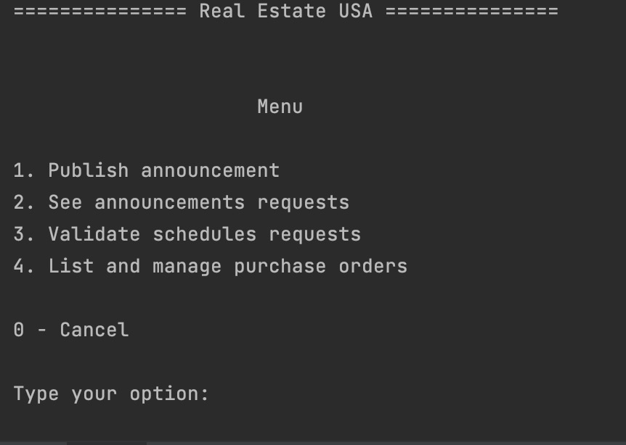

* + 1. Fill in the listing details, including description and contact information.
    2. Verify the information and post the ad.
    3. Send an SMS notification to the owner that the announcement is available.

1. **Employee Registration and Management:**
   * Feature: Facilitate efficient registration and management of new employees.
   * Description: System administrators can register new employees by capturing and organizing their details. This feature enables administrators to maintain an up-to-date employee “database” and effectively assign roles and responsibilities.
   * Steps:
     1. Log in as system administrator.
     2. Access the employee registration option.



* + 1. Fill in the new employee's details such as name, contact details and role.
    2. Verify the information and register the new employee.

**(Print do employee registrado, print do management (Num outro passo?))**

1. **Property Listing Request Submission:**
   * Feature: Allow property owners to submit professional property listing requests.
   * Description: Property owners can submit formal requests to list their properties for sale or rent, selecting competent agents to handle the listings. This feature streamlines the process of property listing and ensures proper assignment of agents.
   * Steps:
     1. Log in as a client.
     2. Access the listing request option.



* + 1. Fill in the form with the details of the property, such as type, location and additional information.
    2. Choose the agent responsible for the listing.
    3. Submit the request and wait for the agent to review it.

1. **Branch Registration and Integration:**
   * Feature: Register new stores and seamlessly integrate them into the network.
   * Description: System administrators can effortlessly create records for new stores within the network, fostering a structured and coordinated system setup. This feature is specifically designed to accommodate teams with five students and supports efficient store management.
   * Steps:
     1. Log in as system administrator.
     2. Select the branch registration option.



* + 1. Fill in the store details such as name, address and contact information.
    2. Check the information and register the new branch.

1. **Specify cities, districts and estates:**
   * Feature: Enable administrators to define precise geographical hierarchies.
   * Description: System administrators can specify and configure states, districts, and cities within the system, establishing a granular geographical structure. This feature is available as an optional enhancement for outstanding teams, allowing them to tailor the system to their specific geographical context.
   * Steps:
     1. Log in as system administrator.



* + 1. Access Specify cities, districts and estates option.



* + 1. Configure states, districts and cities in the system.
    2. Save the settings.

1. **User Registration and Authentication:**
   * Feature: Enable seamless user registration and secure authentication.
   * Description: Unregistered users can register within the system, accessing advanced features such as property saving, inquiries submission, and personalized experiences. This feature ensures a smooth onboarding process and enhances user engagement.
   * Steps:
     1. Open the UI.
     2. Access the unregisted user option.



* + 1. Select the register option.



* + 1. Fill in the registration form with the required information such as name, email address and password.
    2. Verify the information and complete the registration.
    3. Wait for the registration confirmation to access all the system functionalities.

1. **Property Announcement Request Management:**
   * Feature: Efficiently manage property announcement requests from owners.
   * Description: Agents can effectively handle property announcement requests submitted by property owners. They can review, approve, reject and post announcements. This feature facilitates streamlined communication between agents and property owners.
   * Steps:
     1. Access the system as an agent.
     2. Select “See announcement requests” option.



* + 1. Choose the announcement request to accept or reject.
    2. Select the option.
    3. If accept, define the commission and confirm, if reject, define the reason and confirm.

1. **Scheduled Property Visits:**
   * Feature: Enable clients to schedule professional property visits.
   * Description: Clients can request visits to properties of interest by providing preferred date, and desired time slots. The system displays available properties in chronological order, offering a convenient scheduling option for clients.
   * Steps:
     1. Access the system as a client.
     2. Select the request schedule option.



* + 1. Look at the list of available properties and choose the property of your interest.
    2. Complete the requested information about your preferred date and time to visit.
    3. Send the appointment message.

1. **Order Placement for Property Purchase:**

* Feature: Allow clients to place orders for property purchases.
* Description: Clients can submit orders specifying the desired property and the offered purchase amount. The system validates the order amount, ensuring it does not exceed the property's listed price. This feature facilitates efficient and organized property purchasing.
* Steps:
  1. Access the system as a client.
  2. Select the “Place an order to purchase property” option.



* 1. Look at the list of available properties, then choose the property to view more details.
  2. Check the price set by the owner.
  3. In the purchase order form, enter the amount you are willing to pay for the property, make sure your order amount does not exceed the price set by the owner.
  4. Confirm the purchase order.

1. **Purchase Order Management for Agents:**

* Feature: Enable agents to manage purchase orders for properties they handle.
* Description: Agents can access and review purchase orders for the properties they manage. The orders are grouped by property and sorted based on the offered amounts. Agents can accept or decline offers, triggering email notifications to clients. This feature streamlines the process of managing purchase orders.
* Steps:

1. Access the system as an agent.
2. Access to the List and manage Purchase Orders option.



1. For each offer, the agent can accept or decline the request.
2. **Legacy System Data Import:**

* Feature: Facilitate data import from legacy systems using CSV files.
* Description: System administrators can import data from existing legacy systems by uploading CSV files. The system validates the file content and imports the data, ensuring a seamless transition from previous systems. This feature simplifies the migration process and ensures data continuity.
* Steps:
  + 1. Access the system as an administrator
    2. Access the Import from legacy system option.



* + 1. Select the path to CSV file to import.
    2. Make sure the selected file is a valid CSV file.

1. **Employee Network Listing:**

* Feature: Provide a comprehensive listing of employees within the network.
* Description: Network managers can access a detailed list of employees in each store. This feature supports efficient employee management.
* Steps:
  1. Access the system as a network manager.
  2. Access to List all employee option.



* 1. See all employees.

1. **Appointment Request Response Tracking:**

* Feature: Enable clients to track responses to appointment requests.
* Description: Clients can monitor and review responses to their appointment requests. If a request is rejected, clients have the option to suggest a new date and time for a visit. This feature enhances communication and flexibility in scheduling property visits.
* Steps:
  + 1. Access the system as a client.
    2. Access to Read Response of an appointment request option.



* + 1. Display the list of responses to the customer.
    2. If an appointment request is rejected, allow the customer to suggest a new date and time for the visit, triggering a new appointment request.

1. **Booking Request Management for Agents:**

* Feature: Enable agents to manage booking requests for properties they handle.
* Description: Agents can access and review booking requests for the properties they manage within a specific period. The requests are sorted by date, utilizing a configurable sorting algorithm. This feature empowers agents to efficiently handle and prioritize property bookings, ensuring a streamlined booking process for clients.
* Steps:

1. **Respond to Bookings:**

* Feature: Ability to respond to booking requests.
* Description: Agents have the ability to respond to booking requests made by users. They can accept, decline, or request further information before confirming the booking. This functionality enables efficient communication between agents and users, ensuring that any queries are addressed before finalizing the booking.
* Steps:
  + 1. Access the system as an agent.
    2. Access the Validate schedules request option.



* + 1. Respond to the user who scheduled the visit via email.
    2. Submit.

1. **List all deals made:**

* Feature: ability to see the deals made.
* Description: This functionality allows the network manager to access the system and list all the deals carried out. The system offers the option to choose between at least two available classification algorithms, which can be manually selected by the network manager.
* Steps:
  + 1. Access the system as a network manager.
    2. Access to List all deal made option.



* + 1. Choose the sorting algorithm.
    2. See the results of the classification.

1. **Analyze deals made:**
   * Feature: Ability to analyze the deals done compared to the predicted values.
   * Description: In this functionality, the store manager has the possibility to analyze the deals carried out in comparison with the predicted values. In this section, a comparison is made between the sales values ​​of the properties and the predicted values. This analysis allows the manager to identify discrepancies between actual values ​​and estimated values.
   * Steps:
     1. Access the system as store manager.
     2. Access Analyze Deals option.



* + 1. Choose the regression.

1. **Divide the set of all stores**:

* Feature: Ability to divide the set of all stores into two subsets
* Description: Set of all stores into two subsets so that the total number of store properties between the two subsets is as close as possible.
* Steps:

1. Access the system as a network manager.
2. Go to the store breakdown section.
3. Choose the option Divide to see sublists.
4. See the the sublists of the partition satisfying the condition and the difference between the sums of the elements of the sublists.
5. **Accept or Reject appointment request:**

• Feature: Read and respond to appointment requests.

• Description: Clients can view appointment requests and decide whether to accept or reject them. This feature enables effective communication between agents and clients, allowing for efficient appointment scheduling.

• Steps:

1. Access the system as a client.
2. Navigate to the appointment requests section.
3. Review the details of the appointment request, including property information and the proposed date.
4. Choose to accept or reject the appointment.
5. If accepting, confirm the appointment and any additional details.
6. If rejecting, provide a reason for the rejection and confirm.
7. **Register Visit:**

• Feature: Record visit details and provide feedback.

• Description: Agents can document their visit to a property and share their opinion about the potential deal. This feature allows for comprehensive record-keeping and helps agents track their assessments of various properties.

• Steps:

1. Access the system as an agent.
2. Navigate to the visit registration section.
3. Choose the visit to register.
4. Share your opinion about the potential deal, and classify the visit from 1 (least likely) to 5 (most likely).
5. Submit the visit registration.

# TROUBLESHOOTING

1. **Login Issues:**
   * Problem: Unable to log in to the application.
   * Solution: Make sure you are using the correct username and password. Check for any typos or case-sensitive characters. If you still can't log in, contact the system administrator for assistance.
2. **Property Search Problems:**
   * Problem: Unable to find desired properties or search results are inaccurate.
   * Solution: Ensure that you have entered the correct search criteria, such as property type, number of rooms, and price range. Double-check your filters and try again. If the issue persists, contact the customer support for further assistance.
3. **Publication of Announcements:**
   * Problem: Facing difficulties in publishing property sale announcements.
   * Solution: Verify that you have provided all the required information accurately, including property details, price, and contact information. Make sure you have the necessary permissions to publish announcements. If the problem persists, reach out to the system administrator.
4. **Appointment Request Issues:**
   * Problem: Unable to schedule a visit to a property or experiencing errors in appointment requests.
   * Solution: Check that you have provided all the required information correctly, such as your name, contact details, preferred date, and time slot. Ensure that the requested property is available for visitation. If you encounter persistent errors, contact the customer support for resolution.
5. **Purchase Order Problems:**
   * Problem: Facing issues while placing a purchase order for a property.
   * Solution: Ensure that the order amount does not exceed the property's listed price. If another client has already placed an order for the same property, the system will prioritize the previous order. Wait for the previous order to be declined before submitting a new one. If you encounter further difficulties, seek assistance from the system administrator.
6. **Importing Legacy System Data:**
   * Problem: Encountering errors or issues while importing data from a legacy system.
   * Solution: Ensure that the file you are attempting to import is in the required CSV format. Double-check the file's content and verify its compatibility with the application. If you continue to experience problems, contact the system administrator for support.
7. **Regression Analysis and Property Valuation:**
   * Problem: Difficulties in using the regression models and estimating property sale prices accurately.
   * Solution: Make sure you have selected the appropriate regression model for property valuation. Review the documentation in the user manual regarding the regression analysis and its implementation. If you need further assistance or clarification, consult with the system administrator or refer to the provided resources.
8. **Store Subset Division Algorithm:**
   * Problem: Issues with dividing the set of stores into two subsets with an equal number of properties.
   * Solution: Ensure that you have followed the instructions for using the brute-force algorithm correctly. Review the pseudocode provided in the user manual to understand the algorithm's implementation. If you encounter difficulties or unexpected results, seek guidance from the system administrator or refer to the runtime tests conducted for insights.
9. **Data Backup and Recovery:**
   * Problem: Unable to perform data backup or encounter issues during data recovery.
   * Solution: Ensure that the data backup process is implemented correctly using appropriate Java serialization techniques. Verify that the backup files are saved in a secure location and can be retrieved using the deserialization process. If you experience difficulties with data recovery, review the serialization and deserialization logic or consult with a Java developer for assistance.

# FREQUENTLY ASKED QUESTIONS (FAQs)

**Q: How do I log into the application?**

**A**: Enter your assigned username and password on the login page. Your password should contain seven alphanumeric characters, including three capital letters and two digits.

**Q: How do I list a property for rent or sale?**

**A**: If you are a registered owner, navigate to the 'List Property' section. Fill in the required information about the property and submit it. The property will then be reviewed by an agent before being published.

**Q: How can I schedule a visit to a property?**

**A**: From the property listing, select the property you are interested in and then select the "Schedule a visit" option. Fill in the required details and submit your request.

**Q: How do I contact a real estate agent?**

**A**: Each property listing includes the contact information of the corresponding real estate agent. You can either call them directly or send them a message.

**Q: How does the system administrator register new employees or branches?**

**A**: As a system administrator, navigate to the 'Register Employee’ and ‘Register Branch´ section where you can add new employees or branches by filling in the necessary details.

**Q: What happens if the application crashes or I encounter a bug?**

**A**: Please report any issues to our technical support team via the 'Help & Support' section of the application.

# Attachments

**MATDISC**

Optimal Partitioning of Stores in Network Management

* 1. Introduction

As a key feature of the system created, the network manager can effortlessly perform an optimal partitioning of a list containing any number of stores. By simply providing a file with the necessary store details, the program empowers the manager to analyze and process the data, automatically determining the most balanced and efficient distribution of stores into two sub lists. This algorithm calculates and identifies the partitioning scheme that minimizes the difference between the two sub lists, ensuring a nearly equal distribution of resources.

With this feature, network managers can now achieve optimal resource allocation without the need for manual calculations or guesswork. By leveraging the system's advanced capabilities, they can effectively streamline operations, enhance network performance, and promote equitable resource utilization across the store network. This automated partitioning process not only saves valuable time and effort but also guarantees the best possible allocation strategy, maximizing efficiency and minimizing disparities between store subsets.

Pseudocode of the implemented Brute Force Algorithm:



* 1. Runtime tests for inputs of varying sizes

In this test the algorithm was tested with n lists with different store sizes, to evaluate how the run time evolves overtime.

The runtimes generated are totally dependent on the processing power of the CPU and so in other machines runtime may vary.

The inputs (numStores) in this test were 3,6,9,12,15,18,21,24,27,30.

This will show how much the size of the input is relevant to the execution time of the algorithm.

The graph indicates that there is a point where the execution time increases exponentially as the number of stores surpasses a certain threshold. This suggests that there may be an inefficiency in the system when dealing with many stores. It could be an indication of limitations in the underlying infrastructure or in the algorithm used for processing tasks with increasing store counts. Given that the implemented algorithm was a brute force approach, it is expected that the execution time increases significantly as the number of stores grows. Brute force algorithms typically involve exhaustive search or computation of all possible combinations, which can result in exponential time complexity.

* 1. Worst-case time complexity analysis

The worst-case complexity of an algorithm refers to the maximum number of resources such as execution time or memory that the algorithm requires when given an input of a certain size most denoted as n in asymptotic notation. It provides an upper bound on the resources needed by the algorithm ensuring that the algorithm will complete within the specified time frame even for the largest possible input.

|  |  |
| --- | --- |
| **Steps** | **Time Complexity** |
| for i := 1 to totalCombinations do | O(2^numStores) |
| if count of set bits in i is equal to numPartitions then | O(numStores * 2^numStores) |
| partition := empty list, count := 0 | O(1) |
| for j := 0 to numStores do | O(numStores) |
| if bit at position j in i is 1 then | O(1) |
| add j to partition, Increment count by 1 | O(1) |
| if count is equal to numPartitions then | O(1) |
| sum1 := 0 ; sum2 := 0 ; sublist1 := empty list ; sublist2 := empty list | O(1) |
| for storeId := 0 to numStores do | O(numStores) |
| propertiesCount := get storeCount at index storeId | O(1) |
| if storeId is in partition then | O(numPartitions) |

The maximum time complexity theory states that the total time complexity of the algorithm is determined by the step with the most time complexity among all steps of the algorithm. This theory requires us to focus on time-consuming tasks and provides an upper bound on the efficiency of the algorithm used.

In this algorithm, the first loop "for totalCombinations is from i := 1" has a time complexity of O(2^numStores). This step overcomes the overall time complexity of the algorithm. Other steps with lower time complexity are also covered by this step size. Thus, we conclude that the maximum time complexity of the entire algorithm is O(2 ^ numStores).

**MATCP**

**1 Simple Linear Regression**

**1.1 Overview of Simple Linear Regression (Brief theoretical description.)**

Simple Linear Regression is a statistical technique used to understand and model the linear relationship between an independent variable and a dependent variable. In this case, we are interested in predicting the sale price of properties based on a single independent variable, such as the property area or distance from the center or number of bedrooms or number of bathrooms or number of parking spaces in the property.

**1.2 Simple Linear Regression Model**

**1.2.1 Model significance (Brief explanation of the results obtained by the Anova table, including the information of correlation coefficient.)**

After performing Simple Linear Regression and obtaining the regression coefficients, it is important to assess the significance of the model. We can refer to the Anova table and the correlation coefficient to do so.

The Anova table, also known as the analysis of variance table, provides information about the statistical significance of the regression model. It helps us determine whether the relationship between the independent variable and the dependent variable is statistically significant.

In the Anova table, we can find the following relevant information:

Sum of Squares (SS): The sum of squares represents the total variability of the data around the mean. It is decomposed into two parts: SS for the model and SS for the error.

Degrees of Freedom (DF): Degrees of freedom represent the number of independent values that can vary in a statistical analysis. In the case of Simple Linear Regression, we have two degrees of freedom: one for the model and one for the error.

Mean Squares (MS): Mean squares are calculated by dividing the sum of squares by the corresponding degrees of freedom.

F-statistic: The F-statistic is calculated as the ratio between the mean square for the model and the mean square for the error. It helps us determine whether there is a meaningful relationship between the independent variable and the dependent variable.

p-value: The p-value is a measure of statistical significance. It indicates the probability of obtaining an F-statistic equal to or more extreme than the observed one, assuming the null hypothesis is true. A p-value smaller than a pre-determined significance level (usually 0.05) indicates that the model is statistically significant.

In addition to the Anova table, the correlation coefficient (R) is also an important measure for assessing the relationship between variables. It ranges from -1 to 1, where a value close to -1 indicates a strong negative correlation, a value close to 1 indicates a strong positive correlation, and a value close to 0 indicates a weak or non-existent correlation. The correlation coefficient helps us understand the strength and direction of the linear relationship between the property area and the sale price.

By analyzing the Anova table and the correlation coefficient, we can determine whether the Simple Linear Regression model is statistically significant and whether the independent variable (property area) has a significant linear relationship with the dependent variable (sale price). This information is essential for understanding the validity and usefulness of the regression model.

Fonte Variação GL Soma de Quadrática Média Quadrática F0

Regressão

Erro (residual)

Total

R^2

R

**1.2.2. Hypothesis tests for model coefficients (Brief explanation of the regressor meaning/significance. The test decision must be obtained for significant levels of 1% and 5%.)**

After performing Simple Linear Regression and obtaining the regression coefficients, it is important to conduct hypothesis tests to assess the significance of the coefficients and determine if they have a significant effect on the dependent variable.

For each coefficient β₁ of the independent variable, we can conduct a hypothesis test using the p-value. The null (H₀) and alternative (H₁) hypotheses are as follows:

H₀: The coefficient β₁ is equal to zero, meaning there is no linear relationship between the independent variable and the dependent variable.

H₁: The coefficient β₁ is different from zero, meaning there is a significant linear relationship between the independent variable and the dependent variable.

Based on the p-value obtained for the coefficient β₁, we can decide regarding the rejection or acceptance of the null hypothesis. Typically, we use significance levels of 1% and 5% to make this decision.

If the p-value is less than the chosen significance level (1% or 5%), we reject the null hypothesis and conclude that the coefficient β₁ is statistically significant. This indicates the independent variable significantly affects the dependent variable.

On the other hand, if the p-value is greater than the chosen significance level, we do not have sufficient evidence to reject the null hypothesis. This suggests that the coefficient β₁ is not statistically significant, and there is no significant linear relationship between the independent variable and the dependent variable.

By conducting these hypothesis tests for each coefficient in the model, we can determine which independent variables have a significant influence on the dependent variable. This information helps us understand which features are relevant in determining the sale price of the properties.

**1.2.3 Confidence intervals for prediction values (Construction of confidence intervals for prediction values with confidence levels of 90% and 95% with a brief explanation of the results.)**

After performing Simple Linear Regression and obtaining the regression coefficients, it is possible to construct confidence intervals for the prediction values. Confidence intervals provide a range of values within which we expect the predicted values to fall with a certain level of confidence.

To construct the confidence intervals, we use the estimated regression coefficients, the standard deviation of the errors, and the desired confidence level. We use confidence levels of 90% and 95%.

For each prediction value, we calculate the confidence interval, which is given by:

Confidence Interval = Prediction Value ± (Critical Value x Standard Error of Prediction)

The critical value is determined based on the desired confidence level and the t-Student distribution. The standard error of prediction is a measure of the uncertainty of the prediction and is calculated using the regression residuals.

By constructing confidence intervals for the prediction values, we can state with a certain confidence level (90% or 95%) that the true value of the dependent variable will fall within this interval. The narrower the interval, the higher the precision of the prediction.

It is important to note that confidence intervals provide a range of values but do not guarantee that the true value will fall within this range with 100% certainty. They help us understand the uncertainty associated with the predictions and provide a measure of precision for the predicted values.

When interpreting the confidence intervals, we can observe whether they are wide or narrow. Wider intervals indicate greater uncertainty in the prediction, while narrower intervals indicate higher precision. Therefore, it is important to consider the confidence intervals when interpreting and communicating the results of the predicted values.

**2 Multiple Linear Regression**

**2.1 Overview of Multiple Linear Regression (Brief theoretical description.)**

Multiple Linear Regression is a statistical technique used to model the linear relationship between a dependent variable and multiple independent variables. In contrast to Simple Linear Regression, which involves only one independent variable, Multiple Linear Regression allows us to consider the combined effect of multiple independent variables on the dependent variable.

**2.2 Multiple Linear Regression Model**

**2.2.1 Model significance (Brief explanation of the results obtained by the Anova table, including the information of the coefficient of determination.)**

In Multiple Linear Regression, assessing the model's significance is crucial to determine if the combination of independent variables has a significant impact on the dependent variable. This can be done by analyzing the Anova table and the coefficient of determination (R-squared).

The Anova table provides information on the overall significance of the Multiple Linear Regression model. It partitions the sum of squares into two components: the sum of squares due to regression (explained sum of squares) and the sum of squares due to residual (unexplained sum of squares). The table also provides the degrees of freedom and mean squares for each component.

The F-statistic, obtained from the Anova table, is used to test the null hypothesis that all regression coefficients are zero. A significant F-statistic indicates that at least one of the independent variables has a significant relationship with the dependent variable. The corresponding p-value indicates the probability of obtaining an F-statistic as extreme as the one observed under the null hypothesis.

The coefficient of determination (R-squared) is another important metric to evaluate the model's significance. It represents the proportion of variance in the dependent variable explained by the independent variables. R-squared ranges from 0 to 1, where a value closer to 1 indicates that a larger proportion of the variance is accounted for by the independent variables. However, it is important to note that R-squared alone does not provide information about the statistical significance of the model.

By analyzing the Anova table and considering the F-statistic and its associated p-value, we can determine if the overall Multiple Linear Regression model is statistically significant. A small p-value (typically below a significance level of 0.05) indicates that the model is significant, suggesting that the combination of independent variables has a significant impact on the dependent variable. Additionally, a higher R-squared value indicates a better fit of the model to the data, indicating a stronger relationship between the independent variables and the dependent variable.

**2.2.2. Hypothesis tests for model coefficients (Brief explanation of the regressor meaning/significance. The test decision must be obtained for significant levels of 1% and 5%.)**

In Multiple Linear Regression, hypothesis tests are conducted to evaluate the significance of individual regression coefficients (regressors) and determine if they have a meaningful impact on the dependent variable. The test decision is typically obtained for significant levels of 1% and 5%.

For each regressor in the model, we can perform a hypothesis test using the corresponding p-value. The null hypothesis (H₀) and alternative hypothesis (H₁) are as follows:

H₀: The regression coefficient for the specific regressor is equal to zero, implying that the regressor has no effect on the dependent variable.

H₁: The regression coefficient for the specific regressor is not equal to zero, suggesting that the regressor has a significant impact on the dependent variable.

By examining the p-value associated with each regressor, we can decide on the rejection or acceptance of the null hypothesis. The p-value represents the probability of observing a coefficient as extreme as the one estimated, assuming the null hypothesis is true.

To determine if a regressor is statistically significant, we compare the p-value to the chosen significance levels of 1% and 5%. If the p-value is lower than the significance level (0.01 for 1% or 0.05 for 5%), we reject the null hypothesis and conclude that the regressor has a significant impact on the dependent variable. Conversely, if the p-value is greater than the significance level, we fail to reject the null hypothesis and conclude that there is not enough evidence to suggest a significant relationship between the regressor and the dependent variable.

By conducting these hypothesis tests for each regressor in the model, we can identify which independent variables have a statistically significant impact on the dependent variable. This information helps us understand the individual significance of each regressor and their contribution to the overall Multiple Linear Regression model.

**2.2.3 Confidence intervals for prediction values (Construction of confidence intervals for prediction values with confidence levels of 90% and 95% with a brief explanation of the results.)**

In Multiple Linear Regression, we can construct confidence intervals for the predicted values to provide a range of possible values within which we expect the predictions to fall with a certain level of confidence. Typically, confidence levels of 90% and 95% are used.

To construct the confidence intervals, we utilize the estimated regression coefficients, the standard deviation of the errors, and the desired confidence level.

For each predicted value, we calculate the confidence interval, which is given by:

Confidence Interval = Predicted Value ± (Critical Value x Standard Error of Prediction)

The critical value is determined based on the desired confidence level and the t-distribution. The standard error of prediction is a measure of the uncertainty of the prediction and is calculated using the residuals from the regression.

By constructing confidence intervals for the predicted values, we can state with a certain level of confidence (90% or 95%) that the true value of the dependent variable will fall within this interval. The narrower the interval, the greater the precision of the prediction.

It is important to note that confidence intervals provide a range of possible values, but they do not guarantee that the true value will fall within that range with 100% certainty. They help us understand

The uncertainty associated with the predictions and provide a measure of accuracy for the predicted values.

When interpreting the confidence intervals, we can observe whether they are wide or narrow. Wider intervals indicate greater uncertainty in the prediction, while narrower intervals indicate higher precision. Therefore, considering the confidence intervals is crucial when interpreting and communicating the results of value predictioted values.