**Extraction Of Nematodes From Soil Using The Baermann Funnel Method**

***Overview***

The Baermann funnel method can be used for extraction of active nematodes (i.e., excluding cyst forms) from plant material and soil samples and it can give us a qualitative view of what nematode species are present in a particular sample/habitat. The sample size depends on the funnel diameter as well as the study purpose (i.e., qualitative vs. quantitative). In the case of soil samples, these are usually washed and sieved multiple times (3-4 repetitions) prior to the Baermann funnel procedure. Using a bucket and a set of sieves (e.g., a 1mm mesh sieve on top of a 45 μm mesh sieve), soil samples are repeatedly washed and the material retained in the smaller sieve transferred to a Baermann funnel setup (Fig. 1A-B). Nematodes can be recovered after 12-24 hrs in the Baermann funnels.

***Materials***

Glass/plastic funnels

Rubber tubes (2-3 cm long)

Window screen (metal material; these can be cut to match the diameter of the funnels)

Paper tissue (these can be cut to match the diameter of the funnels)

Squeeze water bottle

Small sieve (45 μm/No.325 or smaller)

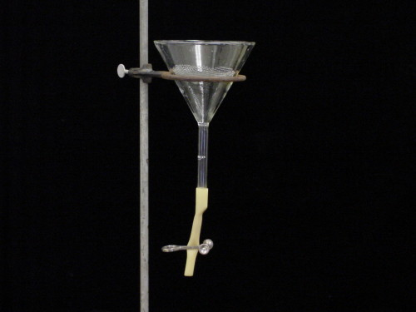 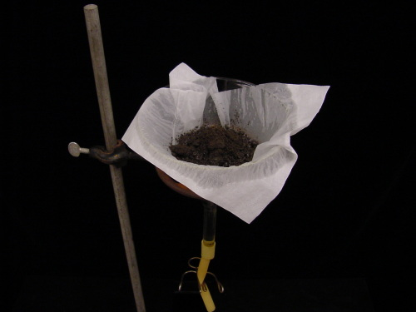

**B**

**A**

**Figure 1.** (A) Baermann funnel apparatus. (B) Soil sample added to the Baermann funnel on top of a window screen and tissue paper. Resource: https://www.plantpath.iastate.edu/tylkalab/content/extracting-nematodes-soil-baermann-funnel

***Procedure***

1. Before starting the process, make sure all materials (e.g., funnels, sieves, window screens) are clean to avoid contamination between samples.
2. Assemble the Baermann funnel apparatus. For several soil samples, you might consider to use a rack so that multiple funnels/soil samples can be set up at once. (Fig. 2).
3. A clamped rubber tube (use a metal or plastic clip) is placed below the funnel, so that the water with nematodes does not scape (i.e. leak) during the process (Figs.1 and 2).

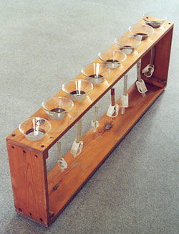

**Figure 2.** A wood rack used to set multiple Baermann funnels at once. Resource: http://www.rvc.ac.uk/review/parasitology/Baermann/Step1.htm

1. A piece of window screen (or similar material) is placed on the mouth of the funnel to sustain the paper tissue and the soil that will be placed on the funnel (Fig. 3).

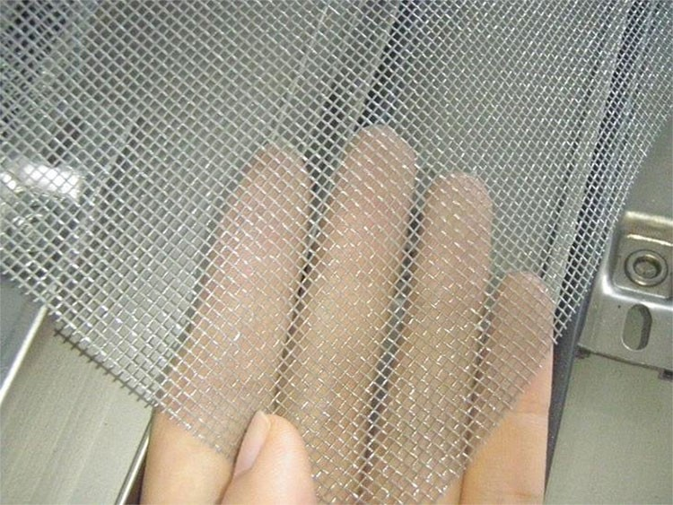

**Figure 3.** Window screen example. Resource: https://sc01.alicdn.com/kf/UT8bLuoXCJbXXagOFbXt/222183547/UT8bLuoXCJbXXagOFbXt.jpg

1. The funnel is placed into a rack or holder and a tissue-paper on top of the screen material. Both the tissue-paper and the screen material can be cut to fit the funnel mouth (i.e. similar diameter). A larger surface area can result into a more efficient extraction.
2. Using a squeeze water bottle, transfer the soil material from the washed/sieved step to a small glass beaker (250 ml) or directly to the funnel containing the window screen and paper tissue (Fig. 4).

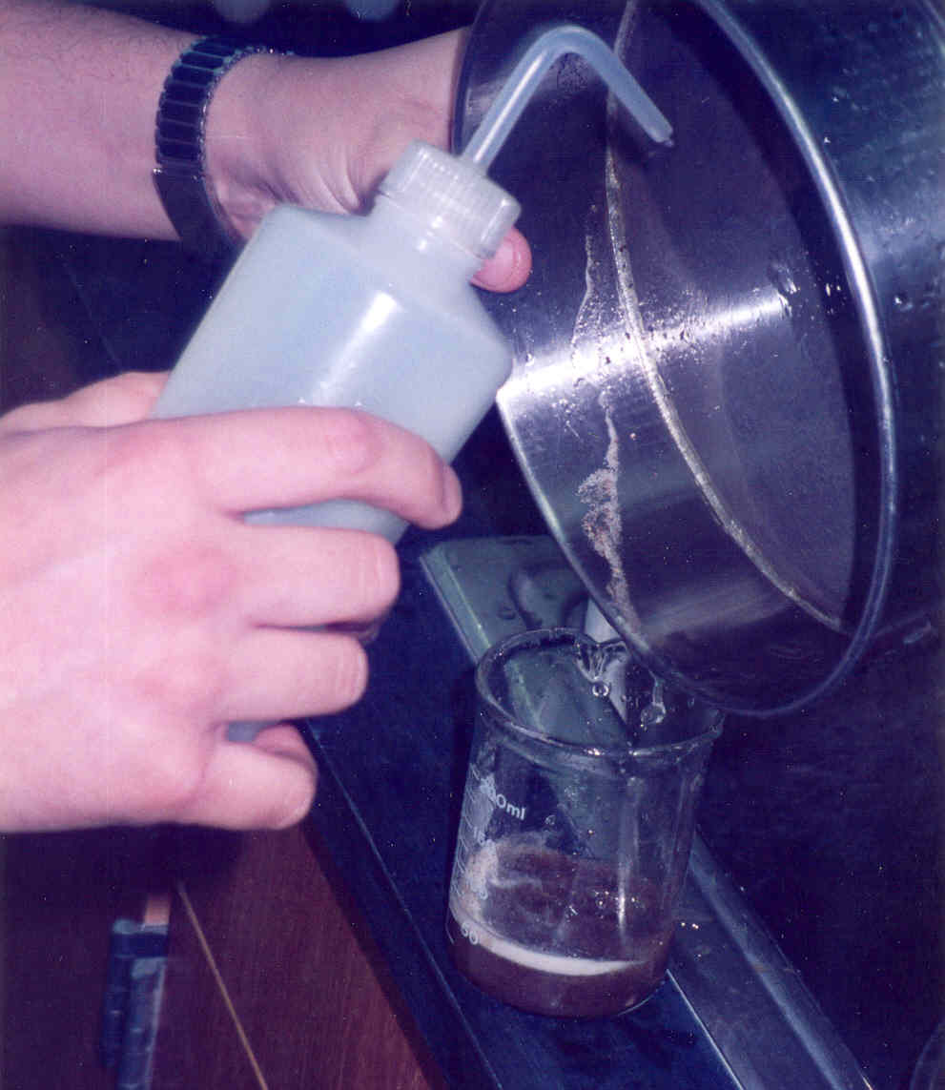

**Figure 4.** Soil sample retained in the smaller sieve can be transferred to a beaker with a squeeze water bottle before placing it on the funnel. Resource: https://www.cdfa.ca.gov/plant/PPD/nematology/research.html

1. Add water to the funnel setup until the screen and soil sample are immersed. Be careful to avoid formation of air bubbles. Also, to avoid/minimize evaporation, you might cover the funnels using plastic covers or aluminum foil.
2. Wait overnight (or longer if desired) for recollecting the nematodes. Usually nematode recovery is done after 12-24hrs. Note: samples obtained using different extraction times cannot be compared. Also, Regularly tapping and adding water increases nematode vitality due to water oxygenation.
3. Gather the first couple of drops of water from the bottom of the tube by slowly releasing the clamp on the tubing. If preferred, you might recover all the water in the funnel with a small beaker and concentrate it using a 45 μm mesh sieve.
4. Specimens can be examined under the dissecting and compound microscopes for morphological and molecular identification.

Note that this technique will work only with actively mobile, living nematodes.