FEBA can give almost perfect fairness as shown in [Cicc] when comparing with Greedy approach. In this project, we want to investigate how the logical topology of nodes and the offered load affect the two metrics of interest: delay and throughput.
- Scenario setup
We use the same setup parameters as specified in the system profile profP3_10[Air]:
- Channel bandwidth = 10Mhz
- Frame duration 4ms
- The nodes use 16-QAM-1/2 MCS unless stated otherwise
- Each traffic flow employs a 100kB buffer
We run each simulation 10 times independently and take the average. Each simulation lasts 120s with a 30s warm-up period as in [Cicc]
- Simulation and results
a/ Average end-to-end delay comparison between FEBA and Greedy approach:
We use a chain topology with 10 nodes. Each node sends an Internet traffic flow (with 192-byte packet size) at the rate 100000b/s to the destination. Here, we use QPSK-1/2 MCS.
FEBA
averaged measure = e2e_owd_a

(0) = 0.344823 [0.344823, -1]

(1) = 0.319732 [0.319732, -1]

(2) = 0.279025 [0.279025, -1]

(3) = 0.251236 [0.251236, -1]

(4) = 0.259578 [0.259578, -1]

(5) = 0.211673 [0.211673, -1]

(6) = 0.171693 [0.171693, -1]

(7) = 0.138556 [0.138556, -1]

(8) = 0.0706094 [0.0706094, -1]

Greedy:
averaged measure = e2e_owd_a

(0) = 0.293743 [0.293743, -1]

(1) = 0.272443 [0.272443, -1]

(2) = 0.240555 [0.240555, -1]

(3) = 0.217589 [0.217589, -1]

(4) = 0.201546 [0.201546, -1]

(5) = 0.169889 [0.169889, -1]

(6) = 0.135432 [0.135432, -1]

(7) = 0.0824005 [0.0824005, -1]

(8) = 0.0419112 [0.0419112, -1]

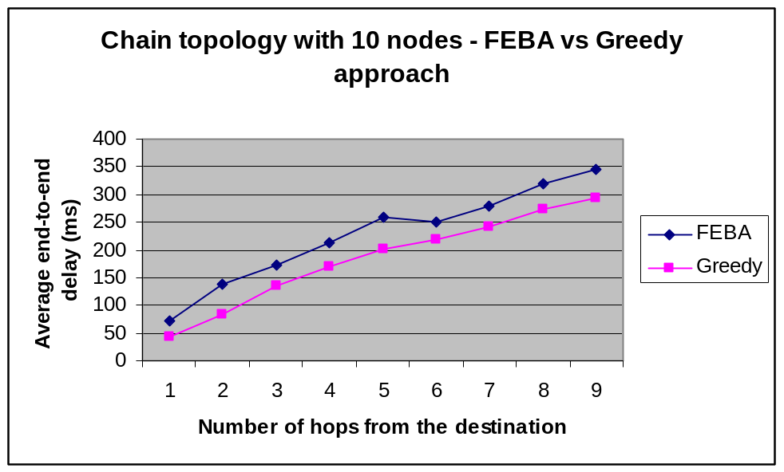
In the paper, the authors only evaluate the average end-to-end delay of FEBA with different number of control slots per frame but they do not compare between FEBA and Greedy to verify whether FEBA can give a faster response.
From the simulation result, it is clear that the delay is affected by the distance from the source to the destination, as the average end-to-end delay increases when the number of hops increases. We can notice that FEBA has a longer delay compared to Greedy approach. This is because FEBA has to tradeoff between delay and fairness among traffic flows.

______________________________________________________________
TO-DO:
- How to use priority in FEBA -> VoIP/Video traffic flow
- Alpha = 0.1 is an optimal value? How to optimize it?
- Can we use different XmtHoldoff to improve FEBA performance or provide a QoS differentiation scheme?

