Abstract—These instructions give you guidelines for preparing papers for IEEE TRANSACTIONS and JOURNALS. Use this document as a template if you are using Microsoft Word 6.0 or later. Otherwise, use this document as an instruction set. The electronic file of your paper will be formatted further at IEEE. Define all symbols used in the abstract. Do not cite references in the abstract. Do not delete the blank line immediately above the abstract; it sets the footnote at the bottom of this column.
Fair End-to-end Bandwidth Allocation (FEBA) algorithms observation and improvement
H.N. Truong, T.T.T. Do, D. Tran

Department of ECE, National University of Singapore
dothutrang@nus.edu.sg

Index Terms—About four key words or phrases in alphabetical order, separated by commas. For a list of suggested keywords, send a blank e-mail to keywords@ieee.org or visit http://www.ieee.org/organizations/pubs/ani_prod/keywrd98.txt

INTRODUCTION
THIS PART is Duong’s part. Please use equation 3.0 to edit your formulas. The total length for your I + II parts is 1.5 pages excluding abstract and index terms.

Bandwidth balancing Role in WMNs
In networking, load balancing is a technique to spread work between two or more network nodes, links, gateways, or other resources, in order to get optimal throughput, response time, and optimal resouce utilization. In wireless mesh networks (WMNs), load balancing is critical to obtain efficient utilization of the network capacity. Load imbalance in WMNs may be classified as gateway loading, center loading, and bottleneck node formation. Gateway loading imbalance occurs because of traffic aggregation at the gateway nodes and bandwidth constraint. It may result in congestion, packet loss, and buffer overflow. Center loading imbalance arises primarily due to shortest path routing. In the short path routing schemes, nodes which are close to the center of the network become points of contention, and usually exhaust their resources before the others, like bandwidth, processing power and memory storage in static WMNs, or battery energy reserve in portable WMNs. Similar to center loading, certain nodes at critical positions in the WMN also form network bottlenecks, that causes bottleneck node formation load imbalance. Load balancing, therefore, is essential to improve throughput and scalability of the WMN [Mano].
Load imbalance occurs even when the WMN has uniform data generation rate and uniform node distribution. There exist several issues for load imbalance, which include traffic stability arising out of fluctuations due to utilization of load balancing schemes, bandwidth stripping and effects to higher layer protocols, and so on.
In WMN load balancing, bandwidth plays an important role. It together with network capacity are the two main resources that limit the WMN. Bandwidth refers to the data rate through the radio interface, and can be understood simply as the throughput of end-to-end paths in the networks [Cicc]. With more balanced bandwidth usage, higher throughput for nodes is achievable.
Bandwidth balancing implies the fairness of bandwidth allocation in the network [Cicc]. Therefore, it is often measured by fairness index. One approach to calculate the fairness index is as following:
If a system allocates resources to n contending users, such that the ith user receives an allocation xi, then fairness index is:
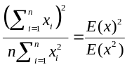
For the above fairness index formula, fairness index always lies between 0 and 1. For example, a distribution algorithm with a fairness of 0.10 means it is unfair to 90% of the users. Fairness does not necessarily mean equal distribution of resources. In some cases, it is justifiable to give more resources to some consumers than others. Therefore, fairness index is just one appropriate performance metric and would be the ratio of the resource allocated and the right for allocation [Jain]. For some load-balancing schemes, load is defined as a flow from one source node to one destination node, and the size of the load is defined as the bandwidth of the associated request. Therefore, load-balancing sometimes may be understood as bandwidth balacing. However, as aforementioned, other limited resources may also be utilized, for example, load balancing in order to provide higher network capacity. Furthermore, not only is fairness index utilized as degree of load-balance metric, other metrics such as bandwitdth blocking rate may also be utilized in performance evaluation.

FEBA
Fair End-to-end Bandwidth Allocation (FEBA) algorithm is designed for IEEE 802.16 nodes to negotiate bandwidth in a multi-channel environment [Cicc]. By assigning bandwidth requests and grants at each neighbor in a round-robin fashion, with an amount of service proportional to the number of traffic flows going to or coming from the neighbor, respectively, FEBA can provide a fair bandwidth allocation, in terms of throughput, to end-to-end traffic flows regardless of their path length.

IEEE 802.16 Mesh – Channels, Frames and Subframes
In IEEE 802.16 Mesh, time is divided into frames of fixed duration. Each frame comprises two sub-frames: a control sub-frame and a data sub-frame (Fig. 1). Control sub-frames are partitioned into slots of fixed duration (named control slots). Control messages can be sent in the control slots by nodes in a regular, though not periodical, manner. Although IEEE 802.16 mesh networks can utilize up to 16 multiple non-interfering channels for data transmission, control messages only can be sent in the same channel for all the nodes, e.g., channel Ch1 in Fig. 1. Data sub-frames comprises a fixed number of data mini-slots (named slots).
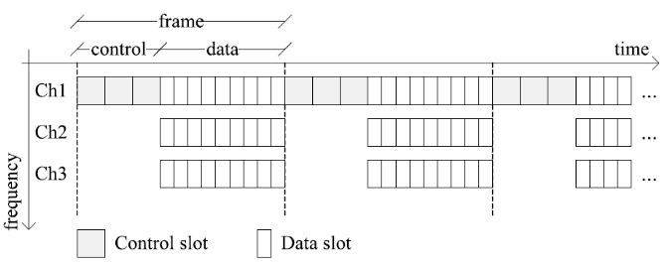
Fig. 1. Example of frame structure, with three channels.

Nodes use Mesh Distributed Schedule (MSH-DSCH) messages for bandwidth negotiation. MSH-DSCH messages contain a list of information elements (IEs), classified by the IEEE 802.16 standard into four types: request IEs, grant IEs, confirmation IEs and availability IEs. Negotiation procedure is a three-way handshake procedure: (i) requester node asks a neighbor node, granter, to allocate some bandwidth; (ii) the granter advertises a set of slots as ‘granted’ to the requester; (iii) the requester confirms that it will actually use that set of slots (or part thereof) to transmit data.

Bandwidth request/grant in FEBA
A simple network example in the Fig. 2 can be used to explain the request/grant data structures, in which neighbor nodes are connected by an edge; and active flows are represented by dashed arrows. The data structures used for bandwidth negotiation at node X also are illustrated. R and G are represented for Requesting and Granting queues respectively.
A weight 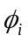 is assigned for each active queue i (requesting and granting), which is computed so that the amount of service is proportional to the number of traffic flows under service:
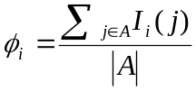, (1)
Where A is the set of all active traffic flows served by this node, j is an active flow, and 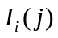is an indicator function which equals 1 if j is under service at queue i, 0 otherwise. Since each traffic flow is under service at exactly one queue, 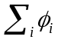 = 1.
As can be seen from Fig. 2, X has 3 neighbors, i.e. A, B, C. Totally, there are 10 flows going through X. Therefore, C granting queue has 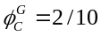, while the weight of C requesting queue is 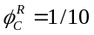. This is because there are only 2 requesting flows coming from C to X, i.e. C-X and C-X-B, while there is only 1 requesting flow from X to C.
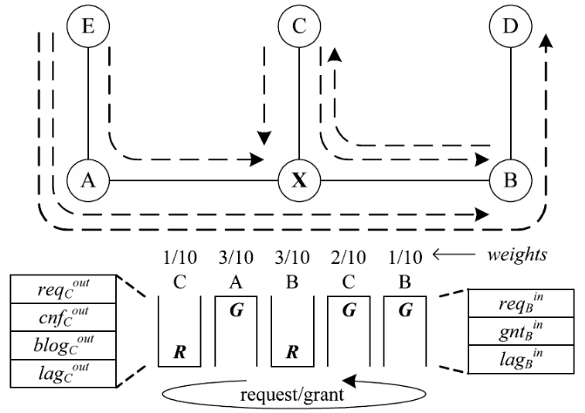
Fig. 2. Bandwidth request/grant data structure at node X.

Each queue i is entitled to grant/request up to 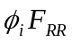bytes to/from neighbor i, where F_{RR} is target round duration system parameter. The granter should not schedule data slots too early, i.e. before the requester has the chance to confirm them, and not too late, which would entail longer response times of the handshaking procedure and greater per-hop packet transmission delays.
The bandwidth request/grant procedures are executed in a round-robin manner over all the queues in the active list until any of the following conditions becomes true: (i) the active list becomes empty; (ii) there is not enough space left in the control slot to add another IE to the MSH-DSCH message; (iii) the lag of the queue under service exceeds lag_{max}.
The procedure includes the following steps: (i) Randomly select a channel; (ii) Find the first available slot in the first frame of the grant horizon; (iii) If no slots are available, move to the next channel; (iv) If all channels have been searched, move to the next available frame of the grant horizon.
Fig. is a simple example of this procedure. Assume that the granter needs to assign three slots for the transmission of its i^{th} neighbor. It first randomly selects one channel between the two available ones, say channel 1. Then, it visits the grant hor-

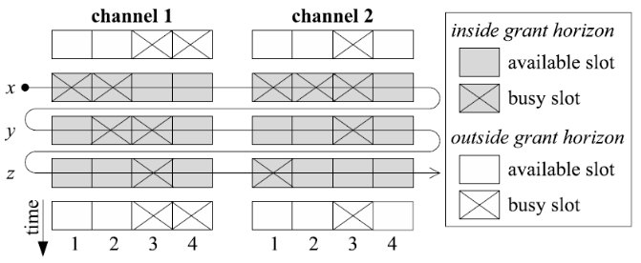
Fig. 5. Example of grant allocation of data slots within the grant horizon.
-izon from the earliest frame, i.e. x in Fig. 5. Slots 3 and 4 in channel 1 are available, thus a two-slot grant is issued. Since there is still one slot to be granted, the granter continues searching for available slots. Note that slot 4 in channel 2 cannot be granted anymore, since it overlaps in time with slot 4 in channel 1. Thus, slot 1 of frame y in channel 1 is granted instead, which completes the procedure. In the example the following grant IEs are thus added to MSH-DSCH: ⟨[3, 4], [x, x], 1⟩ and ⟨[1, 1], [y, y], 1⟩.

FEBA observation, Advantages and Disadvantages

Authors’ observation
The author of FEBA compared FEBA with Greedy in term of end-to-end throughput, MAC throughput, fairness. When the number of nodes increases, end-to-end throughput for FEBA dramatically decreases, which is higher than that of Greedy. Meanwhile, FEBA achieves a lower MAC throughput than Greedy.
However, FEBA/DRR attains almost perfect fairness among all the traffic flows in all cases, while the Greedy/DRR is only fair when the number of nodes is below seven.
In addition, because FEBA is designed for multi-channel used, the authors also observed the improvement of end-to-end throughput when the number of channel increases.

Advantages
In wireless mesh networks, the end-to-end throughput of traffic flows depends on the path length, i.e. the higher the number of hops, the lower becomes the throughput.
The main idea of FEBA is to assign bandwidth requests and grants at each neighbor: in a round-robin fashion; with an amount of service proportional to the number of end-to to-end flows going to or coming from the neighbor respectively; within a time window whose size depends on the frequency with which the neighbor transmits control messages.
FEBA gives a very high bandwidth fairness index, which is used to measure bandwidth balancing. The “Fairness” is a desirable property for any MAC protocol employed as the backhaul tier of a WMN.

Disadvantages
While fairness is the outstanding feature of FEBA, MAC throughput and average delay are the two drawbacks.
In the paper, the authors affirmed the MAC throughput weakness of FEBA, which is lower than Greedy. However, the authors did not compare FEBA and Greedy in terms of average end-to-end delay to verify whether FEBA can give a faster response.
In order to evaluate this, we setup a set of simulations.

Scenario setup
We use the same setup parameters as specified in the system profile profP3_10[Air]:
- Channel bandwidth = 10Mhz
- Frame duration 4ms
- The nodes use 16-QAM-1/2 MCS unless stated otherwise
- Each traffic flow employs a 100kB buffer
We run each simulation 10 times independently and take the average. Each simulation lasts 120s with a 30s warm-up period as in [Cicc]

Simulation and results
We use a chain topology with 10 nodes. Each node sends an Internet traffic flow (with 192-byte packet size) at the rate 100000b/s to the destination. Here, we use QPSK-1/2 MCS.
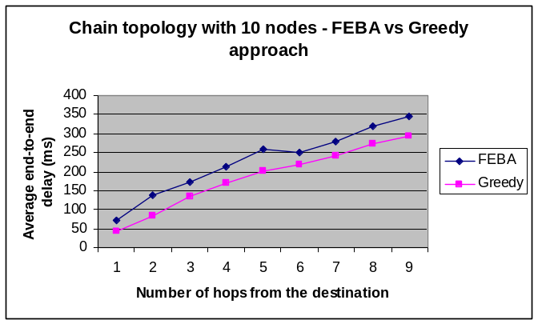
Fig. Average end-to-end delay versus number of hops from destination for FEBA and Greedy
From the simulation result, it is clear that the delay is affected by the distance from the source to the destination, as the average end-to-end delay increases when the number of hops increases. We can notice that FEBA has a longer delay compared to Greedy approach. This is because FEBA has to tradeoff between delay and fairness among traffic flows.

Improvement

Prioritizing traffic flows in FEBA

Motivation
As we discussed earlier the mechanism in requesting/grating processes using a weight (Φ), in order to maintain a fair allocation to each flow, FEBA assigns I_{i}(j) a value of 1 if j is under service at queue I, and 0 otherwise. That means the weight Φ_{i} of any queue i is proportional to the number of traffic flows under service according to expression (1). This will lead to a nearly perfect fairness index: every flow will have the same bandwidth regardless of the path length or characteristics of the flow. However, in a real network, each traffic flow has different level of priority. We cannot allocate the same amount of bandwidth to an Internet flow and a Video-streaming flow.
By assigning different values to indicator function I_{i}(j), we can increase or decrease the weight of one queue. This allows some traffic flows to have higher priority than others.

Proposed solution
For each flow, we can add a 3-bit field in the header of its packet to contain the priority of the flow. So in total we can have 2³ = 8 levels of priority. At each node, we can maintain a table of priority level to help us calculate the weight for each queue. For example, we can use this table in differentiating services:
When a node receives a packet from one flow, it will check the priority field and look up in its priority table to know which factor it has to use to calculate the weight.

Simulation result
In Fig. 6 we show the bandwidth allocation among the three flows with different levels of priority. Here we use a chain topology with 4 nodes. Node 0 and Node 1 send an asymptotic flow towards Node 3 with priority 1. Node 2 sends an asymptotic flow towards Node 3 with a changing priority from 1 to 8. As can be seen, when the three flows have the same priority, each flow have nearly the same amount of bandwidth (33%). When the priority of flow 2 to 3 increases, the amount of bandwidth it achieves also increases. For example, when its priority is eight times more than others, it gets around 80% of the total bandwidth while others get 10% each.

Optimization of alpha value

Problem
In expression (2), authors of FEBA claimed that when = 0.1, FEBA can produce the most accurate estimations for control latency h. In this section we will try to evaluate the performance of FEBA on changing the value of α. From the simulation we can know whether the author’s claim is valid.
TABLE I
PRIORITIY TABLE AND CORRESPONDING SERVICE
Index | Priority I_{i}(j) | Corresponding service
0 | 1 | FTP file transfer
1 | 2 | UDP tunnel
2 | 4 | Internet web browsing
3 | 6 | VoIP
4 | 8 | Video conferencing
5 | 16
6 | 32
7 | 64
For priority which is greater than 8, we can reserve for future use with higher-data-rate real time application.

Simulation

Modified FEBA for QoS differentiation in WiMAX

Observation
In the IEEE 802.16-2004 PMP mode (point-to-multipoint), we have four QoS classes of service: unsolicited grant service (UGS), real-time polling service (rtPS), non-realtime polling service (nrtPS) and best effort (BE). However, in Mesh Mode, we do not have a clear QoS differentiation scheme like that.
In addition, one of the reasons that affect the delay in FEBA is the system parameter XmtHoldoffExponent [Cicc] which defines the MSH-DSCH transmission interval. Hence, to provide different QoS (in this case, we discuss only the average end-to-end delay) services to different applications, the eligibility interval or the parameter XmtHoldoffExponent should be different for each node.
TABLE I
Units for Magnetic Properties (Short Title Here)
Symbol | Quantity | Conversion from Gaussian and  CGS EMU to SI ª
Φ | magnetic flux | 1 Mx → 10⁻⁸ Wb = 10⁻⁸ V·s
B | magnetic flux density,  magnetic induction | 1 G → 10⁻⁴ T = 10⁻⁴ Wb/m²
H | magnetic field strength | 1 Oe → 10³/(4π) A/m
m | magnetic moment | 1 erg/G = 1 emu  → 10⁻³ A·m² = 10⁻³ J/T
M | magnetization | 1 erg/(G·cm³) = 1 emu/cm³  → 10³ A/m
4πM | magnetization | 1 G → 10³/(4π) A/m
σ | specific magnetization | 1 erg/(G·g) = 1 emu/g → 1 A·m²/kg
j | magnetic dipole  moment | 1 erg/G = 1 emu  → 4π × 10⁻¹⁰ Wb·m
J | magnetic polarization | 1 erg/(G·cm³) = 1 emu/cm³  → 4π × 10⁻⁴ T
χ, κ | susceptibility | 1 → 4π
χ_{ρ} | mass susceptibility | 1 cm³/g → 4π × 10⁻³ m³/kg
μ | permeability | 1 → 4π × 10⁻⁷ H/m  = 4π × 10⁻⁷ Wb/(A·m)
μ_{r} | relative permeability | μ → μ_{r}
w, W | energy density | 1 erg/cm³ → 10⁻¹ J/m³
N, D | demagnetizing factor | 1 → 1/(4π)
No vertical lines in table. Statements that serve as captions for the entire table do not need footnote letters. A longer description of the table would go here.
ªGaussian units are the same as cgs emu for magnetostatics; Mx = maxwell, G = gauss, Oe = oersted; Wb = weber, V = volt, s = second, T = tesla, m = meter, A = ampere, J = joule, kg = kilogram, H = henry.

Simulation

Conclusion
A conclusion section is not required. Although a conclusion may review the main points of the paper, do not replicate the abstract in the conclusion. A conclusion might elaborate on the importance of the work or suggest applications and extensions.
Acknowledgment
Author thanks ...
References
- [Cicc] Cicconetti, C.; Akyildiz, I.F.; Lenzini, L. Bandwidth Balancing in Multi-Channel IEEE 802.16 Wireless Mesh Networks. INFOCOM 2007. 26th IEEE International Conference on Computer Communications. Page(s):2108 - 2116
- [Jain] R. Jain, W. Hawe, D. Chiu. A Quantitative measure of fairness and discrimination for resource allocation in shared computer system. DEC-TR-301, September 26, 1984.
- [Mano] B.S. Manoj; Ramesh R. Rao Wireless mesh networking - Architectures, protocols and standards. Load balancing in wireless mesh networks. Auerbach Publications
- [Aky1] IAN F. AKYILDIZ, XUDONG WANG. A Survey on Wireless Mesh Networks. IEEE Radio Communications. September 2005
- [Aky2] Ian F. Akyildiz, Xudong Wang, Weilin Wang. Wireless mesh networks: a survey. Computer Networks 47 (2005) 445-487
- [Mogre] Parag S. Mogre, Matthias Hollick, Ralf Steinmetz. QOS in Wireless Mesh Networks: Challenges, Pitfalls, and Roadmap to its Realization. NOSSDAV , Urbana, Illinois USA.
- [Sw] http://info.iet.unipi.it/

 

