Async Booking — Retry & Request-Validity Plan
High-level plan for team review. Edge / Ascend Scheduling Phase 2. Tracking: EDGE-460.

Summary
When Margo books an appointment, the request runs asynchronously. If the partner or integration is unavailable, the request is held and retried within a bounded request-validity window of 3 hours. This plan unifies the retry behavior under one clock and makes every outcome visible to Platform.

Background — how a booking flows today
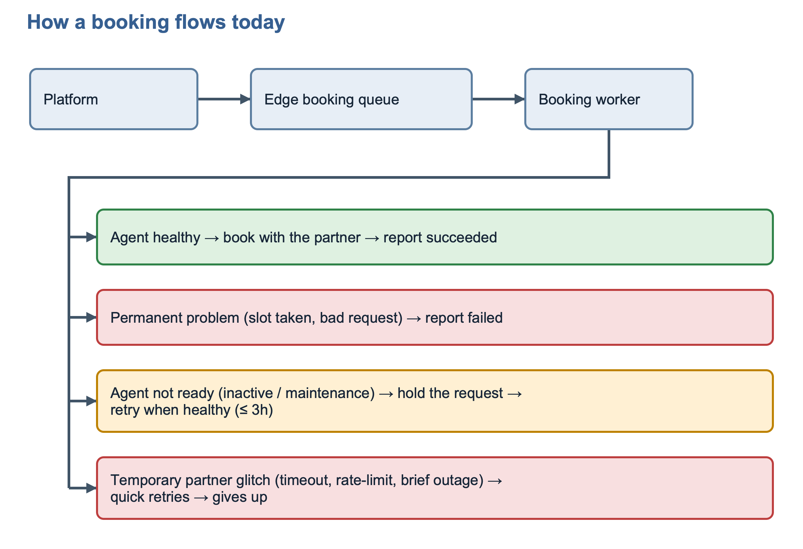
Situation | How long we keep trying | How it reports back
Agent not ready | Up to 3 hours | Held, then failed if the window expires
Temporary partner or infrastructure glitch | A few minutes | Not clearly reported today

The problem
- Inconsistent windows. Temporary outages give up after minutes even though the booking remains valid for 3 hours.
- The window can quietly stretch. Re-holding a request can reset its clock and let it live longer than intended.
- Silent give-ups. A request can age out without Platform receiving a failure outcome.

Proposed — one 3-hour request-validity window
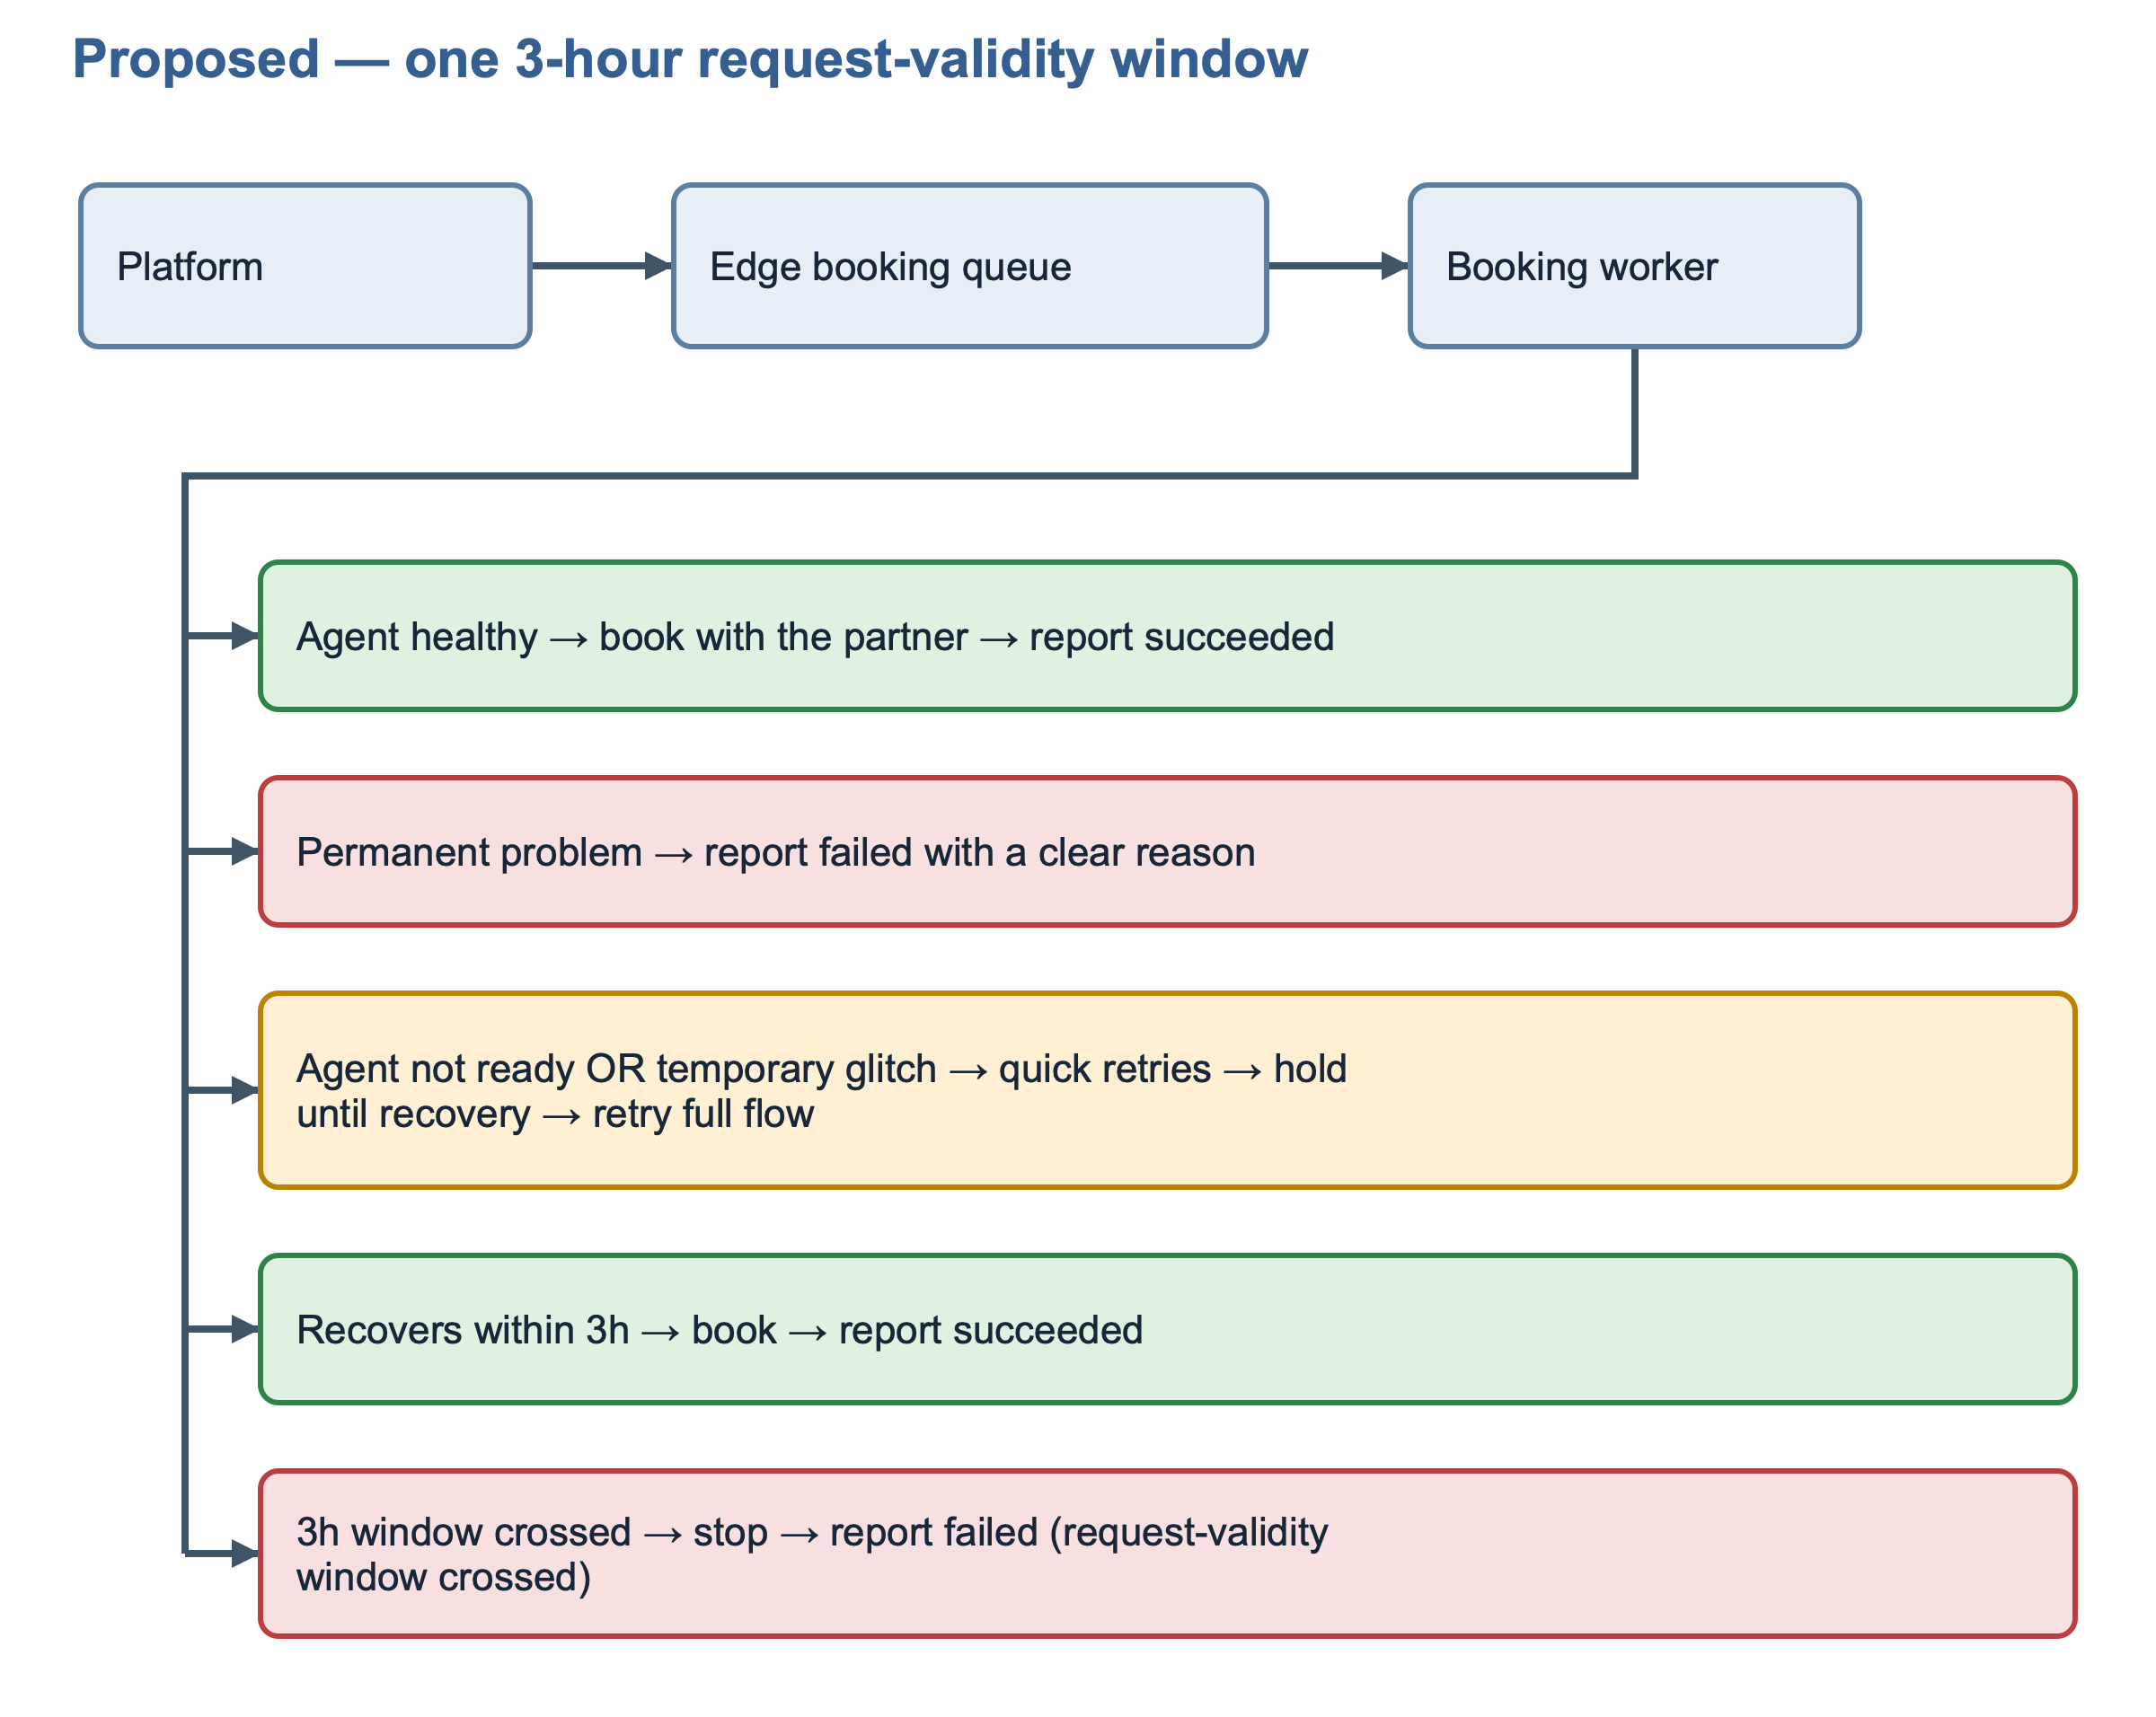
The request carries one absolute deadline from arrival time plus 3 hours. The deadline is never reset. Temporary failures are held rather than dropped, recovery replays the normal booking flow, and expiry always reports a failed outcome with a clear reason.

What Platform sees
- `succeeded` — booked; includes appointment details.
- `parked` — held for a temporarily unavailable agent or partner; will be retried.
- `failed` — will not be booked; includes a reason such as slot taken or request-validity window crossed.

Benefits
- One consistent 3-hour promise for both agent unavailability and temporary partner glitches.
- No lost bookings inside the window, and no bookings that outlive it.
- Full visibility for every success, hold, and give-up.
- Kind to partners — retry when they recover, not on a blind timer.

