Personal Work Intelligence Assistant
  - High-level architecture | Draft v0.1 | 2 November 2026
Status: proposed. Companion to the project brief v0.5, which defines what the layer must do; this document describes how it’s built. The Phase 0 checks in section 11 can still change parts of it.

1. Overview
The layer is one Python background service on my Ubuntu laptop. It collects local sources, records and transcribes meetings, stores everything in SQLite, and serves Claude Desktop through MCP. A browser frontend on 127.0.0.1 is the only place where I delete data or change settings. Online sources (Gmail, Calendar, Drive, Notion, GitHub, Google Chat) are not copied; Claude reads them live through connectors.
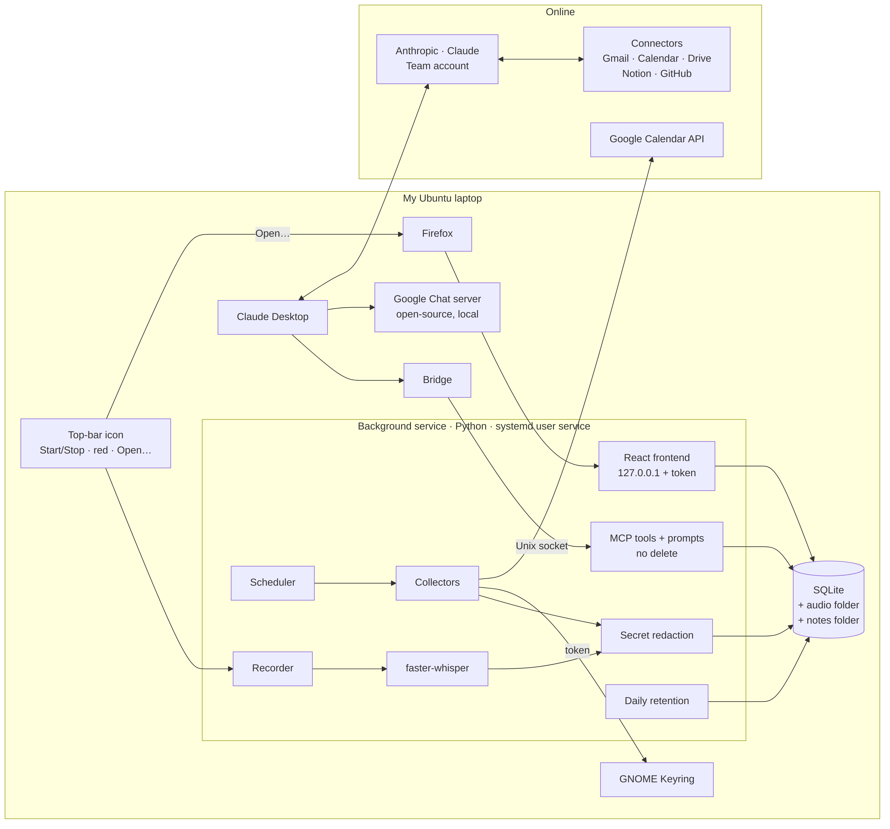

Main components
- Background service: Python, starts at login as a systemd user service, and runs whether or not Claude Desktop is open.
- Bridge: a tiny program that Claude Desktop starts; it passes MCP messages to the service over a Unix socket.
- Collectors: read Git, the Claude Code session index, Firefox history, app usage and today’s calendar.
- Recorder and transcription: two-track meeting capture and local transcription with faster-whisper.
- Store: SQLite, plus folders for audio and meeting notes.
- MCP tools and prompts: what Claude can read and write. There are no delete tools.
- Frontend: a React app in Firefox, served by the service on 127.0.0.1.
- Top-bar icon: Start/Stop recording, a red indicator while recording, and Open… for the frontend.

2. Runtime
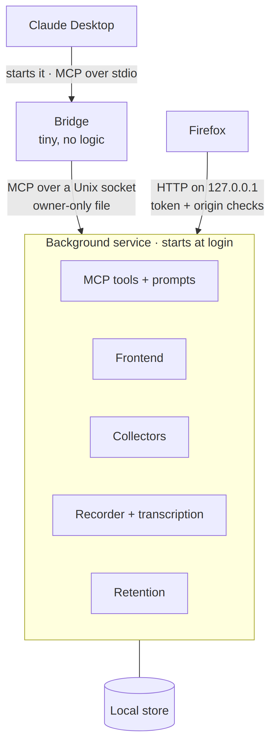
- Language: Python. Rust would use somewhat less RAM at idle (roughly 5–20 MB against 40–100 MB, typical figures to confirm in the benchmark), but that’s about 1% of the laptop’s memory, and the heaviest task, transcription, runs in native code either way. Python also has the most mature local speech tooling, and it’s the language I know best.
- Process: one background service that starts at login as a systemd user service, which also restarts it after a crash.
- Connection to Claude Desktop: MCP. Claude Desktop starts local servers as child processes over stdio, while connectors added in its settings are reached from Anthropic’s cloud, which can’t see my laptop. So Claude Desktop starts a tiny bridge, and the bridge talks to the service over a Unix socket that only my user can open. No network port is used for Claude.
- Connection to the frontend: HTTP on 127.0.0.1 (section 7), because a browser can’t use a Unix socket.

3. Storage
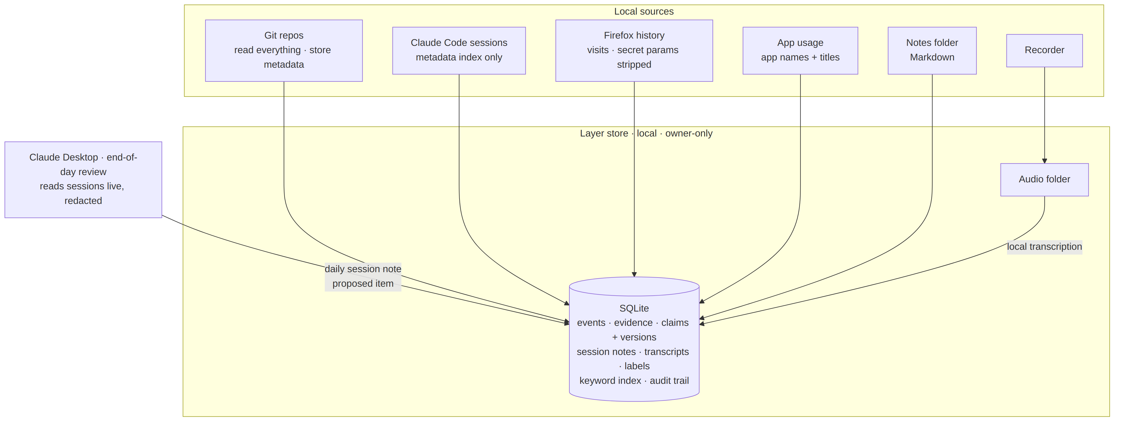

Store
- SQLite for everything structured: events, evidence, claims and their versions, session notes, transcripts, labels, the keyword index and the audit trail. It’s one file with no database server.
- Audio folder for recordings, readable only by my user.
- Notes folder with Markdown files for meetings without audio.

What each source keeps
- Git: everything is read; only metadata is stored (message, author, date, files changed, line counts, uncommitted-change counts). Code changes are read from the repository when needed.
- Claude Code: sessions are read live and never copied. The layer stores a metadata index (session ID, project, start and end time, file path) and the daily session notes written by Claude.
- Firefox: visits are copied, with secret-looking URL parameters stripped and the frontend’s own address ignored.
- App usage: app names, window titles, and active vs idle time.

Search
- Keyword search with SQLite’s built-in full-text index; Claude tries several wordings. Meaning-based search is added only if the 5-day evaluation shows keyword search is too weak.

Retention
- 3 months by default, configurable per type: Firefox visits, app usage, Git metadata, the Claude Code index, session notes, transcripts, unconfirmed claims and the audit trail.
- Confirmed claims: kept until I delete them.
- Audio: deleted after I mark the transcript reviewed, or after 30 days.

4. Context server (MCP)
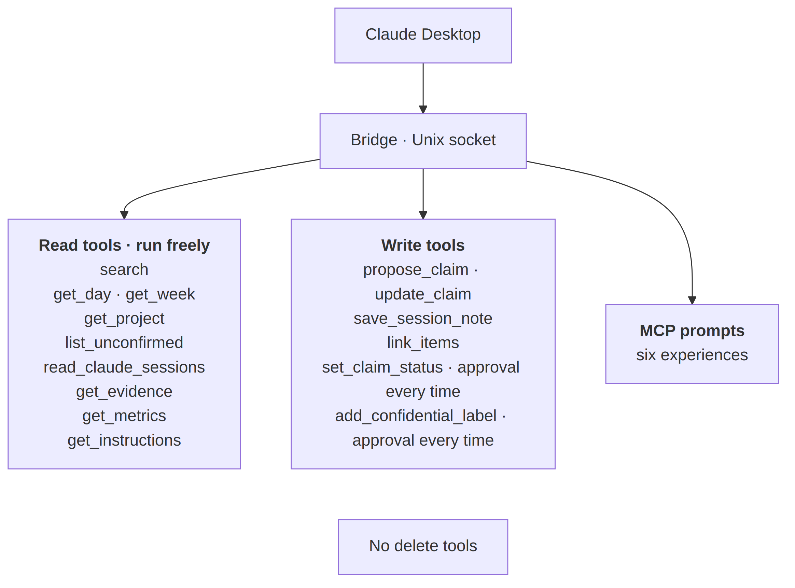

Read tools (run freely)
- search: keyword search with filters for project, date range and source.
- get_day / get_week: everything for one day or one week.
- get_project: a project’s resumption context.
- list_unconfirmed: all unconfirmed claims.
- read_claude_sessions: Claude Code sessions for a day, with secrets redacted, used to write session notes.
- get_evidence: one piece of evidence in full.
- get_metrics: quality metrics.
- get_instructions: the template for one experience, as a fallback for MCP prompts.

Write tools
- propose_claim / update_claim: add a claim, or a new version of one.
- save_session_note: save a daily session note as a proposed item.
- link_items: link two items.
- set_claim_status: confirm, dispute or retract a claim. Claude Desktop asks my approval every time.
- add_confidential_label: add the label. Claude Desktop asks my approval every time, and there is no tool to remove a label.

Rules
- No delete tools.
- Content returned by read tools is marked as data from its source, never as instructions.
- When the data is older than 5 minutes, a read triggers a quick refresh first.

Experience instructions
- The six experiences are served as MCP prompts. The same templates are available through get_instructions, from one source, in case the Linux beta doesn’t show MCP prompts.

5. Collectors
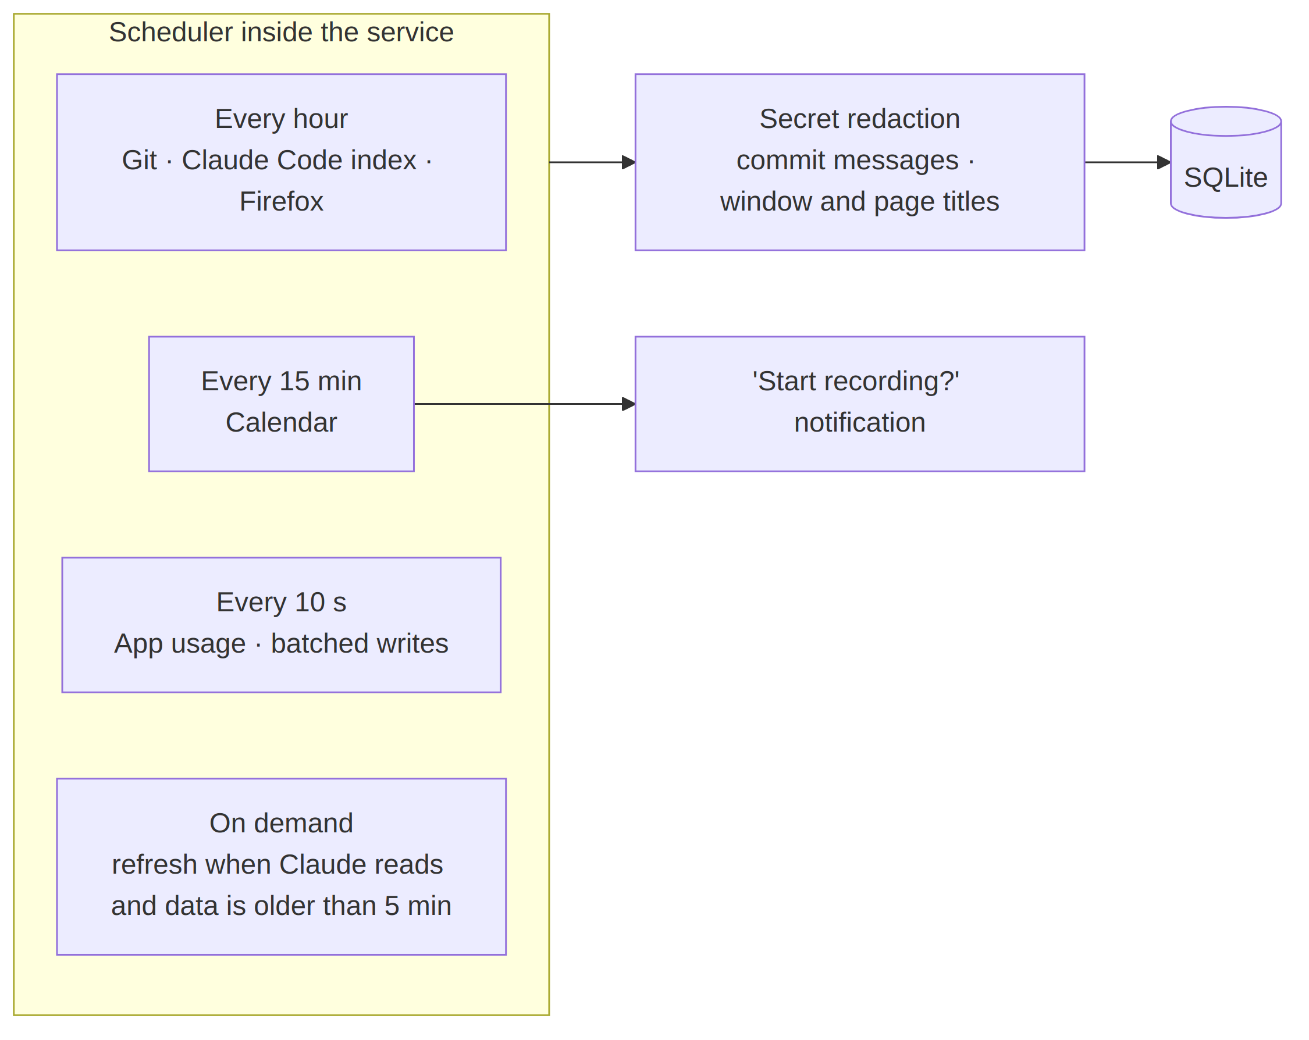
- Git: scans allowlisted repositories every hour. No Git hooks, so there’s no setup per repository, and uncommitted changes are seen.
- Claude Code index: reads session metadata from ~/.claude/projects every hour.
- Firefox: reads a temporary copy of the history database every hour, because Firefox locks the original while it runs.
- App usage: checks the active window every 10 seconds through the Focused Window D-Bus GNOME extension, which is needed because Wayland doesn’t expose the active window. Idle time comes from GNOME’s built-in idle monitor. Writes are batched. If this slows the laptop, it falls back to PC usage time only.
- Calendar: reads today’s meeting titles and start times every 15 minutes through the layer’s own read-only Google sign-in. The token is stored in GNOME Keyring.
- Redaction: commit messages and window and page titles are scanned for secrets before storage.

6. Meeting pipeline
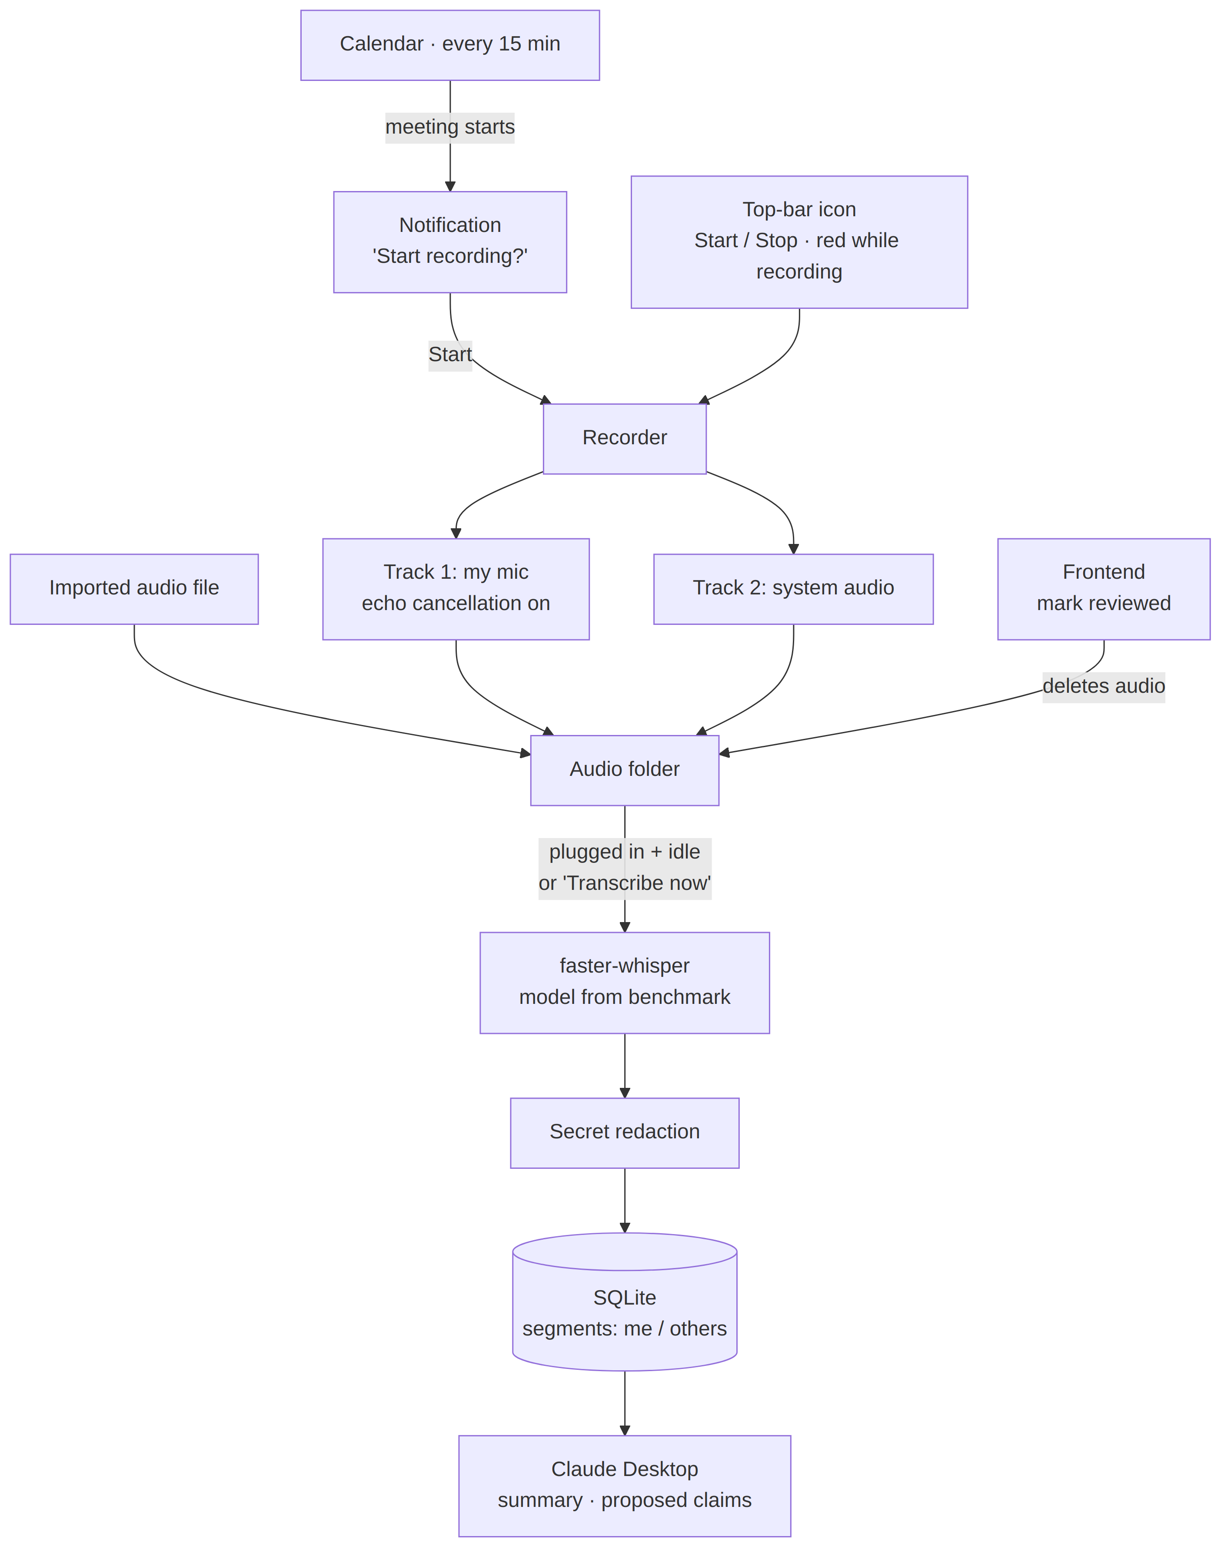

Capture
- When a calendar meeting starts, a notification asks “Start recording?”. I can also start and stop from the top-bar icon, which turns red while recording.
- Two tracks: my microphone (track 1) and system audio (track 2). Echo cancellation is always on for the microphone.
- I can import an audio file, and write notes without audio as Markdown files in the notes folder.

Processing
- faster-whisper on the CPU, with the model size chosen by the Phase 0 benchmark using real recordings that mix Portuguese and English.
- Runs automatically when the laptop is plugged in and I’m idle, or when I click Transcribe now in the frontend.
- Segments are labelled “me” (track 1) or “others” (track 2). A speaker-separation model is added only if the evaluation shows it’s needed.
- Transcripts are redacted before storage. Claude produces summaries and proposed claims when I ask.

Review
- Marking a transcript reviewed in the frontend deletes its audio.
- An existing Linux recorder (Hankanman/Parley) was considered and not adopted; the layer builds its own capture.

7. Frontend
- A React app, built with Node.js. The build output is plain files served by the Python service, so Node.js isn’t needed day to day.
- Opened in Firefox from the top-bar icon (Open…).
- Covers meetings (recordings, Transcribe now, transcripts, mark reviewed), deletion (with a decision for each affected claim), confidential labels, retention settings per type, allowlists, and collector status.

Protection
- Listens on 127.0.0.1 only; the port is configurable.
- A random secret is created at each start. Open… hands it to the browser, which keeps it as a session cookie.
- Every request is checked for origin and host, which blocks other websites and DNS-rebinding tricks.
- Its npm packages are pinned to exact versions and reviewed.

8. Retention, deletion and backup
- Retention cleanup runs once a day, at the first moment the laptop is idle.
- Deletion happens only in the frontend. When I delete evidence, the frontend shows the claims based on it and I decide for each one.
- The audit trail records what was collected or deleted and when, never the content, and is kept for 3 months.
- Backup is still open: its destination, and where its encryption key lives.

9. Security boundaries
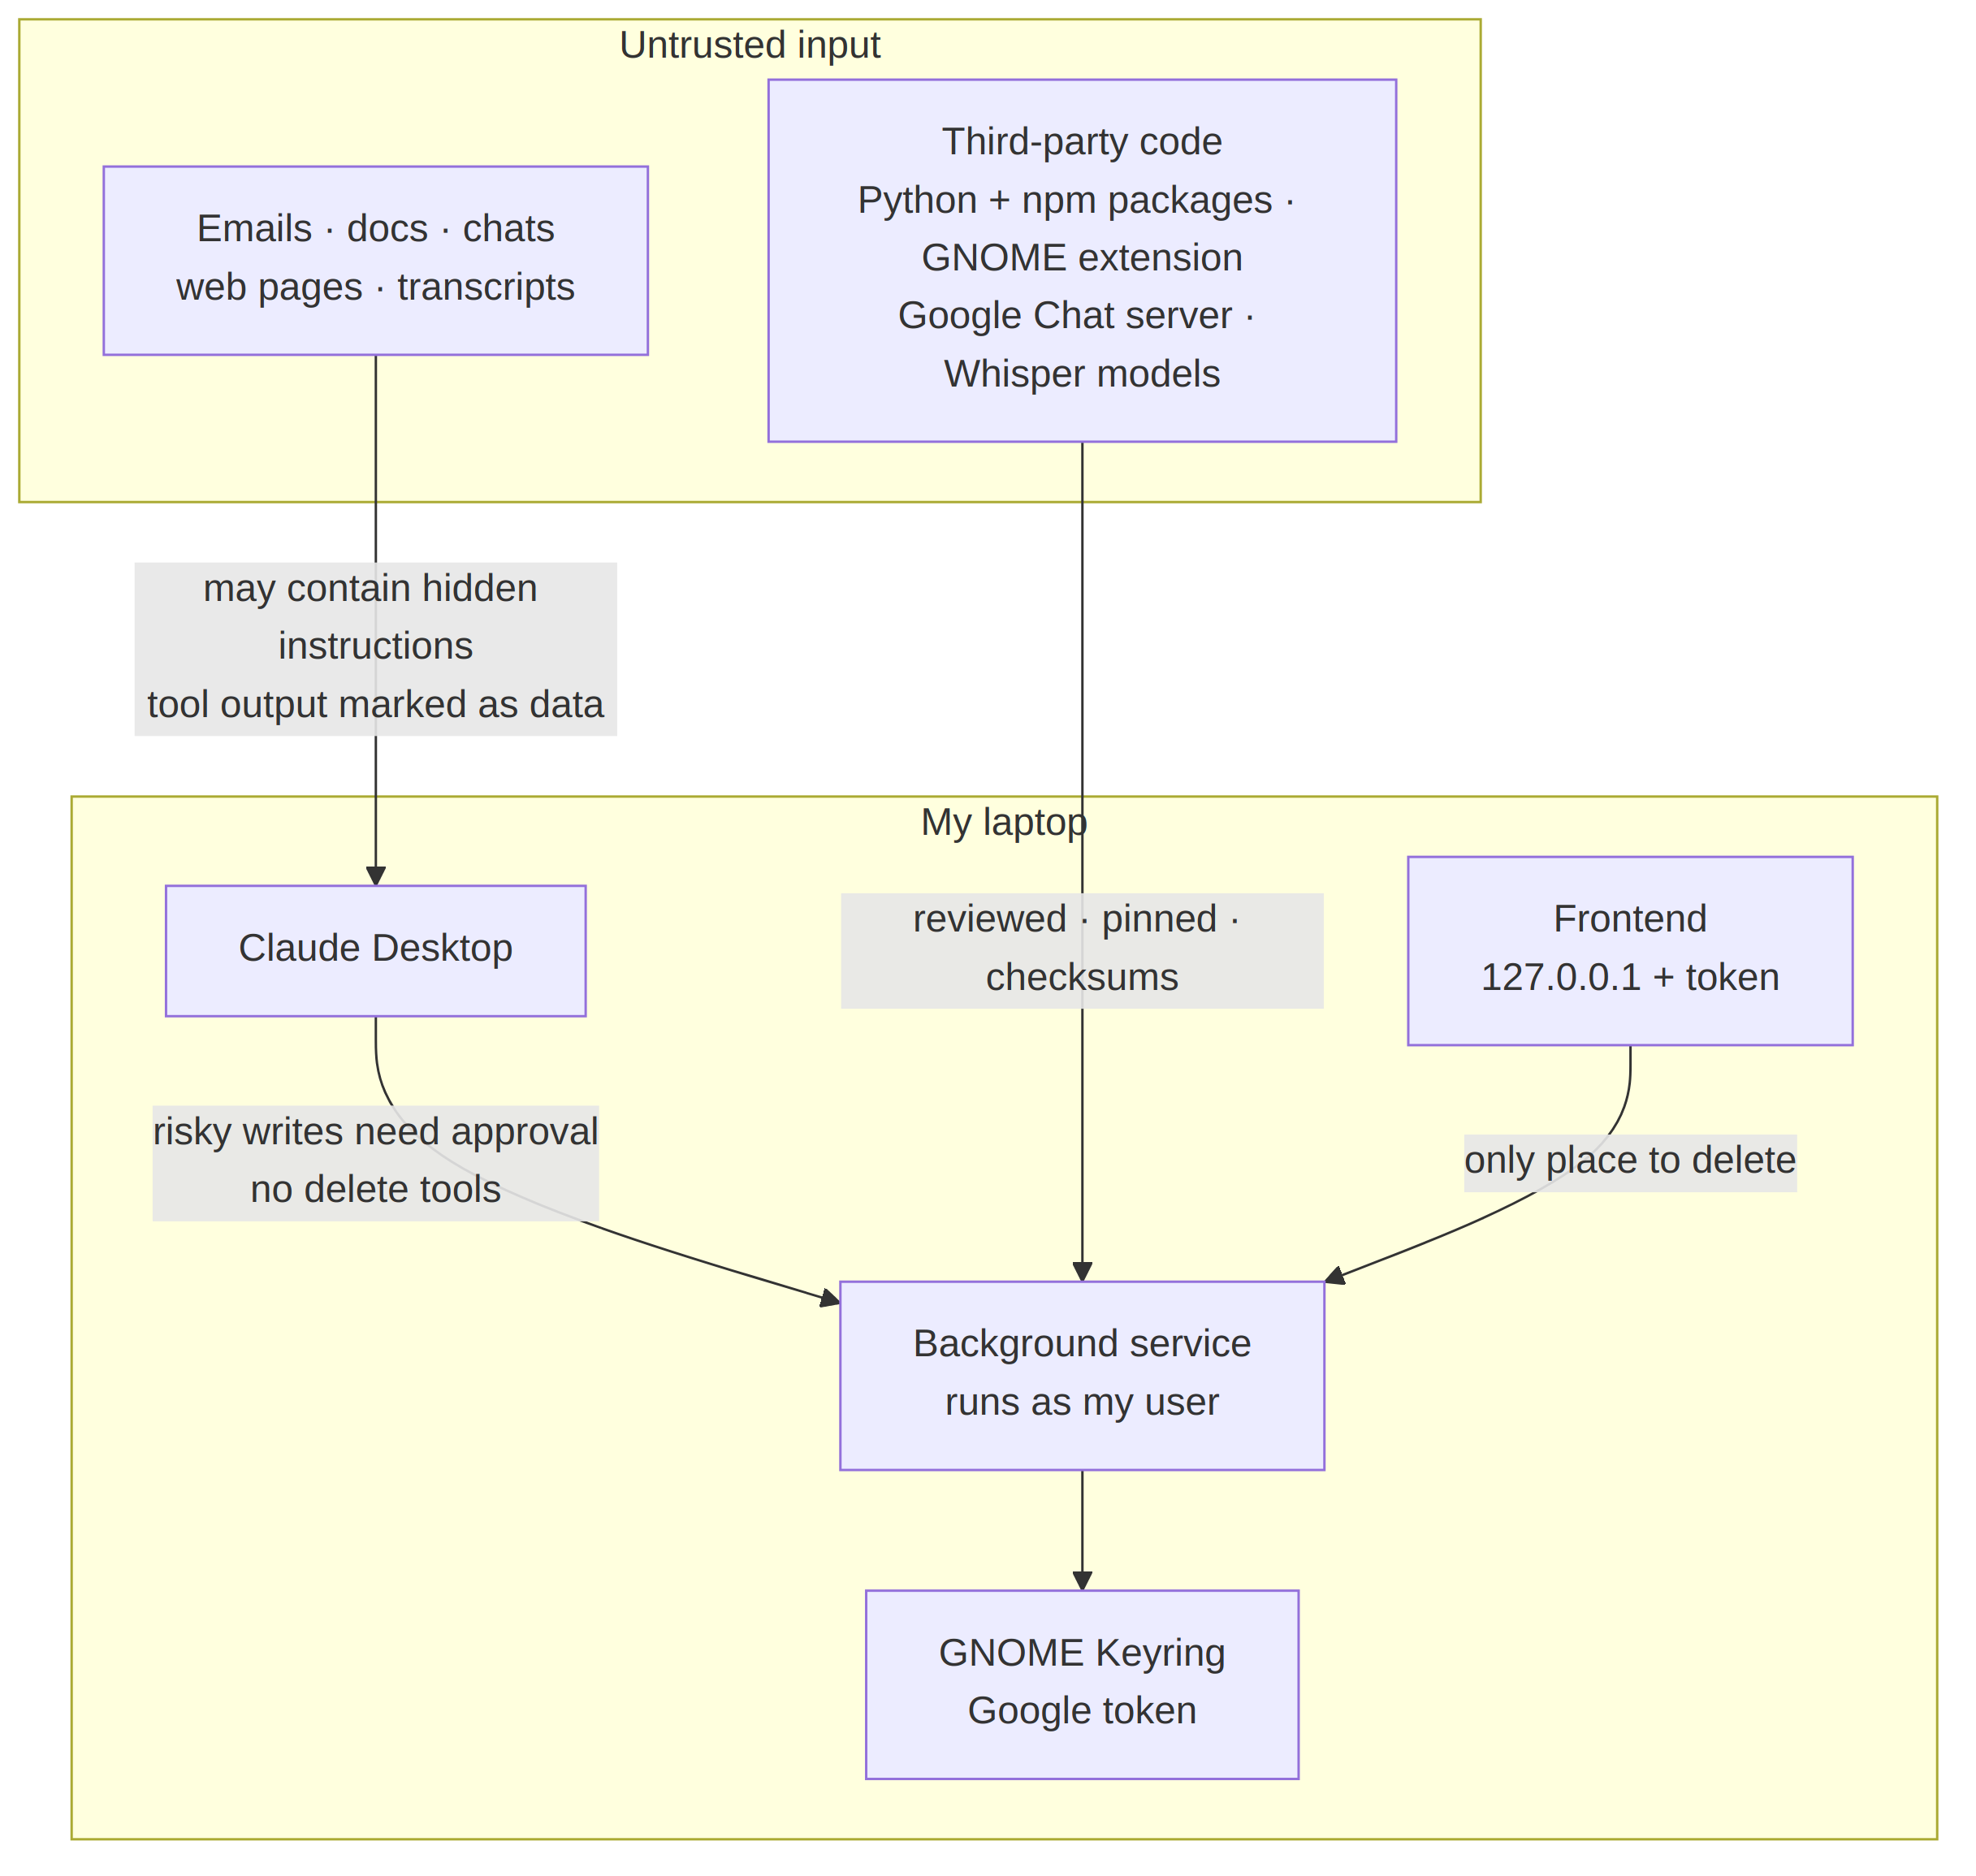
- Untrusted content (emails, documents, chats, web pages, transcripts) may contain hidden instructions. Read results are marked as data, there are no delete tools, and status changes and labels need my approval.
- Third-party code (Python and npm packages, the GNOME extension, the Google Chat server, Whisper models) is reviewed, pinned and checksum-verified. There are no automatic updates.
- Local interfaces: the bridge uses a Unix socket; the frontend uses 127.0.0.1 with a token and origin checks.
- Secrets are redacted in Claude Code session content before it reaches Claude, and in commit messages, titles and transcripts before storage.
- Network: the service’s network access is not sandboxed.

10. Decisions log
- Language: Python. Small resource difference compared with Rust, the best local speech tooling, and my strongest language.
- Process model: one service plus a bridge. Collectors must run without Claude Desktop, and Claude needs no network port.
- Database: SQLite plus folders. One file, no server, low RAM.
- Search: keyword first. Meaning-based search only if the evaluation shows it’s needed.
- Claude Code: read live, metadata index, daily notes. No copies of sessions.
- Git: metadata only. Code is read from the repository when needed.
- Collection: hourly. Calendar every 15 minutes, app usage every 10 seconds, and a refresh when Claude reads stale data.
- App tracking: Focused Window D-Bus extension, with window titles.
- Meetings: built in-house. Two tracks, echo cancellation, faster-whisper; speaker separation deferred.
- Frontend: React in the browser on 127.0.0.1. Chosen over a native GTK app, accepting one local port.
- Network sandbox: not applied.

11. Open items and Phase 0 checks
- Linux beta: local context servers, MCP prompts, and keeping a single tool on “ask every time”.
- Ubuntu version: 22.04 or later.
- Company: recording-consent policy, and whether the layer’s own Google Calendar sign-in is allowed.
- Reviews: the Focused Window D-Bus extension and the Google Chat server.
- CPU benchmark: Whisper model choice with mixed Portuguese and English, and app-usage overhead.
- Backup: destination and key location.
- Known limitation: if I skip end-of-day reviews for more than 30 days, Claude Code deletes those sessions before a note is written.

Appendix — Diagram sources (Mermaid)
The diagrams above are generated from these Mermaid sources, so they can be edited and regenerated.

1. Overview
flowchart LR
subgraph Laptop["My Ubuntu laptop"]
ICON["Top-bar icon<br/>Start/Stop · red · Open…"]
FF["Firefox"]
CD["Claude Desktop"]
BR["Bridge"]
GCS["Google Chat server<br/>open-source, local"]
subgraph SVC["Background service · Python · systemd user service"]
SCH["Scheduler"]
COL["Collectors"]
REC["Recorder"]
STT["faster-whisper"]
RED["Secret redaction"]
MCP["MCP tools + prompts<br/>no delete"]
WEB["React frontend<br/>127.0.0.1 + token"]
RET["Daily retention"]
end
DB[("SQLite<br/>+ audio folder<br/>+ notes folder")]
KR["GNOME Keyring"]
end
subgraph Online
ANT["Anthropic · Claude<br/>Team account"]
CONN["Connectors<br/>Gmail · Calendar · Drive<br/>Notion · GitHub"]
GCAL["Google Calendar API"]
end
SCH --> COL --> RED --> DB
ICON --> REC --> STT --> RED
ICON -- "Open…" --> FF --> WEB --> DB
CD --> BR -- "Unix socket" --> MCP --> DB
RET --> DB
COL -- "token" --> KR
COL --> GCAL
CD --> GCS
CD <--> ANT <--> CONN

2. Runtime
flowchart TB
CD["Claude Desktop"] -- "starts it · MCP over stdio" --> BR["Bridge<br/>tiny, no logic"]
BR -- "MCP over a Unix socket<br/>owner-only file" --> SVC
FF["Firefox"] -- "HTTP on 127.0.0.1<br/>token + origin checks" --> SVC
subgraph SVC["Background service · starts at login"]
CTX["MCP tools + prompts"]
WEB["Frontend"]
COL["Collectors"]
MEET["Recorder + transcription"]
RET["Retention"]
end
SVC --- DB[("Local store")]

3. Storage
flowchart TB
subgraph Sources["Local sources"]
GIT["Git repos<br/>read everything · store metadata"]
CCI["Claude Code sessions<br/>metadata index only"]
FF["Firefox history<br/>visits · secret params stripped"]
APP["App usage<br/>app names + titles"]
NOTES["Notes folder<br/>Markdown"]
REC["Recorder"]
end
CDR["Claude Desktop · end-of-day review<br/>reads sessions live, redacted"] -- "daily session note<br/>proposed item" --> DB
subgraph Store["Layer store · local · owner-only"]
DB[("SQLite<br/>events · evidence · claims + versions<br/>session notes · transcripts · labels<br/>keyword index · audit trail")]
AUD["Audio folder"]
end
GIT --> DB
CCI --> DB
FF --> DB
APP --> DB
NOTES --> DB
REC --> AUD
AUD -- "local transcription" --> DB

4. Context server
flowchart TB
CD["Claude Desktop"] --> BR["Bridge · Unix socket"]
BR --> R
BR --> W
BR --> P
R["<b>Read tools · run freely</b><br/>search<br/>get_day · get_week<br/>get_project<br/>list_unconfirmed<br/>read_claude_sessions<br/>get_evidence<br/>get_metrics<br/>get_instructions"]
W["<b>Write tools</b><br/>propose_claim · update_claim<br/>save_session_note<br/>link_items<br/>set_claim_status · approval every time<br/>add_confidential_label · approval every time"]
P["<b>MCP prompts</b><br/>six experiences"]
X["No delete tools"]
W ~~~ X

5. Collectors
flowchart LR
subgraph SCHED["Scheduler inside the service"]
H["Every hour<br/>Git · Claude Code index · Firefox"]
Q["Every 15 min<br/>Calendar"]
S["Every 10 s<br/>App usage · batched writes"]
D["On demand<br/>refresh when Claude reads and data is older than 5 min"]
end
SCHED --> RED["Secret redaction<br/>commit messages · window and page titles"]
RED --> DB[("SQLite")]
Q --> NOTIF["'Start recording?' notification"]

6. Meeting pipeline
flowchart TB
CAL["Calendar · every 15 min"] -- "meeting starts" --> N["Notification<br/>'Start recording?'"]
N -- "Start" --> REC
ICON["Top-bar icon<br/>Start / Stop · red while recording"] --> REC["Recorder"]
REC --> MIC["Track 1: my mic<br/>echo cancellation on"]
REC --> SYS["Track 2: system audio"]
IMP["Imported audio file"] --> AUD["Audio folder"]
MIC --> AUD
SYS --> AUD
AUD -- "plugged in + idle<br/>or 'Transcribe now'" --> STT["faster-whisper<br/>model from benchmark"]
STT --> RED["Secret redaction"] --> DB[("SQLite<br/>segments: me / others")]
WEB["Frontend<br/>mark reviewed"] -- "deletes audio" --> AUD
DB --> CD["Claude Desktop<br/>summary · proposed claims"]

9. Security boundaries
flowchart TB
subgraph Untrusted["Untrusted input"]
EM["Emails · docs · chats<br/>web pages · transcripts"]
TP["Third-party code<br/>Python + npm packages · GNOME extension<br/>Google Chat server · Whisper models"]
end
subgraph Laptop["My laptop"]
CD["Claude Desktop"]
SVC["Background service<br/>runs as my user"]
WEB["Frontend<br/>127.0.0.1 + token"]
KR["GNOME Keyring<br/>Google token"]
end
EM -- "may contain hidden instructions<br/>tool output marked as data" --> CD
CD -- "risky writes need approval<br/>no delete tools" --> SVC
TP -- "reviewed · pinned · checksums" --> SVC
WEB -- "only place to delete" --> SVC
SVC --> KR

