1.

1. Determine appropriate primary and foreign keys needed for the baseball database.

Master table

Primary key: PLAYERID

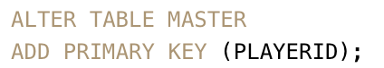

Batting table

Primary key: PLAYERID, YEARID, STINT

Foreign key: PLAYERID (MASTER), YEARID, LGID, TEAMID (TEAM)

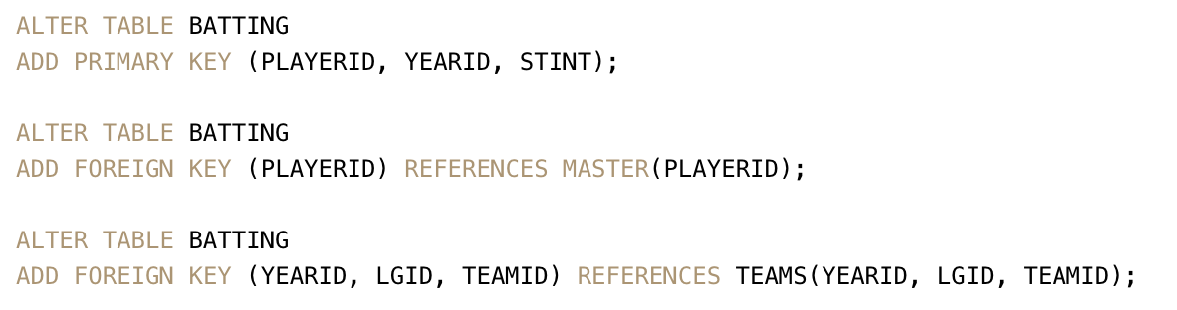

Pitching table

Primary key: PLAYERID, YEARID, STINT

Foreign key: PLAYERID (MASTER), YEARID, LGID, TEAMID (TEAMS)

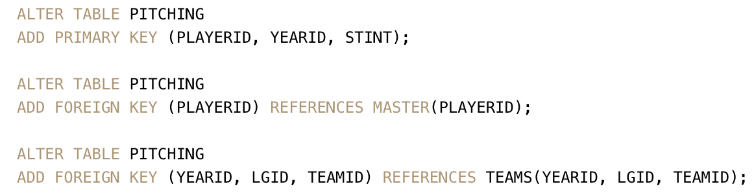

Fielding table

Primary key: PLAYERID, YEARID, STINT, POS

Foreign key: PLAYERID (MASTER), YEARID, LGID, TEAMID (TEAMS)

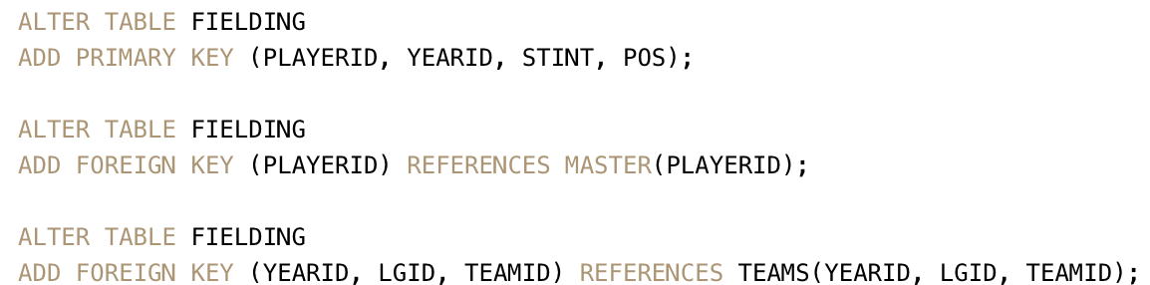

AllstarFull table

Primary key: PLAYERID, YEARID, GAMENUM

Foreign key: PLAYERID (MASTER), YEARID, LGID, TEAMID (TEAMS)

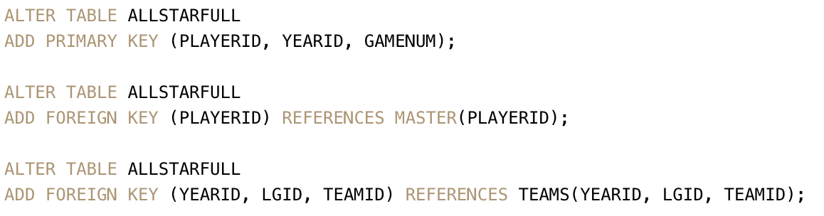

HallOfFame table

Primary key: PLAYERID, YEARID, VOTEDBY

Foreign key: PLAYERID (MASTER)

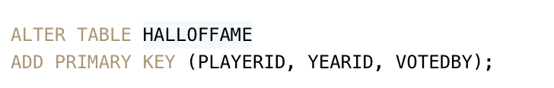

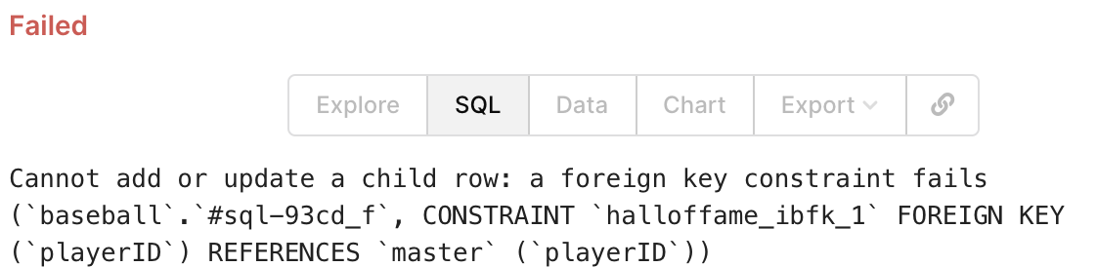

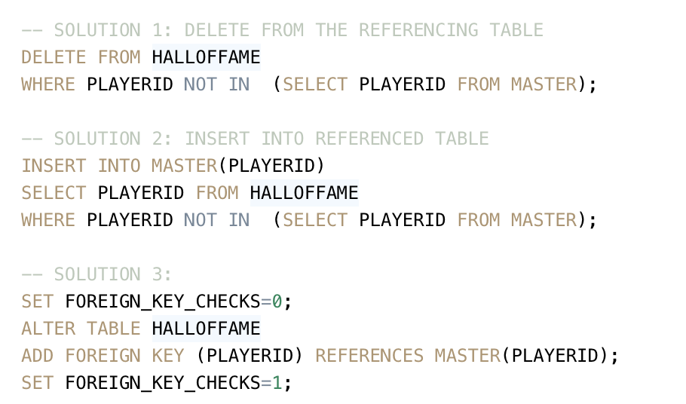

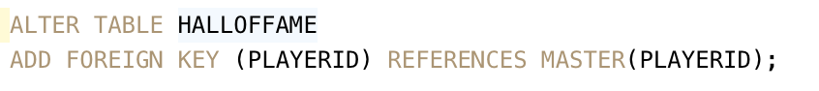

Managers table

Primary key: PLAYERID, YEARID, INSEASON

Foreign key: PLAYERID (MASTER), YEARID, LGID, TEAMID (TEAMS)

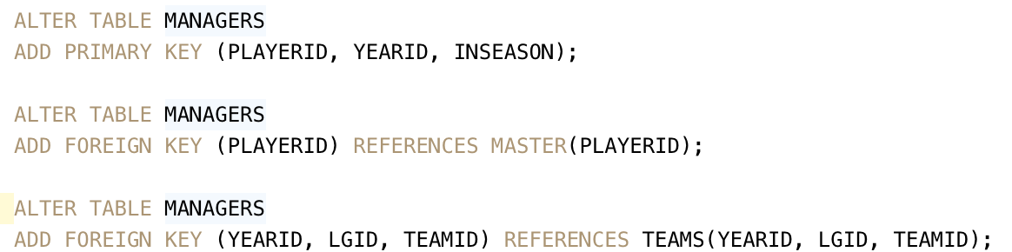

Teams table

Primary key: YEARID, LGID, TEAMID

Foreign key: FRANCHID(TEAMFRANCHISES)

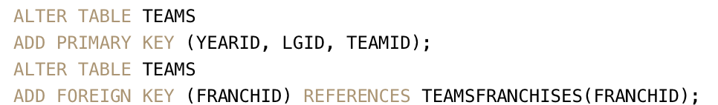

BattingPost table

Primary key: YEARID, ROUND, PLAYERID

Foreign key: PLAYERID (MASTER), YEARID, LGID, TEAMID (TEAMS)

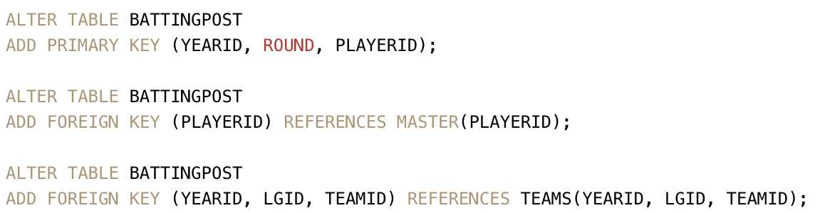

PitchingPost table

Primary key: YEARID, ROUND, PLAYERID

Foreign key: PLAYERID (MASTER), YEARID, LGID, TEAMID (TEAMS)

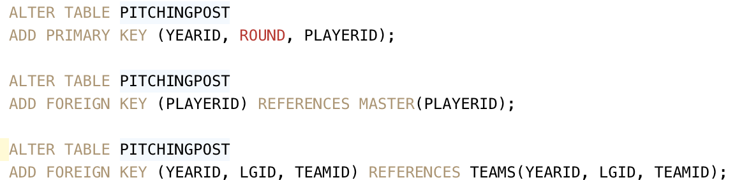

TeamFranchises table

Primary key: FRANCHID



FieldingOf table

Primary key: PLAYERID, YEARID, STINT

Foreign key: PLAYERID (MASTER)

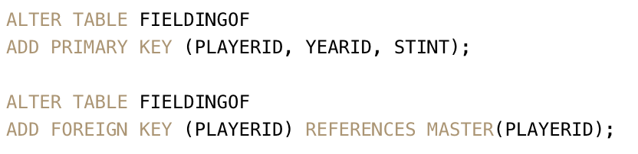

ManagersHalf table

Primary key: PLAYERID, HALF

Foreign key: PLAYERID, YEARID, INSEASON (MANAGERS)

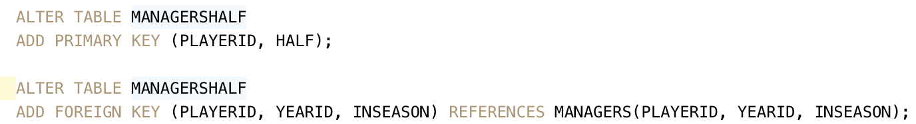

TeamsHalf table

Primary key: TEAMID, HALF

Foreign key: YEARID, LGID, TEAMID (TEAM)

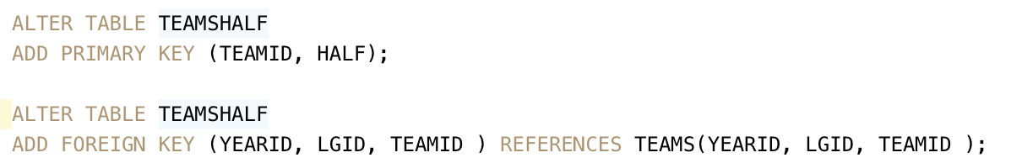

Salaries table

Primary key: TEAMID, YEARID, PLAYERID

Foreign key: PLAYERID (MASTER), YEARID, LGID, TEAMID (TEAMS)

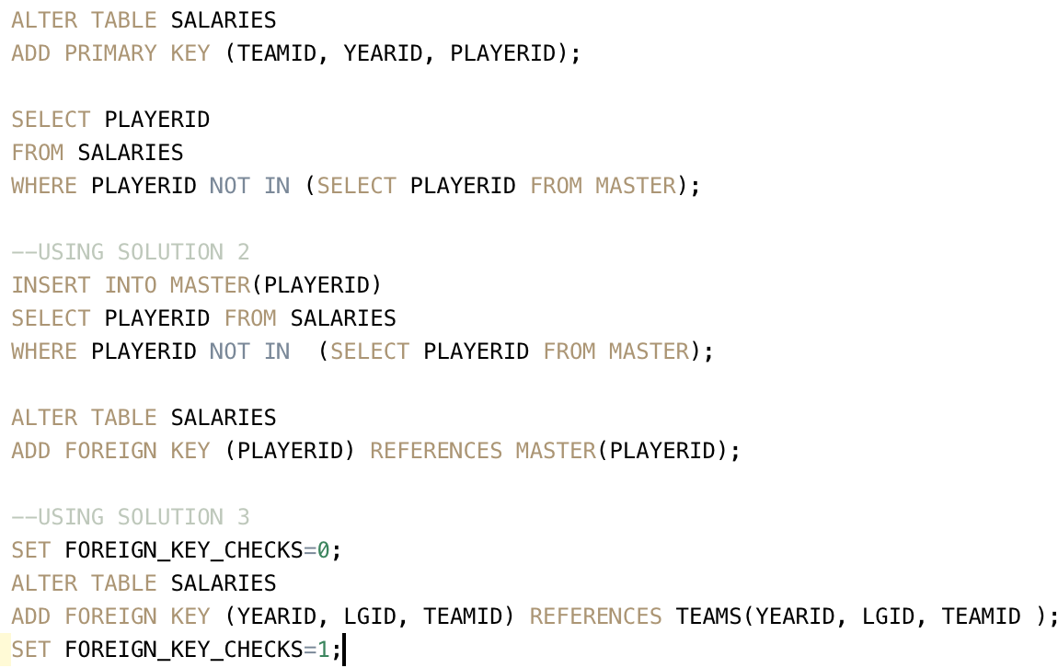

SERIESPOST table

Primary key: YEARID, ROUND

Foreign key: YEARID, teamIDwinner, lgIDwinner (TEAMS), YEARID, teamIDloser, lgIDloser (TEAMS)

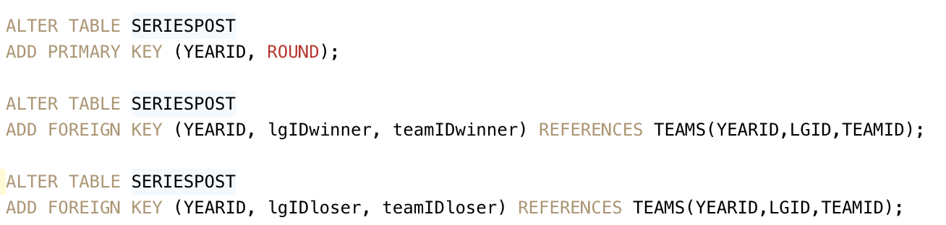

AwardsManagers table

Primary key: PLAYERID, AWARDID, YEARID

Foreign key: PLAYERID (MASTER)

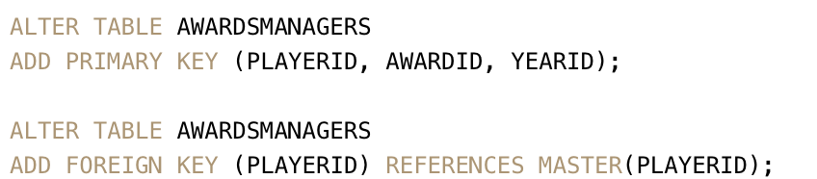

AwardsPlayer table

Primary key: PLAYERID, AWARDID, YEARID, LGID

Foreign key: PLAYERID (MASTER)

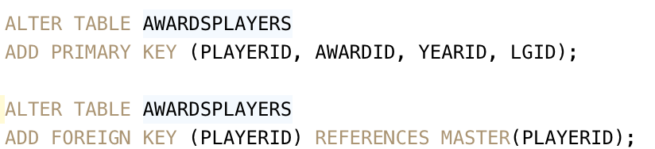

AwardsShareManagers table

Primary key: YEARID, PLAYERID

Foreign key: PLAYERID, AWARDID, YEARID (AWARDSMANAGER)

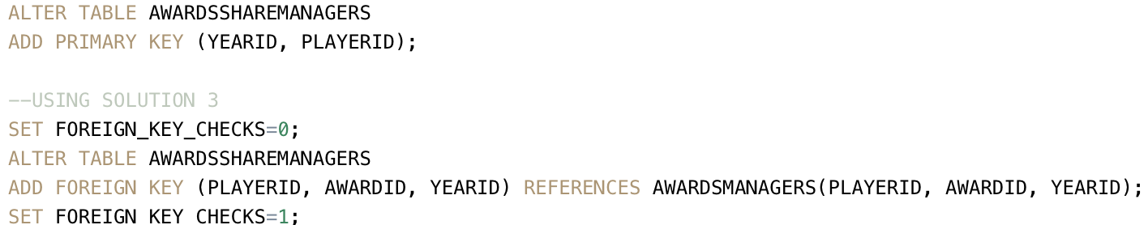

AwardsSharePlayers table

Primary key: AWARDID, YEARID, PLAYERID

Foreign key: PLAYERID, AWARDID, YEARID, LGID (AWARDSPLAYER)

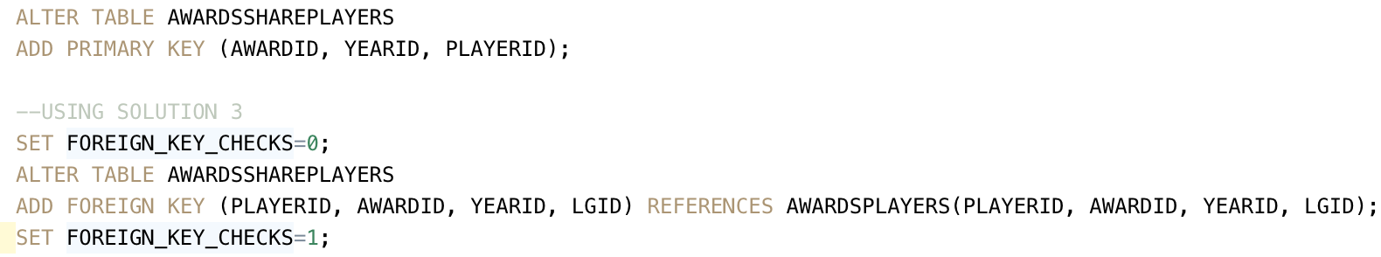

FieldingPost table

Primary key: PLAYERID, YEARID, ROUND, POS

Foreign key: PLAYERID (MASTER), YEARID, LGID, TEAMID (TEAMS)

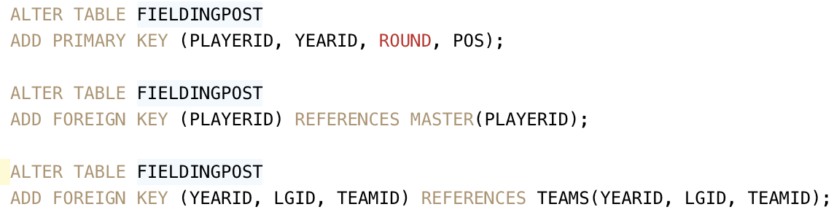

Appearances table

Primary key: YEARID, TEAMID, PLAYERID

Foreign key: PLAYERID (MASTER), YEARID, LGID, TEAMID (TEAMS)

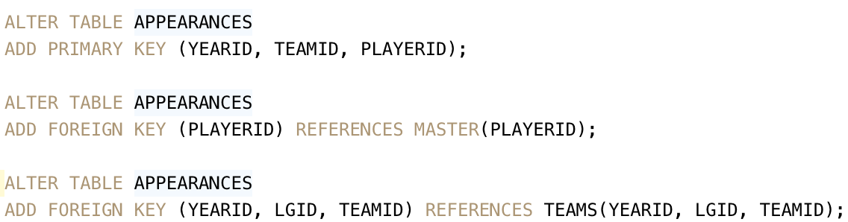

Schools table

Primary key: SCHOOLID

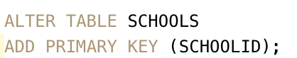

CollegePlaying table

Primary key: PLAYERID, SCHOOLID, YEARID

Foreign key: PLAYERID (MASTER), SCHOOLID(SCHOOLS)

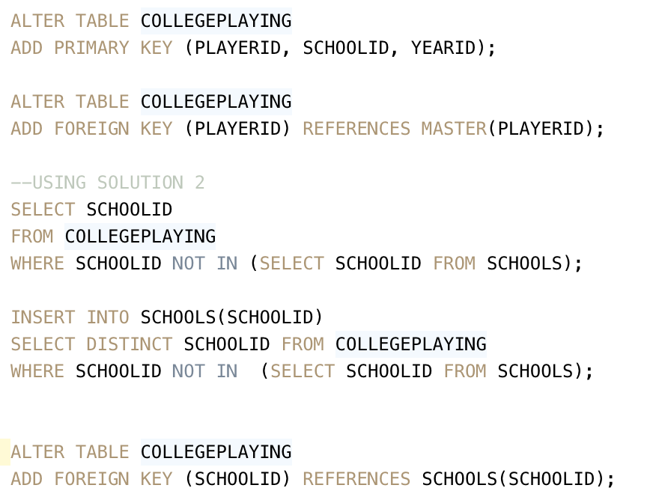

FieldingOFsplit table

Primary key: PLAYERID, YEARID, STINT, POS

Foreign key: YEARID, LGID, TEAMID (TEAMS)

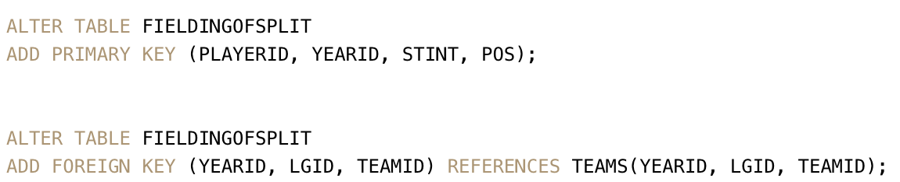

Parks table

Primary key: PARK.KEY

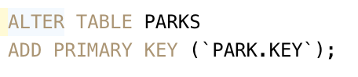

HomeGames table

Primary key: `YEAR.KEY`, `TEAM.KEY`, `PARK.KEY`

Foreign key: PARK.KEY(PARKS), `YEAR.KEY`, `LEAGUE.KEY`, `TEAM.KEY`(TEAMS)

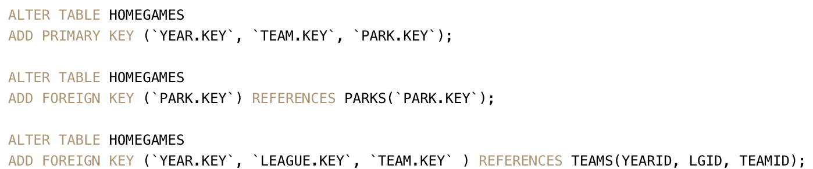

2.

Where is the csv data located relative to CLI and DB server?

mysql> show global variables like "%datadir%";

datadir | /usr/local/mysql/data/

/usr/local/bin/bash

we can see that CLI and DB server locate on the same computer for this question, and the csv data locate on the DB server, in the DB server data forder.

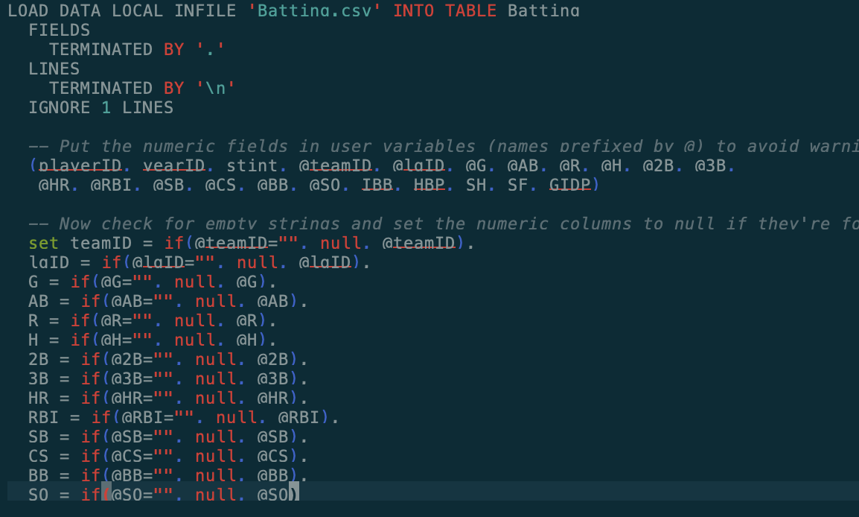

1. Load statement

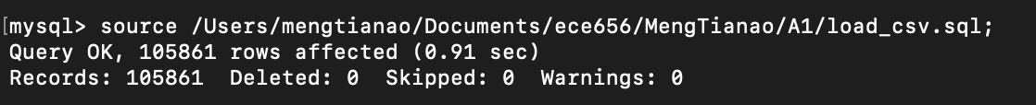

1. Insert statement

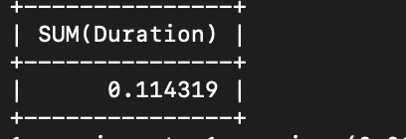

How to calculate the total runtime of multiple queries:

1. SET profiling = 1;
2. Execute the multiple queries;
3. SELECT SUM(Duration) from information_schema.profiling;

3.

RA is shown in ECE656_A1.pdf.

1)

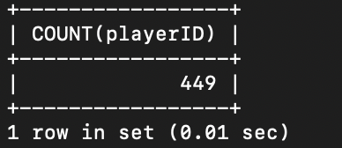

2)

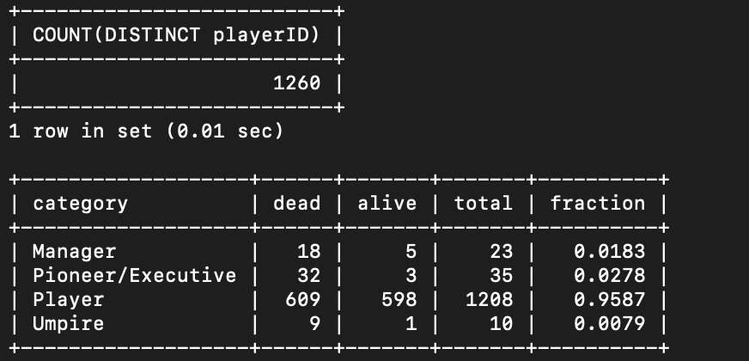

3)

Toal

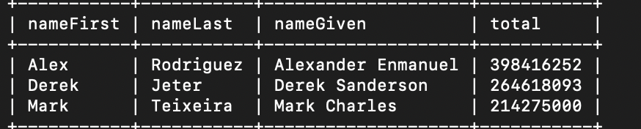

Player_only

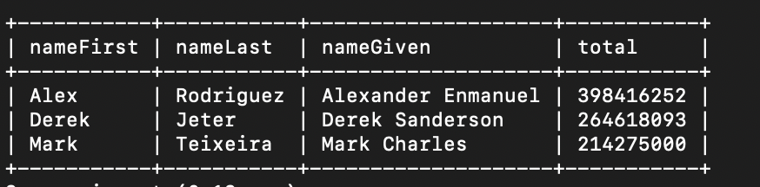

Manager only

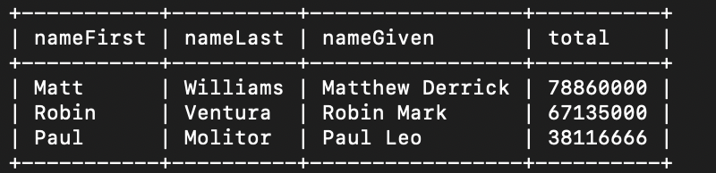

Other



4)

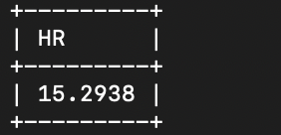

5)

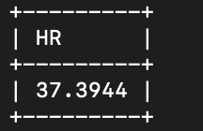

6)

