2.

Firstly, find all the candidate key:

Initial schema R = (Game_ID, Rated, Start_time, End_time, Number_of_Turns, Game_Status, Winner, Time_increment, White_Player_ID, White_Player_Rating, Black_Player_ID, Black_Player_Rating, moves, Opening_Eco, Opening_Name, Opening_Ply).

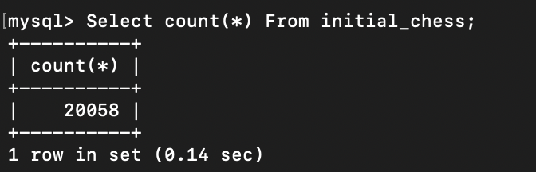

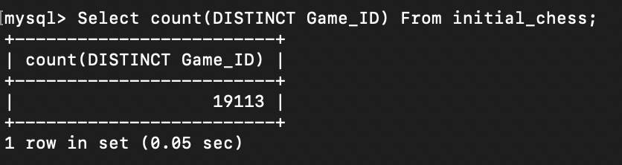

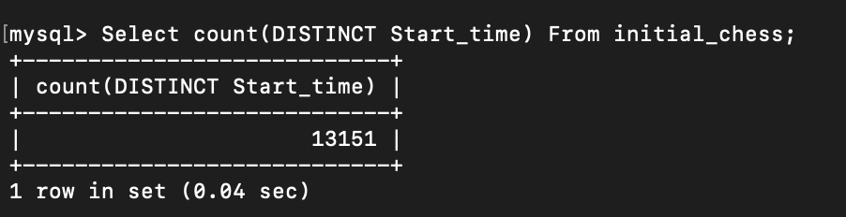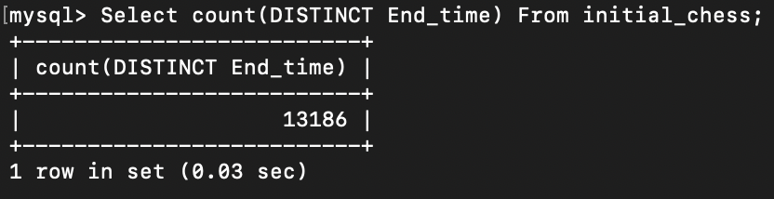

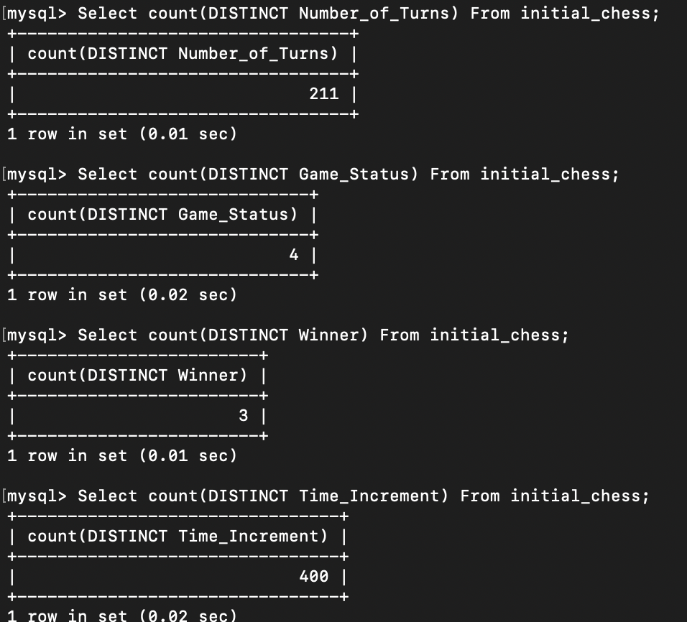

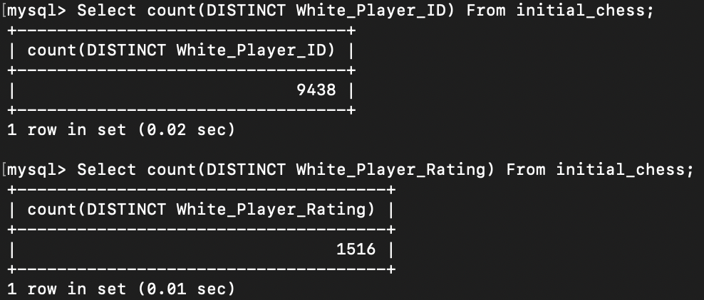

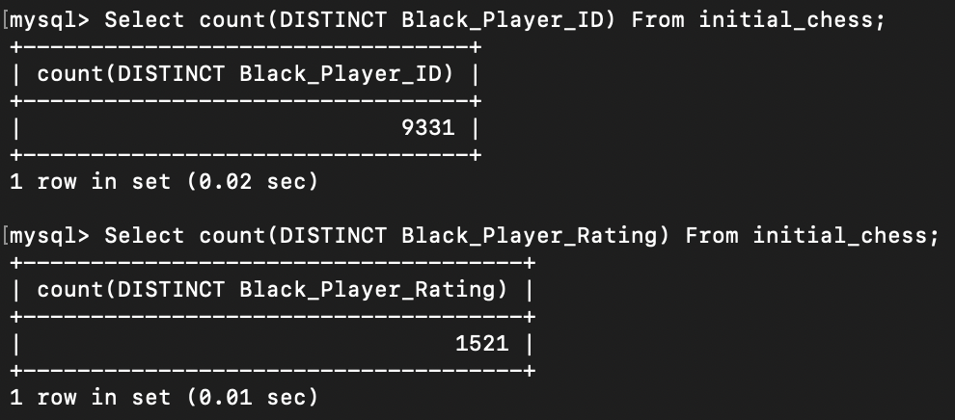

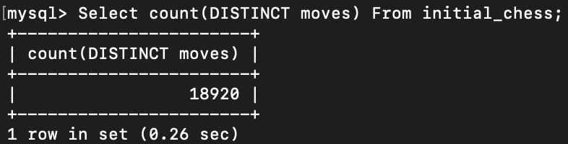

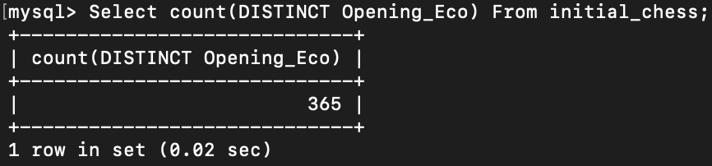

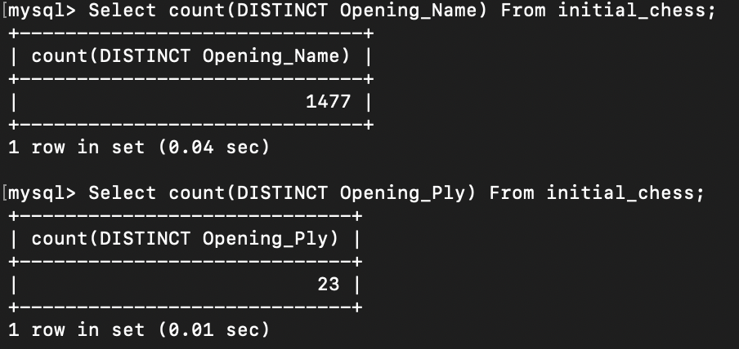

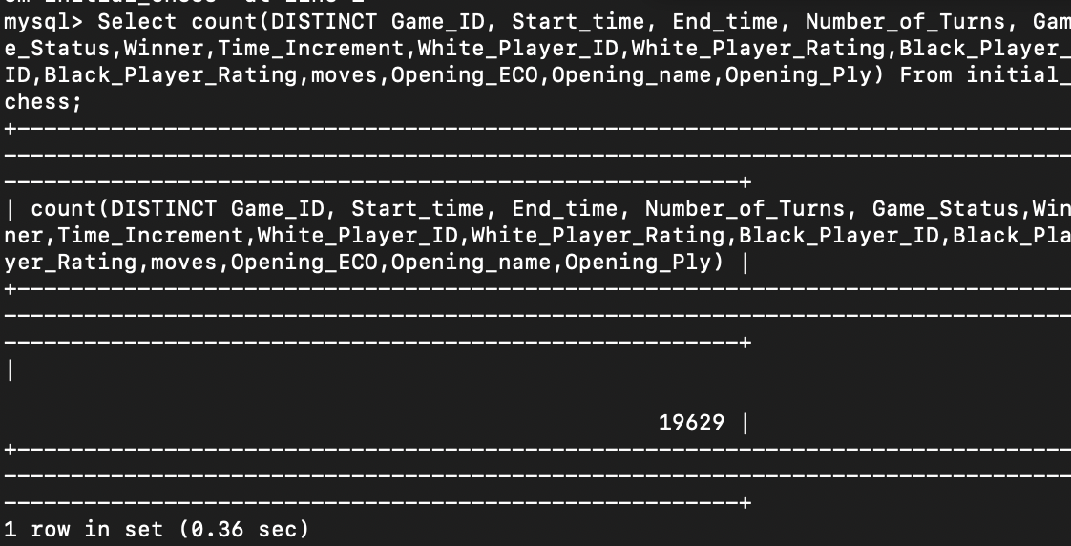

From this result, we can see that there are some duplicate rows in the given dataset.

To figure the primary key, we need to remove the duplicate rows in the given dataset

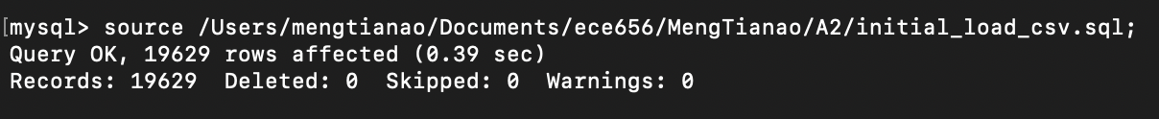



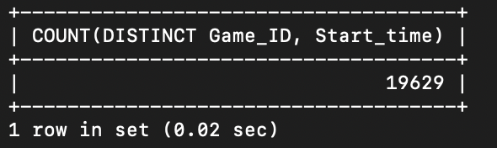

Thus, we can get that that Game_ID and Start_time is our primary key; To make the table in BCNF, we need atomic attributes; However, the move attribute in this table is not atomic.

Seen in py file.