1.

T1 T2

Update Ece353 enrollment - 20;

Read Ece353 enrollment;

Update Ece353 enrollment + 20;

Commit;

Commit;

This process involves phantom reads and dirty reads.

Possible combinations of isolation level:

**Read-uncommitted**

**Read-uncommitted**

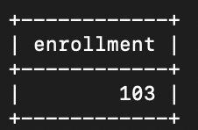

**Read-uncommitted**

**Read-committed**

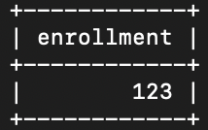

**Read-uncommitted**

**Repeatable-read**

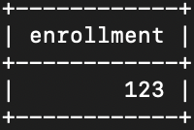

**Read-uncommitted**

**Serializable**

Waiting transaction 1 to commit before getting the result;

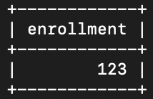

**Read-committed**

**Read-uncommitted**

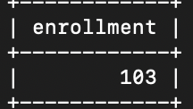

**Read-committed**

**Read-committed**

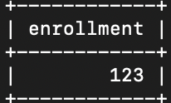

**Read-committed**

**Repeatable-read**

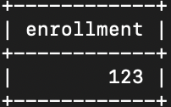

**Read-committed**

**Serializable**

Waiting transaction 1 to commit before getting the result.

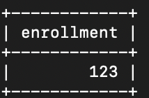

**Repeatable-read**

**Read-uncommitted**

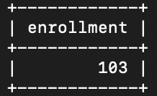

**Repeatable-read**

**Read-committed**

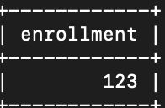

**Repeatable-read**

**Repeatable-read**

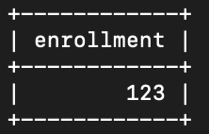

**Repeatable-read**

**Serializable**

Waiting transaction 1 to commit before getting the result.

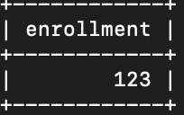

**Serializable**

**Read-uncommitted**

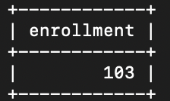

**Serializable**

**Read-committed**

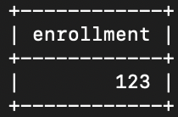

**Serializable**

**Repeatable-read**

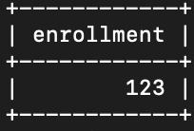

**Serializable**

**Serializable**

Waiting transaction 1 to commit.



**Conclusion:**

We can see that the isolation level only has impact on the traction that involves reading data.

For the T2 that uses read uncommitted level, it can read the data that has not been committed in T1; therefore, the enrollment is 103.

For the T2 that uses read committed and repeatable read level, it cannot read the data that has not been committed in T1; therefore, T2 can avoid dirty reads and get the original enrollment 123.

For the T2 that uses serializable level, it cannot read the data that has not been committed and cannot read the data that will be changed in T1; therefore, every time when reading in T2, it will wait T1 to commit to determine if T1 has committed and does not change the data.

It will change the original order to:

T1 T2

Update Ece353 enrollment - 20;

Update Ece353 enrollment + 20;

Commit;

Read Ece353 enrollment;

Commit;

Therefore, get the enrollment 123.