Exercise 3

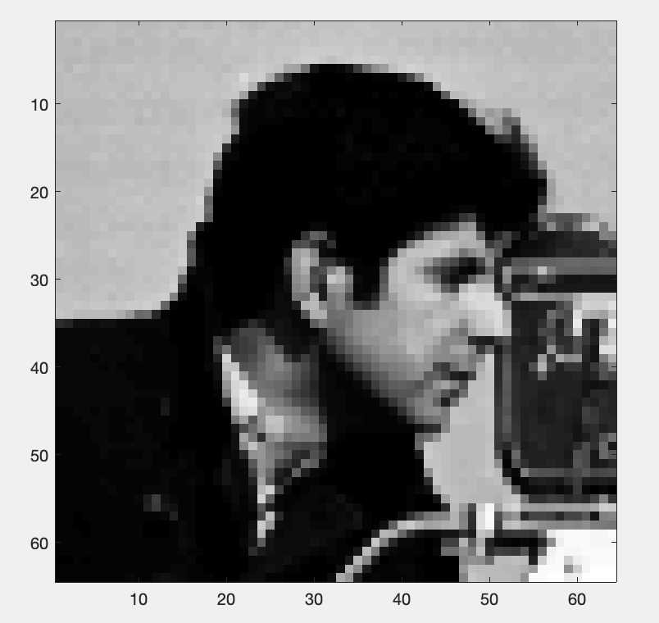

Figure 1

The figure 1 is the original grey-scaled cameraman picture

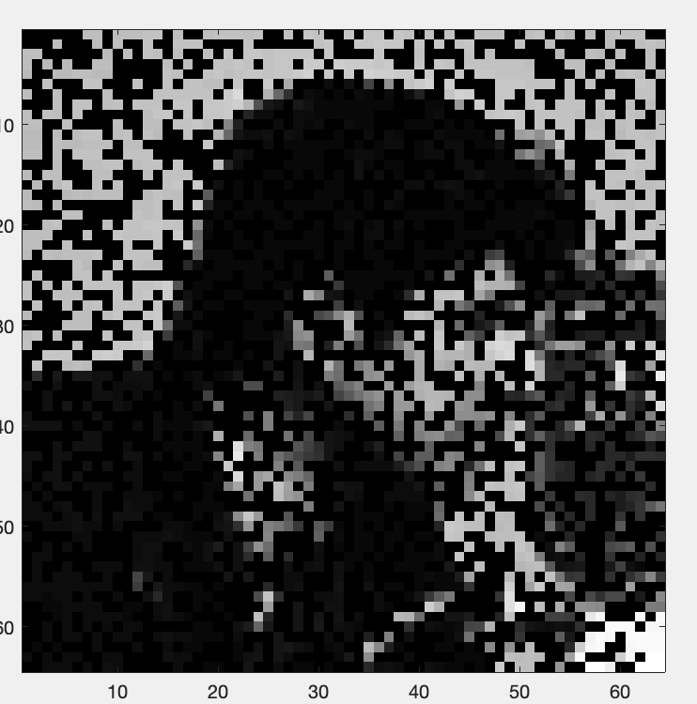

Figure 2

The figure 2 is the masked grey-scaled cameraman picture

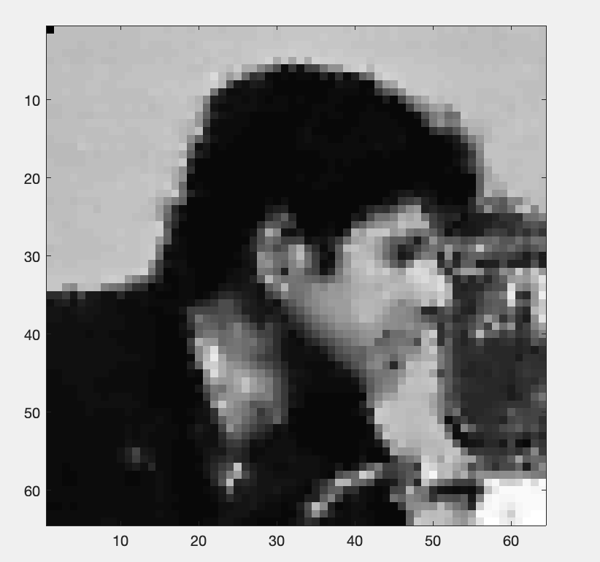

Figure 3

The figure 3 is the recovered grey-scaled cameraman picture, using TR method

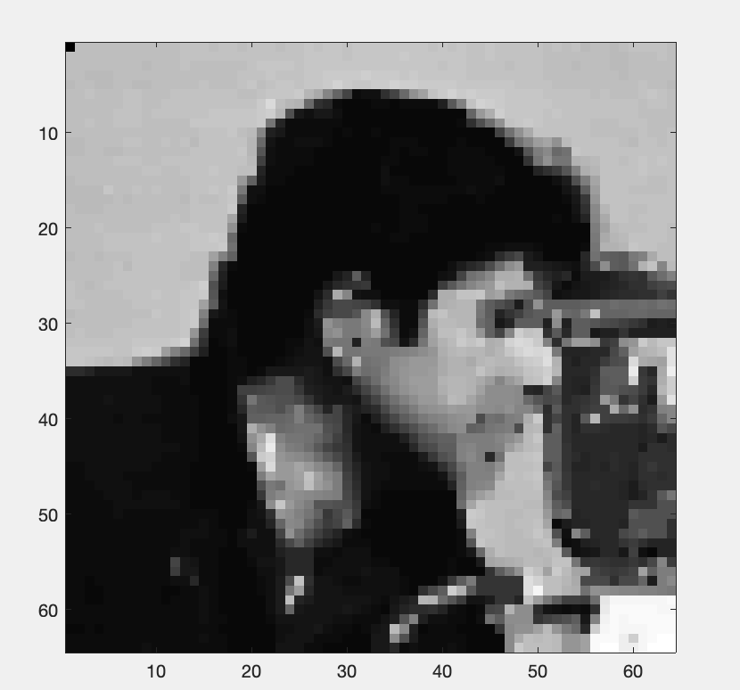

Figure 4

The figure 4 is the recovered grey-scaled cameraman picture, using aTV method

I use min square error(MSE) to calculate the square gap of the recovered matrix and the original matrix I0, which represents accuracy of TR and aTV method,

The calculate result is defined as gap in my matlab file

The gap result of TR method is 1.1036 e+06

The gap result of aTV method is 1.1260 e+06

From the Figure 3, Figure 4 and the accuracy calculate, we can see that TR method is more accurate.