AI in modern healthcare

BY TIANA PFEIFER

Norquest

XCMP-1560

Table of Contents

The Role of AI in Modern Healthcare 2

Introduction 2

What Benefits does AI offer? 2

Concerns about AI in Healthcare 3

References 4

# The Role of AI in Modern Healthcare

## Introduction

There are many new advancements concerning AI in healthcare, beneficial to both patients and doctors alike. This article will explore the benefits and problems that AI faces. I will address the myriad of healthcare solution that Ai can offer, from diagnostic, to process automation. Also, we will look at the Ethics surrounding AI.

## What Benefits does AI offer?

First let’s look at the many benefits of AI. The integration of AI into healthcare holds the promise of enhancing diagnostic accuracy, personalizing treatment approaches, optimizing healthcare processes, and empowering patients to take an active role in managing their health. (Rayhan, 2023) Patients and doctors alike can benefit greatly from these advances and tools AI can provide. From identifying tumors in medical images to diagnosing rare conditions, AI has shown remarkable potential in augmenting the capabilities of healthcare professionals and improving patient outcomes. (Rayhan, 2023)

Historically, the process of discovering and developing new drugs has been costly and time-consuming. (Esmaeilzadeh, 2020) AI technologies, such as machine learning and natural language processing, are now being employed to accelerate drug discovery by analyzing vast databases of chemical compounds and predicting potential drug candidates. (Rayhan, 2023) Its not hard to see the many good things that AI can offer. Think of how fast patients can access the medication and support they need. Various benefit from AI as seen in the Figure below. (Figure 1) (Vaananen, 2021) 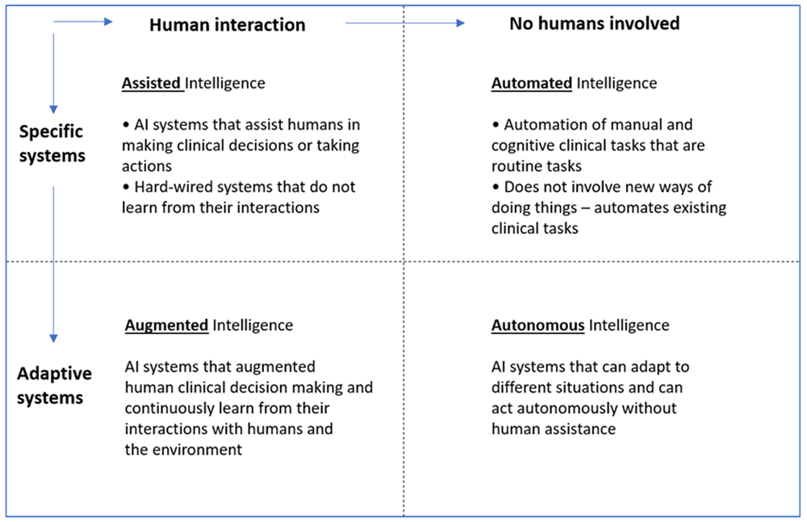

With current advances in AI research we have found that AI have outperformed physicians in speed and accuracy of medical diagnosis in some fields of healthcare sectors. (Vaananen, 2021)

## Concerns about AI in Healthcare

So now that we have review some benefits of AI in Healthcare, let’s take a look at some Concerns. Data Privacy and Security are incredibly important aspects that will constantly need to be monitored for the benefit of all parties. Policymakers must develop guidelines and standards for the ethical deployment of AI technologies in healthcare settings. (Esmaeilzadeh, 2020) AI algorithms trained on biased data may perpetuate disparities in healthcare delivery, leading to unequal access to care and potential misdiagnoses. (Esmaeilzadeh, 2020) How the creators of Ai and the users proceed knowing these things is critical in the continuation of these Ai explorations.

The past five or so years has seen the development of various guidelines for the ethical use of AI,… These reviews have highlighted a strong convergence around five key ethical principles: transparency; justice and fairness; non-maleficence; responsibility & accountability; and privacy (Smallman, 2022)

## Conclusion

There are so many arguments for and against AI in Healthcare, and here I have barely touched the surface. I hope that whomever is responsible for the future of AI in healthcare considers all the factors and ethics involved in their ventures and that these advances in technology can continue to benefit people.

# References

Esmaeilzadeh, P. (2020). Use of AI-based tools for healthcare purposes: A survey study from consumers'perspectives. *BMC Medical Informatics and decison making* , 19.

Rayhan, A. &. (2023). The Role of AI in healthcare: Revolutionizing Patient Care and Well-being.

Smallman, M. (2022). Multi scale Ethics - Why we need to consider the ethics of AI on Healthcare at different scales. *Science and Engineering Ethics*, 63.

Vaananen, A. &.-J. (2021). AI in Healthcare :A narrative Review. *F1000Research*, 6.