MOHAMMED V UNIVERSITY of Rabat

Computer Science department

Master in Data Engineering and Software Development

Entitled:
Question Answering

Prepared by:
NAIT Hamza
Supervisor:
Pr. Abderrahmane EZ-ZAHOUT

Academic year 2020-2021

Contents:

1.Introduction…………………………………………………………………………………3
2.Algorithms and Software………………………………………………………….3
2.1 Simple transformers……………………………………………………………………………………..3
2.2 torshvision……………………………………………………………………………………………………..3
2.3 WandB…………..…………..…………..…………..…………..…………..…………..…………..………3
2.4 BERT…………..…………..…………..…………..…………..…………..…………..…………..…………..3
2.5 Google Collab…………..…………..…………..…………..…………..…………..…………..…………4
2.6 JSON…………..…………..…………..…………..…………..…………..…………..…………..………….4

3.Realisation………………………………………………………………………………..4
3.1 Data-set…………..…………..…………..…………..…………..…………..…………..…………..…….4
3.2 importations…………..…………..…………..…………..…………..…………..…………..………….5
3.3 model creation…………..…………..…………..…………..…………..…………..…………..………6
3.4 model training…………..…………..…………..…………..…………..…………..…………..……….6
3.5 evaluate model…………..…………..…………..…………..…………..…………..…………..……..7
3.6 predict answer…………..…………..…………..…………..…………..…………..…………..………8

4.Conclusion………………………………………………………………………………..9

1. Introduction
Question Answering (QA) is a research area that combines
research from different, but related, fields which are
Information Retrieval (IR), Information Extraction (IE) and
Natural Language Processing (NLP).
Actually, what a current information retrieval system or
search engine can do is just “document retrieval”, i.e. given
some keywords it only returns the relevant ranked documents
that contain these keywords. Information retrieval systems do
not return answers, and accordingly users are left to extract
answers from the documents themselves. However, what a
user really wants is often a precise answer to a question.
1. Introduction
Question Answering (QA) is a research area that combines
research from different, but related, fields which are
Information Retrieval (IR), Information Extraction (IE) and
Natural Language Processing (NLP).
Actually, what a current information retrieval system or
search engine can do is just “document retrieval”, i.e. given
some keywords it only returns the relevant ranked documents
that contain these keywords. Information retrieval systems do
not return answers, and accordingly users are left to extract
answers from the documents themselves. However, what a
user really wants is often a precise answer to a question.
1. Introduction
Question Answering (QA) is a research area that combines
research from different, but related, fields which are
Information Retrieval (IR), Information Extraction (IE) and
Natural Language Processing (NLP).
Actually, what a current information retrieval system or
search engine can do is just “document retrieval”, i.e. given
some keywords it only returns the relevant ranked documents
that contain these keywords. Information retrieval systems do
not return answers, and accordingly users are left to extract
answers from the documents themselves. However, what a
user really wants is often a precise answer to a question.
1. Introduction
Question Answering (QA) is a research area that combines
research from different, but related, fields which are
Information Retrieval (IR), Information Extraction (IE) and
Natural Language Processing (NLP).
Actually, what a current information retrieval system or
search engine can do is just “document retrieval”, i.e. given
some keywords it only returns the relevant ranked documents
that contain these keywords. Information retrieval systems do
not return answers, and accordingly users are left to extract
answers from the documents themselves. However, what a
user really wants is often a precise answer to a question.
1. Introduction
Question Answering (QA) is a research area that combines
research from different, but related, fields which are
Information Retrieval (IR), Information Extraction (IE) and
Natural Language Processing (NLP).
Actually, what a current information retrieval system or
search engine can do is just “document retrieval”, i.e. given
some keywords it only returns the relevant ranked documents
that contain these keywords. Information retrieval systems do
not return answers, and accordingly users are left to extract
answers from the documents themselves. However, what a
user really wants is often a precise answer to a question.
1. Introduction
Question Answering (QA) is a research area that combines research from different, but related, fields which are Information Retrieval (IR), Information Extraction (IE) and
Natural Language Processing (NLP).
Actually, what a current information retrieval system or search engine can do is just “document retrieval”, i.e. given some keywords it only returns the relevant ranked documents that contain these keywords. Information retrieval systems do not return answers, and accordingly users are left to extract answers from the documents themselves. However, what a user really wants is often a precise answer to a question.
However, the main type of questions submitted by users in
natural language are the factoid questions, such as “When did
the Egyptian revolution take place?” But, the recent research
trend is shifting toward more complex types of questions such
as definitional questions (e.g. “Who is the President of
Egypt?” or “What is SCAF?”), list questions (e.g. “List the
countries that won the Cup of African Nations”), and why-
type questions (e.g. “Why was Sadat assassinated?”).
However, the main type of questions submitted by users in
natural language are the factoid questions, such as “When did
the Egyptian revolution take place?” But, the recent research
trend is shifting toward more complex types of questions such
as definitional questions (e.g. “Who is the President of
Egypt?” or “What is SCAF?”), list questions (e.g. “List the
countries that won the Cup of African Nations”), and why-
type questions (e.g. “Why was Sadat assassinated?”).
However, the main type of questions submitted by users in
natural language are the factoid questions, such as “When did
the Egyptian revolution take place?” But, the recent research
trend is shifting toward more complex types of questions such
as definitional questions (e.g. “Who is the President of
Egypt?” or “What is SCAF?”), list questions (e.g. “List the
countries that won the Cup of African Nations”), and why-
type questions (e.g. “Why was Sadat assassinated?”).
However, the main type of questions submitted by users in
natural language are the factoid questions, such as “When did
the Egyptian revolution take place?” But, the recent research
trend is shifting toward more complex types of questions such
as definitional questions (e.g. “Who is the President of
Egypt?” or “What is SCAF?”), list questions (e.g. “List the
countries that won the Cup of African Nations”), and why-
type questions (e.g. “Why was Sadat assassinated?”).
However, the main type of questions submitted by users in natural language are the factoid questions, such as “When did the Egyptian revolution take place?” But, the recent research trend is shifting toward more complex types of questions such as definitional questions (e.g. “Who is the President of Egypt?” or “What is SCAF?”), list questions (e.g. “List the countries that won the Cup of African Nations”), and why-type questions (e.g. “Why was Sadat assassinated?”).
2. algorithms and softwares
2.1 Simple transformers
Simple Transformer models are built with a particular Natural Language Processing (NLP) task in mind. Each such model comes equipped with features and functionality designed to best fit the task that they are intended to perform. The high-level process of using Simple Transformers models follows the same pattern.
- Initialize a task-specific model
- Train the model with train_model()
- Evaluate the model with eval_model()
- Make predictions on (unlabelled) data with predict()
However, there are necessary differences between the different models to ensure that they are well suited for their intended task. The key differences will typically be the differences in input/output data formats and any task specific features/configuration options. These can all be found in the documentation section for each task.
2.2 torshvision
This library is part of the PyTorch project. PyTorch is an open-source machine learning framework, The torchvision package consists of popular datasets, model architectures, and common image transformations for computer vision.
2.3 WandB
Weights & Biases is the machine learning platform for developers to build better models faster. Use W&B's lightweight, interoperable tools to quickly track experiments, version and iterate on datasets, evaluate model performance, reproduce models, visualize results and spot regressions, and share findings with colleagues.
W&B can be set up in 5 minutes, then quickly iterate on machine learning pipeline with the confidence that datasets and models are tracked and versioned in a reliable system of record.
2.4 BERT
We introduce a new language representation model called BERT, which stands for Bidirectional Encoder Representations from Transformers. Unlike recent language representation models, BERT is designed to pre-train deep bidirectional representations from unlabeled text by jointly conditioning on both left and right context in all layers. As a result, the pre-trained BERT model can be fine-tuned with just one additional output layer to create state-of-the-art models for a wide range of tasks, such as question answering and language inference, without substantial task-specific architecture modifications.
BERT is conceptually simple and empirically powerful. It obtains new state-of-the-art results on eleven natural language processing tasks, including pushing the GLUE score to 80.5% (7.7% point absolute improvement), MultiNLI accuracy to 86.7% (4.6% absolute improvement), SQuAD v1.1 question answering Test F1 to 93.2 (1.5 point absolute improvement) and SQuAD v2.0 Test F1 to 83.1 (5.1 point absolute improvement).
2.5 Google Collab
Colaboratory, or “Colab” for short, is a product from Google Research. Colab allows anybody to write and execute arbitrary python code through the browser, and is especially well suited to machine learning, data analysis and education. More technically, Colab is a hosted Jupyter notebook service that requires no setup to use, while providing free access to computing resources including GPUs.
2.6 JSON
JSON (JavaScript Object Notation) is a lightweight data-interchange format. It is easy for humans to read and write. It is easy for machines to parse and generate. It is based on a subset of the JavaScript Programming Language Standard ECMA-262 3rd Edition - December 1999. JSON is a text format that is completely language independent but uses conventions that are familiar to programmers of the C-family of languages, including C, C++, C#, Java, JavaScript, Perl, Python, and many others. These properties make JSON an ideal data-interchange language.
3.Realisation
3.1 Data-set
For question answering tasks, the input data can be in JSON files or in a Python list of dictionaries in the correct format. The structure of both formats is identical, i.e. the input may be a string pointing to a JSON file containing a list of dictionaries, or it the input may be a list of dictionaries itself.
ach such dictionary contains two attributes, the "context" and "qas".
- context: The paragraph or text from which the question is asked.
- qas: A list of questions and answers (format below).
Questions and answers are represented as dictionaries. Each dictionary in qas has the following format.
- id: (string) A unique ID for the question. Should be unique across the entire dataset.
- question: (string) A question.
- is_impossible: (bool) Indicates whether the question can be answered correctly from the context.
- answers: (list) The list of correct answers to the question.
A single answer is represented by a dictionary with the following attributes.
- text: (string) The answer to the question. Must be a substring of the context.
- answer_start: (int) Starting index of the answer in the context.

Train Data Format
This is a part of the data set I made my self to train the model, using some easy questions and answers in French.
[
{
"qas": [
{
"question": "quel est son nom?",
"id": 0,
"answers": [
{
"text": "Hamza",
"answer_start": 11
}
],
"is_impossible": false
},
{
"question": "quel age a-t-il?",
"id": 1,
"answers": [
{
"text": "21 ans",
"answer_start": 24
}
],
"is_impossible": false
}
],
"context": "je m'appel Hamza, j'est 21 ans",
"document_id": 0
}
]
3.2 importations
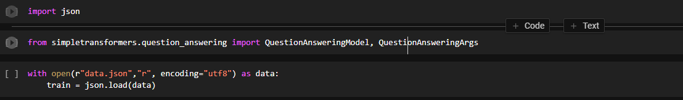
Import json to use it to read the data-set, and QuestionAnsweringModel to create and train the model

3.3 model creation
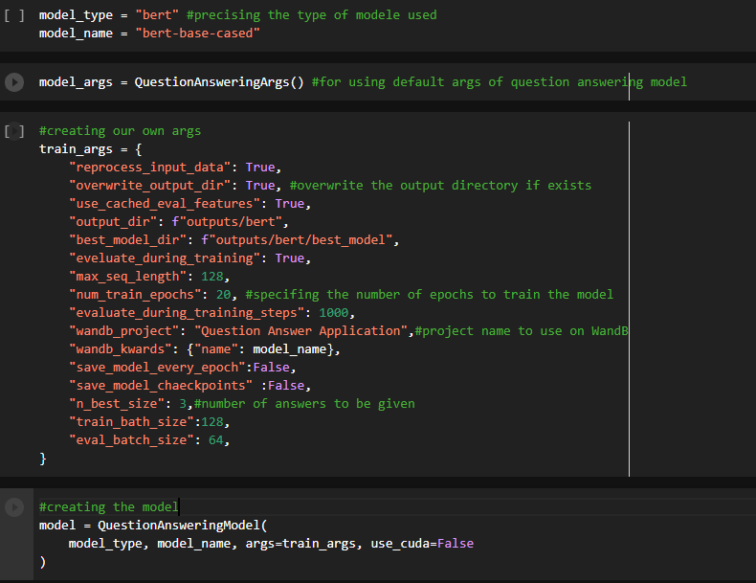
3.4 model training
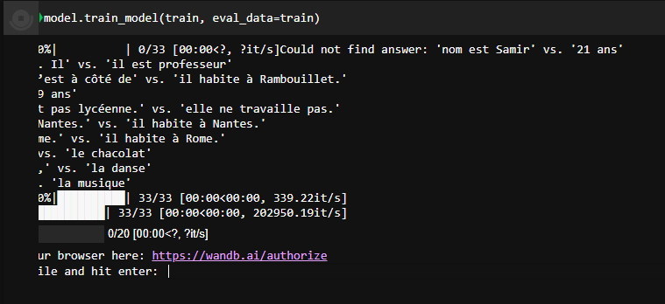
To use WandB a key is demanded you can get this key by clicking on the link. (Create an account if needed) 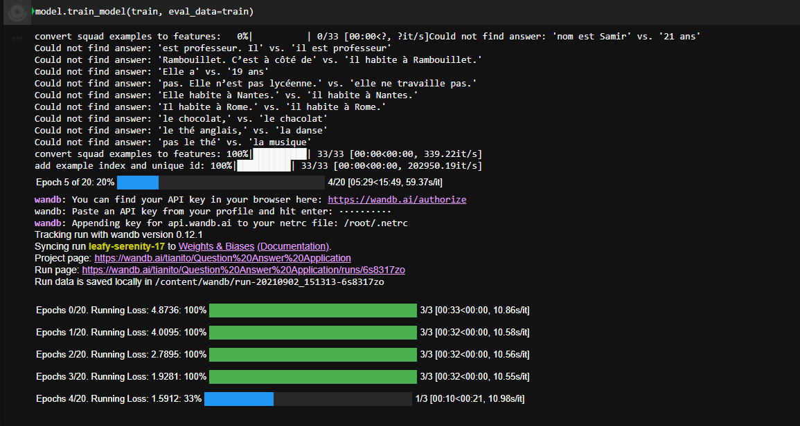
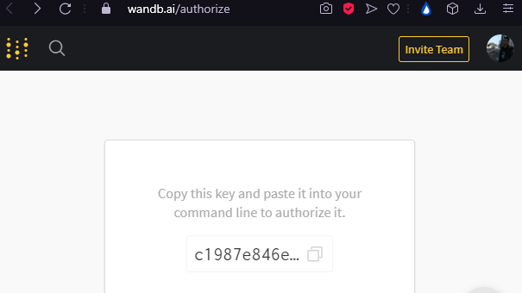
You can watch the progress of your model while training on the page project in WandB
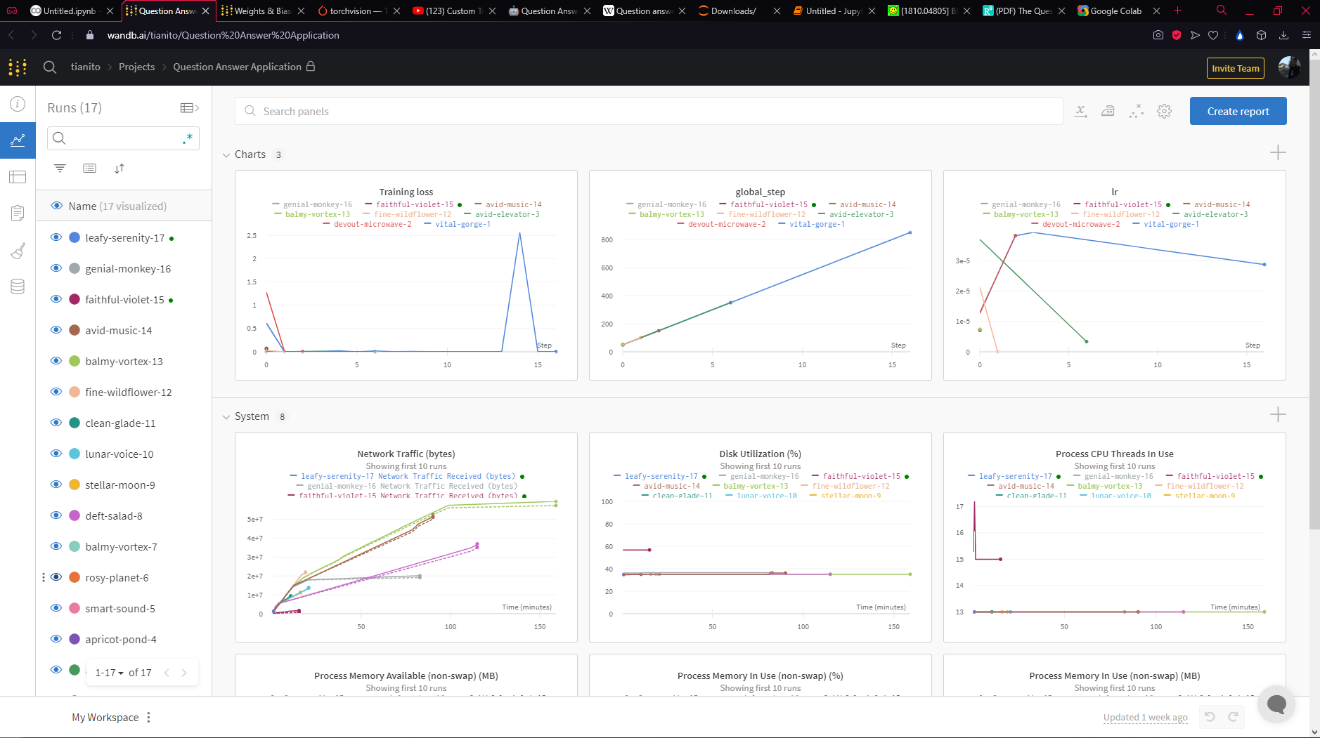
The model will train for 20 epochs (can be changed in model args) which seemed enough for the small data-set I created

3.5 evaluate model 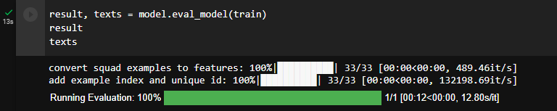
Show the results to see the answers your model was able to predict correctly and the answers he could not.
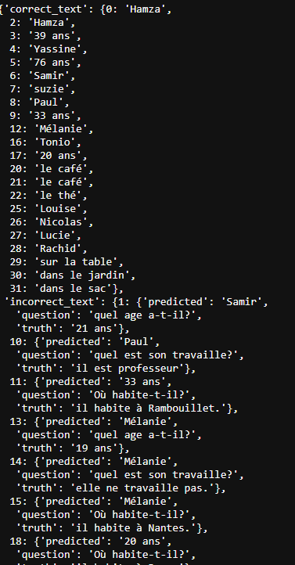
3.6 predict answer
Now you can predict the answer of a question not far from the contexts that exist on the data-set:
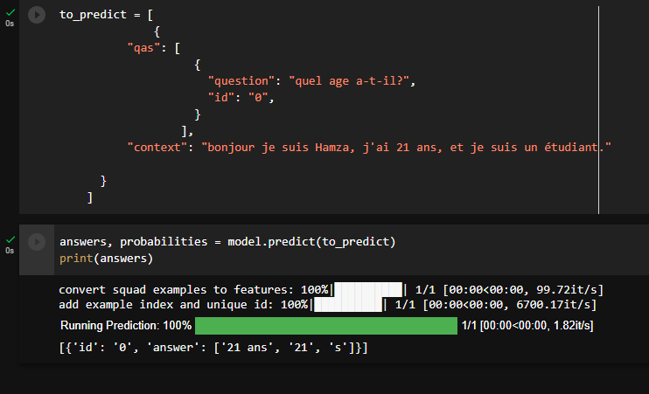

4 Conclusion
As much as it is trained our model can answer more and more questions, which means that in order to create an Artificial Intelligence capable of answering most questions we will need huge amounts of data, which explains the race that huge companies such as Google, Amazon and Facebook to collecting data, so that they can analyze the market and the bombard it with adds, in this field who has more data wins.

