一、项目要求
- 本文讨论的日志处理方法中的日志，仅指Web日志。其实并没有精确的定义，可能包括但不限于各种前端Web服务器——apache、lighttpd、nginx、tomcat等产生的用户访问日志，以及各种Web应用程序自己输出的日志。

二、需求分析： KPI指标设计
PV(PageView): 页面访问量统计
IP: 页面独立IP的访问量统计
Time: 用户每小时PV的统计
Source: 用户来源域名的统计
Browser: 用户的访问设备统计
下面我着重分析浏览器统计

三、分析过程

1、 日志的一条nginx记录内容
222.68.172.190 - - [18/Sep/2013:06:49:57 +0000] "GET /images/my.jpg HTTP/1.1" 200 19939
"http://www.angularjs.cn/A00n"
"Mozilla/5.0 (Windows NT 6.1) AppleWebKit/537.36 (KHTML, like Gecko) Chrome/29.0.1547.66 Safari/537.36"

2、对上面的日志记录进行分析
remote_addr : 记录客户端的ip地址, 222.68.172.190
remote_user : 记录客户端用户名称, –
time_local: 记录访问时间与时区, [18/Sep/2013:06:49:57 +0000]
request: 记录请求的url与http协议, “GET /images/my.jpg HTTP/1.1″
status: 记录请求状态,成功是200, 200
body_bytes_sent: 记录发送给客户端文件主体内容大小, 19939
http_referer: 用来记录从那个页面链接访问过来的, “http://www.angularjs.cn/A00n”
http_user_agent: 记录客户浏览器的相关信息, “Mozilla/5.0 (Windows NT 6.1) AppleWebKit/537.36 (KHTML, like Gecko) Chrome/29.0.1547.66 Safari/537.36″

3、java语言分析上面一条日志记录（使用空格切分）
String line = "222.68.172.190 - - [18/Sep/2013:06:49:57 +0000] \"GET /images/my.jpg HTTP/1.1\" 200 19939 \"http://www.angularjs.cn/A00n\" \"Mozilla/5.0 (Windows NT 6.1) AppleWebKit/537.36 (KHTML, like Gecko) Chrome/29.0.1547.66 Safari/537.36\"";
String[] elementList = line.split(" ");
for(int i=0;i<elementList.length;i++){
System.out.println(i+" : "+elementList[i]);
}

测试结果：
0 : 222.68.172.190
1 : -
2 : -
3 : [18/Sep/2013:06:49:57
4 : +0000]
5 : "GET
6 : /images/my.jpg
7 : HTTP/1.1"
8 : 200
9 : 19939
10 : "http://www.angularjs.cn/A00n"
11 : "Mozilla/5.0
12 : (Windows
13 : NT
14 : 6.1)
15 : AppleWebKit/537.36
16 : (KHTML,
17 : like
18 : Gecko)
19 : Chrome/29.0.1547.66
20 : Safari/537.36"
3

4、实体Kpi类的代码：
package org.hmahout.kpi.entity;

public class Kpi {
private String remote_addr;// 记录客户端的ip地址
private String remote_user;// 记录客户端用户名称,忽略属性"-"
private String time_local;// 记录访问时间与时区
private String request;// 记录请求的url与http协议
private String status;// 记录请求状态；成功是200
private String body_bytes_sent;// 记录发送给客户端文件主体内容大小
private String http_referer;// 用来记录从那个页面链接访问过来的
private String http_user_agent;// 记录客户浏览器的相关信息
private String httP_user_agent_info;
private String method;//请求方法 get post
private String http_version; //http版本

public String getHttP_user_agent_info() {
return httP_user_agent_info;
}
public void setHttP_user_agent_info(String httP_user_agent_info) {
this.httP_user_agent_info = httP_user_agent_info;
}
public String getMethod() {
return method;
}
public void setMethod(String method) {
this.method = method;
}
public String getHttp_version() {
return http_version;
}
public void setHttp_version(String http_version) {
this.http_version = http_version;
}
public String getRemote_addr() {
return remote_addr;
}
public void setRemote_addr(String remote_addr) {
this.remote_addr = remote_addr;
}
public String getRemote_user() {
return remote_user;
}
public void setRemote_user(String remote_user) {
this.remote_user = remote_user;
}
public String getTime_local() {
return time_local;
}
public void setTime_local(String time_local) {
this.time_local = time_local;
}
public String getRequest() {
return request;
}
public void setRequest(String request) {
this.request = request;
}
public String getStatus() {
return status;
}
public void setStatus(String status) {
this.status = status;
}
public String getBody_bytes_sent() {
return body_bytes_sent;
}
public void setBody_bytes_sent(String body_bytes_sent) {
this.body_bytes_sent = body_bytes_sent;
}
public String getHttp_referer() {
return http_referer;
}
public void setHttp_referer(String http_referer) {
this.http_referer = http_referer;
}
public String getHttp_user_agent() {
return http_user_agent;
}
public void setHttp_user_agent(String http_user_agent) {
this.http_user_agent = http_user_agent;
}
@Override
public String toString() {
return "Kpi [remote_addr=" + remote_addr + ", remote_user="
+ remote_user + ", time_local=" + time_local + ", request="
+ request + ", status=" + status + ", body_bytes_sent="
+ body_bytes_sent + ", http_referer=" + http_referer
+ ", http_user_agent=" + http_user_agent + ", method=" + method
+ ", http_version=" + http_version + "]";
}

}

5、kpi的工具类
package org.hmahout.kpi.util;

import java.util.HashSet;
import java.util.Set;
import java.util.regex.Matcher;
import java.util.regex.Pattern;

import org.hmahout.kpi.entity.Kpi;

public class KpiUtil {
/***
* line记录转化成kpi对象
*
* @param line
* 日志的一条记录
* @author tianbx
* */
public static Kpi transformLineKpi(String line) {
String[] elementList = line.split(" ");
if(elementList.length<=10){
System.out.println(line);
return null;
}
Kpi kpi = new Kpi();
kpi.setRemote_addr(elementList[0]);
kpi.setRemote_user(elementList[1]);
kpi.setTime_local(elementList[3].substring(1));
kpi.setMethod(elementList[5].substring(1));
kpi.setRequest(elementList[6]);
kpi.setHttp_version(elementList[7]);
kpi.setStatus(elementList[8]);
kpi.setBody_bytes_sent(elementList[9]);
kpi.setHttp_referer(elementList[10]);

if (elementList.length > 11) {
kpi.setHttp_user_agent(elementList[11] );
kpi.setHttP_user_agent_info(line.substring(line.indexOf(elementList[11])));
}
if (elementList.length > 12) {
kpi.setHttp_user_agent(elementList[11] + " " + elementList[12]);
}

return kpi;
}

public static String getDomain(String url){
Pattern p = Pattern.compile("(?<=http://|\\.)[^.]*?\\.(com|cn|net|org|biz|info|cc|tv)"
,Pattern.CASE_INSENSITIVE);
Matcher matcher = p.matcher(url);
if(matcher.find()){
return matcher.group();
}else{
return url;
}

}

public static void main(String[] args) {
getDomain(null);
}

public static boolean isNull(Kpi kpi){
return kpi==null?true:false;
}
public static boolean isValid(Kpi kpi) {
if (kpi == null) {
return false;
}
Set<String> pages = new HashSet<String>();
pages.add("/about");
pages.add("/black-ip-list/");
pages.add("/cassandra-clustor/");
pages.add("/finance-rhive-repurchase/");
pages.add("/hadoop-family-roadmap/");
pages.add("/hadoop-hive-intro/");
pages.add("/hadoop-zookeeper-intro/");
pages.add("/hadoop-mahout-roadmap/");

if (pages.contains(kpi.getRequest())) {
return true;
}
return false;
}
}

6、算法模型: 并行算法
Browser: 用户的访问设备统计
– Map: {key:$http_user_agent,value:1}
– Reduce: {key:$http_user_agent,value:求和(sum)}
7、map-reduce分析代码

package org.hmahout.kpi.app;

import java.io.IOException;
import java.util.Iterator;

import org.apache.hadoop.fs.Path;
import org.apache.hadoop.io.IntWritable;
import org.apache.hadoop.io.Text;
import org.apache.hadoop.mapred.FileInputFormat;
import org.apache.hadoop.mapred.FileOutputFormat;
import org.apache.hadoop.mapred.JobClient;
import org.apache.hadoop.mapred.JobConf;
import org.apache.hadoop.mapred.MapReduceBase;
import org.apache.hadoop.mapred.Mapper;
import org.apache.hadoop.mapred.OutputCollector;
import org.apache.hadoop.mapred.Reducer;
import org.apache.hadoop.mapred.Reporter;
import org.apache.hadoop.mapred.TextInputFormat;
import org.apache.hadoop.mapred.TextOutputFormat;
import org.hmahout.kpi.entity.Kpi;
import org.hmahout.kpi.util.KpiUtil;

import cz.mallat.uasparser.UASparser;
import cz.mallat.uasparser.UserAgentInfo;

public class KpiBrowserSimpleV {

public static class KpiBrowserSimpleMapper extends MapReduceBase
implements Mapper<Object, Text, Text, IntWritable> {
UASparser parser = null;
@Override
public void map(Object key, Text value,
OutputCollector<Text, IntWritable> out, Reporter reporter)
throws IOException {
Kpi kpi = KpiUtil.transformLineKpi(value.toString());

if(kpi!=null && kpi.getHttP_user_agent_info()!=null){
if(parser==null){
parser = new UASparser();
}
UserAgentInfo info =
parser.parseBrowserOnly(kpi.getHttP_user_agent_info());
if("unknown".equals(info.getUaName())){
out.collect(new Text(info.getUaName()), new IntWritable(1));
}else{
out.collect(new Text(info.getUaFamily()), new IntWritable(1));
}

}
}
}

public static class KpiBrowserSimpleReducer extends MapReduceBase implements
Reducer<Text, IntWritable, Text, IntWritable>{

@Override
public void reduce(Text key, Iterator<IntWritable> value,
OutputCollector<Text, IntWritable> out, Reporter reporter)
throws IOException {
IntWritable sum = new IntWritable(0);
while(value.hasNext()){
sum.set(sum.get()+value.next().get());
}
out.collect(key, sum);
}
}
public static void main(String[] args) throws IOException {
String input = "hdfs://127.0.0.1:9000/user/tianbx/log_kpi/input";
String output ="hdfs://127.0.0.1:9000/user/tianbx/log_kpi/browerSimpleV";
JobConf conf = new JobConf(KpiBrowserSimpleV.class);
conf.setJobName("KpiBrowserSimpleV");
String url = "classpath:";
conf.addResource(url+"/hadoop/core-site.xml");
conf.addResource(url+"/hadoop/hdfs-site.xml");
conf.addResource(url+"/hadoop/mapred-site.xml");

conf.setMapOutputKeyClass(Text.class);
conf.setMapOutputValueClass(IntWritable.class);

conf.setOutputKeyClass(Text.class);
conf.setOutputValueClass(IntWritable.class);

conf.setMapperClass(KpiBrowserSimpleMapper.class);
conf.setCombinerClass(KpiBrowserSimpleReducer.class);
conf.setReducerClass(KpiBrowserSimpleReducer.class);

conf.setInputFormat(TextInputFormat.class);
conf.setOutputFormat(TextOutputFormat.class);

FileInputFormat.setInputPaths(conf, new Path(input));
FileOutputFormat.setOutputPath(conf, new Path(output));

JobClient.runJob(conf);
System.exit(0);
}

}

8、输出文件log_kpi/browerSimpleV内容
AOL Explorer 1
Android Webkit 123
Chrome 4867
CoolNovo 23
Firefox 1700
Google App Engine 5
IE 1521
Jakarta Commons-HttpClient 3
Maxthon 27
Mobile Safari 273
Mozilla 130
Openwave Mobile Browser 2
Opera 2
Pale Moon 1
Python-urllib 4
Safari 246
Sogou Explorer 157
unknown 4685

8 R制作图片

data<-read.table(file="borwer.txt",header=FALSE,sep=",")
names(data)<-c("borwer","num")
qplot(borwer,num,data=data,geom="bar")

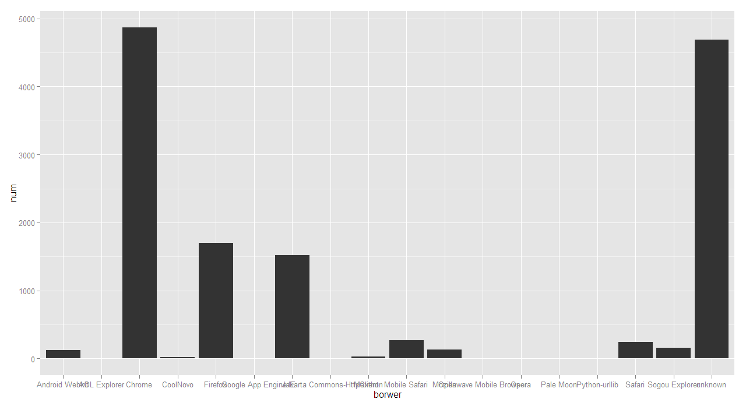

14

