目录
一 作业要求 2
二R数据准备 2
1 把测试数据拷贝到R工作目录下面 2
2 user.csv文件中增加标题 2
3 rating.csv文件中增加标题 2
4 导入user.csv数据 3
5 导入rating.csv数据 3
三 推荐代码,条件过滤出男性 3
1 推荐类BookFilterFGenderResult.java 3
2 运行结果 6
四 用户4推荐书96 7
1 查看userid=4 用户信息 7
2 查看bookid=96多有用户评分 7
3 查看用户（18,22,26,54,73,79,91,117,130,163,172）的属性 8
4 查看用户2评分的书 9
5查看用户（18,22,54,73,79,117,130,163,172）打分集合 9
6 查看用户2和用户（18,22,54,73,79,117,130,163,172）共同看过的书 10
7 再次查看用户172评分的书 10
五 总结 11

一 作业要求
. 接第2题，增加过滤条件，排除男性，只保留对女性用户的推荐评分，然后进行推荐，并解释推荐结果，是否合理。要求有代码，运行过程抓图，代码的文档说明，解释结果的文档说明等。1

二R数据准备

1 把测试数据拷贝到R工作目录下面

2 user.csv文件中增加标题
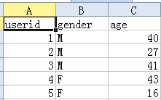

3 rating.csv文件中增加标题
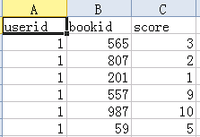

4 导入user.csv数据
> user <-read.table(file="user.csv",header=TRUE,sep=",")
> user[1,]
userid gender age
1 1 M 40
>

5 导入rating.csv数据
> rating <-read.table(file="rating.csv",header=TRUE,sep=",")
> rating[1,]
userid bookid score
1 1 565 3
>

三 推荐代码,条件过滤出男性

1 推荐类BookFilterFGenderResult.java
package org.conan.mymahout.recommendation.book;

import java.io.BufferedReader;
import java.io.File;
import java.io.FileReader;
import java.io.IOException;
import java.util.HashSet;
import java.util.List;
import java.util.Set;

import org.apache.mahout.cf.taste.common.TasteException;
import org.apache.mahout.cf.taste.eval.RecommenderBuilder;
import org.apache.mahout.cf.taste.impl.common.LongPrimitiveIterator;
import org.apache.mahout.cf.taste.model.DataModel;
import org.apache.mahout.cf.taste.recommender.IDRescorer;
import org.apache.mahout.cf.taste.recommender.RecommendedItem;

public class BookFilterFGenderResult {

final static int NEIGHBORHOOD_NUM = 2;
final static int RECOMMENDER_NUM = 3;

public static void main(String[] args) throws TasteException, IOException {
String file = "datafile/book/rating.csv";
DataModel dataModel = RecommendFactory.buildDataModel(file);
RecommenderBuilder rb1 = BookEvaluator.userEuclidean(dataModel);
RecommenderBuilder rb2 = BookEvaluator.itemEuclidean(dataModel);
RecommenderBuilder rb3 = BookEvaluator.userEuclideanNoPref(dataModel);
RecommenderBuilder rb4 = BookEvaluator.itemEuclideanNoPref(dataModel);

long uid = 4;
System.out.print("userEuclidean =>");
filterGender(uid, rb1, dataModel);
System.out.print("itemEuclidean =>");
filterGender(uid, rb2, dataModel);
System.out.print("userEuclideanNoPref =>");
filterGender(uid, rb3, dataModel);
System.out.print("itemEuclideanNoPref =>");
filterGender(uid, rb4, dataModel);
}

/**
* 对用户性别进行过滤
*/
public static void filterGender(long uid, RecommenderBuilder recommenderBuilder, DataModel dataModel) throws TasteException, IOException {
Set<Long> userids = getGril("datafile/book/user.csv");

//计算女性用户打分过的图书
Set<Long> bookids = new HashSet<Long>();
for (long uids : userids) {
LongPrimitiveIterator iter = dataModel.getItemIDsFromUser(uids).iterator();
while (iter.hasNext()) {
long bookid = iter.next();
bookids.add(bookid);
}
}

IDRescorer rescorer = new FilterFRescorer(bookids);
List<RecommendedItem> list = recommenderBuilder.buildRecommender(dataModel).recommend(uid, RECOMMENDER_NUM, rescorer);
RecommendFactory.showItems(uid, list, false);
}

/**
* 获得男性用户ID
*/
public static Set<Long> getMale(String file) throws IOException {
BufferedReader br = new BufferedReader(new FileReader(new File(file)));
Set<Long> userids = new HashSet<Long>();
String s = null;
while ((s = br.readLine()) != null) {
String[] cols = s.split(",");
if (cols[1].equals("M")) {// 判断男性用户
userids.add(Long.parseLong(cols[0]));
}
}
br.close();
return userids;
}

/**
* 获得女性用户ID
*/
public static Set<Long> getGril(String file) throws IOException {
BufferedReader br = new BufferedReader(new FileReader(new File(file)));
Set<Long> userids = new HashSet<Long>();
String s = null;
while ((s = br.readLine()) != null) {
String[] cols = s.split(",");
if (cols[1].equals("F")) {// 判断女性
userids.add(Long.parseLong(cols[0]));
}
}
br.close();
return userids;
}

}

/**
* 对结果重计算
*/
class FilterFRescorer implements IDRescorer {
final private Set<Long> userids;

public FilterFRescorer(Set<Long> userids) {
this.userids = userids;
}

@Override
public double rescore(long id, double originalScore) {
return isFiltered(id) ? Double.NaN : originalScore;
}

@Override
public boolean isFiltered(long id) {
return !userids.contains(id);
}
}
主意 : 类FilterFRescorer中的方法 isFiltered(long id) 是过滤出男性没有看过的书.这里重要的是取反,老师给出的代码没有取反.

2 运行结果
userEuclidean
AVERAGE_ABSOLUTE_DIFFERENCE Evaluater Score:0.0
Recommender IR Evaluator: [Precision:0.3010752688172043,Recall:0.08542713567839195]
itemEuclidean
AVERAGE_ABSOLUTE_DIFFERENCE Evaluater Score:1.3647841021305582
Recommender IR Evaluator: [Precision:0.0,Recall:0.0]
userEuclideanNoPref
AVERAGE_ABSOLUTE_DIFFERENCE Evaluater Score:4.493589743589744
Recommender IR Evaluator: [Precision:0.09045226130653267,Recall:0.09296482412060306]
itemEuclideanNoPref
AVERAGE_ABSOLUTE_DIFFERENCE Evaluater Score:2.48616706409535
Recommender IR Evaluator: [Precision:0.6005025125628134,Recall:0.6055276381909548]
userEuclidean =>uid:4,
itemEuclidean =>uid:4,(173,9.294118)(898,9.118644)(256,9.040816)
userEuclideanNoPref =>uid:4,(4,1.000000)(723,1.000000)(300,1.000000)
itemEuclideanNoPref =>uid:4,(96,4.908584)(185,4.783333)(40,4.166667)

用户4(,基于item,Euclidean距离,不考虑评分)推荐书96,185,40

四 用户4推荐书96

1 查看userid=4 用户信息
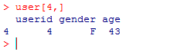>

2 查看bookid=96多有用户评分
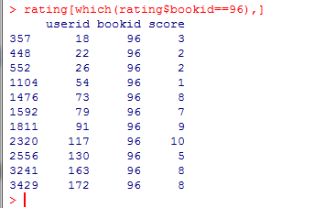

3 查看用户（18,22,26,54,73,79,91,117,130,163,172）的属性
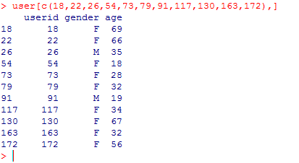
这里过滤出男性,只分析女性

4 查看用户2评分的书
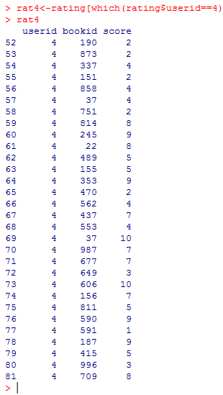

5查看用户（18,22,54,73,79,117,130,163,172）打分集合
rat18<-rating[which(rating$userid==18),]
rat22<-rating[which(rating$userid==22),]
rat54<-rating[which(rating$userid==54),]
rat73<-rating[which(rating$userid==73),]
rat79<-rating[which(rating$userid==79),]
rat117<-rating[which(rating$userid==117),]
rat130<-rating[which(rating$userid==130),]
rat163<-rating[which(rating$userid==163),]
rat172<-rating[which(rating$userid==172),]

6 查看用户2和用户（18,22,54,73,79,117,130,163,172）共同看过的书
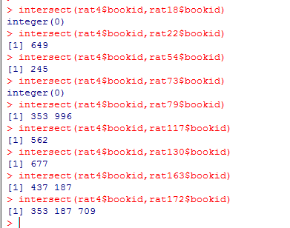

7 再次查看用户172评分的书

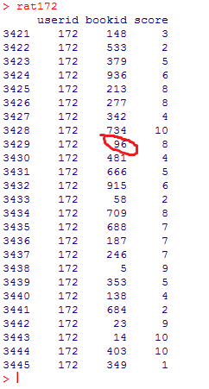

五 总结
通过R分析,说明推荐书96给用户4是合理的.

