<http://svnchina.com/svn/third2> svn地址

[http://svnchina.com](http://svnchina.com/) svn中国网址

<http://www.aaa.com/fadacai/index.php> 网站后台

Ajax.call('flow.php?step=aa&order_id='+vat_id, '', fapiao, 'GET', 'JSON');

define('DY_PRICE','0.0096656'); //大样计算参数 = PRICE_XISHU * 1.12

define('DH_PRICE','0.0093204'); //大货计算参数 = PRICE_XISHU * 1.08

data/app_picture/1492399281.jpg

unserialize反转译

/[\x{4e00}-\x{9fa5}a-z0-9]/u 匹配汉语的正则表达式

求一维数组的最大值最小值

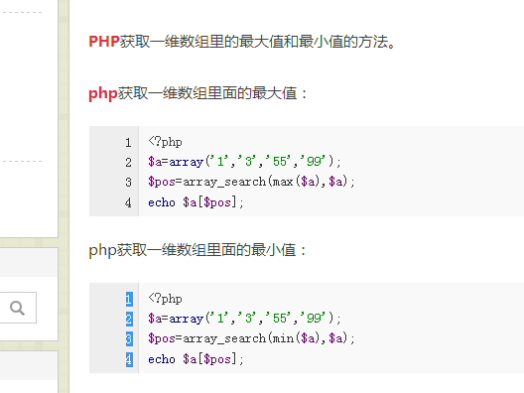

<https://v2.modao.cc/app/Wyz1rSsjXkE5eVa3c8b5oeKSIdW05tA> app地址