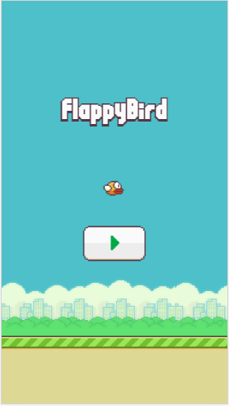 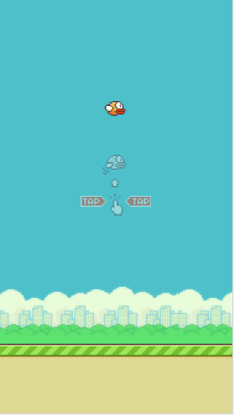

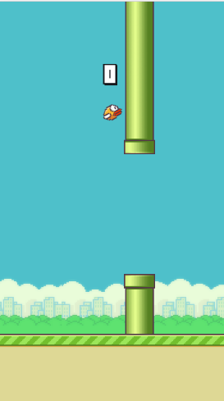 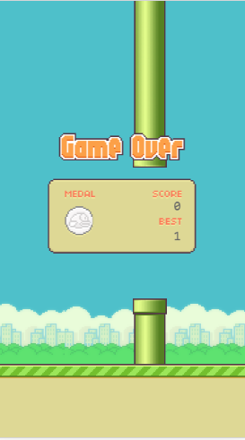

this.allImg={

"bg_day":"images/bg_day.png",

"land":"images/land.png",

"pipe_down" : "images/pipe_down.png",

"pipe_up" : "images/pipe_up.png",

"bird0_0":"images/bird0_0.png",

"bird0_1":"images/bird0_1.png",

"bird0_2":"images/bird0_2.png",

"title":"images/title.png",

"button_play":"images/button_play.png",

"tutorial":"images/tutorial.png",

"shuzi0" : "images/font_048.png",

"shuzi1" : "images/font_049.png",

"shuzi2" : "images/font_050.png",

"shuzi3" : "images/font_051.png",

"shuzi4" : "images/font_052.png",

"shuzi5" : "images/font_053.png",

"shuzi6" : "images/font_054.png",

"shuzi7" : "images/font_055.png",

"shuzi8" : "images/font_056.png",

"shuzi9" : "images/font_057.png",

"baozha1" : "images/1.png",

"baozha2" : "images/2.png",

"baozha3" : "images/3.png",

"baozha4" : "images/4.png",

"baozha5" : "images/5.png",

"baozha6" : "images/6.png",

"baozha7" : "images/7.png",

"baozha8" : "images/8.png",

"baozha9" : "images/9.png",

"game_over":"images/text_game_over.png",

"score_panel":"images/score_panel.png",

"medals_0" : "images/medals_0.png",

"medals_1" : "images/medals_1.png",

"medals_2" : "images/medals_2.png",

"medals_3" : "images/medals_3.png",

};