Given a source geometry defined in terms of a 3D pointcloud $p_{j}={\left[\begin{matrix}ϕ_{j} & λ_{j} & d_{j}\end{matrix}\right]}^{T}$ (lat,lon,depth), the following procedure implemented in SeismicHazard allows assigning the source events from an earthquake catalog



Figure 1 – 3D Surface representation of a seismic source

1. **Convert the source geometry from WGS84 coordinates to ECEF coordinates**: the transformation for every point $p_{j}$ is

$$P_{j}=\left[\begin{matrix}x_{j} \\ y_{j} \\ z_{j}\end{matrix}\right]=\left[\begin{matrix}\left(N_{j}+d_{j}\right)\cos\left(ϕ_{j}\right)\cos\left(λ_{j}\right) \\ \left(N_{j}+d_{j}\right)\cos\left(ϕ_{j}\right)\sin\left(λ_{j}\right) \\ \left(\left(1-e^{2}\right)N_{j}+d_{j}\right)\sin{ϕ_{j}}\end{matrix}\right]$$

where $N_{j}=a {\left(1-e^{2}\sin^{2}{ϕ_{j}}\right)}^{-0.5}$, a=6387.137 km is the semi-major axis, a=6356.752 km is the semi-minor axis, and $e=\sqrt{a^{2}-b^{2}}/a$ is earth’s eccentricity.



1. **Translate the source coordinates $P_{j}$ to its centroid $P_{0}$ and rotate the coordinates to its ‘best fitting plane’, $Π$.** The transformation for every point $P_{j}$ is

$${\tilde{P}}_{j}=V^{T}\left(P_{i}-P_{0}\right)$$

where $P_{0}=N^{-1}\sum_{j=1}^{N_{p}}{P_{j}}$ is the centroid of points $P_{j}$, and $V$ is the ‘right singular vector’ form the singular value decomposition (SVD), such that:

$$\left(P_{j}-P_{0}\right){\left(P_{j}-P_{0}\right)}^{T}=U S V^{T}$$

The columns of matrix $V$ form a base of orthogonal vectors $e_{1},e_{2},e_{3}.$ Vectors $e_{1}$ and $e_{2}$ are tangent to $Π$ and vector $e_{3}$ is normal to $Π$.



The figure below shows the seismic source in the **E** coordinate system



1. **Translate the events location from WGS84 to the E coordinate system.** For an event with coordinates ($ϕ_{i},λ_{i}$, $d_{i}$), the transformation takes the form is
$$h_{i}=\left[\begin{matrix}\left(N_{i}+d_{i}\right)\cos\left(ϕ_{i}\right)\cos\left(λ_{i}\right) \\ \left(N_{i}+d_{i}\right)\cos\left(ϕ_{i}\right)\sin\left(λ_{i}\right) \\ \left(\left(1-e^{2}\right)N_{i}+d_{i}\right)\sin{ϕ_{i}}\end{matrix}\right]$$

$${\tilde{h}}_{i}=V^{T}\left(h_{i}-P_{0}\right)$$

2. **Define two additional planes, $Π_{top}$** and $Π_{bot}$**, by shifting the seismic source a distance $±d_{max}$ along the normal $e_{3}$.**



The planes $Π_{top}$ and $Π_{bot}$ define a volume $Ω$. If the event coordinates ${\tilde{h}}_{i}$ are inside $Ω,$ the event is associate to the source, if not, the event is an outlier to the source.

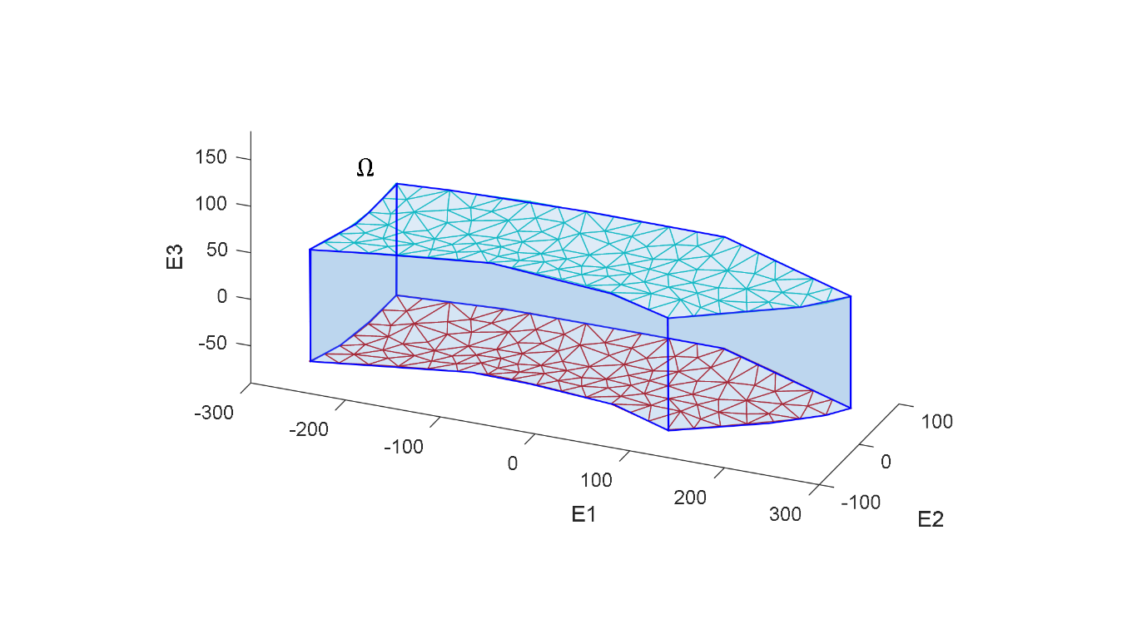

1. **An additional criterion is applied to dipping sources, in which the event is excluded if the event’s depth $d_{i}$ is not contained with the maximum and minimum source depths.**