

TONGJI UNIVERSITY

姓 名：田甘迅

学 号：1552215

所在院系：电子与信息工程学院

专 业：计算机科学与技术

指导教师：汪海航

二〇一八年十二月

# Background

## Problem

* The badminton courts in our campus are always busy, and there are often no free
* courts. However, students don’t know if there is an available badminton court until they

┊

* get to the gym. It is so inefficient and there's a lot of conflict.

┊

┊

* Students wonder:
* ➢ Is there an available court at the moment?

┊

* ➢ Does anyone want to play together at this time?

┊

┊

## 1.2 Solution overview

装

* The lack of information known to users is the root cause of the conflict. So we are
* ready to provide a platform for information sharing to resolve the difficulties faced by the

┊

* user.

┊ 订

## 1.3 Target user group

┊

* Our target user group is student

┊

┊

# 线 2. Tasks

┊

## 2.1 Easy task

┊

* Register & Login & Display user information

┊

* User registration and login are the most basic and essential functions. And a user
* friendly login registration function will bring users a better experience. We also provide a

┊

* interface that allow users to view their own information.

┊

┊

## 2.2 Medium task

┊

Booking court

For the lack of space, we are prepared to make the use of the site more efficient by booking the site in advance. Booking the site in advance can reduce the time cost caused by the uncertainty of the site information. You can see the booking of the courts from the

platform and reserve an unreserved court.The booking situation of the court will be displayed on the platform in time, which will avoid conflicting user schedules.

## 2.3 Hard task

┊

* Seek partners

┊

* As for the lack of partners, we are ready to find partners by issuing invitations.
* Everyone on the platform can see the invitation you posted and choose to accept it to play

┊

* with you. In the invitation letter, we also added the function of message discussion so that
* the inviter and the invitee can communicate with each other to make the cooperation more

┊

* pleasant. While choosing sports venues, you can also meet some like-minded friends and
* effectively expand the channels for college students to make friends.

┊

装

┊

# 3. Design Evoltion

┊

## 3.1 Global Structure Design

* The initial conception:

订

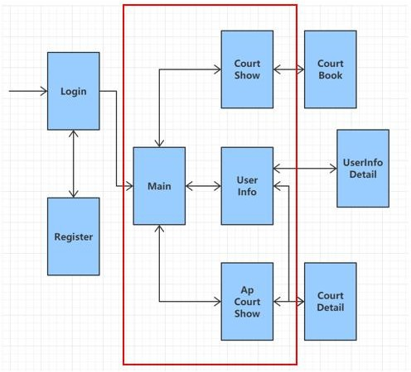┊

┊

┊

┊

┊ 线

┊

┊

┊

┊

┊

┊

┊

┊

┊

┊

┊

┊

┊

Each rectangle represents one page, and the arrows show the relationship between these pages. We found that this structure has a deep hierarchy and it is not convenient for the user, so we make a change to it.

The improved version:

┊

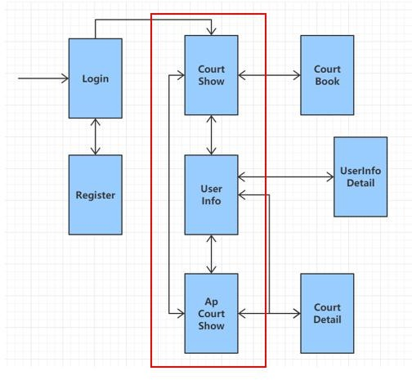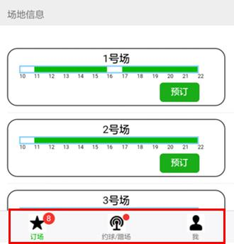

┊

┊

┊

┊

┊

┊

┊

┊

┊

┊

┊

┊ 装

┊

┊

┊

┊

┊

订 We alter the structure, remove the redundant page to reduce the hierarchy. Besides,

* we add a navigation bar on the homepage to combine these three pages.

┊

┊

## 3.2 User Interface Design

┊

线 We design our user interface according some rules and principles.

┊

┊

* ➢ Operation Visibility
* Operation visibility refers to how the user is shown the availability of operations that

┊

* can be performed. Here we use the icon to indicate the selection bar, and indicate a button

┊

* by its shape and color, what’s more, we provide a navigation bar fixed at the bottom of the
* page, which is easy to catch the user’s attention.

┊

┊

┊

┊

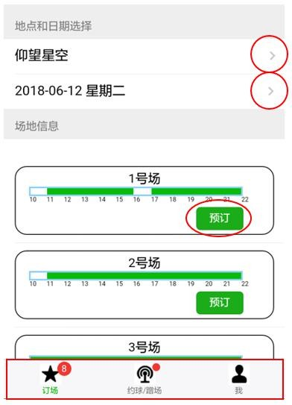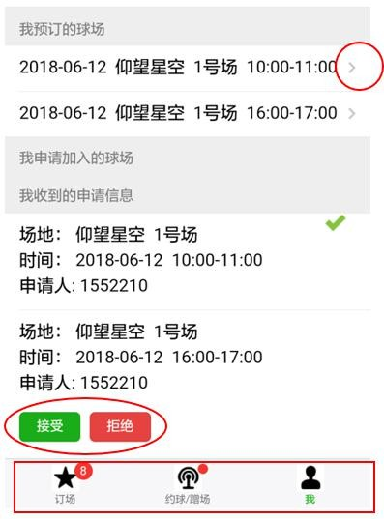┊

┊

┊

┊

┊

┊

┊

┊

┊

┊

┊

┊

┊ 装

* ➢ Honesty

┊

* Honesty relates to the ability of UI to provide an observable and informative account
* of change. Booking court is one of the function of our application. Take it as an example

┊

订 here. When the user finishes a booking operation, the change can be seen immediately. For

* example, the status of the court will change to unavailable, and on the personal information

┊

* page, the booking record is shown.

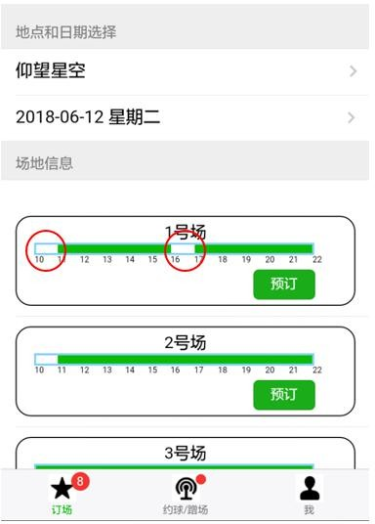┊

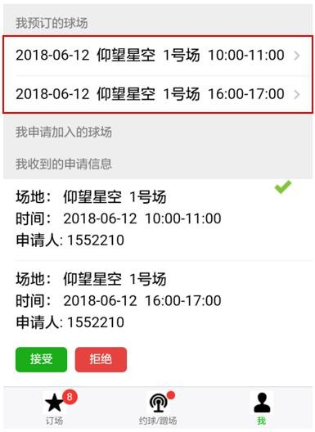┊ 线

┊

┊

┊

┊

┊

┊

┊

┊

┊

┊

┊

┊

┊