**Scenario 1. Stionary bandits – noisy continuous awards**

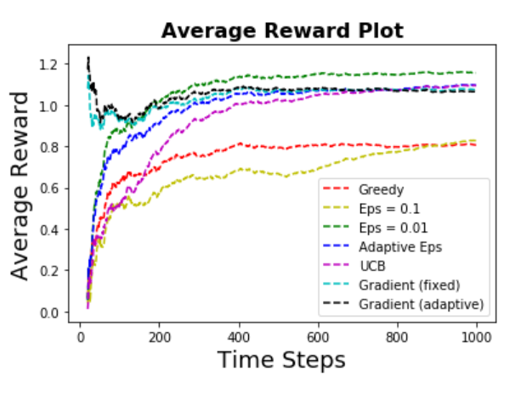

**Scenario 2. Stionary bernoulli bandits [0.5,0.7,0.4,0.3]**

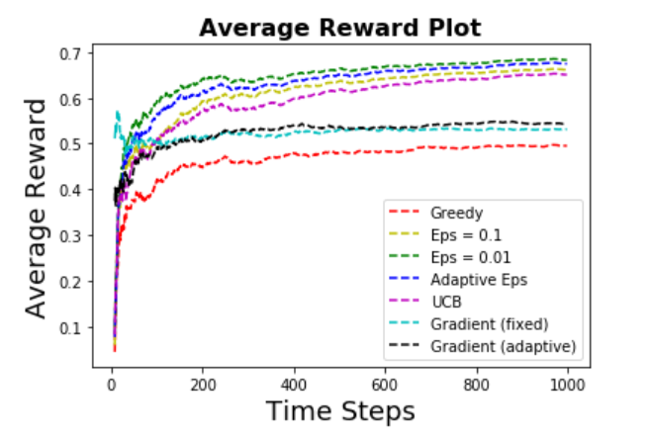

**Scenario 3. Non-stionary bandits – noisy continuous awards**

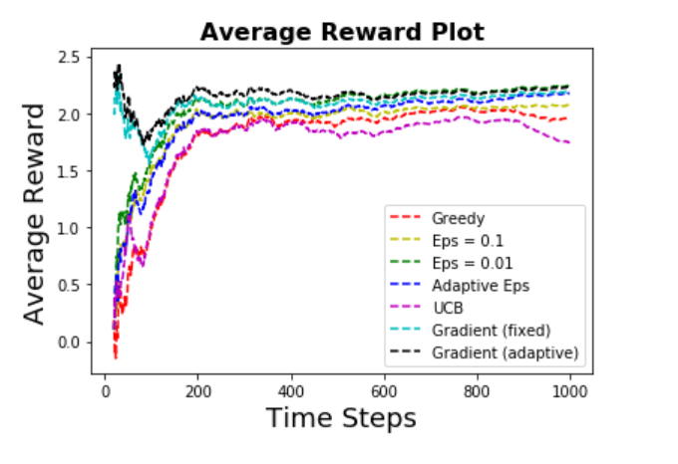

**Scenario 4. Non-stionary bernoulli bandits**

