Manual of detonationFoam solver
Jie Sun
July 18, 2023

Contents
Abstract 3
1. Governing equations and models 4
2. Compiling the libraries and applications 7
3. Example cases 8
3.1 1D flame 8
3.2 1D detonation 8
3.3 2D cellular detonation 9
References 10

Abstract
detonationFoam is an open-source solver which can accurately and efficiently simulate compressible, multi-component reactive flow and detonation processes. It is developed based on the OpenFOAM framework. This manual provides a summary of the governing equations and model. Besides, the detailed on how to install and use the solver are provided together with several testing cases.

Governing equations and models
The conservation equations for unsteady, compressible, multi-component reactive flow are solved in detonationFoam. The governing equations for mass, momentum, energy and species are [1]
Here ρ is the density of the mixture, V = (u, v, w) is the velocity vector, and P is the pressure. Y_{k}, V_{k}' and ω_{k} are respectively the mass fraction, diffusion velocity and production rate of the k-th species. N_{S} is the total number of the species. The viscous stress is
in which μ is the dynamic viscosity of the mixture and I is unit tensor.
We assume that the mixture is ideal gas and the equation of state is:
where T is the temperature, R＝8.314 J/(mole∙K) is the universal gas constant, and‾W is the mean molar weight of the mixture.
The total energy E and heat flux q in Eq. (3) are
where λ is the thermal conductivity of the mixture, and h_{k} is the enthalpy of the k-th species. The thermodynamic properties of each species are evaluated with JANAF polynomials [2]. The enthalpy, h_{k}, and the specific heat capacity at constant pressure, C_{p},_{k} of the k-th species are:
where a_{n,k} with n = 1~5 are the coefficients for the k-th species.
The mixture-averaged transport model provided by Dasgupta et al. [3] is modified and incorporated into detonationFoam. The Wilke formula [4, 5] is used to calculate the dynamic viscosity of the mixture:
where X_{k} is the mole fraction and μ_{k} is the dynamic viscosity coefficient of the k-th species. Φ_{kj} is the dimensionless partition function defined as [5]:
where W_{k} is the molecule weight of the k-th species.
The thermal conductivity of the mixture is obtained from the following formula [6]
where λ_{k} is the thermal conductivity of the k-th species.
The diffusion velocity, V_{k}' in Eq. (4), consists of three parts [7]
where V'_{k,Y} is the ordinary diffusion velocity and V'_{k,T} is the thermal diffusion velocity. The expressions for V’_{k,Y} and V’_{k,T} are:
where D_{km} is the mixture-averaged mass diffusion coefficient and Θ_{k} is the thermal diffusion ratio of the k-th species.
The correction velocity, V'_{k,C}, is introduced to ensure the compatibility between the species mass conservation and the total mass conservation [1]. It is determined according to the following requirement:
In detonationFoam, the detailed kinetic model can be considered. For a kinetic model containing N_{S} species, the N_{R} elementary reactions can be written as [8]
Here M_{k} represents the molecular formula for the k-th species. ν'_{k,j} and ν''_{k,j} are the stoichiometric coefficients of the k-th species in the j-th elementary reaction. K_{f,j} and K_{b,j} respectively represent the forward and backward reaction rate constants of the j-th elementary reaction. The production rate of the k-th species can be expressed as [8]
where C_{k} is the molar concentration of the k-th species. The reaction rate constant, K_{f,j}, can be written in the Arrhenius Law [8] as
Here A_{j}, β_{j} and E_{a,j} are respectively the pre-exponential factor, temperature exponent and activation energy of the j-th forward reaction. The backward reaction rate, K_{b,j}, can be evaluated based on K_{f,j} and the equilibrium constant of the j-th elementary reaction [8].

Compiling the libraries and applications
detonationFoam consists of the Euler equations solver, detonationEulerFoam, and the N-S equations solver, detonationNSFoam. The framework of the procedure is described in Fig. 1. Depending on the diffusion model used, detonationNSFoam is divided into detonationNSFoam_mixtureAverage and detonationNSFoam_Sutherland.
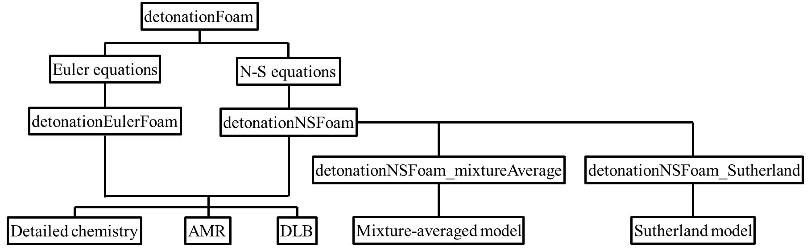
Fig. 1 The framework of the detonationFoam solver.

The user can install the program according to the following steps:
- The solver, detonationFoam, is developed based on OpenFOAM V6 [9]. Before installing the solver, please ensure you have installed OpenFOAM V6. Please refer to https://openfoam.org/download/6-ubuntu.

- For the solver detonationNSFoam_mixtureAverage, the transport fitting tool, fitTransport, is needed to be installed, which depends on the GNU Scientific Library. The GNU Scientific Library must be installed and added into the default path before installing the solver. The installation methods of GSL can be referred to https://www.gnu.org/software/gsl.

- Compiling detonationFoam.
- cd applications/solvers/detonationFoam
- ./Allwmake

Example cases

1D flame
The 1D plane flame tutorial is located in /detonationFoam/tutorials/1D_flame. The initial field is described as follows: the atmospheric stoichiometric H₂/air mixture is filled with computing domain. In the region 0 < x < 2 mm, the mixture temperature is set to 1800 K to ignite the mixture. The mixture temperature in remaining region equals to 300 K. The uniform grid size used in this case is 10 μm. The user can run the tutorial using the Allrun script in /detonationFoam/tutorials/1D_flame. The temporal velocity and temperature distributions are plotted in Fig. 2.
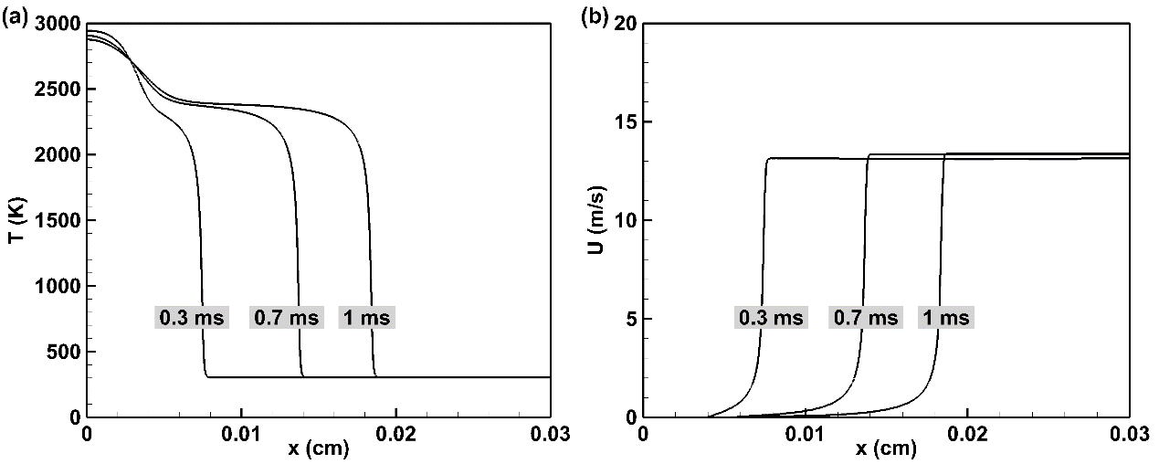
Fig. 2 The temporal velocity and temperature distributions of the 1D plane flame.

1D detonation
The 1D detonation tutorial is located in /detonationFoam/tutorials/1D_detonation. The initial field is described as follows: the H₂/air mixture with pressure, p = 90 atm, and temperature, T = 3000 K, is set in the region 0 < x < 2 mm to initiate the detonation. The remaining region is the stoichiometric H₂/air mixture with pressure, p = 1 atm, and temperature, T = 300 K. The uniform grid size used in this case is 5 μm. The user can run the tutorial using the Allrun script in /detonationFoam/tutorials/1D_detonation. The temporal pressure and temperature distributions are plotted in Fig. 3.
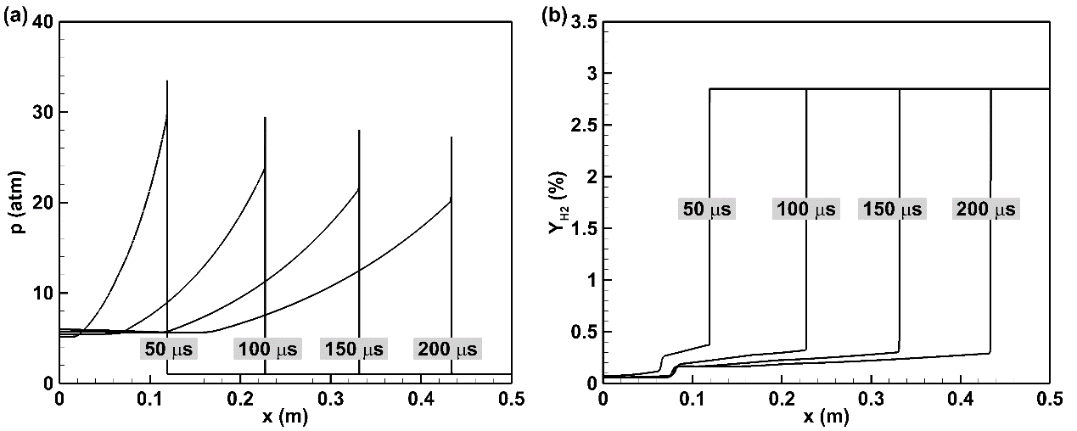
Fig. 3 The temporal pressure and temperature distributions of the 1D detonation wave.

2D cellular detonation
The two-dimensional cellular detonation wave for stoichiometric H₂/O₂ mixtures with p = 8 kPa and T = 300 K is calculated. The basic grid size in this case is 200 μm and four-layer adaptive refinement mesh are used. The initial field settings can be checked in /detonationFoam/tutorials/2D_detonation/0. The user can run the tutorial using the Allrun script in /detonationFoam/tutorials/2D_detonation and the simulation results are described in Fig. 4.
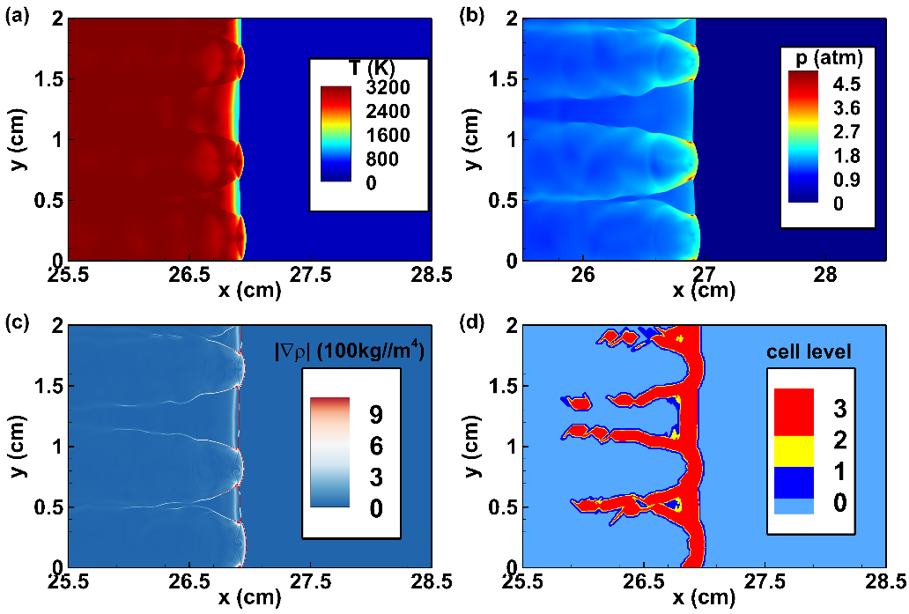
Fig. 4 The contours for (a) temperature, (b) pressure, (c) density gradient and (d) mesh level at t = 100 μs for 2D cellular detonation wave.

References
[1] T. Poinsot, D. Veynante, Theoretical and numerical combustion, R.T. Edwards, Inc. 2005.
[2] D. R. Stull, H. Prophet, JANAF thermochemical tables (2nd ed), U.S. National Bureau of Standards 1971.
[3] A. Dasgupta, E. Gonzalez-Juez, D. C. Haworth, Flame simulations with an open-source code, Computer Physics Communications 237 (2019) 219-229.
[4] R. B. Bird, W. E. Stewart, E. N. Lightfoot, Transport Phenomena (2nd ed), John Wiley & Sons, Inc. 2006.
[5] C. R. Wilke, A viscosity equation for gas mixtures, The Journal of Chemical Physics 18 (1950) 517-519.
[6] S. Mathur, P. K. Tondon, S. C. Saxena, Thermal conductivity of binary, ternary and quaternary mixtures of rare gases, Molecular Physics 12 (1967) 569-579.
[7] R. J. Kee, F. M. Rupley, J. A. Miller, M. E. Coltrin, J. F. Grcar, E. Meeks, H. K. Moffat, A. E. Lutz, G. Dixon-Lewis, M. D. Smooke, J. Warnatz, G. H. Evans, R. S. Larson, R. E. Mitchell, L. R. Petzold, W. C. Reynolds, M. Caracotsios, W. E. Stewart, P. Glarborg, C. Wang, O. Adigun, TRANSPORT-a software package for the evaluation of gas-phase, multicomponent transport properties, Reaction Design, Inc. 2000.
[8] C. K. Law, Combustion physics, Cambridge University Press 2010.
[9] OpenFOAM, https://openfoam.org.

