https://github.com/SJTU-IPADS/fgnn-artifacts

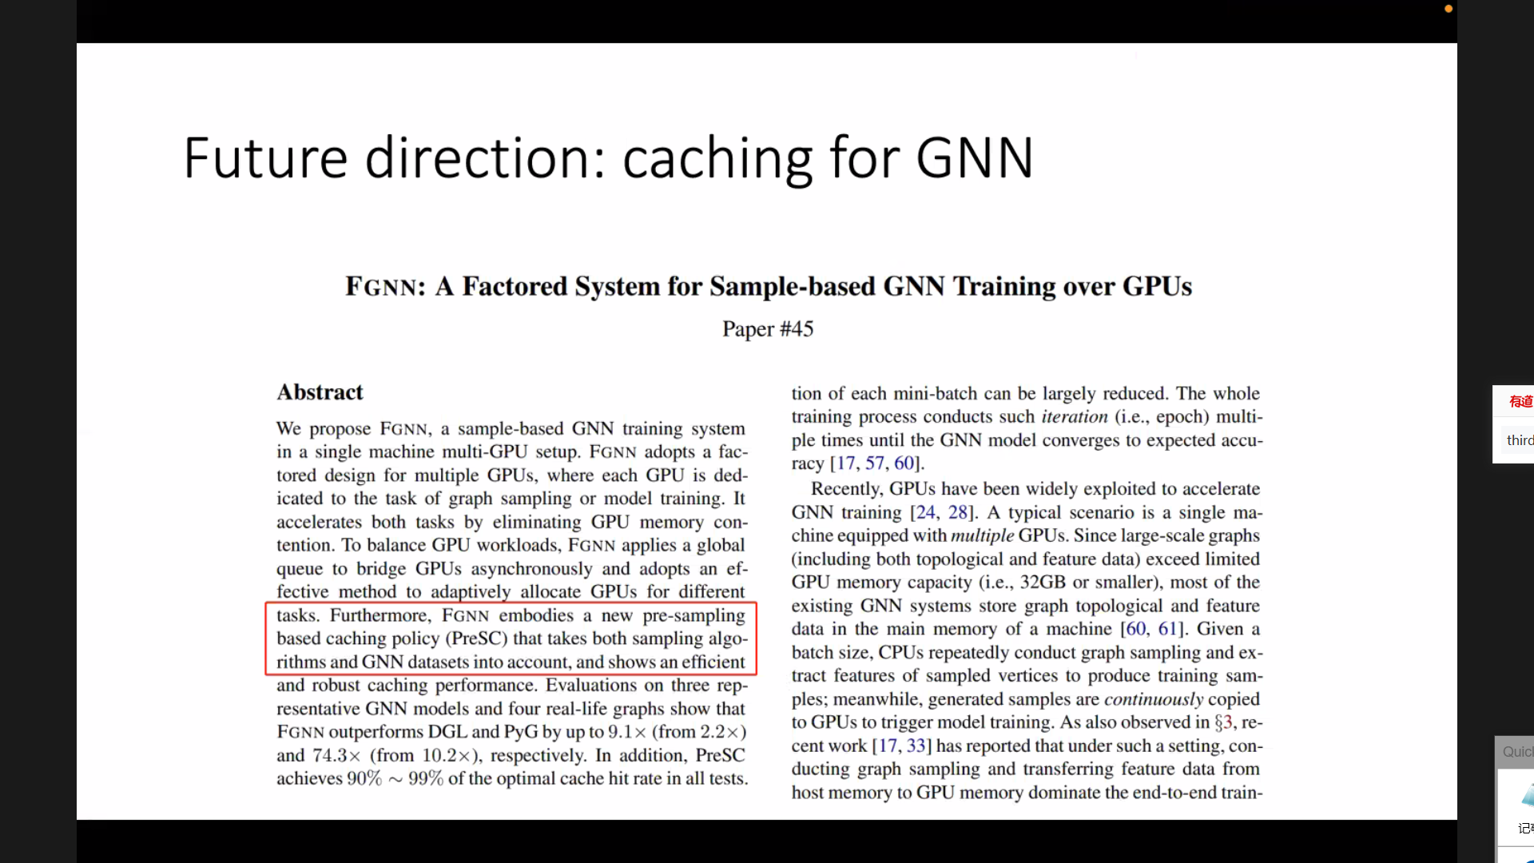 GPU 预期 memory验证哪个层次实现

GPU 预期 memory

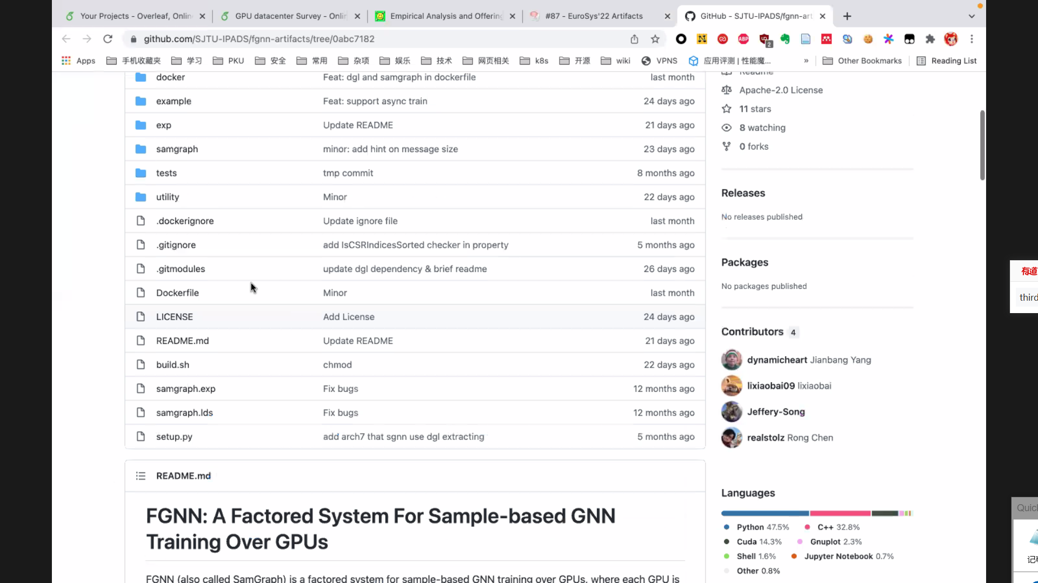

验证

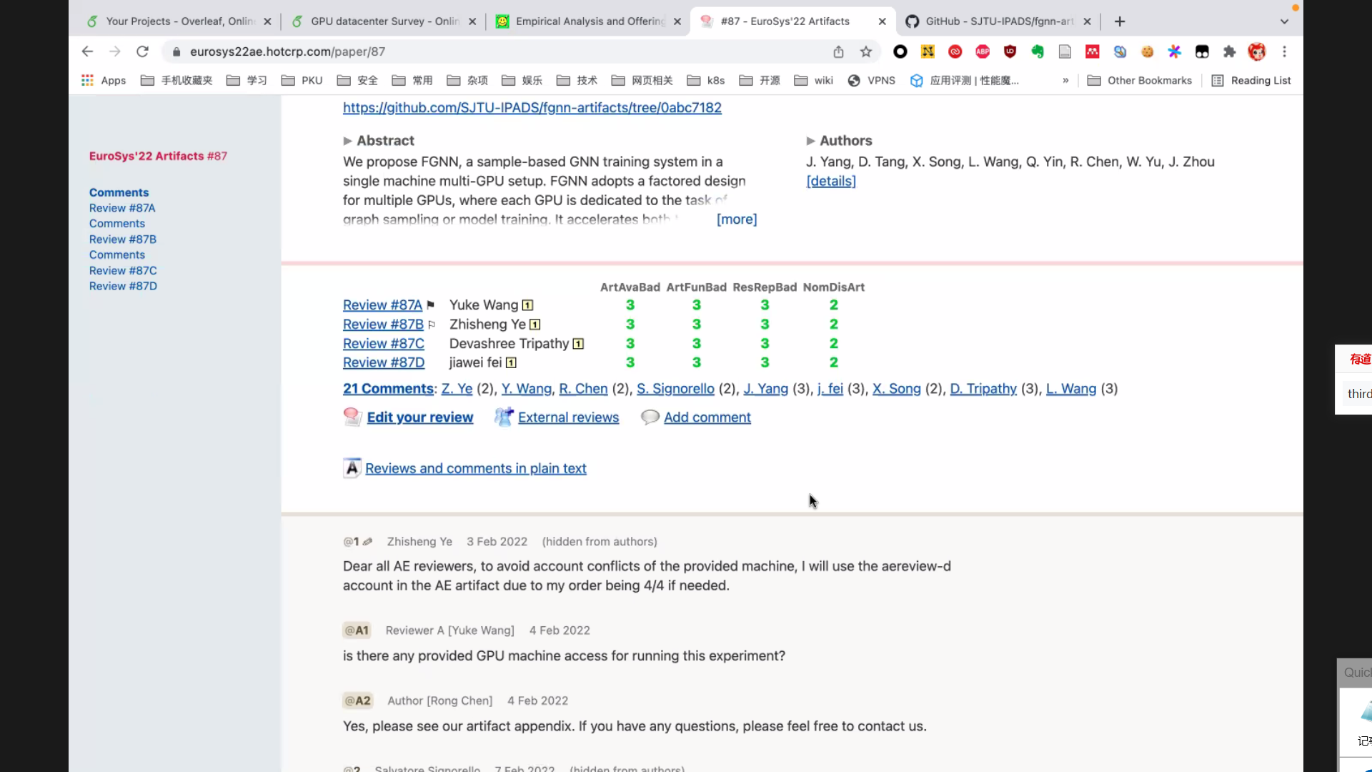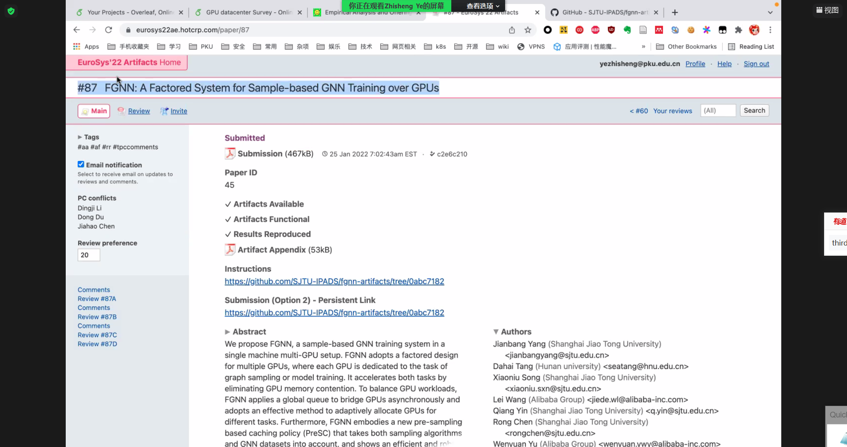

哪个层次实现