Supplementary Materials for

A self-cleaning, bio-inspired high retention filter for a major entry path of microplastics

Leandra Hamann*¹, Christian Reuß^{1,2}, Hendrik Herzog¹, Kristina Schreiber^{1,3}, Christian Geitner⁴, Alexander Blanke¹

*corresponding author. Email: lhamann@biob.uni-bonn.de

¹ Bonn Institute for Organismic Biology, University of Bonn, An der Immenburg 1, 53121 Bonn, Germany
² DSG-Canusa GmbH, Boschstraße 17, 53359 Rheinbach, Germany; Development Engineer
³ Biomimetics Group, Energy and Sustainability Research Institute, University of Groningen, Nijenborgh 7, 9747 AG, Groningen, The Netherlands
⁴ Fraunhofer Institute for Environmental, Safety and Energy Technology UMSICHT, Osterfelder Straße 3, 46047 Oberhausen, Germany

Supplementary Note 1

Technical Requirements in Washing machines

The use of washing machines is common in the European Union ¹. In Germany, 96% of the households owned one in 2007 and washed 164 to 234 times annually ¹. The typical European washing machine is front loading (Supplementary Figure 1) and has a standardized size of 85 cm in height, 60 cm in width, and 60 in depth. A large part of the inner space of washing machines is used for the drum and additional room for it to swing during the spinning cycle. The remaining space is used for valves, pipes, the detergent drawer, and a coarse filter to protect the pump by retaining stones or coins ². This leaves an available space of an average 34 cm in height, 21 cm in width, and 16 cm in depth for an additional filter (own measurements in four models).
During washing, fresh water is let through the detergent drawer into the drum (Supplementary Figure 1). Depending on the washing programme, it usually takes two to three washing cycles. Afterwards, the implemented pump transports the effluent out of the drum and into the wastewater system with a pressure of around 0.1 to 0.15 bar (for example, Miele PWM 908 DV/DP). Depending on the washing load, type of programme, and washing machine model, the amount of water varies between 20 l and 120 l but is around 60 l in most washing programmes in Germany ³. There are typically two to three pumping cycles in one washing programme, of which each can have a maximum volume flow of up to 5 l/min and a maximum flow velocity of 0.5 m/s (pipe diameter of 20 mm; own measurements). The washing temperature is usually between 30°C and 60°C, with a maximum of 95°C ¹.
Fibre release from textiles into the effluent depends on factors such as the textiles' composition, age and structure, washing machine type, and washing machine programme ^{4,5}. Textile fibres are made from natural sources, e.g., cotton, flax, wool, silk, cellulose, and viscose, or made from plastics, e.g., polyester, polyamide, or polypropylene ⁵. MPs fibres have a maximum length of 15 mm and a length-to-diameter ratio of >3 ⁵. Washing machines remove stains, oils, greases, and dirt, such as sand, dust, pollen or hair from clothing and other textiles. Dirt that ends up in the effluent could affect the MP filter’s performance by blocking the filter mesh. Additionally, detergents can increase clogging because they contain insoluble ingredients, such as zeolites. This is not a problem for liquid or gel detergents, but powders can contain up to 20% of zeolites ⁴.
In later design stages, the biomimetic filter should also sustain temperatures up to 90°C, alkaline detergents, and a wet or moist environment. Ideally, the filter could be added to the position of the already installed coarse filter to retrofit old washing machine models. A marked-ready product should be cost-efficient, eco-friendly, reduce fouling, and user-friendly, especially for cleaning and removal of captured lint ⁶.

Supplementary Note 2

Test Stand and Test Procedure

Selecting a filter medium with an appropriate mesh size and permeability is an important step in fulfilling the separation task, but it also determines the volume flow through the fish-inspired filter (FiF) ⁷. High permeability represents a low resistance to flow and vice versa. It is directly proportional to flow rate, fluid viscosity, filter medium thickness, and inversely proportional to filter area and fluid density ⁷. During the filtration process, particle deposition on the filter medium increases the hydrodynamic drag, and the flow rate will decrease and eventually stop when the filter is clogged. In order to maintain a constant flow rate, the pumping pressure has to be increased (energy and cost investment), or the filter medium needs to be cleaned ⁸.
Before each experiment, the water reservoir was filled with 25 l. We tested cotton fibres, polyamide MP fragments, and 2mm polyamide MP fibres (for particle details see Main Text Table 2) and added 5 ml of liquid detergent to the suspension to reduce the adherence of the test particles to the walls of the test stand. As tested in supplement experiments, the liquid detergent does not influence the sample analytics (Supplementary Note 3). The volume flow was recorded with a camera (Nikon D850, Macro lens Nikkor AF-S 24-120 mm 1:4 G ED) directed towards the water reservoir to monitor the water level over time. The experiment ended after 20 l passed the FiF by closing two manual valves at the permeate and concentrate outlet.
Each combination was repeated five times. Between each trial, the test stand was rinsed with clean water, and the filter element was washed manually to remove retained particles. The recorded videos were analysed for the time when 5 l, 10 l, 15 l, and 20 l passed the FiF. The data was analysed and visualised using the R programming environment (R Core Team, R version 4.2.2, 2022) and the ggplot2 package ⁹. Experiments were repeated when something unusual occurred during the experiment, e.g., a kink in the hose. Results are presented in line graphs with the filtered volume plotted over time (Supplementary Figure 4). The time to filter 15 l was extracted and presented in boxplots.

Four inlets, i.e., short, long, swirl, and snail, were tested in all combinations with the four filter elements and no filter element in the filter housing. No particles, siphons or valves were used. The time to filter 20 l through the filter module increases linearly in all filter elements when no particles are filtered, showing a steady volume flow (Supplementary Figure 4A). The different inlets have little influence on the time to filter 15 l. Across all combinations, the long inlet with the Large-11 filter element has the fastest volume flow with 60.8 ± 4.4 s to filter 15 l, and the slowest is the snail inlet with no filter element with 64.8 ± 1.3 s, a difference of 0.27 s/l.

The influence of different particle types on volume flow was tested with three different particle types: cotton fibres, 2 mm MP fibres, and MP fragments (Main text, Table 2). The particle concentration was set to 0.1 g/l. In order to achieve the highest effect and eventually clogging, the Small-11 filter element was chosen because it has the smallest filtration area, and was tested in combination with the small and snail inlet. No siphons and valves were used in this setup. The MP fibres are the fastest to be filtered (Supplementary Figure 4B). The suspension with MP fragments takes the longest in combination with the small inlet, and the cotton fibres take the longest with the snail inlet.

In order to implement the cleaning mechanism by automated valves, the setup was changed. A siphon was formed with the pipe of the permeate outlet and the valves were integrated in the concentrate and permeate outlet. The volume flow through the new setup was tested with the snail inlet but no filter element and no particles. The implementation of the valves does not influence volume flow. The siphon in the permeate outlet increases the time to pass the filter module by around 160% (Supplementary Figure 4C).

Two automatic valves were implemented in the concentrate and permeate pipe to clean the filter element at set intervals. The concentrate outlet opened and the permeate outlet closed for 0.6 s for the Small filter elements and 1.3 s for the Large filter elements when 10 l and 20 l passed the filter module. The cleaning effect on volume flow was tested with the Small-11 filter element and cotton fibres (0.1 g/l), as this combination has the highest chance of clogging. The snail inlet was used, and a siphon was formed in the permeate outlet pipe. The cleaning of the filter element after 10 l and 20 l does not influence the volume flow when no particles are present. When cotton fibres are filtered, the time to filter one litre increases from 4.04 s/l for the first 5 l to 9.92 s/l for the last 5 l (Supplementary Figure 4D). After 15 l, the filtering process of cotton fibres is 125% slower compared to MP fibres. The cleaning of the filter element after 10 l and 20 l reduces the time to filter 15 l to 93%.

The volume flow through the Large-11 filter element with the bio-inspired surface structures (Fig. 2C) were compared to the Large-11 filter element with no surface structures and the dead-end filter. The snail inlet was used, MP fibres were added (0.025 g/l), and the siphon was present. Only 10 l were filtered and the filter element was cleaned after 5 l and 10 l. The surface structures in the Large-11 filter element do not influence the volume flow compared to the Large-11 filter element with no surface structures or the dead-end filter (Supplementary Figure 4E).

Supplementary Note 3

Analytical Procedure

Three samples were taken after each experiment: 1) the total volume of the concentrate, 2) one litre of the permeate, and 3) all the MP fibres that remained within the filter element, i.e., the retentate (M_{R}) suspended in a maximum of one litre. The MP fibre mass fractions were separated from the water using a suction filter (Nalgene Reusable Bottle Top Filter) with round filtering papers (ROTILABO Type 11A, ø 45 mm, retention range 12-15 µm) and a vacuum pump (Vaccubrand MZ 2C, 1.7 m³/h = 28.3 l/min). Prior to the vacuum filtration, the filtering papers were labelled, dried in a heating cabinet (minimum 30 min), cooled down in a desiccator (minimum 30 min), and weighted with a precision scale (Sartorius ED153-CW, weighing capacity 150 g, readability 0,001 g, repeatability (std. deviation) ≤± 0.001 g). After the samples were poured onto the suction filter, the bottle, bottle cap, and walls of the suction filter were rinsed with deionized water, so all fibres were collected on the filtering paper. Afterwards, the filtering papers with the MP fibres (Fig. 9) were dried in the heating cabinet and desiccator and weighted again. The weight difference determined the MP fibre mass of each sample.
In order to test the lab contamination and the scale's accuracy, three control samples were treated with the analytical procedure but filtered with 1000 ml of clean tap water and weighted three times. The weight difference of the filter papers without experimental samples are 0.00107 g, 0.00010 g, and 0.00010 g. Additionally, we ran three blank trials after rinsing the test stand and without adding MP fibres to determine the contamination of the test stand and the influence of previous trials. The weight difference of the filter papers with the blank samples are 0.00082 g, -0.00029 g, and -0.00059 g for the concentrate samples and -0.00667 g, -0.01148 g, and -0.01574 g for the permeate samples. Due to the high contamination in the permeate samples, all results are rounded to two decimal places.
Washing machine effluent usually contains detergents, either as a liquid or powder ⁴. In previous studies, it was shown that the powder can cause clogging of the filtering papers in the analytical process of effluent analysis, because it contains small particles, so called zeolites. To test the influence of detergents on the analytical procedure and decide on a final effluent mixture for the experiments, we tested two powder detergents (P1: Persil Universal Color Pulver, P2: Frosch Voll-Waschpulver), one liquid detergent (FL: Frosch Sensitiv-Waschmittel Aloe Vera), and a liquid fabric softener (WS: Sodasan Weichspüler Lavendel). Based on the manufacturer’s specification, we weighted 3 g/l of the powder detergents and 2 ml/l of the liquid detergents. Each detergent was combined with 50 mg/l of the MP fibres, added to one litre of water four hours prior to the experiment and shaken to dissolve the detergents in the water. The analytical procedure to analyse the suspensions followed the standard previously described for the filter efficiency experiments (Main Text, Materials and Methods). Weight difference and volume of filtered suspension were measured to determine the influence of the analytical procedure.
The results show that the type of detergent has a high influence on clogging of the filtering paper. When powder detergent is used, on average 218.33 ml (N = 6) can be filtered. At the same time, 991 ml (N = 6) of the samples with the liquid detergent or softener can be filtered. Foaming appears during the vacuum filtration of the liquid detergents, which might explain the slight volume loss. Based on the experiments in which all of the suspension is filtered, 97.8% (N = 6) of the particles are recovered, which means that 2.2% of the MP fibres are lost during the analytical procedure. In order to further reduce MP fibres loss, we optimised the handling in the petri dishes. In this experiment, the petri dish cover was leaned against the petri dish bottom to allow air circulation. To improve this setup, we drilled a hole in the covers and closed it with a filter mesh with a mesh size of 20 µm. This allows air circulation and drying, while keeping the MP fibres inside. Only 140 ml of washing machine effluent can be filtered until the filter paper is clogged.

Loss of particles within the experimental setup was determined through the recovery ratio R. It is determined by the sum of the particle mass fractions collected within the concentrate, the permeate (extrapolated to total permeate volume) and the filter in relation to the total particle mass in the feed (Equation 1).
1) | $$\frac{M_{c}+(M_{P}*\left(V_{F}-V_{C}\right)+M_{R})}{M_{0}}*100$$ | with  R = recovery ratio [%]  M_{C} = Particle mass in concentrate [g]  M_{P} = Particle mass in permeate [g]  V_{F} = feed volume [l]  V_{C} = concentrate volume [l]  M_{R} = Particle mass in retentate [g]  M₀ = Total particle  mass in the feed [g/l]

Because we observed agglomeration of cotton fibres in the volume flow experiments, we only used MP fragments particles and MP fibres to then test the particle recovery. However, the initial tests showed that the recovery rate of MP fragments is lower than with MP fibres. A comparison of the MP fragments versus MP fibre recovery across all experiments shows that MP fibres are recovered with 76.4 ± 18.1% (N = 71) and MP fragments are recovered with 32.3 ± 23.7 (N = 5).

Supplementary Figure 1
Setup of a washing machine and fibres extracted from washing machine effluent. (A) Schematic graphic of a washing machine with water flow (blue), functional parts and four potential positions for microplastic filters indicated by F1 to F4. (B) Photo of fibres and dirt separated from washing machine effluent on a filter medium.

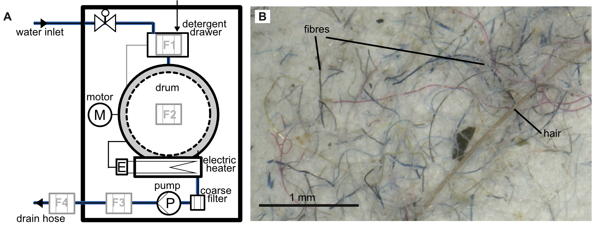

Supplementary Figure 2
Volume render cross-sections through the frontal plane with view on the ventral side of the buccal cavity of Micro-CT scans for each species: (A) the Atlantic mackerel Scomber scombrus, (B) the Indian mackerel Rastrelliger kanagurta, (C) the Atlantic herring Clupea harengus, (D) the Atlantic pilchard Sardina pilchardus, and (E) the Atlantic anchovy Engraulis encrasicolus. For methods see Hamann et al., 2023 ¹⁰. Organisms not to scale. The angle of attack α was measured for each GA in the frontal cross-section between the GR and the hyoid bone, as depicted in (B), using ImageJ (Version 2.3.0) and is given as the mean of the left and right GAS side as bar plots.
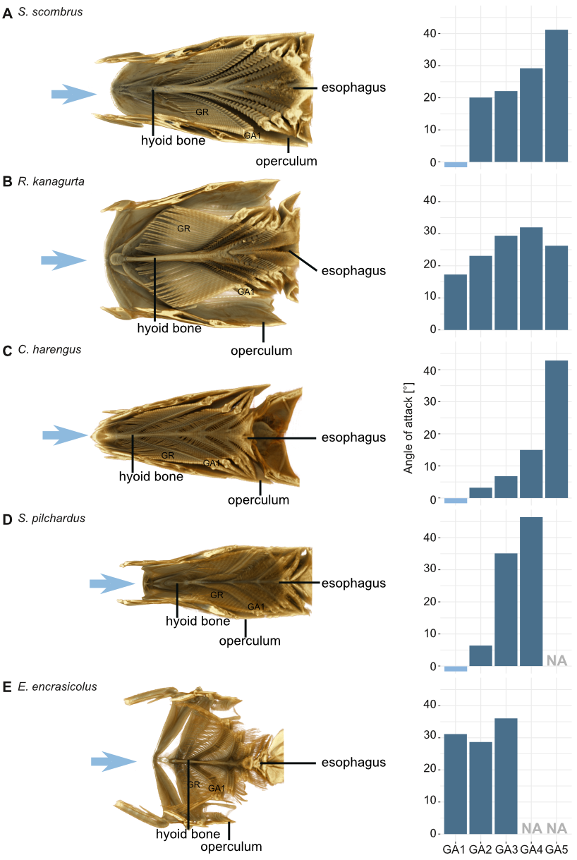

Supplementary Figure 3
Data analysis and results of angle of attack experiments. (A) Examples of extracted particle velocity and fitted Boltzmann sigmoidal curve for brine shrimp eggs and adults for ⍺ = 10° and ⍺ = 60°. A threshold value was set to 0.3 cm/s (20% of the average minimum velocity of all observed particles after contact with the filter medium) to distinguish rolling particles (>0.3 cm/s) and particles that stopped on the filter medium (<0.3 cm/s). The velocity of incoming particles before contact with the filter mesh are indicated by yellow. Particle velocity of particles after contact with the filter mesh (stopped or rolling) are indicated in green. (B) Overview of the average particle velocity before (yellow) and after (green) contact for all angles and particle types (brine shrimp eggs, brine shrimp adults, MP fragments, MP fibres).

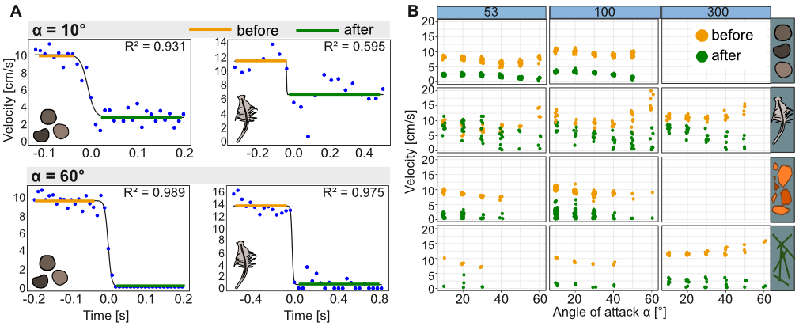

Supplementary Figure 4
The CFD simulation using COMSOL® with flow through the FiF during filtration mode shows the different paths of streamlines flowing through Gap1 depending on the long inlet with (A) no inner wall and (B) an inner wall. (A) The long inlet with no inner wall creates a recirculation zone with a stable, trapped vortex The vortex flows through gap2 and gap3 turns around in the lower corner of the housing and flows back through gap1. (B) In the setup with the long inlet with the inner wall, the streamlines flow through gap1 and towards the permeate outlet. This difference explains the negative angles α(eff) at Gap1 in Fig 4C. Direction of flow is indicated by blue arrows.

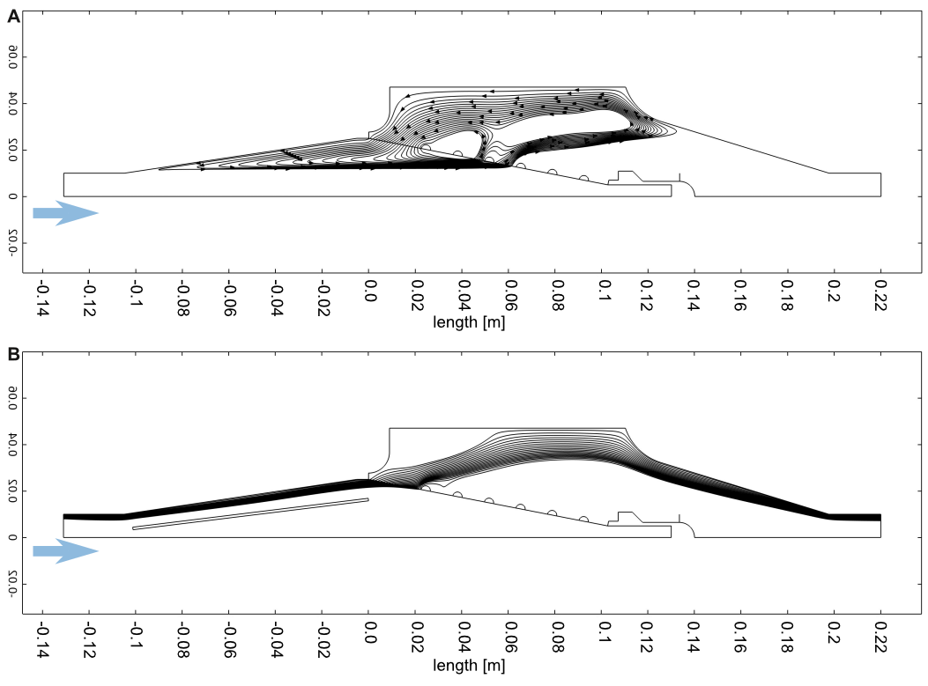

Supplementary Figure 5
Results of preliminary experiments to establish the test procedure and measure volume flow. Volume flow through the biomimetic filter module and comparison of the time to filter 15 l for each tested factor. A) Comparison of the four inlets with each filter element (N= 5, no particles, no siphon, no valves). B) Comparison of three particle types: cotton fibres, MP fibres (F2), and MP fragments (PA) with the Small-11 filter element (no siphon, no valves). C) Influence of siphon and valves on the setup (no filter, no particles, snail inlet). D) Influence of cleaning on volume flow (Small-11 filter element, cotton fibres, snail inlet, siphon). E) Comparison of the Large-11 filter element (L) with biomimetic surface structures (0.5 = half-length with Velcro, 1 = full length with Velcro, B = ellipsoids) and the dead-end filter (snail inlet, siphon).
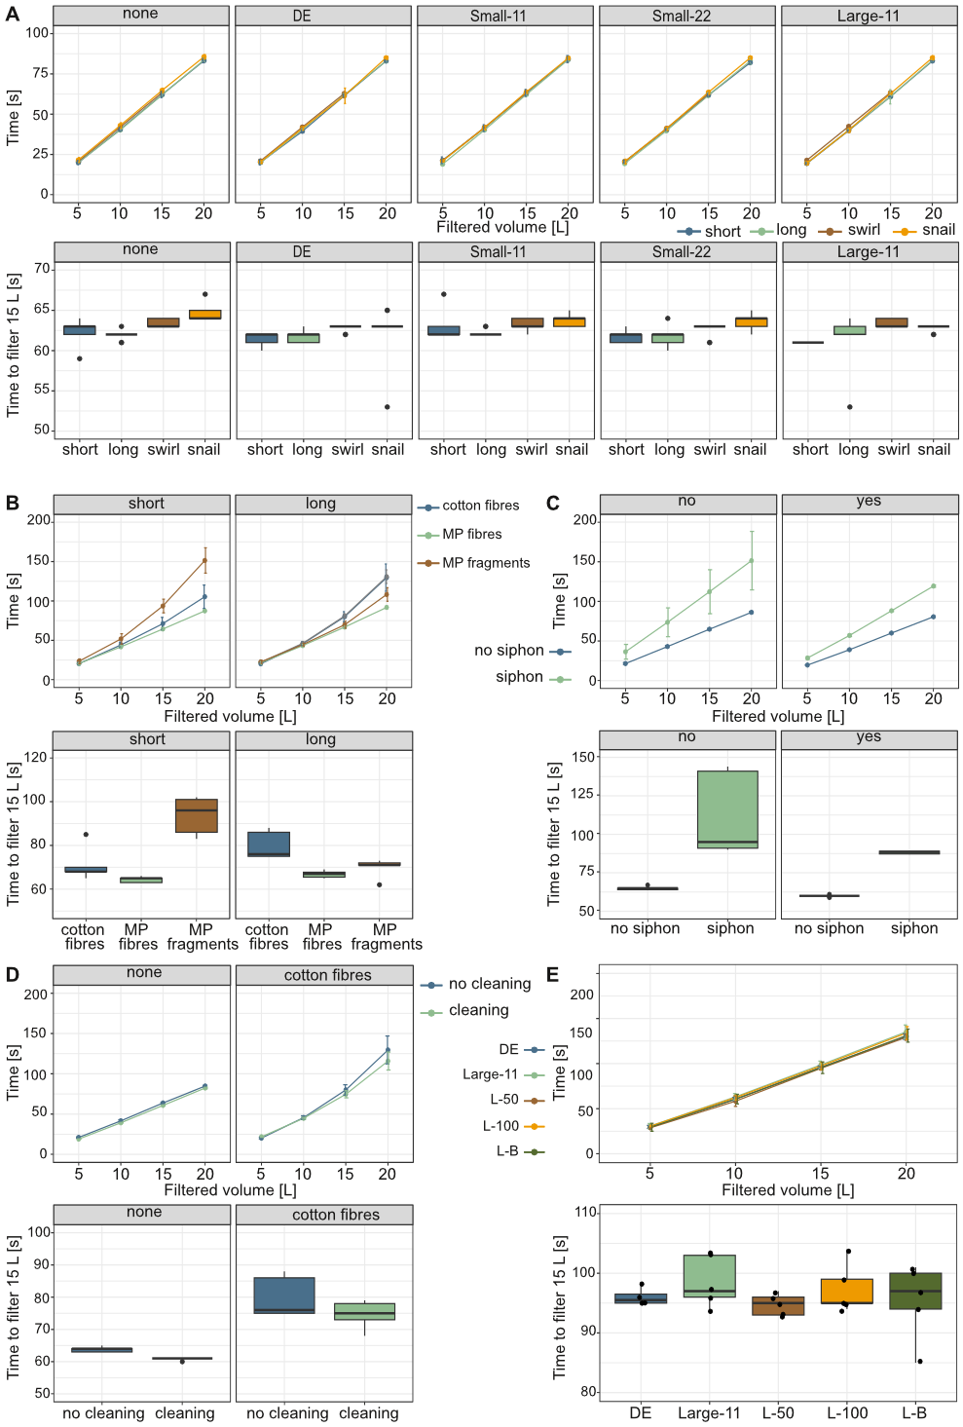

Supplementary References

1. Lasic, E. Sustainable use of washing machine: modeling the consumer behavior related resources consumption in use of washing machines. (University of Bonn, Bonn, Germany, 2014).
2. Masselter, T. et al. Improvement of a microfiber filter for domestic washing machines. Bioinspir. Biomim. 18, 016017 (2023).
3. Pakula, C. & Stamminger, R. Electricity and water consumption for laundry washing by washing machine worldwide. Energy Effic. 3, 365–382 (2010).
4. Schöpel, B. & Stamminger, R. A Comprehensive Literature Study on Microfibres from Washing Machines. Tenside Surfactants Deterg. 56, 94–104 (2019).
5. Zhang, Y.-Q. et al. Microplastics from textile origin – emission and reduction measures. Green Chem. 23, 5247–5271 (2021).
6. Abourich, M., Bellamy, A., Ajji, A. & Claveau-Mallet, D. Washing machine filters to mitigate microplastics release: Citizen science study to estimate microfibers capture potential and assess their social acceptability. Environ. Challenges 16, 100984 (2024).
7. Sutherland, K. Filters and Filtration Handbook. (Elsevier, 2008). doi:10.1016/B978-1-85617-464-0.X0001-6.
8. Richardsons, J. F., Harker, J. H. & Backhurst, J. R. Coulson and Richardson’s Chemical Engingeering: Particle Technology and Separation Processes. vol. 2 (2002).
9. Wickham, H. ggplot2: Elegant Graphics for Data Analysis. (Springer International Publishing, 2016). doi:10.1007/978-3-319-24277-4.
10. Hamann, L. et al. Diversity of filter feeding and variations in cross-flow filtration of five ram-feeding fish species. Front. Mar. Sci. 10, 1–21 (2023).

