作业：每人阅读论文，形成阅读报告。

报告内容：

论文题目

具体问题切入点

解决方案（创新点）

得到的结果

**1. A Characterization of the COVID-19 Pandemic Impact on a Mobile Network Operator Traffic**

Problem:

To investigate how COVID-19 pandemic impact mobile network operator traffic, authors quantified the changes in users’ mobility and investigated how this impacted the cellular network usage and performance in entire UK and specific regions of UK.

Method:

Collected network data from cell towers and radio Interfaces, then captured the user activity, devices catalog and radio network performance.

They used the TAC database to filter only the devices that are smartphones and dropped international users and linked those devices with each radio tower, and then they used two metrics: entropy and radius of gyration, to measure the randomness of the movements of an individual, finally got the dataset about users’ mobility. But they just investigated the relationship between mobility and time (e.g., investigated gyration and entropy variation per day to find the mobility differences in pandemic period and lockdown period), so they didn’t involve other methods like machine learning.

For mobile network performance, they also just ordered their data by time, but we still can clearly see the variation in different periods of pandemic.

Conclusion:

They found there is no correlation between this reduction in mobility and the number of confirmed COVID-19 cases in UK, but the government enforcing order was effective in significantly reducing mobility (overall decrease of 50%) and the reduction is more significant in densely populated urban areas than in rural areas (People left big city like London to escape the pandemic and voluntary or involuntary stayed in countryside).

For specific mobile network traffic, the voice traffic upped to 150% accompanied by an overall decrease of download traffic (-20%), especially in densely populate urban areas (-60%), and an increase of uplink traffic in suburbanites (10%).

But the MNO (Mobile Network Operator) still maintained a good mobile network condition, only a packet loss problem in voice traffic was found and already fixed by MNO.

**2. Mobile Network Performance during the COVID-19 Outbreak from a Testbed Perspective**

Problem:

Using the Measuring Mobile Broadband Networks in Europe (MONROE) platform and use results from long-running measurements to investigate the effects of COVID-19 on the performance of 9 mobile networks in Europe (Italy, Sweden, Norway, and Spain).

Method:

They got dataset from MONROE platform and used the MONROE-browsertime to measure the features like PLT and RTT. Then by using different MONROE Experiments, they got Web Dataset, Nettest Dataset, Ping and Metadata Dataset and Tstat Dataset.

To analysis network performance, they firstly illustrated CDF of Round Trip Time (RTT) and Goodput (performance index for download services) in each month and we can see that the RTT went higher in the later month, but we cannot see any significant variation over time on Goodput.

The rest work they did like investigating average TCP throughput in Downlink and Reference Signal Received Quality (RSRQ) just were illustrated over time, just like the last paper. Most of investigation they did just like that because they can easily get the conclusions from using date as the x-axis (e.g., the Downlink data rate in Italy suddenly went high in the middle of March as the pandemic outbreak and the government forced people locked down).

They also present the distributions of the RTT in the form of a boxplot in January and March respectively. we can see the RTT of an Italy operator varies drastically and the median goes bigger, while the RTT of other operators doesn’t change much in those two months, this just confirms Italy was the first outbreak country in Europe.

At last, they present the figures for RTT and RSRQ in 2 different countries’ operator on a 6 hour scale. Observing variations on this scale is an innovative point. We can clearly see in Italy, a wider range of high RTT in March but it turns to lower values beginning in the second half of April and in Sweden, the values are much lower than for operator in Italy.

Conclusion:

They evaluated mobile performance like web Quality of Experience, TCP throughput, RTT. Overall, their findings suggest that mobile operators have been able to cope with the pandemic period, although some short-term performance degradations are observable and different countries’ mobile networks are impacted by COVID-19 at different times based on the outbreak timelines in these countries.

**3. Detecting Regions At Risk for Spreading COVID-19 Using Existing Cellular Wireless Network Functionalities**

Problem:

How to predict COVID-19 pandemic from user’s mobile devices without jeopardizing user’s privacy (without installation of any app nor any other action on the part of mobile users).

Method:

Exploiting cellular-network devices (user equipment (UE)) to investigating its user’s mobility. According to the Infectivity of SARS-Cov-2, they can mark different areas as high risk (at-risk) or low risk. Their strategy is based on inferring the crowdedness and mobility using measurements of quantities already accessible to the cellular wireless network via UE mobility management protocols.

To achieve that, they exploit existing network functionalities required to keep each UE connected while moving, exchanging UE-specific information with the network. The mobility of each UE is handled by two essential protocols: handover (HO) and cell (re)selection (CS). In short, by judging whether UE have hand overed or reselected to other cell towers, they can get the data of whether user leave their cell.

So In a high density area, if user moves frequently, UEs will frequently initiate HO/CS events. If the HO/CS rates from a certain cell are relatively high, this cell should be classified at-risk. And then, for example, the network might broadcast advisory messages to the affected UEs: “This Area is at risk of COVID-19: It has many actively moving people.”

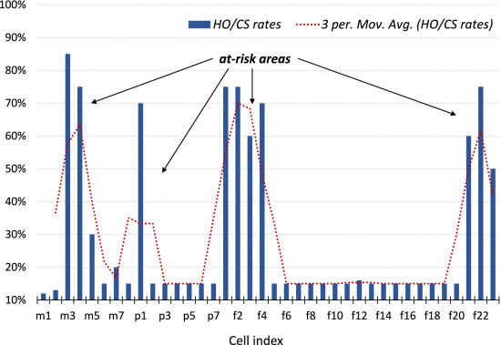

Conclusion:

Their new strategy can be used as identifying areas that potentially contribute to the spread of COVID-19, and MNOs can use this information to remind users be aware of potential pandemic spread in their area.