测试样例，**45456803 紧急联系人社区**

1. **Deepwalk 无向图**

参数 walk_length=20, num_walks=80

{'micro': 0.55863539445629, 'macro': 0.3777254562348335, 'samples': 0.55863539445629, 'weighted': 0.5116491793805881, 'acc': 0.55863539445629}

聚类效果

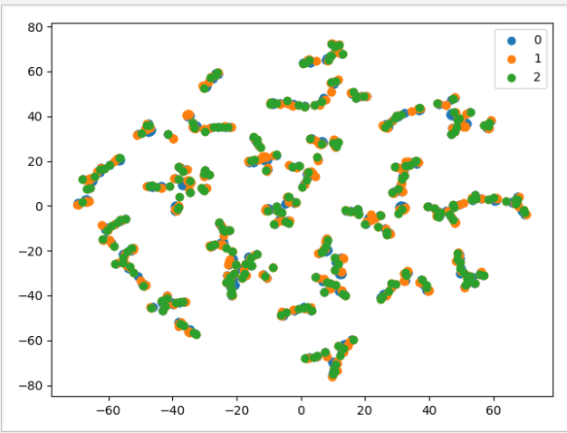

参数 walk_length=40, num_walks=80

**{'micro': 0.5543710021321961, 'macro': 0.3841693833911733, 'samples': 0.5543710021321961, 'weighted': 0.5166485078326648, 'acc': 0.5543710021321961}**

参数 walk_length=80, num_walks=80

{'micro': 0.5671641791044776, 'macro': 0.3868299894555129, 'samples': 0.5671641791044776, 'weighted': 0.5222637678659173, 'acc': 0.5671641791044776}

有向图 参数 walk_length=40, num_walks=80

{'micro': 0.8614072494669509, 'macro': 0.6068376068376069, 'samples': 0.8614072494669509, 'weighted': 0.81132797550708, 'acc': 0.8614072494669509}

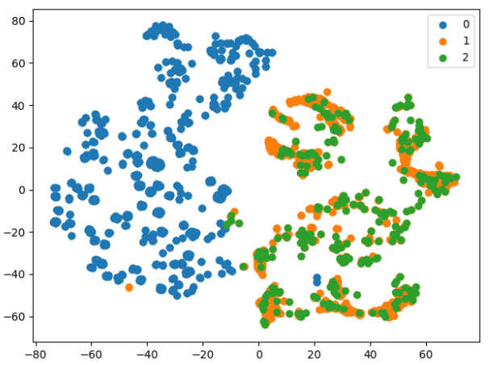

对于人和电话的区分度非常高，主要没有区分个人电话与紧急联系人电话的能力

1. **Line**

**参数** batch_size=1024, epochs=150, verbose=2

embedding_size=128, order=**'second' 无向图**

**{'micro': 0.7782515991471216, 'macro': 0.5461988304093568, 'samples': 0.7782515991471215, 'weighted': 0.7300259834431083, 'acc': 0.7782515991471215}**

**参数** embedding_size=300, order=**'second' 无向图**

**{'micro': 0.7889125799573561, 'macro': 0.5573834053395369, 'samples': 0.7889125799573561, 'weighted': 0.7459046102630276, 'acc': 0.7889125799573561}参数** embedding_size=400, order=**'second' 无向图**

**{'micro': 0.8038379530916845, 'macro': 0.5673016916035206, 'samples': 0.8038379530916845, 'weighted': 0.7584780097331941, 'acc': 0.8038379530916845}参数** embedding_size=500, order=**'second' 无向图**

**{'micro': 0.8081023454157783, 'macro': 0.576820209603922, 'samples': 0.8081023454157783, 'weighted': 0.7726869876649297, 'acc': 0.8081023454157783}**

embedding_size=600, order=**'second' 无向图**

**{'micro': 0.8208955223880597, 'macro': 0.5950248321598297, 'samples': 0.8208955223880597, 'weighted': 0.7875315049604084, 'acc': 0.8208955223880597}**

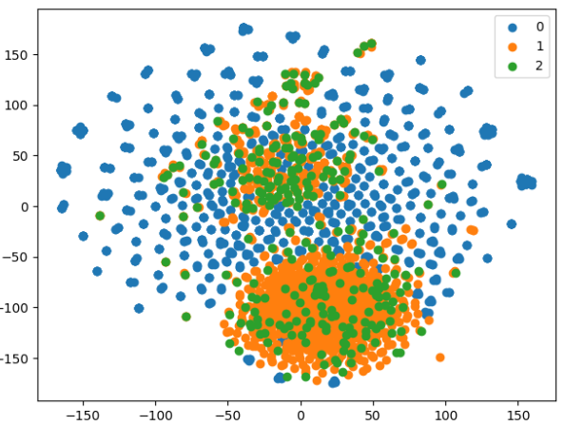

**参数** embedding_size=128, order=**'second' 有向图**

{'micro': 0.8848614072494669, 'macro': 0.6244131455399061, 'samples': 0.8848614072494669, 'weighted': 0.8345896273161356, 'acc': 0.8848614072494669}**参数** embedding_size=300, order=**'second' 有向图**

{'micro': 0.8848614072494669, 'macro': 0.6244131455399061, 'samples': 0.8848614072494669, 'weighted': 0.8345896273161356, 'acc': 0.8848614072494669}

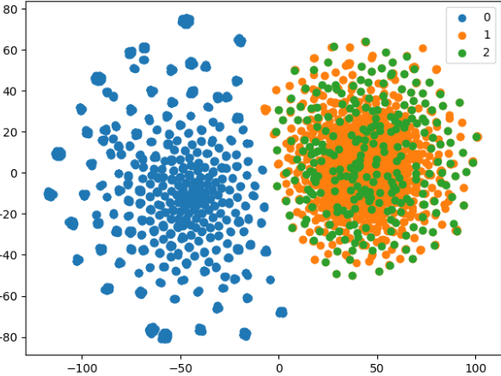

**对电话个用户是有完全的区分能力，对个人电话和紧急联系人电话区分能力弱**

1. **SDNE**

hidden_size=[256, 128] 无向图

batch_size=3000, epochs=150, verbose=2

**{'micro': 0.7057569296375267, 'macro': 0.4994633701039987, 'samples': 0.7057569296375267, 'weighted': 0.6673411954258115, 'acc': 0.7057569296375267}**

hidden_size=[256, 256]

**{'micro': 0.7505330490405118, 'macro': 0.5307944307944309, 'samples': 0.7505330490405118, 'weighted': 0.7083375680390607, 'acc': 0.7505330490405118}**

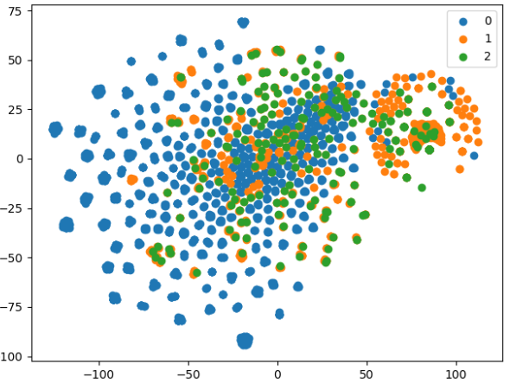

hidden_size=[256, 128] 有向图

batch_size=3000, epochs=150, verbose=2

**{'micro': 0.8805970149253731, 'macro': 0.6215909711974641, 'samples': 0.8805970149253731, 'weighted': 0.8308297770510807, 'acc': 0.8805970149253731}**

hidden_size=[256, 256] 有向

**{'micro': 0.8848614072494669, 'macro': 0.6244131455399061, 'samples': 0.8848614072494669, 'weighted': 0.8345896273161356, 'acc': 0.8848614072494669}**

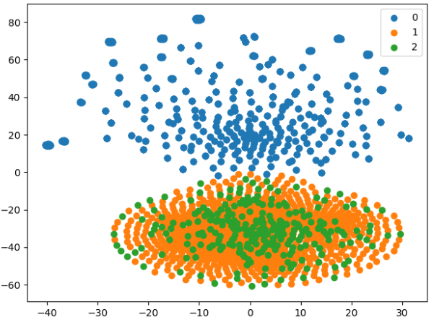

**二分类的情况下**

**{'micro': 0.9957356076759062, 'macro': 0.9957323287471791, 'samples': 0.9957356076759062, 'weighted': 0.9957351032253328, 'acc': 0.9957356076759062}**