第一题：select

a.age,

avg(t.Rate) as avg_rate

from t_rating t

left join t_user a

on t.UserID=a.UserID

where t.MovieID='2116'

group by

1. age;

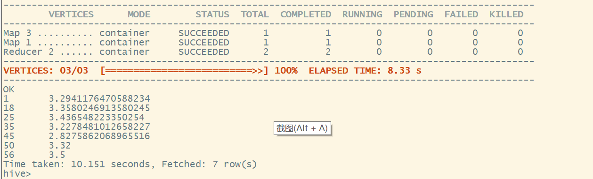

第二题：

select

c.MovieName,

count(1) as cishu,

avg(t.Rate) as avg_rate

from t_rating t

left join t_user a

on t.UserID=a.UserID

left join t_movie c

on t.MovieID=c.MovieID

where a.Sex='M'

group by c.MovieName

having count(1)>50

order by avg(t.Rate) desc

limit 10;

