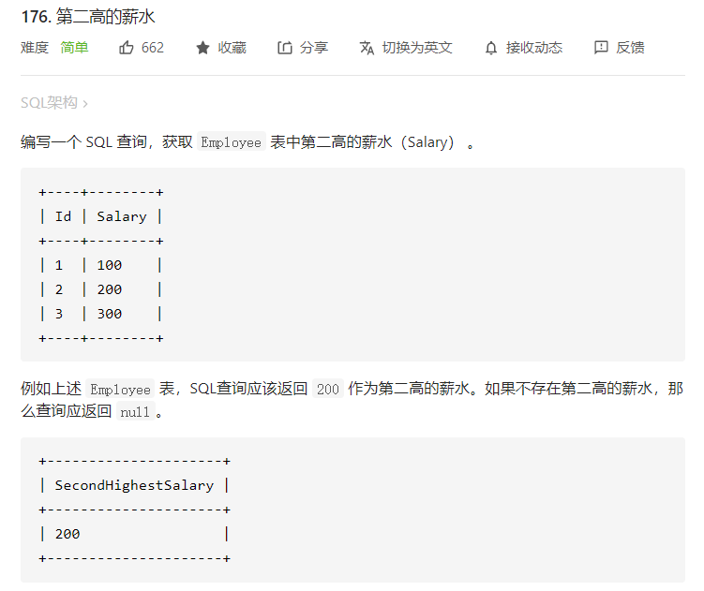

select ifnull (

(select distinct salary from Employee

order by salary desc

limit 1,1),null ) as SecondHighestSalary;

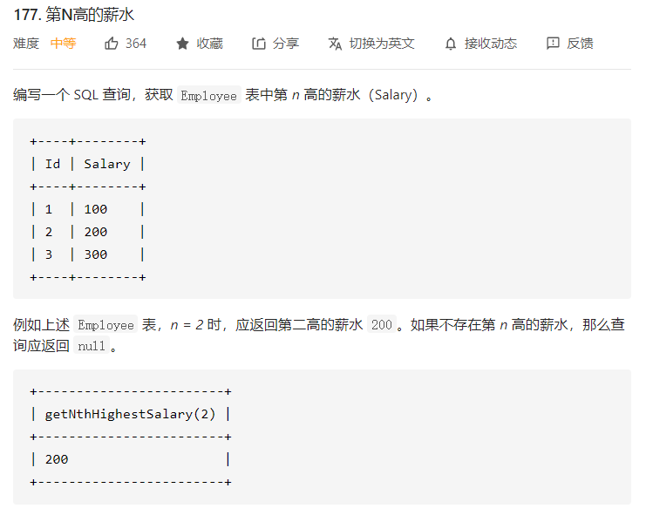

#构建一个函数

CREATE FUNCTION getNthHighestSalary(N INT) RETURNS INT

BEGIN

    declare m INT;

    set m = N-1;

  RETURN (

      # Write your MySQL query statement below.

      select ifnull((select distinct Salary from Employee order by Salary desc limit m,1),null)

  );

END