2020-8-12

S(t) = (1-epsilon)*S(t-Trev)+V(t)*epsilon

I_drive(t) = I_rev(t)+S(t)

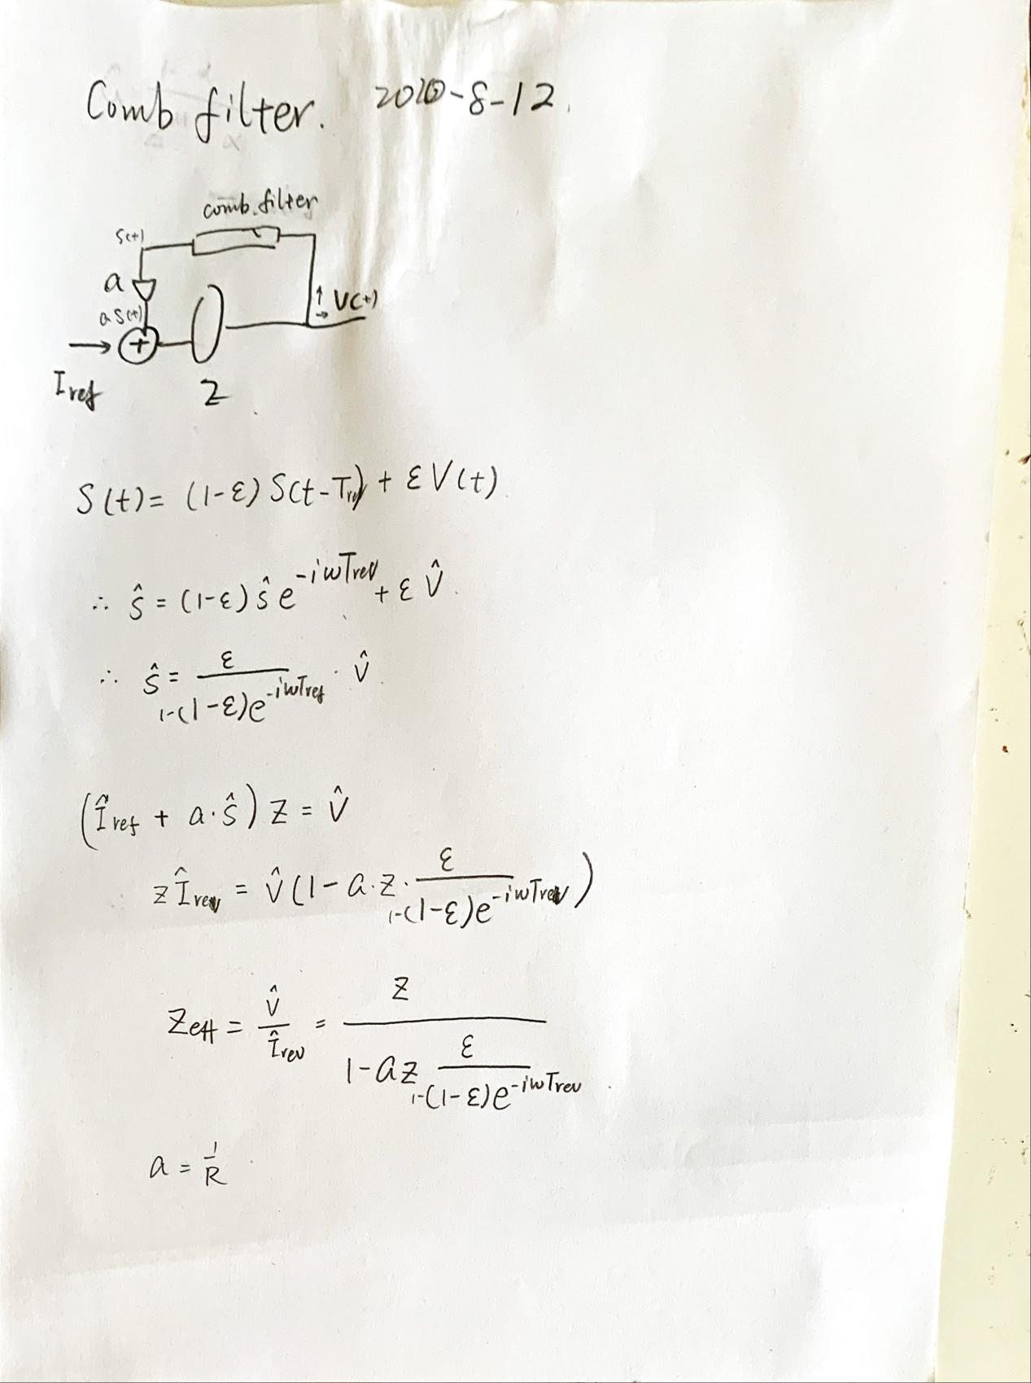

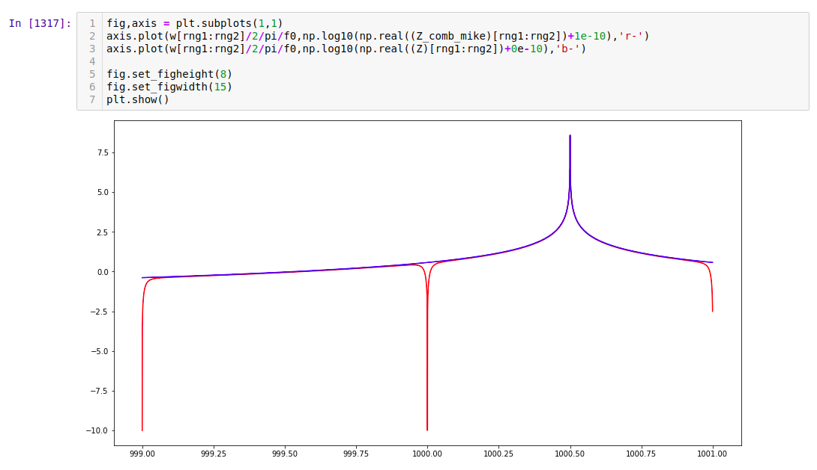

20200815

But if I look at the abs of the Zeff, it is not changing by much.

And to get a significant reduction on the abs, I had to use Q~1e3.

Old wrong version:

===========================================================================I tried one turn delay feedback, basically this is what I did:

