Higgs Booster Sanity Check:

Ig = Vc/Z-IbDC\*2\*Z

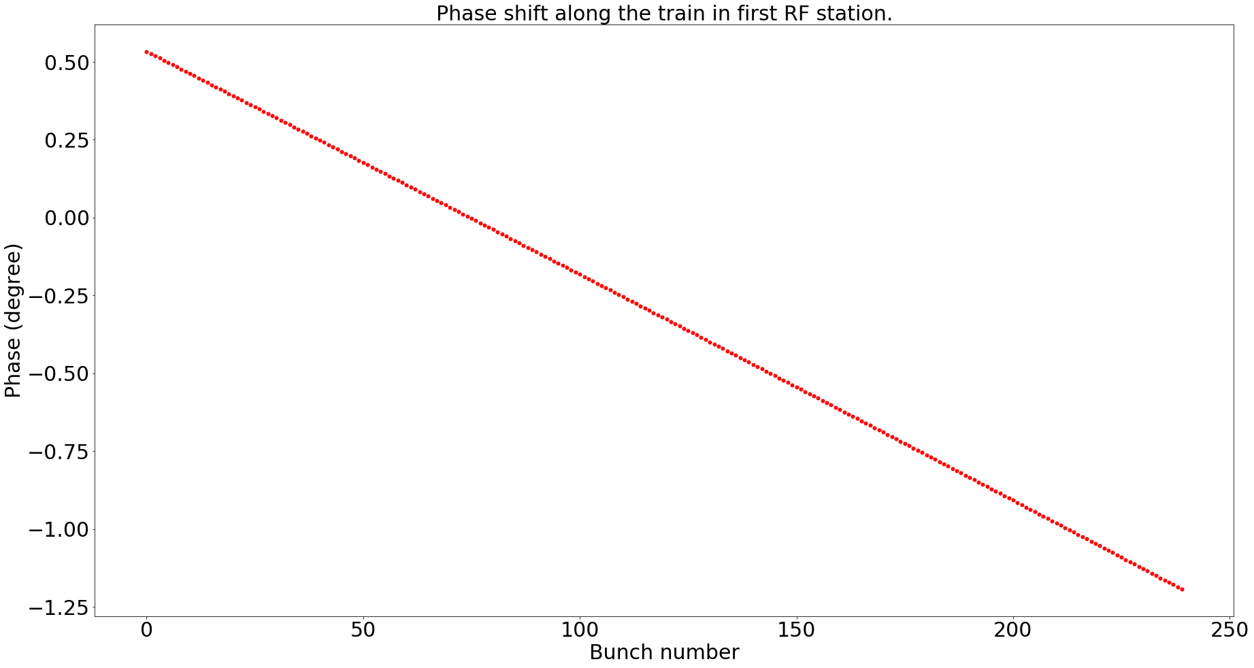

Ig = (Vc/Z-IbDC\*2\*Z)\*exp(j wrf Trf/360\*0.5), namely pre-shift the phase of the voltage by 0.5 degree, the total phase slips are the same by the overall shift is shited with the cavity voltage:

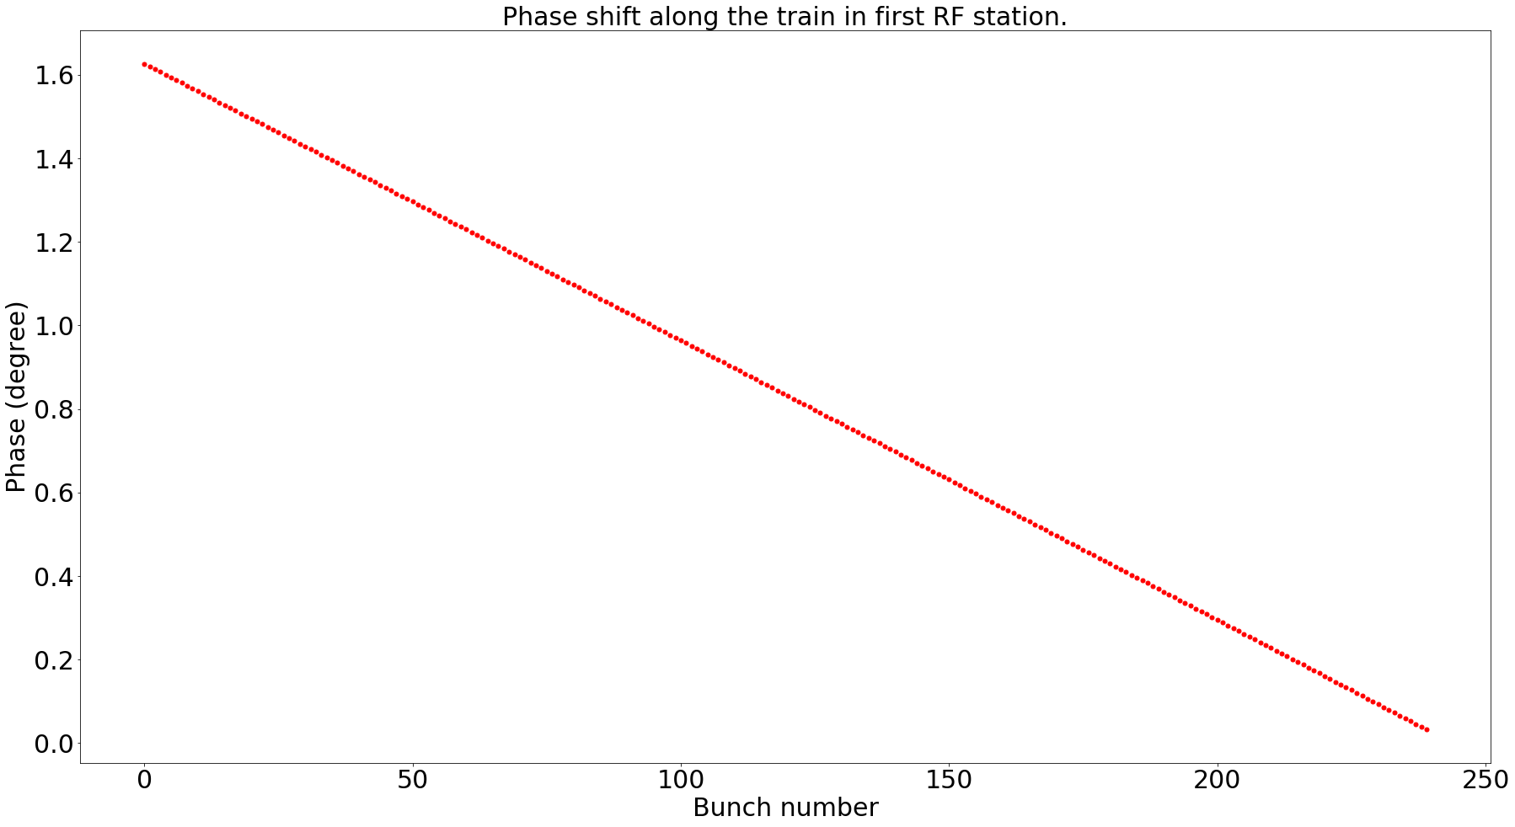

2022-5-6

Unit test:

Create a unit test case to test the growth rate of different coupled bunch modes and compare with analytical results.