Multi-Phase Segmentation of 3D CT Images of Dried Respiratory Droplets
Tianning Huang
Abstract
This project segments 3D X-ray micro-CT images to analyze the internal microstructure of evaporated respiratory droplets that contain SARS-CoV-2. The goal is to understand how viruses may still be infectious after evaporation. The analysis focuses on three primary components captured in X-ray CT images: the substrate pillars, the crystal regions, and the amorphous phase. These components are labeled using image segmentation. The residue contains irregular 3D boundaries, multiple air regions at different size scales, and components with low contrast. This work develops a practical segmentation framework to address these challenges. The methods combine manual segmentation in Dragonfly with automated segmentation in MATLAB, including both Distance Regularized Level Set Evolution (DRLSE) and threshold-based approaches. This report offers image segmentation methodologies that can be adapted to similar challenges in experimental imaging.
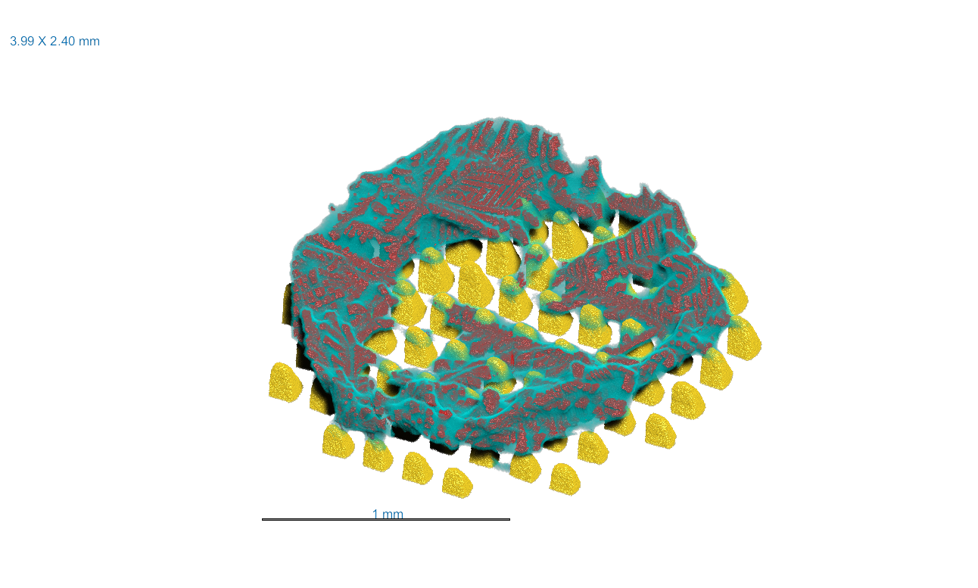
Introduction
As stated by Pierre Soille (2004), “Image segmentation is the division of an image into different regions, each having certain properties.” It is a step that enables quantitative measurements and further analysis such as volume fraction and surface areas. While traditional segmentation techniques such as clustering-based methods or the Watershed algorithm often work well for images with clear boundaries or strong intensity contrasts, they are not always sufficient. The droplet residue boundaries vary significantly across slices and lack sharp definition, and the substrate pillars share similar intensity values with the residue, making them difficult for automated techniques to distinguish. Internal air pockets of varying sizes complicate the segmentation process. Traditional methods cannot distinguish these small and low-contrast regions from noise or artifacts. These limitations require combining manual and algorithmic approaches tailored to the dataset’s specific conditions.
Figure 1: Demonstration of substrate (yellow), crystal regions (red), and amorphous phase (blue).
Methodology: Dragonfly & DRLSE & Thresholding
The substrate pillars pose an initial challenge: their intensity is similar to the residue, making it difficult for automated algorithms to distinguish them. Traditional approaches often mislabel the pillars or fail to identify their boundaries, leading to inaccurate segmentation. To overcome this, the pillars are segmented manually in Dragonfly by examining the CT data in three orthogonal planes and coloring a subset of slices in the XY plane from bottom to top. Then, the interpolation tools in Dragonfly are used to generate three-dimensional reconstructions of each pillar. To avoid introducing interpolation artifacts, the procedure assigns each pillar a separate region of interest, and all regions are merged at the end to create a unified substrate component. Manual segmentation ensures reliable distinction of features that automated algorithms cannot detect, particularly when the contrast between components is low.
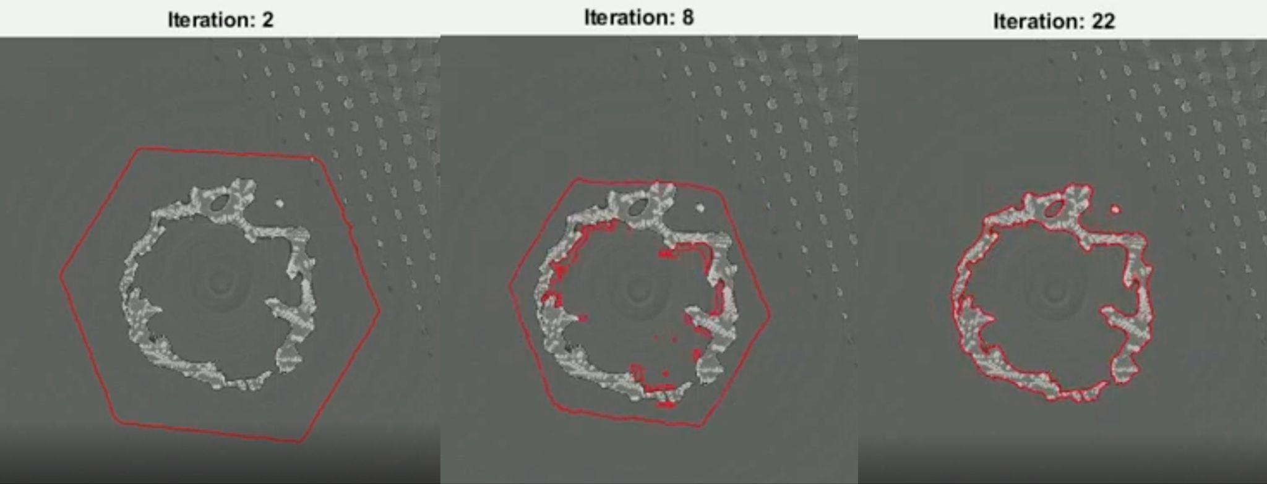
Once the substrate segmentation is complete, both the substrate and the full CT reconstruction are imported into MATLAB to perform automated segmentation of the residue and crystal regions. A median filter reduces noise in the CT images. The algorithm segments the residue using Distance Regularized Level Set Evolution, which evolves an initialized contour inward until it aligns with object boundaries defined by gradients in the image. DRLSE is particularly effective for objects that have irregular and complex-shaped boundaries, which makes it well suited for the droplet residue in this case. Adjusting the sensitivity to edge strength, smoothing level controls, and number of iterations, is necessary to accommodate every residue, as they vary by sizes and shapes. The initial boundaries consist of a 2D contour larger than the residue slices, extruded through the full droplet height to form a 3D enclosing surface. As the initial boundaries collapse down onto the residue, the external air is removed, segmenting the residue outer envelope. Internal air pockets trapped between the residue and substrate pillars present another major challenge. These pockets are much smaller and isolated from the external air, making them difficult to segment in the first DRLSE algorithm with the outer region. To address this, the algorithm performs a second round of DRLSE segmentation using seed points placed inside the air pocket regions. The seed points expand with each iteration, filling the internal holes. This second DRLSE algorithm ensures that the segmentation does not overshoot or undershoot the target regions based on different size scales from the first round. The algorithm isolates the residue after removing the air pockets. A morphological closure operation fills tiny holes and ensures continuous segmentation of the residue.
Figure 2: Behavior of the DRLSE in different iterations
Lastly, the crystal phase is segmented using intensity thresholding, this is because crystals absorb X-rays more strongly and therefore appear significantly brighter than the amorphous residue. By selecting an appropriate intensity threshold, the crystal structure separates from the surrounding material. Small, unconnected noise voxels are removed, leaving only the major connected crystal regions for further analysis. Subtracting the substrate and crystal phase from the residue retrieves the amorphous phase.
Each segmentation method has its own advantages and limitations. Manual segmentation in Dragonfly is essential for handling low-contrast components and performed particularly well for structures with regular shapes but relies on human accuracy. DRLSE excels in handling irregular boundaries and offers flexibility through parameter tuning, though the tuning process could be time-consuming. Thresholding proved effective for isolating phases with distinct intensity differences, though it is sensitive to noise.
Conclusion
This report demonstrates the use of three segmentation approaches: manual segmentation in Dragonfly, DRLSE, and thresholding. The workflow combines these methods to isolate the substrate, crystal phase, and amorphous phase in complex CT images. DRLSE offers capabilities for segmenting components with irregular boundaries and multi-scale features. Manual segmentation remains essential when two phases’ intensity contrasts are too similar for automated methods. Thresholding provides an efficient solution when one component shows distinct intensity differences. These methods create an adaptable segmentation workflow that overcomes the limitations of traditional techniques. This workflow applies to systems containing low-contrast phases, irregular boundaries, or features of multiple size scales. These challenges occur across a wide range of fields, from biomedical imaging to environmental studies. The workflow presented here can be applied to any scientific imaging problems involving multi-phase 3D structures.

