NamaPeserta : Septyan Yevta Irawan

Kode Peserta : FSDO001ONL015

Tugas : Assigment 2

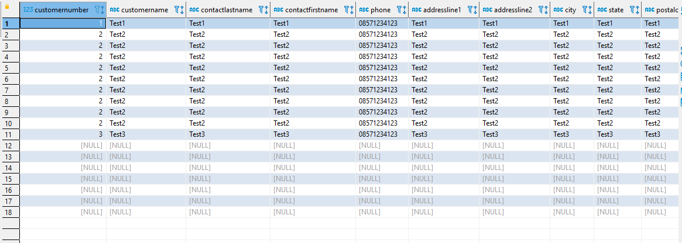

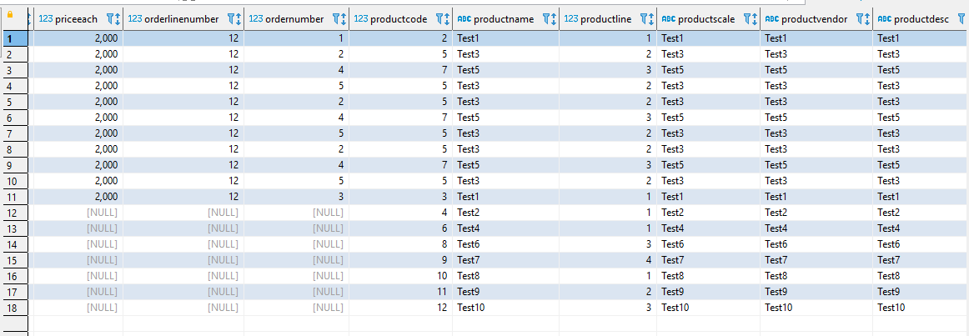

**NO 1. SHOW ALL DATA BESERTA RELASI NYA**

**select** a1.*,a2.*,a3.*,a4.*,a5.*,a6.*,a7.*,a8.* **from** tbl_customers a1

**full** **join** employee a2 **on** a1.customernumber = a2.customernumber

**full** **join** tbl_offices a3 **on** a3.officecode = a2.officecode

**full** **join** tbl_payment a4 **on** a4.customernumber = a1.customernumber

**full** **join** tbl_orders a5 **on** a5.customernumber = a1.customernumber

**full** **join** tbl_orderdetail a6 **on** a6.ordernumber = a5.ordernumber

**full** **join** tbl_products a7 **on** a7.productcode = a6.productcode

**full** **join** tbl_productlines a8 **on** a8.productline = a7.productline;

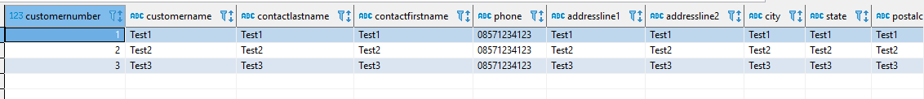

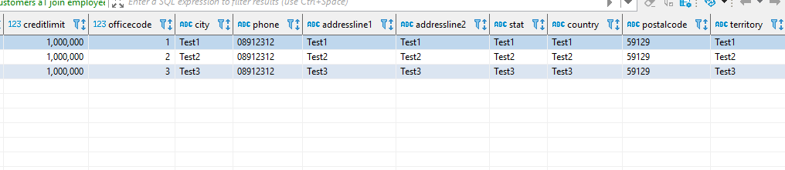

No2 . Show Data Customer Beserta Employee Dan Office nya

**select** a1.*,a2.* **from** tbl_customers a1

**join** employee a3 **on** a3.customernumber = a1.customernumber

**join** tbl_offices a2 **on** a2.officecode = a3.officecode

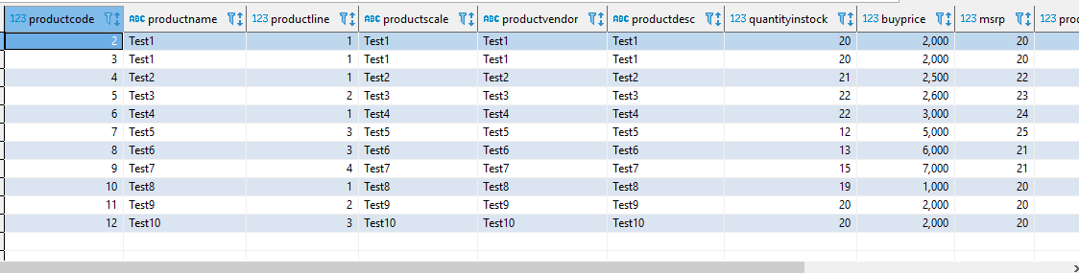

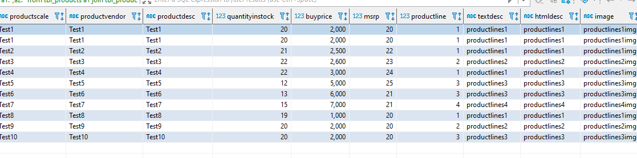

No3. Show Product With Productlines

**select** a1.*,a2.* **from** tbl_products a1

**join** tbl_productlines a2 **on** a1.productline = a2.productline