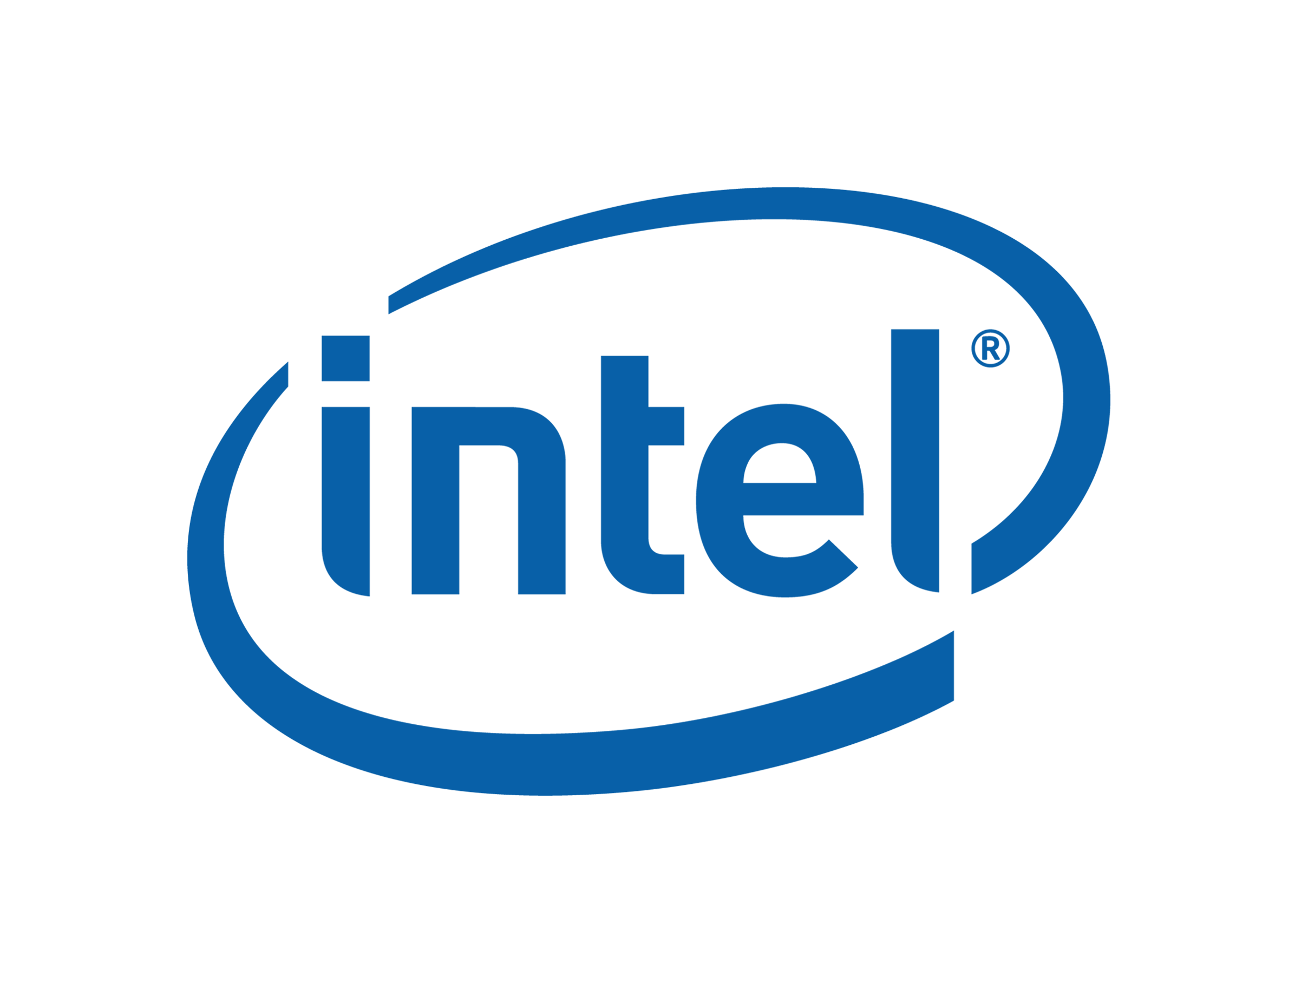

GenFw High Level Design

August, 2007

Revision 0.01

Intel Confidential

INFORMATION IN THIS DOCUMENT IS PROVIDED IN CONNECTION WITH INTEL® PRODUCTS. NO LICENSE, EXPRESS OR IMPLIED, BY ESTOPPEL OR OTHERWISE, TO ANY INTELLECTUAL PROPERTY RIGHTS IS GRANTED BY THIS DOCUMENT. EXCEPT AS PROVIDED IN INTEL’S TERMS AND CONDITIONS OF SALE FOR SUCH PRODUCTS, INTEL ASSUMES NO LIABILITY WHATSOEVER, AND INTEL DISCLAIMS ANY EXPRESS OR IMPLIED WARRANTY, RELATING TO SALE AND/OR USE OF INTEL PRODUCTS INCLUDING LIABILITY OR WARRANTIES RELATING TO FITNESS FOR A PARTICULAR PURPOSE, MERCHANTABILITY, OR INFRINGEMENT OF ANY PATENT, COPYRIGHT OR OTHER INTELLECTUAL PROPERTY RIGHT. Intel products are not intended for use in medical, life saving, or life sustaining applications.

Intel may make changes to specifications and product descriptions at any time, without notice.
Designers must not rely on the absence or characteristics of any features or instructions marked “reserved” or “undefined.” Intel reserves these for future definition and shall have no responsibility whatsoever for conflicts or incompatibilities arising from future changes to them.

Contact your local Intel sales office or your distributor to obtain the latest specifications and before placing your product order.
Intel and the Intel logo are trademarks or registered trademarks of Intel Corporation or its subsidiaries in the United States and other countries.
*Other names and brands may be claimed as the property of others.
Copyright © 2007, Intel Corporation. All rights reserved.
Contents
1 Introduction 1
Overview 1
Related Information 1
Terms 1
Typographic Conventions used in this document 4
2 Workflow 6
2.1 Inputs and Outputs 6
2.2 Algorithm 7
2.3 Return Values 7
2.4 Components 8
2.5 Flow Chart 8
3 Components 11
3.1 MicrocodeReadData 11
3.1.1 MicrocodeReadData task 11
3.1.2 Work flow 11
3.2 ZeroDebugData 11
3.2.1 ZeroDebugData task 11
3.2.2 Work flow 12
3.3 SetStamp 12
3.3.1 SetStamp task 12
3.3.2 Work flow 12
3.4 ConvertElf 13
3.4.1 ConvertElf task 13
3.4.2 Work flow 13
4 Important data structures 15
4.1 Operation type definition 15
4.2 MicroCode binary image header 15
5 Limitations 17

Figures
Figure 2-1. Utility Inputs and Outputs 6

Revision History

Revision  Number | Description | Revision  Date
0.01 | Initial release. | August 2007

§

Introduction

Overview
This document provides an overview of the design of GenFw to generate UEFI Firmware Image, PI Terse Executable image, ACPI table image from the PE/PE32+ images, and modify PE/PE32+ images by zero debug data, set the timestamp or remove image header, and parse a text microcode definition file to create an output binary microcode file.

Related Information
The following publications and sources of information may be useful, or are referred to by this specification:
EDKII FDF Specification, Version 0.31, Intel, 2007, http://TBD.
EDKII Base Tools Project Specification, Verison 0.23, Intel 2007, http://TBD.
Unified Extensible Firmware Interface Specification, Version 2.0, Unified EFI, Inc, 2006, http://www.uefi.org.
Unified Extensible Firmware Interface Specification, Version 2.1, Unified EFI, Inc, 2007, http://www.uefi.org.
Intel® Platform Innovation Framework for EFI Specifications, Intel, 2006, http://www.intel.com/technology/framework/.
Platform Initialization Specification Pre-EFI Initialization Core Interface, Version 1.0, Unified EFI, Inc, 2006, http://www.uefi.org/specs.
Platform Initialization Specification Driver Execution Environment Core Interface, Version 1.0, Unified EFI, Inc, 2006, http://www.uefi.org/specs
Platform Initialization Specification Shared Architectural Elements, Version 1.0, Unified EFI, Inc, 2006, http://www.uefi.org/specs.
Microsoft Portable Executable and Common Object File Format Specification, Version 8.0, Microsoft Corporation, http://www.microsoft.com/whdc/system/platform/firmware/PECOFF.mspx

Terms
Terms used throughout this document to describe varying aspects of input localization follow:
Component
An executable image. Components defined in this specification support one of the defined module types.
CIS
Core Interface Specification.
DXE
Framework Driver Execution Environment phase.
EFI
Generic term that refers to one of the versions of the EFI specification: EFI 1.02, EFI 1.10, or UEFI 2.0.
EFI 1.10 Specification
Intel Corporation published the Extensible Firmware Interface Specification. Intel has donated the EFI specification to the Unified EFI Forum, and the UEFI now owns future updates of the EFI specification. See UEFI Specification Version 2.0.
Foundation
The set of code and interfaces that glue implementations of EFI together.
Framework
Intel® Platform Innovation Framework for EFI consists of the Foundation, plus other modular components that characterize the portability surface for modular components designed to work on any implementation of the Tiano architecture.

GUID
Globally Unique Identifier. A 128-bit value used to name entities uniquely. An individual without the help of a centralized authority can generate a unique GUID. This allows the generation of names that will never conflict, even among multiple, unrelated parties.
Module
A module is either an executable image or a library instance. For a list of module types supported by this package, see module type.
Module Type
All libraries and components belong to one of the following module types: BASE, SEC, PEI_CORE, PEIM, DXE_CORE, DXE_DRIVER, DXE_RUNTIME_DRIVER, DXE_SMM_DRIVER, DXE_SAL_DRIVER, UEFI_DRIVER, or UEFI_APPLICATION. These definitions provide a framework that is consistent with a similar set of requirements. A module that is of module type BASE, depends only on headers and libraries provided in the MDE, while a module that is of module type DXE_DRIVER depends on common DXE components. For a definition of the various module types, see module type.
Protocol
An API named by a GUID as defined by the EFI specification.
PEI
Pre-EFI Initialization Phase.
PPI
A PEIM-to-PEIM Interface that is named by a GUID as defined by the PEI CIS.
Runtime Services
Interfaces that provide access to underlying platform-specific hardware that might be useful during OS runtime, such as time and date services. These services become active during the boot process but also persist after the OS loader terminates boot services.
SAL
System Abstraction Layer. A firmware interface specification used on Intel® Itanium® Processor based systems.
SEC
Security Phase is the code in the Framework that contains the processor reset vector and launches PEI. This phase is separate from PEI because some security schemes require ownership of the reset vector.
UEFI Application
An application that follows the UEFI specification. The only difference between a UEFI application and a UEFI driver is that an application is unloaded from memory when it exits regardless of return status, while a driver that returns a successful return status is not unloaded when its entry point exits.
UEFI Driver
A driver that follows the UEFI specification.
Unified EFI Forum
A non-profit collaborative trade organization formed to promote and manage the UEFI standard. For more information, see www.uefi.org.

UEFI Specification Version 2.0
First version of the EFI specification released by The Unified EFI Forum. This specification builds on the EFI 1.10 specification and transfers ownership of the EFI specification from Intel to a non-profit, industry trade organization.

UEFI Specification Version 2.1

Current version of the EFI specification released by the Unified EFI Forum.

Typographic Conventions used in this document
This document uses the typographic and illustrative conventions described below:
Plain text | The normal text typeface. Used for the vast majority of the descriptive text in a specification.
Plain text (blue) | Any plain text that is underlined and in blue indicates an active link to the cross-reference. Click on the word to follow the hyperlink.
Bold | In text, a Bold typeface identifies a processor register name. In other instances, a Bold typeface can be used as a running head within a paragraph.
Italic | In text, use an Italic typeface as emphasis to introduce a new term or to indicate a manual or specification name.
BOLD Monospace | Computer code, example code segments, and all prototype code segments use a BOLD Monospace typeface with a dark red color. These code listings normally appear in one or more separate paragraphs, though words or segments can also be embedded in a normal text paragraph.
Bold Monospace | Words in a Bold Monospace typeface that is underlined and in blue indicate an active hyperlink to the code definition for that function or type definition. Click on the word to follow the hyperlink.
Italic Monospace | In code or in text, words in Italic Monospace indicate placeholder names for required variable information (i.e., arguments).
Plain Monospace | In code, words in a Plain Monospace typeface that is a dark red color but is not bold or italicized indicate pseudo code or example code. These code segments typically occur in one or more separate paragraphs.

§

Workflow

Inputs and Outputs
TeImage
PeImage
GenFw
EfiImage TeImageAcpiDat, Modified PeImage
MicroCode
Dump TeImage Header
Binary MicroCode

Figure 2-1. Utility Inputs and Outputs
In Figure 2-1:
- The PeImage file is the input file. According to the different options, it can be processed to EfiImage, TeImage, AcpiImage, or modified PeImage (Zero Debug Data, Update TimeStamp and Remove Pe Header).
- The TeImage file is as the input file, whose TeImage Header is dumped into the output file.
- The text microcode definition file is as the input file, which will be parsed to create an output binary microcode output file.

Algorithm
Processing by the FwImage utility consists of the following steps:
- Process the command line arguments
- Open the input file for reading, and Open the output file for writing.
- If option is to merge several microcode binary images into a single file, then combine all input files into the output files and return.
- If option is to convert microcode text file, then parse the input microcode file to create the output microcode binary file and return.
- If option is to dump TeImage header, then check TE signature and output TE image header information to the output file, then return.
- If option is to create EFI image, then map the input Component or Module types to the subsystem type set in the final EFI image.
- Check the DOS and PE signatures, if the input image is one ELF format, it will first be converted into PE image format.
- If option is to create bin file, then extract PE image data without PE header, and write the output file, return.
- If option is to zero debug data, then zero the data in debug directory of PE image, and write the output file, return.
- If option is to set time stamp, then set the new time stamp in PE header, Export, Resource and Debug Directory of PE image, and write the output file, then return.
- If option is to get Acpi data, then extract acpi data from PE Image data section and check acpi data is valid, and write the output file, then return.
- In the PE file’s DOS header, clear all fields except the magic number and the offset to the new EXE header
- Clear all the contents from after the DOS header to the start of the new EXE header
- Set the subsystem in the PE file’s optional header and Clear option header version, Stack, and Heap field.
- For PE+ image, zero the .pdata section if the machine type is X64.
- Strip zero padding at the end of the .reloc section.
- If option is to generate TeImage, create TeImage Header based on PE header, and write TeImage header and PE image data into the output file, then return.
- Write the processed PE image (Efi image) to the output file, then return.

Return Values
Possible return values for the GenFw utility are listed in the table below.

Return Value | Description
STATUS_SUCCESS | Successful completion
STATUS_ERROR | Unrecoverable errors encountered during processing
Table 2-1. Utility return values

Components
MicrocodeReadData
ConvertElf
ZeroDebugData
SetStamp

Flow Chart
The following diagram shows the overview of this process:
Y
Y
Y
Y
Y
Y
Y
Y
Y
Y
N
N
N
N
N
N
N
N
N
Check input arguments
Merge images
Open input and output files
Parse MCI text
Dump TE head
FW EFI Image
Check ELF file
Check Dos and PE header
FW Bin Image
Zero debug
Set timestamp
FW acpi Table
FW TE Image
Process PE file to efi image
Combine mci bin files
Call MicrocodeReadData to convert MCI txt file

Read TE header data
Map module type to subsystem type.
Call ConvertElf to do Elf to Pe image format

Extract PE data without PE header

Call ZeroDebugData

Call SetStamp

Extract PE data section to get ACPI table

Create TE image header and Extract PE data

Write data to output files
Return

Figure 2-2. Tool work flow

Components

MicrocodeReadData

MicrocodeReadData task
Read a 32-bit microcode data value from a text file and convert to raw binary form.

Work flow
The following diagram shows the overview of this process:
Start

Read whole line string

Look for “dd” assembly data statements

Read data and write its binary format into buffer

Done

Figure 3-1. MicrocodeReadData work flow

ZeroDebugData

ZeroDebugData task
Zero debug directory data in PE/PE+ image.

Work flow
The following diagram shows the overview of this process:
Start

Get DebugEntryTable file offset.
Zero Debug Data and TimeStamp of PEImage
Done

Get DebugEntryTable RVA address.
Not found debug entry

Figure 3-2. ZeroDebugData work flow

SetStamp

SetStamp task
Set new time stamp into PeImage Header and Directory tables: Debug, Export and Resource.

Work flow
The following diagram shows the overview of this process:
Start

Get Debug, Export and Resource EntryTable RVA
Get DirectoryEntryTable file offset
Done

Get time and date that will be set.
Set new time stamp into PeImage Header.

Figure 3-3. SetStamp work flow

ConvertElf

ConvertElf task
Convert ELF image format to PE/PE+ image format.

Work flow
The following diagram shows the overview of this process:
Start

Done

Check ELF header

Compute sections new address.
Write and relocate sections.
Translate and write relocations.
Write debug info

Figure 3-4. ConvertElf work flow

Important data structures
Following data structures defined to convert FW image.

Operation type definition
The following definitions are mapping to the different operations what this tool processes the input images according to.

#define FW_DUMMY_IMAGE 0
#define FW_EFI_IMAGE 1
#define FW_TE_IMAGE 2
#define FW_ACPI_IMAGE 3
#define FW_BIN_IMAGE 4
#define FW_ZERO_DEBUG_IMAGE 5
#define FW_SET_STAMP_IMAGE 6
#define FW_MCI_IMAGE 7
#define FW_MERGE_IMAGE 8
#define DUMP_TE_HEADER 0x11

MicroCode binary image header
This structure definition is for the binary microcode image header.
typedef struct {
UINTN HeaderVersion;
UINTN PatchId;
UINTN Date;
UINTN CpuId;
UINTN Checksum;
UINTN LoaderVersion;
UINTN PlatformId;
UINTN DataSize;
UINTN TotalSize;
UINTN Reserved[3];
} MICROCODE_IMAGE_HEADER;

Limitations
This tool for windows version doesn’t support to convert ELF format image to PE/PE+ format image.

