

GenVtf High Level Design

August, 2007

Revision 0.01

Intel Confidential

INFORMATION IN THIS DOCUMENT IS PROVIDED IN CONNECTION WITH INTEL® PRODUCTS. NO LICENSE, EXPRESS OR IMPLIED, BY ESTOPPEL OR OTHERWISE, TO ANY INTELLECTUAL PROPERTY RIGHTS IS GRANTED BY THIS DOCUMENT. EXCEPT AS PROVIDED IN INTEL’S TERMS AND CONDITIONS OF SALE FOR SUCH PRODUCTS, INTEL ASSUMES NO LIABILITY WHATSOEVER, AND INTEL DISCLAIMS ANY EXPRESS OR IMPLIED WARRANTY, RELATING TO SALE AND/OR USE OF INTEL PRODUCTS INCLUDING LIABILITY OR WARRANTIES RELATING TO FITNESS FOR A PARTICULAR PURPOSE, MERCHANTABILITY, OR INFRINGEMENT OF ANY PATENT, COPYRIGHT OR OTHER INTELLECTUAL PROPERTY RIGHT. Intel products are not intended for use in medical, life saving, or life sustaining applications.

Intel may make changes to specifications and product descriptions at any time, without notice.
Designers must not rely on the absence or characteristics of any features or instructions marked “reserved” or “undefined.” Intel reserves these for future definition and shall have no responsibility whatsoever for conflicts or incompatibilities arising from future changes to them.

Contact your local Intel sales office or your distributor to obtain the latest specifications and before placing your product order.
Intel and the Intel logo are trademarks or registered trademarks of Intel Corporation or its subsidiaries in the United States and other countries.
*Other names and brands may be claimed as the property of others.
Copyright © 2007, Intel Corporation. All rights reserved.
Contents
1 Introduction 1
Overview 1
Related Information 1
Terms 1
Typographic Conventions used in this document 3
2 Workflow 6
2.1 Inputs and Outputs 6
2.2 Algorithm 6
2.3 Return Values 7
2.4 Components 7
2.5 Flow Chart 7
3 Components 10
3.1 GetVtfRelatedInfoFromInfFile 10
3.1.1 GetVtfRelatedInfoFromInfFile task 10
3.1.2 Work flow 10
3.1.3 Interfaces with other components 12
3.2 ProcessAndCreatVtf 12
3.2.1 ProcessAndCreatVtf task 12
3.2.2 Work flow 12
3.2.3 Interfaces with other components 12
3.3 UpdateIA32ResetVector 13
3.3.1 UpdateIA32ResetVector task 13
3.3.2 Work flow 13
3.3.3 Interfaces with other components 13
3.4 UpdateFfsHeader 14
3.4.1 UpdateFfsHeader task 14
3.4.2 Work flow 14
3.4.3 Interfaces with other components 14
3.5 WriteVtfBinary 15
3.5.1 WriteVtfBinary task 15
3.5.2 Work flow 15
3.5.3 Interfaces with other components 15
4 Important data structures 16
4.1 Location Type 16
4.2 Parsed VTF Information 16
4.3 FIT TABLE 17
5 Limitations 18

Figures
Figure 2-1. Utility Inputs and Outputs 6
Figure 1 Tool work flow 8

Revision History

Revision  Number | Description | Revision  Date
0.01 | Initial release. | July 2007

§

Introduction

Overview
This document provides an overview of the design of GenVtf to generate the Boot Strap File (AKA Volume Top File, or VTF) for IPF images.

Related Information
The following publications and sources of information may be useful, or are referred to by this specification:
EDKII FDF Specification, Version 0.31, Intel, 2007, http://TBD.
EDKII Base Tools Project Specification, Verison 0.23, Intel 2007, http://TBD.
Unified Extensible Firmware Interface Specification, Version 2.0, Unified EFI, Inc, 2006, http://www.uefi.org.
Unified Extensible Firmware Interface Specification, Version 2.1, Unified EFI, Inc, 2007, http://www.uefi.org.
Intel® Platform Innovation Framework for EFI Specifications, Intel, 2006, http://www.intel.com/technology/framework/.
Platform Initialization Specification Pre-EFI Initialization Core Interface, Version 1.0, Unified EFI, Inc, 2006, http://www.uefi.org/specs.
Platform Initialization Specification Driver Execution Environment Core Interface, Version 1.0, Unified EFI, Inc, 2006, http://www.uefi.org/specs
Platform Initialization Specification Shared Architectural Elements, Version 1.0, Unified EFI, Inc, 2006, http://www.uefi.org/specs.

Terms
Terms used throughout this document to describe varying aspects of input localization follow:
Component
An executable image. Components defined in this specification support one of the defined module types.
CIS
Core Interface Specification.
DXE
Framework Driver Execution Environment phase.
EFI
Generic term that refers to one of the versions of the EFI specification: EFI 1.02, EFI 1.10, or UEFI 2.0.
EFI 1.10 Specification
Intel Corporation published the Extensible Firmware Interface Specification. Intel has donated the EFI specification to the Unified EFI Forum, and the UEFI now owns future updates of the EFI specification. See UEFI Specification Version 2.0.
Foundation
The set of code and interfaces that glue implementations of EFI together.
Framework
Intel® Platform Innovation Framework for EFI consists of the Foundation, plus other modular components that characterize the portability surface for modular components designed to work on any implementation of the Tiano architecture.

GUID
Globally Unique Identifier. A 128-bit value used to name entities uniquely. An individual without the help of a centralized authority can generate a unique GUID. This allows the generation of names that will never conflict, even among multiple, unrelated parties.
Module
A module is either an executable image or a library instance. For a list of module types supported by this package, see module type.
Module Type
All libraries and components belong to one of the following module types: BASE, SEC, PEI_CORE, PEIM, DXE_CORE, DXE_DRIVER, DXE_RUNTIME_DRIVER, DXE_SMM_DRIVER, DXE_SAL_DRIVER, UEFI_DRIVER, or UEFI_APPLICATION. These definitions provide a framework that is consistent with a similar set of requirements. A module that is of module type BASE, depends only on headers and libraries provided in the MDE, while a module that is of module type DXE_DRIVER depends on common DXE components. For a definition of the various module types, see module type.
Protocol
An API named by a GUID as defined by the EFI specification.
PEI
Pre-EFI Initialization Phase.
PPI
A PEIM-to-PEIM Interface that is named by a GUID as defined by the PEI CIS.
Runtime Services
Interfaces that provide access to underlying platform-specific hardware that might be useful during OS runtime, such as time and date services. These services become active during the boot process but also persist after the OS loader terminates boot services.
SAL
System Abstraction Layer. A firmware interface specification used on Intel® Itanium® Processor based systems.
SEC
Security Phase is the code in the Framework that contains the processor reset vector and launches PEI. This phase is separate from PEI because some security schemes require ownership of the reset vector.
UEFI Application
An application that follows the UEFI specification. The only difference between a UEFI application and a UEFI driver is that an application is unloaded from memory when it exits regardless of return status, while a driver that returns a successful return status is not unloaded when its entry point exits.
UEFI Driver
A driver that follows the UEFI specification.
Unified EFI Forum
A non-profit collaborative trade organization formed to promote and manage the UEFI standard. For more information, see www.uefi.org.

UEFI Specification Version 2.0
First version of the EFI specification released by The Unified EFI Forum. This specification builds on the EFI 1.10 specification and transfers ownership of the EFI specification from Intel to a non-profit, industry trade organization.

UEFI Specification Version 2.1

Current version of the EFI specification released by the Unified EFI Forum.

Typographic Conventions used in this document
This document uses the typographic and illustrative conventions described below:
Plain text | The normal text typeface. Used for the vast majority of the descriptive text in a specification.
Plain text (blue) | Any plain text that is underlined and in blue indicates an active link to the cross-reference. Click on the word to follow the hyperlink.
Bold | In text, a Bold typeface identifies a processor register name. In other instances, a Bold typeface can be used as a running head within a paragraph.
Italic | In text, use an Italic typeface as emphasis to introduce a new term or to indicate a manual or specification name.
BOLD Monospace | Computer code, example code segments, and all prototype code segments use a BOLD Monospace typeface with a dark red color. These code listings normally appear in one or more separate paragraphs, though words or segments can also be embedded in a normal text paragraph.
Bold Monospace | Words in a Bold Monospace typeface that is underlined and in blue indicate an active hyperlink to the code definition for that function or type definition. Click on the word to follow the hyperlink.
Italic Monospace | In code or in text, words in Italic Monospace indicate placeholder names for required variable information (i.e., arguments).
Plain Monospace | In code, words in a Plain Monospace typeface that is a dark red color but is not bold or italicized indicate pseudo code or example code. These code segments typically occur in one or more separate paragraphs.

§

Workflow

Inputs and Outputs
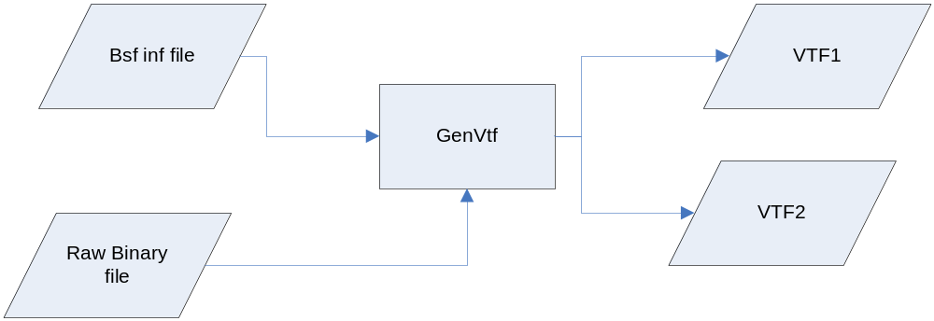
Figure 2-1. Utility Inputs and Outputs
In Figure 2-1:
- The Bsf inf file corresponds to the BsfFileName specified in the command line.
- The raw Binary file(s) are the binary files specified in Bsf inf file.
- If all the components which are required to put into a single VTF file, then only one VTF file (VTF1) will be generated
- If there’s component which is required to put into the second VTF file, then two VTF files, VTF1 and VTF2 will be generated.

Algorithm
Processing by the GenVtf utility consists of the following steps:
Open the input file Bsf.inf for reading
Parse the Bsf file
If output file specified, open the output file for writing if this file exist and create a new file if this file does not exist.
If output files not specified, use “VTF.raw” or “VTF1.raw” and “VTF2.raw”, create this new file
Write to output file

Return Values
Possible return values for the GenVtf utility are listed in the table below.

Return Value | Description
STATUS_SUCCESS | Successful completion
STATUS_ERROR | Unrecoverable errors encountered during processing
Table 2-1. Utility return values

Components
GetVtfRelatedInfoFromInfFile
ProcessAndCreatVtf
UpdateIA32ResetVector
UpdateFfsHeader
WriteVtfBinary

Flow Chart
The following diagram shows the overview of this process:
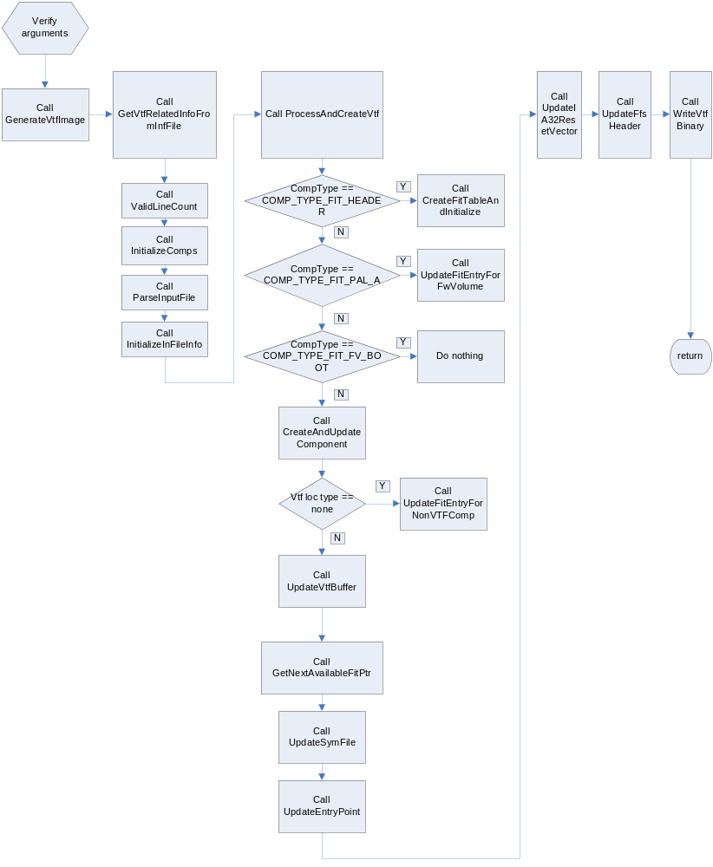
Figure 2 Tool work flow

Components

GetVtfRelatedInfoFromInfFile

GetVtfRelatedInfoFromInfFile task
Reads the input file, parse it and create a list of tokens which is parsed and used, to initialize the data related to VTF

Work flow
The following diagram shows the overview of this process:

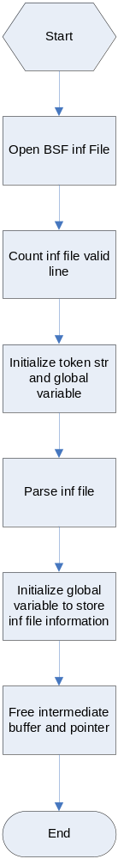
Figure 3-1. GetVtfRelatedInfoFromInfFile work flow

Interfaces with other components
None

ProcessAndCreatVtf

ProcessAndCreatVtf task
Process the link list created during INF file parsing and create component in VTF and updates its info in FIT table

Work flow
The following diagram shows the overview of this process:
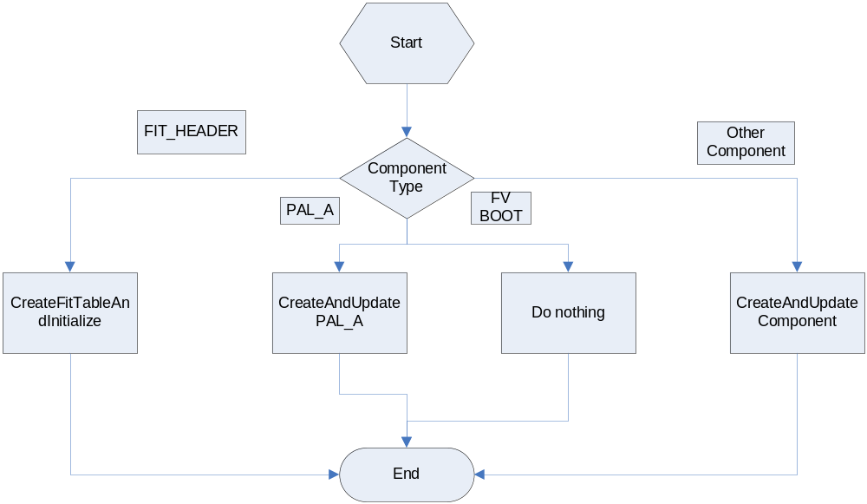

Figure 3-2. ProcessAndCreatVtf work flow

Interfaces with other components
None

UpdateIA32ResetVector

UpdateIA32ResetVector task
Update the 16 byte IA32 Reset vector to maintain the compatibility

Work flow
The following diagram shows the overview of this process:
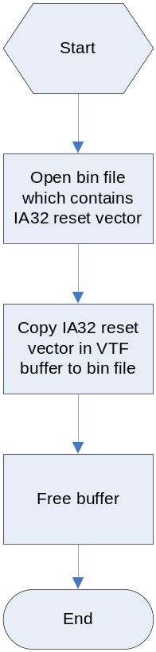

Figure 3-3. UpdateIA32ResetVector work flow

Interfaces with other components
None

UpdateFfsHeader

UpdateFfsHeader task
Update the Firmware Volume Buffer with requested buffer data

Work flow
The following diagram shows the overview of this process:

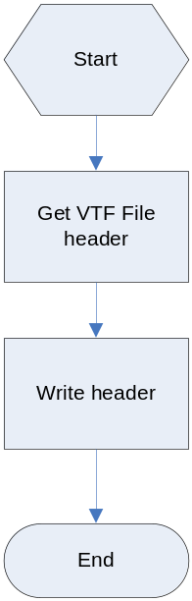
Figure 3-4. UpdateFfsHeader work flow

Interfaces with other components
None

WriteVtfBinary

WriteVtfBinary task
Write Firmware Volume from memory to a file

Work flow
The following diagram shows the overview of this process:
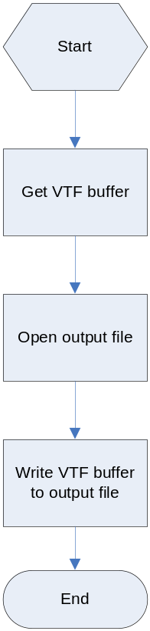

Figure 3-5. WriteVtfBinary work flow

Interfaces with other components
None

Important data structures
Following data structures defined for storing VTF related information.

Location Type
typedef enum _LOC_TYPE
{
NONE, // In case there is - INF file
FIRST_VTF, // First VTF
SECOND_VTF, // Second VTF
} LOC_TYPE;

Parsed VTF Information
typedef struct _PARSED_VTF_INFO {
CHAR8 CompName[COMPONENT_NAME_SIZE];
LOC_TYPE LocationType;
UINT8 CompType;
UINT8 MajorVer;
UINT8 MinorVer;
UINT8 CheckSumRequired;
BOOLEAN VersionPresent; // If it is TRUE, then, Version is in INF file
BOOLEAN PreferredSize;
BOOLEAN PreferredAddress;
CHAR8 CompBinName[FILE_NAME_SIZE];
CHAR8 CompSymName[FILE_NAME_SIZE];
UINTN CompSize;
UINT64 CompPreferredAddress;
UINT32 Align;
struct _PARSED_VTF_INFO *NextVtfInfo;
} PARSED_VTF_INFO;

FIT TABLE
typedef struct {
UINT64 CompAddress;
UINT32 CompSize;
UINT16 CompVersion;
UINT8 CvAndType;
UINT8 CheckSum;
} FIT_TABLE;

Limitations
GenVtf can NOT generate BSF for IA32 and x64 arch now.

