

Self‑Certification Test (SCT) II   
User Guide

June, 2017

The material contained herein is not a license, either expressly or impliedly, to any intellectual property owned or controlled by any of the authors or developers of this material or to any contribution thereto. The material contained herein is provided on an "AS IS" basis and, to the maximum extent permitted by applicable law, this information is provided AS IS AND WITH ALL FAULTS, and the authors and developers of this material hereby disclaim all other warranties and conditions, either express, implied or statutory, including, but not limited to, any (if any) implied warranties, duties or conditions of merchantability, of fitness for a particular purpose, of accuracy or completeness of responses, of results, of workmanlike effort, of lack of viruses and of lack of negligence, all with regard to this material and any contribution thereto.

Designers must not rely on the absence or characteristics of any features or instructions marked "reserved" or "undefined." The Unified EFI Forum, Inc. reserves any features or instructions so marked for future definition and shall have no responsibility whatsoever for conflicts or incompatibilities arising from future changes to them.

ALSO, THERE IS NO WARRANTY OR CONDITION OF TITLE, QUIET ENJOYMENT, QUIET POSSESSION, CORRESPONDENCE TO DESCRIPTION OR NON-INFRINGEMENT WITH REGARD TO THE SPECIFICATION AND ANY CONTRIBUTION THERETO. IN NO EVENT WILL ANY AUTHOR OR DEVELOPER OF THIS MATERIAL OR ANY CONTRIBUTION THERETO BE LIABLE TO ANY OTHER PARTY FOR THE COST OF PROCURING SUBSTITUTE GOODS OR SERVICES, LOST PROFITS, LOSS OF USE, LOSS OF DATA, OR ANY INCIDENTAL, CONSEQUENTIAL, DIRECT, INDIRECT, OR SPECIAL DAMAGES WHETHER UNDER CONTRACT, TORT, WARRANTY, OR OTHERWISE, ARISING IN ANY WAY OUT OF THIS OR ANY OTHER AGREEMENT RELATING TO THIS DOCUMENT, WHETHER OR NOT SUCH PARTY HAD ADVANCE NOTICE OF THE POSSIBILITY OF SUCH DAMAGES.

Copyright © 2017 Unified EFI, Inc. All Rights Reserved

Revision History

|  |  |  |
| --- | --- | --- |
| UEFI Version | User Guide Notes | Release Date |
| 2.1 | Initial SCT Release | May, 2009 |
| 2.3 | Incorporated Mantis tickets:  626 content integration  700 new features: verbose function | January, 2011 |
| 2.3.1 C | Incorporated Mantis ticket:  947 UEFI 2.3.1 implementation alignment | August, 2012 |
| 2.4 B | Incorporated Mantis ticket:  1297 The UEFI SCT User Guide update for the UEFI 2.4 B SCT II Final Candidate | December, 2014 |
| 2.5 A | Incorporated Mantis ticket:  1732 UEFI SCT User Guide Update Request | January, 2017 |

Contents

1 Introduction 1

1.1 Overview 1

1.2 System Requirements 1

1.3 Installation 1

2 Usage Model – Native Mode 3

2.1 Using the Command Line Interface 3

2.2 Using the Menu-Driven Interface 4

2.2.1 Main Menu 4

2.2.2 Managing Test Cases 5

2.2.3 Configuring the Test Environment 7

2.2.4 Generating a Test Report 8

2.2.5 Loading and Saving a Test Sequence 9

2.3 Sample Usage Models 10

2.3.1 Executing from the Command Line Interface 10

2.3.2 Executing from the Menu-Driven Interface 10

2.4 Frequently Asked Questions 10

2.4.1 Stopping Automatic Test Execution When the System Restarts 10

2.4.2 Stopping SCT Execution While Tests Are Running 11

2.4.3 Removing a Test Case that Always Causes the System to Hang 12

2.4.4 When There Are No Test Results after Test Execution 14

2.4.5 When Test Assertion Totals Are Different on Different Platforms 14

3 Usage Model – Passive Mode 15

3.1 Configuring UEFI SCT Agent 15

3.2 Configuring EMS 16

3.2.1 Configuring the EMS Interface 17

3.2.2 Configuring Base Information 17

3.2.3 RemoteExecution & RemoteValidation 19

3.2.4 Reflushing the Case Tree 20

3.2.5 Running Test Cases 20

3.2.6 Loading and Saving a Sequence File 23

3.2.7 Generating Log Files 25

3.2.8 Using the Tools Menu 25

3.2.9 Using the Help Menu 26

4 UEFI SCT For IHV 28

4.1 IHV SCT Installation 28

4.1.1 Installing the IHV SCT 28

4.2 The Usage of IHV SCT 28

4.2.1 Using the Command Line Interface 28

4.2.2 Using the Menu-Driven Interface 29

5 UEFI SCRT 36

5.1 Introduction 36

5.2 The Usage of SCRT 36

5.2.1 System Requirement 36

5.2.2 The location of SCRT Utility 36

5.2.3 Run SCRT Utility 36

5.2.4 Configuration File 37

5.2.5 Analyze SCRT Test Result 38

5.2.6 System Hang 40

5.3 How to Add SCRT Test Cases 40

5.3.1 The Framework of SCRT Utility 40

5.3.2 Example: Adding a Test Case 41

A.1 Test Report Format 43

A.2 Test Category 45

A.3 SCRT Assertion Information 47

Tables

Table 1. SCT Parameters 3

Table 2. Major Items in the Main Menu of the SCT 5

Table 3. User-Configurable Items for Setting Up the Test Environment 8

Table 4. Sub-Frames in the EMS OS application window 21

Table 5. Each Element in the Case Tree Sub-frame 23

Table 6. Submenus of the Tools Menu 26

Table 7. Submenus of the Help Menu 27

Table 8. SCT Parameters 29

Table 9. Major Items in the Main Menu of the SCT 30

Table 10. The Items in the Menu of the Test Device Configuration 32

Table 11. Test Case, Port 80 Display and Log file Relationship for Each Assertion 47

Figures

Figure 1. SCT without parameters 4

Figure 2. Main Menu Screen 5

Figure 3. Test Case Management Screen 6

Figure 4. Run Time Services Screen 6

Figure 5. Test Environment Configuration 7

Figure 6. Generating a Test Report 9

Figure 7. Press the <F5> Key to Load a Test Sequence 9

Figure 8. Press the <F6> Key to Save a Test Sequence 10

Figure 9. Press any Key within 10 Seconds to Stop the Auto Run 11

Figure 10. System Reset Records Message: “System Hangs or Stops Abnormally” 12

Figure 11. Press any Key to Stop Auto Run 13

Figure 12. Select [No] to Discontinue Execution 13

Figure 13. Press <SPACE> to Deselect the Test 14

Figure 14. Choose the NIC 15

Figure 15. Using SCT Passive mode 16

Figure 16. EMS Interface Configuration window 17

Figure 17. EMS Preference window 18

Figure 18. EMS Preference window 19

Figure 19. The Menu of Reflush Case Tree 20

Figure 20. EMS OS application window running the Remote Validation test cases 21

Figure 21. EMS OS application window-Case Tree Sub-frame 22

Figure 22. Sequence File Saving Window 24

Figure 23. Sequence File Loading Window 25

Figure 24. Editing File Window 26

Figure 25. ENTS Case Writer’s Guide Window 27

Figure 26. Main Menu of IHV SCT 30

Figure 27. Test Device Configuration 32

Figure 28. Run SCRT Utility with configure file 37

Figure 29. Excel® File Containing Test Report in CSV Format 44

# Introduction

## Overview

The UEFI Self-Certification Test (SCT) II is a toolset for platform firmware developers to validate UEFI implementations on IA32, X64, and ARM platforms for compliance to the UEFI Specification. The toolset features a Test Harness for executing built-in EFI Compliance Tests, as well as for integrating user-defined tests that were developed using the UEFI SCT open source code.

The UEFI SCT Test Harness provides two different usage models as native mode and passive mode. Please note that most network-related protocols (except SNP & PXEBC) can be tested only in passive mode.

This document also provides descriptions of the IHV SCT. The IHV SCT is designed to aid the testing of UEFI drivers that follow the UEFI Driver Model described in the UEFI Specification. There are several different classes of UEFI drivers, each with many variations. Also, this document provides guidelines on testing for Independent Hardware Vendors (IHV) for UEFI Specification Compliance.

## System Requirements

The UEFI SCT must be executed on a target system that meets the following requirements:

* The target system must have an X64 platform, an IA-32, or an ARM platform.
* The target system firmware must have EFI implemented per the UEFI Specification.
* The EFI implementation on the target system must include an EFI Shell.
* The target system must have at least 1000MB of disk space in the EFI file system to contain the SCT test and log files.

The UEFI SCT must have another host machine for passive mode usage. This machine must the following requirements:

* Installing Microsoft Windows 7® or Microsoft Windows 8® operating system
* The target machine and host machine must be connected directly by network cable.

Refer to the latest UEFI SCT Release Notes for other possible system requirements.

## Installation

A typical installation of the UEFI SCT involves the following:

* Ensuring that the target system is configured to boot to the EFI Shell upon power-on/reset without user intervention.

Setting the boot options is usually done using EFI Boot Manager during the target system’s EFI implementation.

* Installing the UEFI SCT executable files into a default directory in the EFI file system of the target system.
* The default directory is where the target system automatically boots to after bringing up the EFI Shell. The default directory must be on a Read/Write storage medium. In order to get better performance, a hard disk is recommended as the storage location for the default directory.

The UEFI SCT comes in three versions: one for ARM platforms (AARCH64), one for X64 platforms and another for IA-32 platforms. In general, all three versions are bundled with each UEFI SCT release. The user must ensure that the appropriate version of the UEFI SCT is installed on the target platform prior to use.

The above is a general description of the UEFI SCT installation process. Detailed installation instructions are provided in the UEFI SCT Release Notes that accompany each UEFI SCT release. The person performing the installation must make sure that the UEFI SCT Release Notes match the UEFI SCT release being used.

# Usage Model – Native Mode

The native mode is invoked as an EFI application from the EFI Shell. The executable filename is SCT.efi. This executable provides a command line interface (CLI) as well as a menu-driven interface. These are further described below.

## Using the Command Line Interface

Syntax

SCT [-a | -c | -s <seq> | -u] | -p <MNP | IP4 | Serial>] [-r] [-g <report>][-v]

Description of SCT Parameters

XTable 1X provides a description of SCT parameters.

Table 1. SCT Parameters

| Options | Description |
| --- | --- |
| -a | Execute all test cases that are recognized by the UEFI SCT Test Harness. |
| -c | Continue execution of the test case in progress. This option is used to continue execution of test cases that perform system resets as part of their test routine. |
| -g <report> | Generate test report in .CSV format. The filename of the report is specified by report. |
| -r | Resets the environment for a fresh execution of the tests. This option removes results of previous test executions. Generally, it is used with the -a or -s options. |
| -s <seq> | Execute test cases in the sequence specified in the file seq. |
| -u | Start the Test Harness with the menu-driven interface. |
| -p | Passive Mode with specified communication layer |
| -f | Force the operation execution, no confirmation from user. |
| -v | Disables the display of test log information on the screen. |

Test log display on screen is enabled by default. In command line interface, -v option can be used both in native mode & passive mode to disable display of test log information on the screen. It can be used combined with –a / -c / -r / -s / -p. Parameter -v only effects until the end of this command execution.

Selecting SCT without parameters will producethe screen display shown in Figure 1.

Figure 1. SCT without parameters

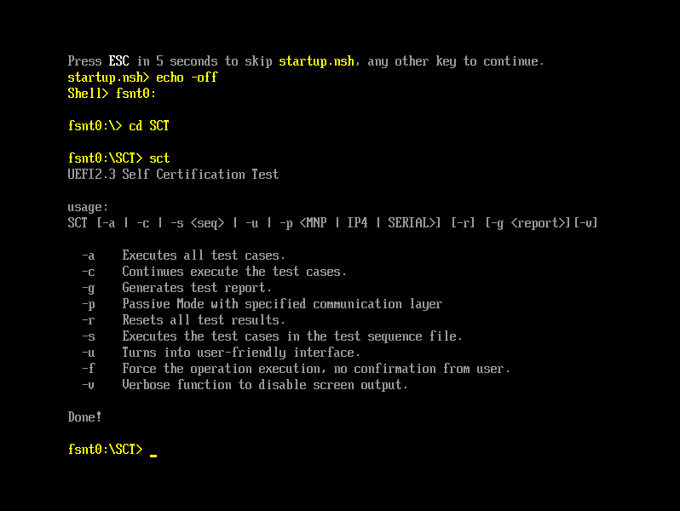

## Using the Menu-Driven Interface

Syntax

SCT -u

Description

Type SCT -u to produce the Main Menu of the menu-driven interface.

### Main Menu

The Main Menu (see Figure 2) contains user-selectable items for initiating a number of UEFI SCT actions.

Figure 2. Main Menu Screen

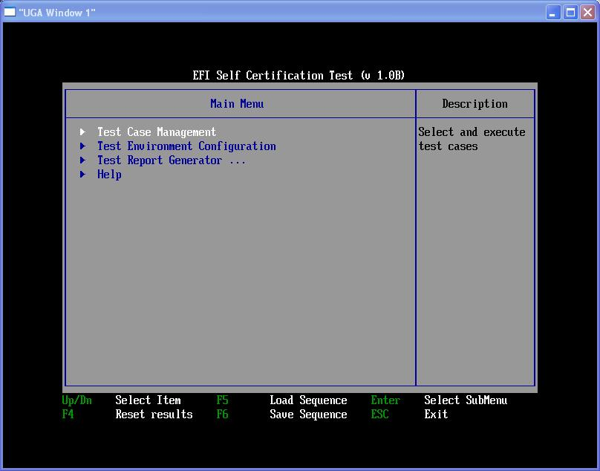

XTable 2X lists and describes the major items found in the Main Menu.

Table 2. Major Items in the Main Menu of the SCT

| Items | Description |
| --- | --- |
| Test Case Management | Selects and executes specific test cases |
| Test Environment Configuration | Sets the parameters for test execution, including the maximum run times for each test case, enabling/disabling screen output, etc. |
| Test Report Generator | Generates a test report in .CSV format. This test report can be opened by the Microsoft® Excel* or the other compatible utilities. |
| F4 (Reset Results) | Resets all test results. It is equivalent to invoking “SCT –r” in the command line. |
| F5 (Load Sequence) | Loads a test sequence file from the storage device. This function allows user to load, edit or execute an existing test sequence file. |
| F6 (Save Sequence) | Saves a user-specified test sequence into a file. This function allows the user to save selected test cases into a file, which can then be used for later test execution via “SCT –s <seq>” from the command line. |

### Managing Test Cases

The UEFI SCT includes a set of test cases for UEFI Specification compliance testing. Note that in Figure 3 the list of test cases corresponds to the major elements of EFI as described in the UEFI Specification. Note how in Figure 4 each test case can have lower‑level test cases in a tree-like structure.

Figure 3. Test Case Management Screen

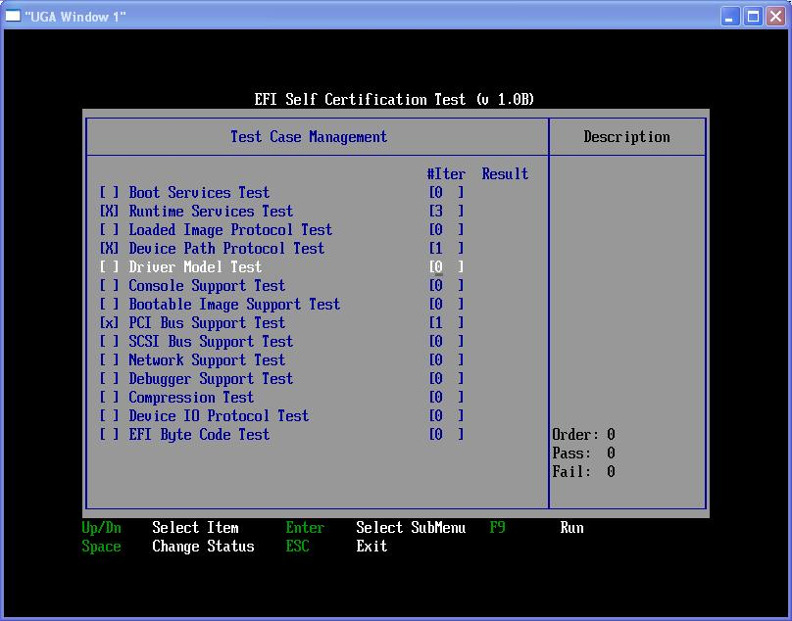

Figure 4. Run Time Services Screen

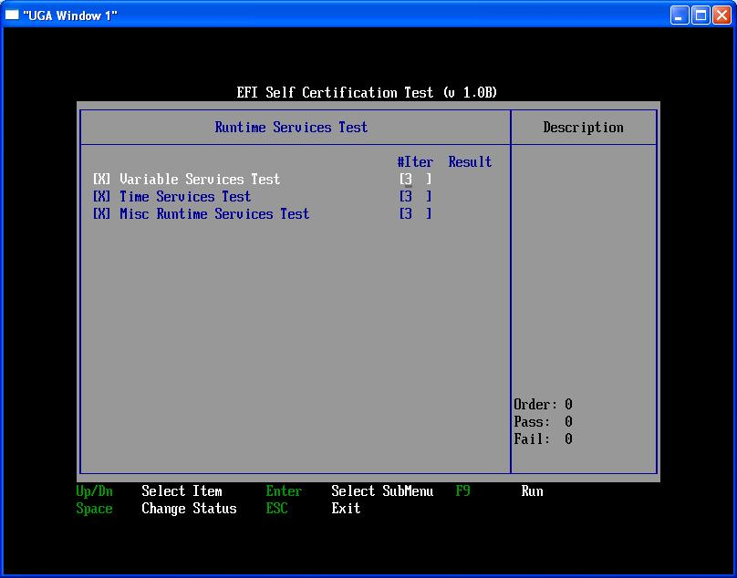

Appendix B describes the method to specify such a tree-like hierarchy of tests for user-defined test cases. Refer to the UEFI SCT Test Writer’s Guide for information on developing user-defined test cases.

In the menu-driven interface, the boxes on the left indicate the selected or unselected status of the corresponding test category.

[X] All test cases in this test category are selected.

[x] One or more test cases in this test category are selected, but not all test cases.

[ ] No test case in this test category has been selected.

The middle boxes below #Iter indicate the number of iterations to be executed for the corresponding test category.

[N] All test cases in this test category will be executed N times.

[*] The test cases in this test category have different numbers of execution iterations.

The summary results (result) show the execution results for the corresponding test category.

PASS All test assertions for all test cases in this test category have passed.

FAIL One or more test assertions within the test cases for this test category has failed.

test One test case in this test category was still executing.

“ ” No test case in this test category was executed.

The number of passed test assertions and the number of failed test assertions is displayed in the lower right corner as shown in the screenshot above. Note that the test case’s place in the order of execution is also displayed. Note also that the order of execution of test cases is based on the user’s order of selection of test cases to execute.

### Configuring the Test Environment

The test environment has user-configurable items for set up, as shown in the screen display below.

Figure 5. Test Environment Configuration

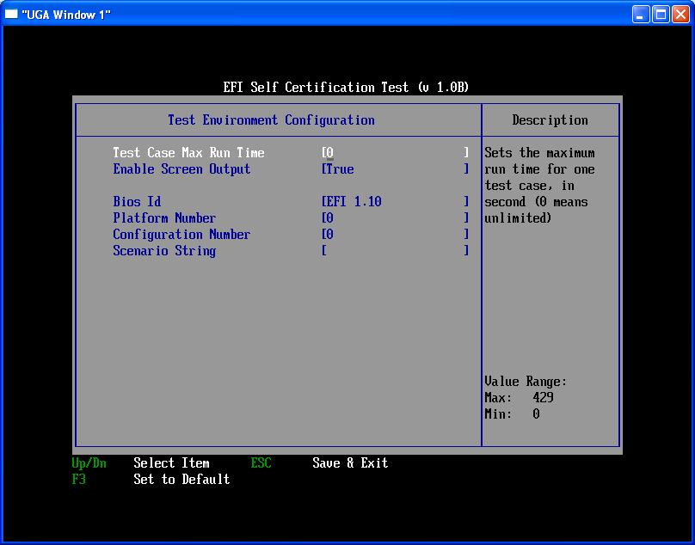X

Table 3X describes the user-configurable items for setting up the test environment.

Table 3. User-Configurable Items for Setting Up the Test Environment

| Items | Description |
| --- | --- |
| Test Case Max Run Time | Sets the maximum execution time for the specified test case. This feature helps prevent system hangs that may occur during execution of a particular test case from indefinitely suspending the entire SCT execution run. Basically, a watchdog timer is set for every test case during execution. If the timer expires, the system automatically restarts and SCT execution automatically continues starting with the next test case in the order of execution. |
| Enable Screen Output | Enables/disables display of test log information on the screen. |
| Bios Id | A string that can be used to identify the BIOS or firmware stack of the target system under test. This information will be included in the log files of the test execution. Generally, Bios Id is used in conjunction with the other strings (identified in this table) for specifying user-controlled parameters for the test execution. |
| Platform Number | A number to identify the platform under test. (e.g., 865, 915). This information is included in the log files of the test execution. Generally, Platform Number is used in conjunction with the other strings (identified in this table) for specifying user-controlled parameters for the test execution. |
| Configuration Number | A number to specify the configuration under test. The numbers used to identify different configurations are entirely up to the user. Generally, a standard configuration is set as 0, a full configuration is set to 1, and so on. This information will be included in the log files of the test execution. Generally, Configuration Number is used in conjunction with the other strings (identified in this table) for specifying user-controlled parameters for the test execution. |
| Scenario String | A string to provide additional information about or further description of the test scenario for the next test execution. This information is included in the log files of the test execution. Generally, this is used in conjunction with the other strings (identified in this table) for specifying user-controlled parameters for the test execution. |

### Generating a Test Report

As shown in Figure 6 below, the user specifies the file name of the test report to be generated for the test execution. The test report file is created in the same directory where the SCT was invoked.

Figure 6. Generating a Test Report

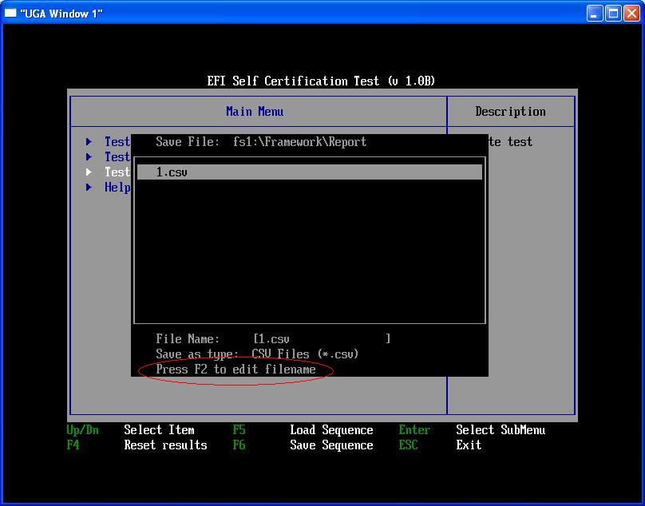

**Note:** *The <F2> key is used to move the cursor between the list box and the edit box.*

***Note:*** *The <TAB> key is used in the EFI Shell to pause execution of an EFI application.*

### Loading and Saving a Test Sequence

To load a test sequence file, press the <F5> key (see Figure 7). To save a test sequence file, press the <F6> key (see Figure 8). The test sequence file is created in the same directory where the SCT was started.

Figure 7. Press the <F5> Key to Load a Test Sequence

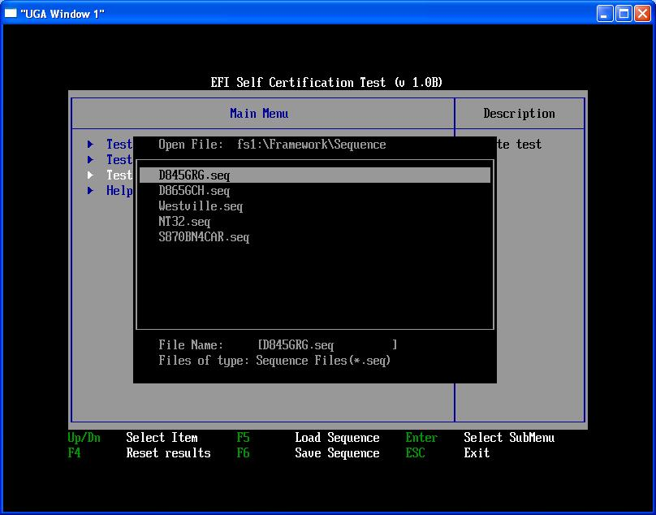

Figure 8. Press the <F6> Key to Save a Test Sequence

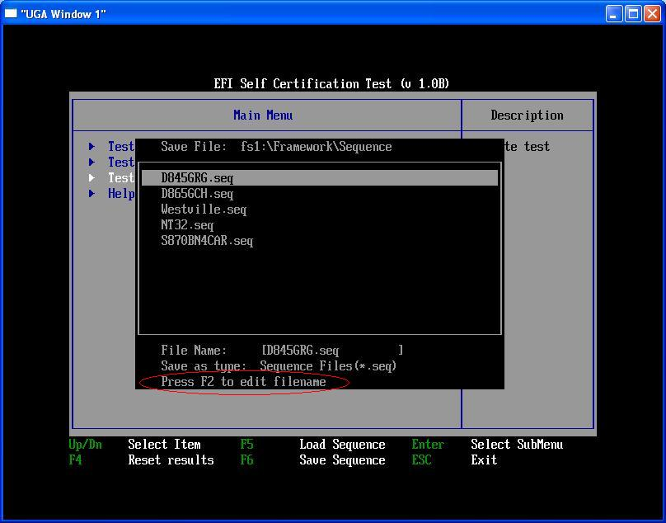

## Sample Usage Models

### Executing from the Command Line Interface

1. To select the test cases to execute, invoke SCT –r –u from the EFI Shell.
2. To save the test case selection into a test sequence file, press <F6>.
3. To start the test execution, return to the EFI Shell and invoke SCT –s <seq>.
4. When test execution completes, invoke SCT –g <report> to generate the test report.

If the same test execution is to be repeated, Steps 1 and 2 can be skipped.

### Executing from the Menu-Driven Interface

1. Invoke SCT –r –u from the EFI Shell; select the test cases to execute.
2. Press <F9> to start test execution.
3. When test execution completes, select “Test Report Generator” to generate the test report.

## Frequently Asked Questions

### Stopping Automatic Test Execution When the System Restarts

The UEFI SCT Test Harness uses a startup script to continue test execution automatically when the system restarts. As shown in Figure 9, the startup script prompts the user to stop the Auto Run by pressing any key. (The user is given only a few seconds to press any key.) After canceling an Auto Run, the user can manually restart the test execution by typing startup.nsh or sct –c.

Figure 9. Press any Key within 10 Seconds to Stop the Auto Run

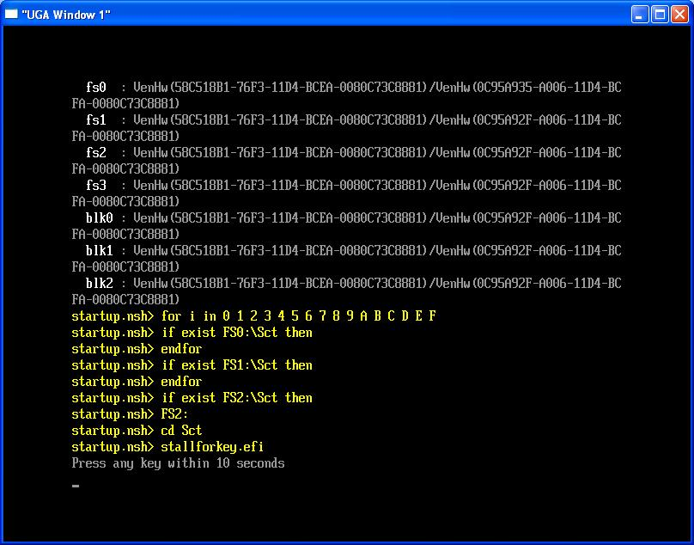

### Stopping SCT Execution While Tests Are Running

The user can manually reset the system to force a test execution to stop. In this case, a message of “system hangs or stops abnormally” is recorded for the interrupted test (see Figure 10), and the interrupted test is skipped and continued in the next restart of test execution.

Figure 10. System Reset Records Message: “System Hangs or Stops Abnormally”

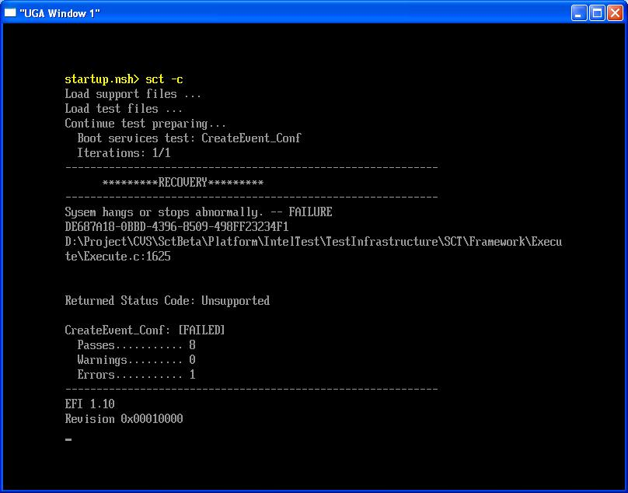

### Removing a Test Case that Always Causes the System to Hang

A test case can be disabled using the menu-driven interface. This is useful when the user needs to disable, or to re-enable, test cases after manually stopping an Auto Run that was causing the system hang. If the test case has been executed after being disabled, there will be no effect on the test execution or to the test results. If the execution of the test case to be disabled is incomplete, or is waiting its turn in the order of execution, the test case is skipped when test execution is continued.

The following are screenshots showing the steps to removing a test case:

1. Press any key to stop Auto Run.

Figure 11. Press any Key to Stop Auto Run



1. Type Sct –u to bring up the Menu-driven interface. Select [No] to discontinue execution.

Figure 12. Select [No] to Discontinue Execution

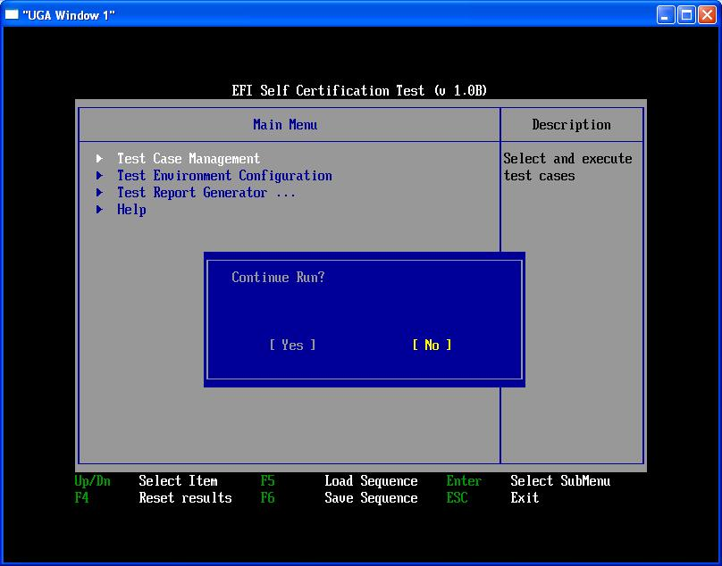

Remove the test using Test Case Management. Press <F8> to continue execution. Press <SPACE> to deselect the test. This effectively removes the test from the execution run.

Figure 13. Press <SPACE> to Deselect the Test

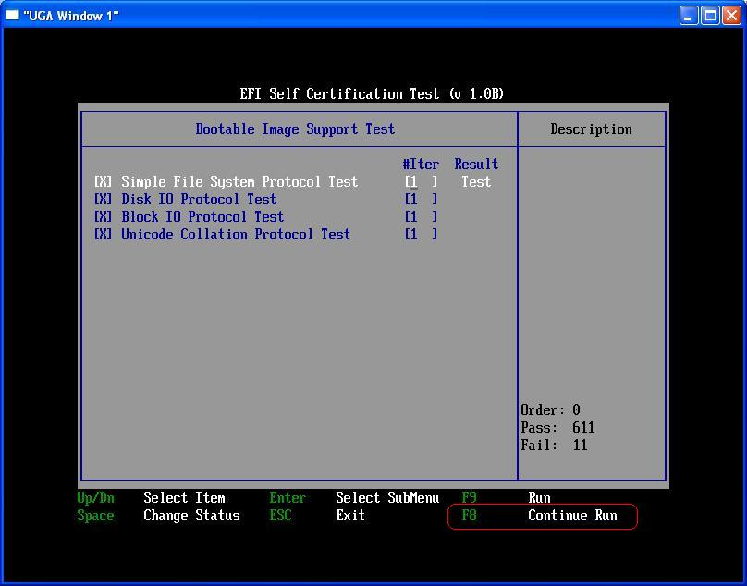

### When There Are No Test Results after Test Execution

Some tests may not have results in the menu-driven interface or in the test report even after execution. There are two possible reasons for this.

1. The test is unable to execute at all. For example, the “Network Support Test” will not execute on a platform that has no network devices.
2. The test case does not record results in conformance to the UEFI SCT Test Development Kit. A user-defined test case can generate its own test output independent of the UEFI SCT test output format.

### When Test Assertion Totals Are Different on Different Platforms

The total numbers in the UEFI SCT test reports show the total number of passed test assertions as well as failed test assertions. The number of applicable test assertions depends on the results of checkpoints in the tests. Platforms of different configuration or devices will cause different results for these checkpoints, and thus different sets of applicable test assertions. For example, the Block I/O test will verify the Read-Only capability when there is a CD in the CD-ROM drive. Another example is when the PCI test verifies resource allocation only if a PCI device requires memory‑mapped IO space.

# Usage Model – Passive Mode

The UEFI SCT Agent runs in the passive mode. All the test cases can be run on the UEFI Management Side (EMS) with the UEFI SCT Agent running in the passive mode.

The following description assumes the user has built the environment on both UEFI SCT Agent side and EMS side.

## Configuring UEFI SCT Agent

This section describes the steps that are necessary to configure the UEFI SCT Agent side.

The following descriptions show the steps to configure the UEFI SCT Agent run in the passive mode. If all of the network drivers are built-in, skip the operation following immediately below:

1. Install UEFI SCT Agent.
2. Switch to the EFI shell to check the network stack is available.
3. Enter the SCT folder and type sct -p mnp to run the SCT passive mode and choose the NIC as shown in Figure 14 that will be used for communication between test machine and host machine.

Figure 14. Choose the NIC

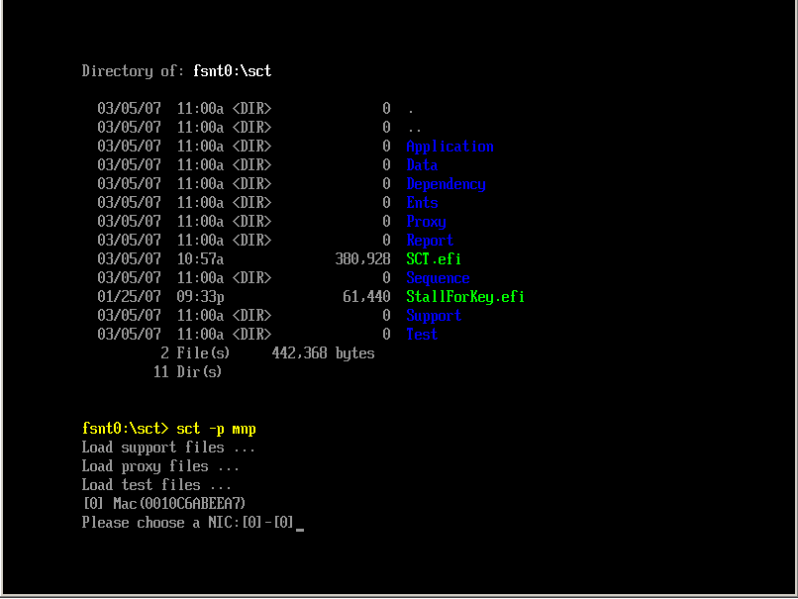

1. Choose the NIC as shown in Figure 15 that will be used for communication between test machine and host machine.

Figure 15. Using SCT Passive mode

;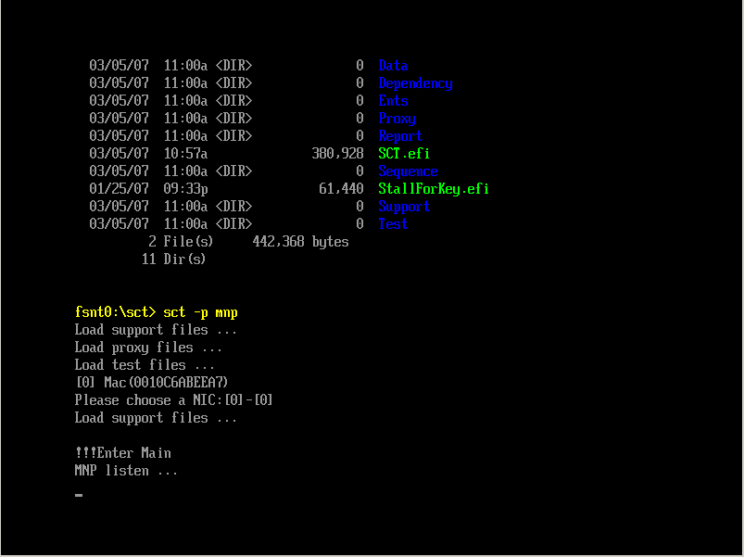

**Note:** Systems without network drivers cannot use SCT passive mode, but you can use the compatible usage as EFI SCT. Refer to Chapter 2.

**Note:** When running UEFI SCT Remote Validation, it is important to keep the test topology environment clean. For example, use one switch (hub) or one cable to connect the EFI target machine and the management host machine, but don't connect the switch (hub) to a public network or other LANs.

**Note:** To run UEFI SCT with local execution usage, make sure the "\Sct\.passive.mode" file is removed.

## Configuring EMS

The EMS side provides a Graphic User Interface (GUI) to run all the test cases. This section describes the steps that are necessary to configure the EMS side and all the menu functions in the EMS OS application window.

### Configuring the EMS Interface

Run the Microsoft Visual Studio 2008 Command Prompt to go to the command line environment. Use the following commands to run the EMS OS application.

1. cd \test\ems\bin
2. Ems Main.Tcl

When the EMS OS application starts, two windows open. Before the main window is available, choose the host interface in the EMS Interface Configuration window. If there are more than one Network Interface cards on your local host, you need to specify the one connected to the EFI target machine. Figure 16 shows the EMS Interface Configuration window.

Figure 16. EMS Interface Configuration window

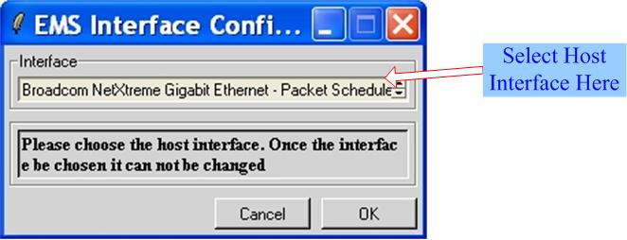

### Configuring Base Information

If you are starting the EMS OS application for the first time, configure the base information. Select the menu “File->Preference…”. The “EMS Preference” window opens. The following list describes each item in the window. The “EMS Preference” window is shown in Figure 17.

Figure 17. EMS Preference window

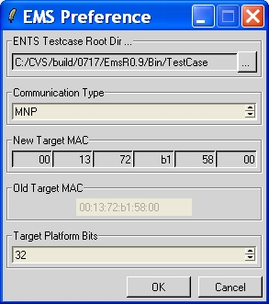

* ENTS Testcase Root Dir...

This item refers to the root directory of all the Remote Validation test cases. Press the Browse button on the right to choose the root directory of the Remote Validation test cases.

* Communication Type

This item refers to the communication type between the EMS side and the UEFI SCT Agent side. Currently, MNP is the only supported communication type.

* New Target MAC

This item refers to the target host MAC address you want to configure. You can type dh –p net in the EFI Shell to get the target host MAC address as shown in Figure 18.

Figure 18. EMS Preference window

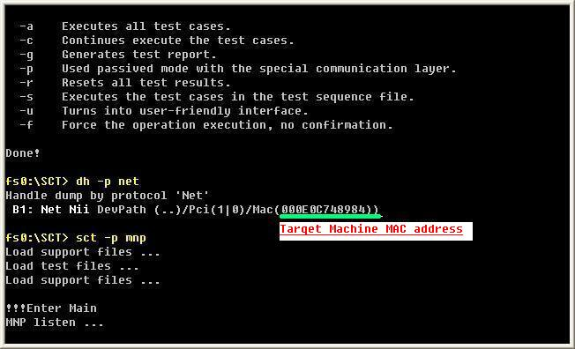

After configuring, click “OK” to confirm the configurations, or click “Cancel” to abort. Clicking “OK” saves the configurations as the default settings.

### RemoteExecution & RemoteValidation

There are two methods to validate the EFI-based machine in UEFI SCT passive mode. One is Remote Execution, and the other is Remote Validation.

* All Remote Execution test case files are located on the UEFI SCT Agent side.

All cases are executed on the EFI side. The EMS performs case management tasks.

* All Remote Validation test case files are in Tcl scripts stored on the EMS side.

All Remote Validation test cases use Remote Procedure Call (RPC) to perform the validation.

When the user selects the menu Windows-> RemoteExecution, the EMS side will download the CaseTree information file from the target host and generate the remote case tree by parsing the file.

When the user selects the menu Windows-> RemoteValidation, the EMS side will traverse all subdirectories under the test case root directory and generate the local case tree.

### Reflushing the Case Tree

The case tree can change after the EMS application starts. So you must reflush the case tree when it changes. Select the menu Windows->Reflush Case Tree to regenerate the case tree. Figure 19 shows the menu in the EMS OS application window.

***Note:*** *When reflushing case tree, the case tree GUI will be re-generated so current case selection and running result will be cleaned up on GUI.*

***Note:*** *For Remote Execution, the EMS side will download the file CaseTree.ini from the target host again and then regenerate a remote case tree by reading the file.*

***Note:*** *For Remote Validation, the EMS side will traverse all the subdirectories of the test case root directory again and then regenerate a local case tree (See section XU3.2.2X).*

Figure 19. The Menu of Reflush Case Tree

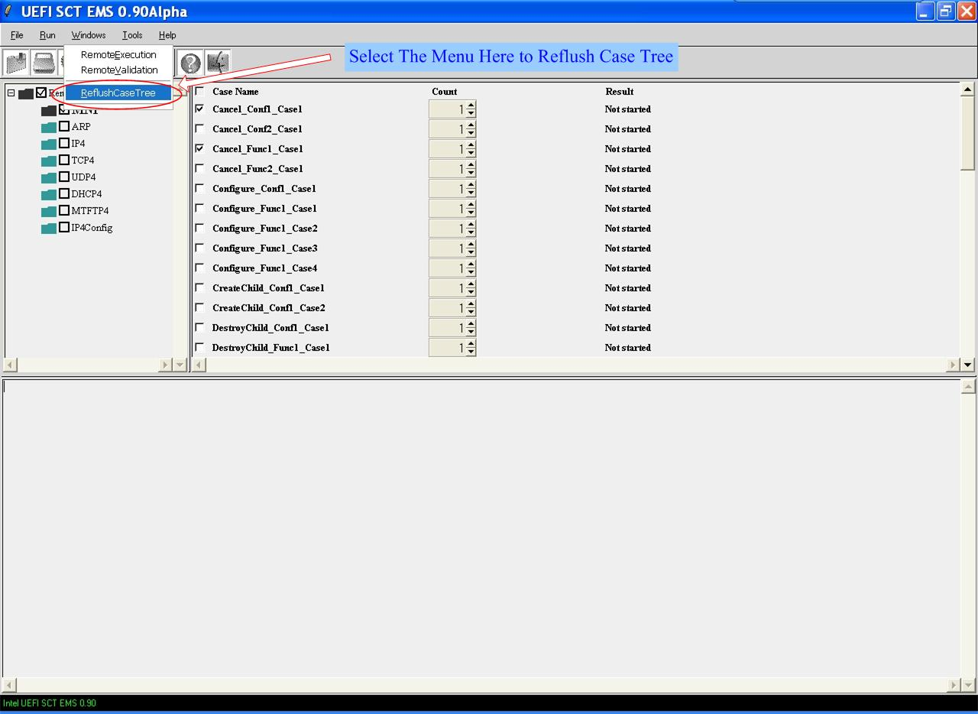

### Running Test Cases

When the EMS configuration is complete and the UEFI SCT Agent is running in the passive mode, run the test cases. Figure 20 shows the EMS OS application window running the Remote Validation test cases.

Figure 20. EMS OS application window running the Remote Validation test cases

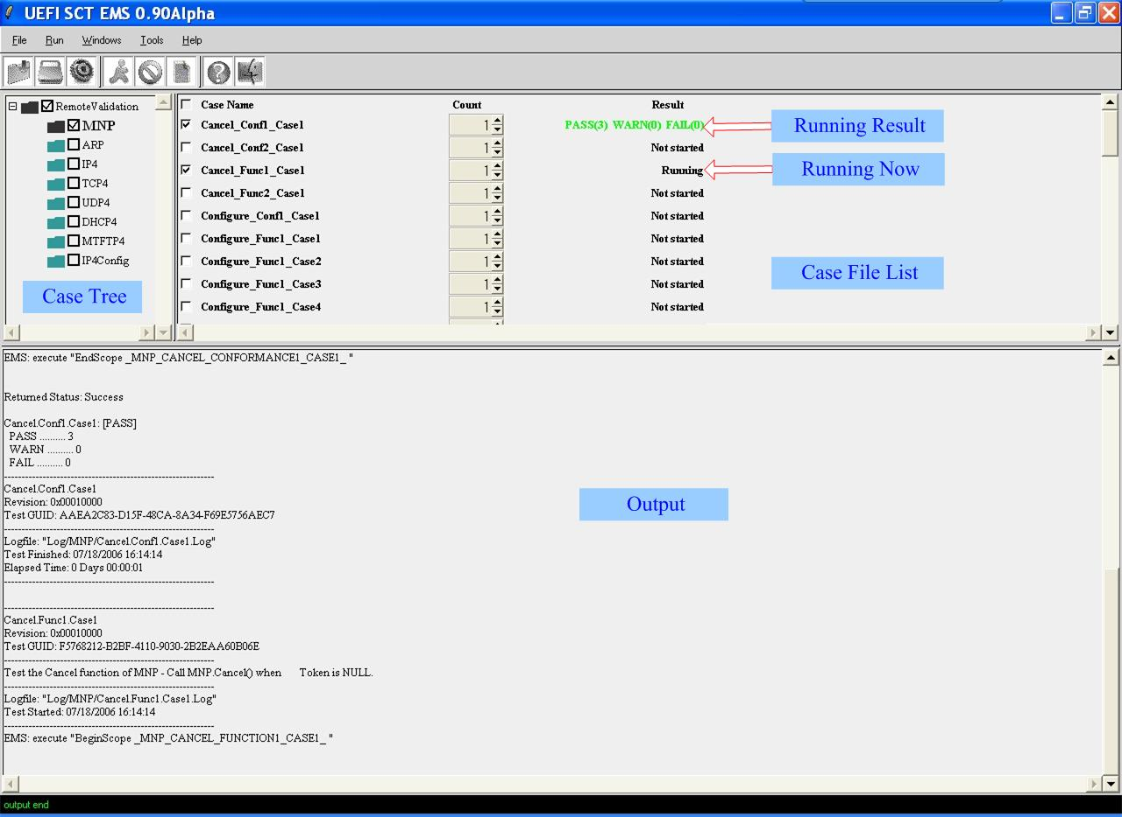

Table 4. Sub-Frames in the EMS OS application window

| Items | Description |
| --- | --- |
| Case Tree | Both the RemoteExecution and the RemoteValidation case tree will be generated in this sub-frame. Select the menu Windows-> RemoteExecution or Windows-> RemoteValidation to switch the case tree. |
| Case File List | Lists all the case files in the selected case tree directory.  Each case file has 3 elements:  Case Name: Case name.  Count: Running iteration of the corresponding test case.  Result: The result of running the selected test case. If the test case is not selected, it will show “Not started”. If the test case is still running, it will show “Running”. If error occurs, it will show “Case Error”. If the test case has been run, it will show the record assertion number of passes, warnings, and failures as shown in XFigure 21 X. |
| Output | Shows the running log for the test cases. There are two kinds of log files: [Case Name].log and [Case Name].ekl. The log files are generated under the directory \bin\log\[Case Directory Name]. |

In the Case Tree sub-frame, each case directory has 3 elements: an icon, a check box, and a directory name text. Figure 21 shows each element and the status of each element.

Figure 21. EMS OS application window-Case Tree Sub-frame

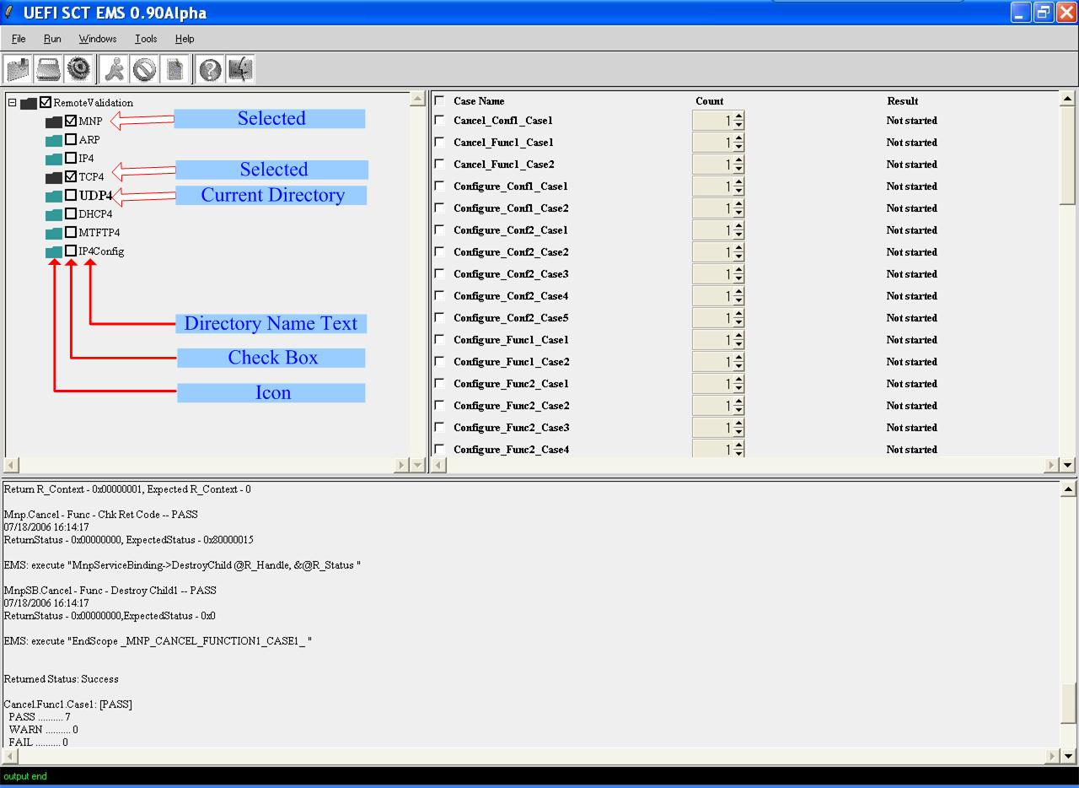

Table 5X describes the usage and the different status meanings of each element for the Case Tree directory.

Table 5. Each Element in the Case Tree Sub-frame

| Items | Description |
| --- | --- |
| Icon | You can click the Icon of a case directory to change the current directory.  Status meanings:  Green Color: no case file was selected.  Black Color: one or more case files were selected. |
| Check Box | You can click the Check Box to select all the case files in the case directory.  Status meanings:  Unchecked: no case file was selected.  Checked: one or more case files were selected. |
| Directory Name Text | Status meanings  Bold: Current case directory.  Regular: Not current case directory. |

After selecting the cases to run, select the menu Run->Start to run the test cases. Status meanings

To stop the case when running, click the menu Run->Stop, and the test will stop after the current running test case has finished. This is to make sure the case running context is clean and that test cases won’t affect each other.

### Loading and Saving a Sequence File

Selected test cases can be saved as a sequence file. Sometimes it is more convenient to run some test cases more than one time, and this function allows one selection, rather than reselecting all the test cases again. Select all the test cases the first time, save the selection as a sequence file, and when running those test cases again, one can load the sequence file to select test cases automatically. The test sequence file is created in the same directory where the SCT was invoked.

To save a sequence file, select one or more test cases, and then select the menu “File->Save sequence file as…” Figure 22 shows the sequence file Save As window.

Figure 22. Sequence File Saving Window

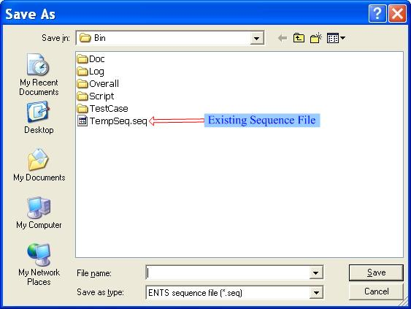

To load a sequence file, select the test case, then select the menu “File->Load sequence file”. Figure 23 shows the sequence file loading window.

Figure 23. Sequence File Loading Window

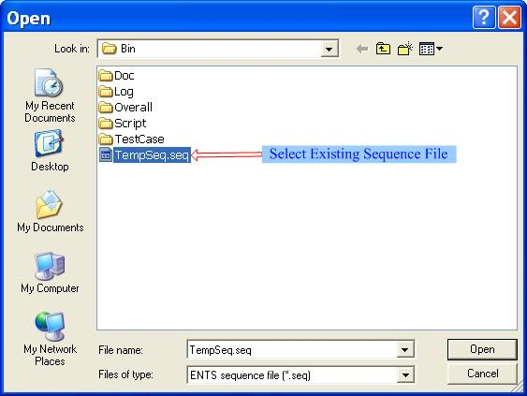

### Generating Log Files

For Remote Validation, the test report file is created in the “Report” subdirectory where the EMS was invoked. Two kinds of reports are generated: one is in case-level and the other is in assertion-level.

For Remote Execution, the test report is created remotely on the EFI target machine and the test report file is transferred back to the report subdirectory where the EMS was invoked.

***Note:*** *The report file is in CSV format and the report file is named by date and time.*

### Using the Tools Menu

XTable 6X describes each submenu function of the Tools menu.

Table 6. Submenus of the Tools Menu

| Items | Description |
| --- | --- |
| Edit | Opens an editing window. This is a simple text editor and it provides highlighting display for UEFI SCT remote validation test cases. Figure 24 shows the functions in detail. |
| Clear Output | Clears current records in the Output sub-frame of the EMS OS application window. |
|  |  |

Figure 24. Editing File Window

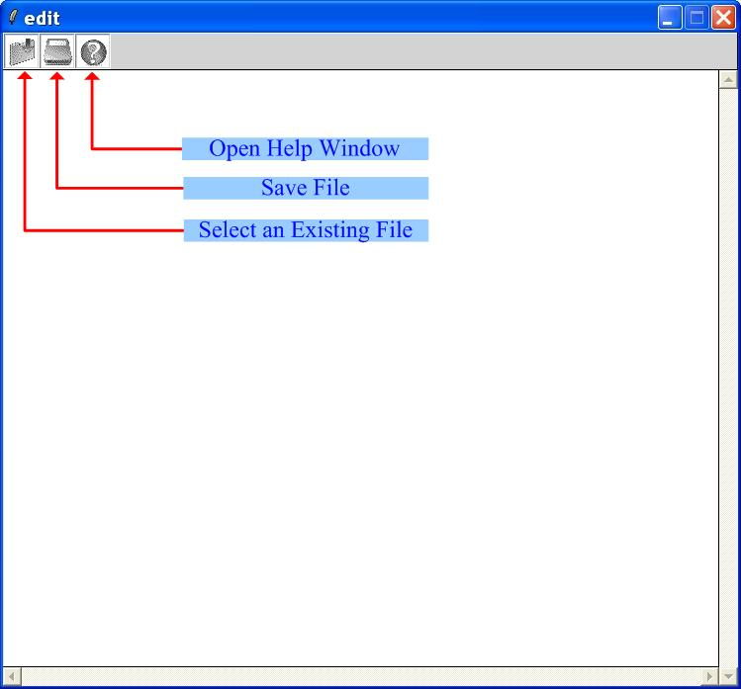

### Using the Help Menu

XTable 7X describes each submenu function of the Help menu.

Table 7. Submenus of the Help Menu

| Items | Description |
| --- | --- |
| Index | Provides a quick reference on Remote Validation Tcl commands for case developers. Find detailed usage information about the commands used in the Tcl script. Figure 25 shows the functions in detail. |
| About ENTS… | Provides the version and copyright information about EMS. |

Figure 25. ENTS Case Writer’s Guide Window

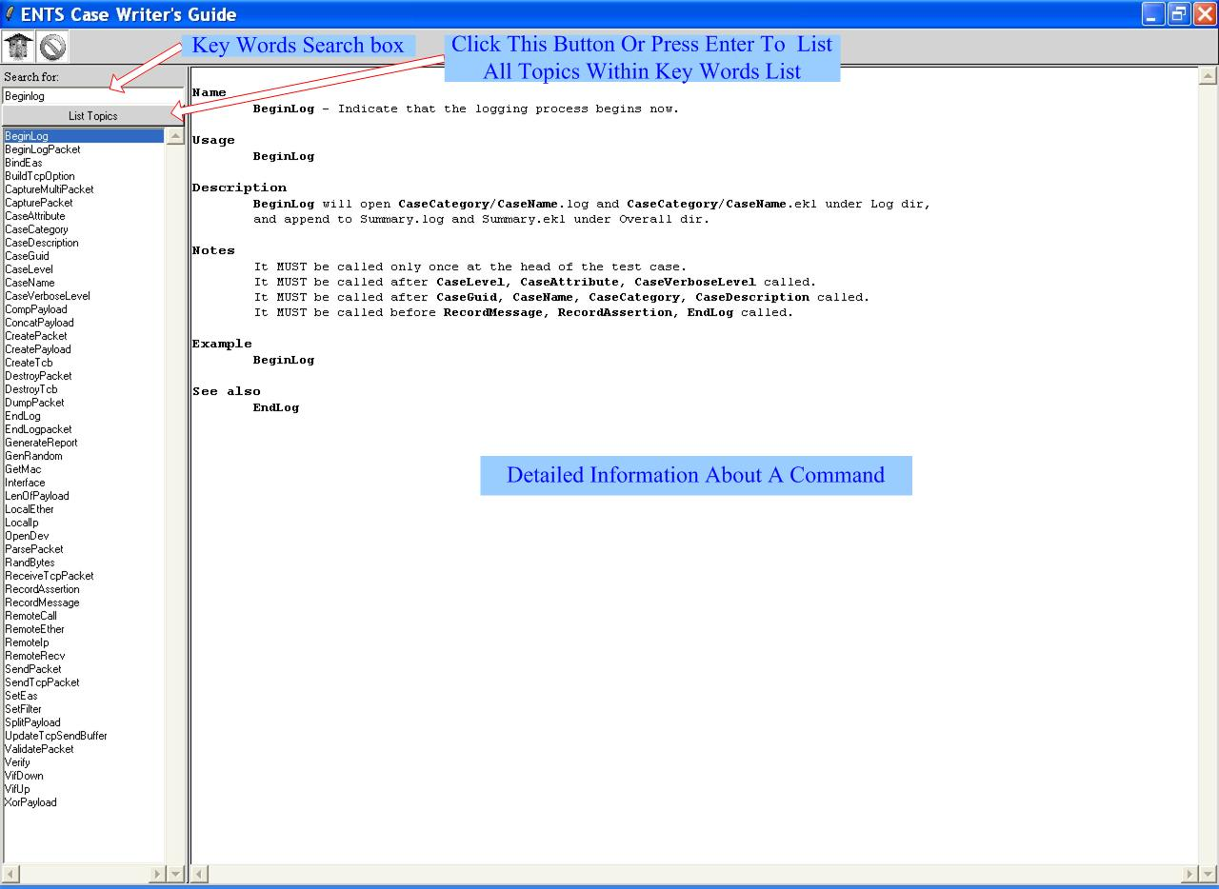

# UEFI SCT For IHV

## IHV SCT Installation

### Installing the IHV SCT

1. The IHV SCT agent is a shell application, so the EFI Shell environment is a must to run IHV SCT agent. Please boot to the specified shell environment, and do the following installation steps, according to different target platforms.

#### Installing the IHV SCT Agent on an IA32 Platform

1. Copy the contents of the IA32 build directory SctPackageIA32 to a USB device.
2. Put the USB device into the USB port and boot the system to the EFI Shell environment.
3. In EFI Shell environment, change the current drive and directory to the USB device drive and SctPackageIA32 directory.
4. Run installIA32.efi and follow the instructions on the screen.

#### Installing the IHV SCT Agent on an X64 Platform

1. Copy the contents of the X64 build directory SctPackageX64 to a USB device.
2. Put the USB device into the USB port and boot the system to the EFI Shell environment.
3. In EFI Shell environment, change the current drive and directory to the USB device drive and SctPackageX64 directory.
4. Run installX64.efi and follow the instructions on the screen.

## The Usage of IHV SCT

### Using the Command Line Interface

The command line interface of the IHV SCT agent is similar to the UEFI SCT’s (see the “UEFI SCT User Guide”), but the IHV SCT does not support the passive mode. The syntax of the IHV SCT’s command line is:

SCT [-a | -c | -s <seq> | -u][-r] [-g <report>][-v]

Table 8. SCT Parameters

| Options | Description |
| --- | --- |
| -a | Execute all test cases that are recognized by the IHV SCT Test Harness. |
| -c | Continue execution of the test case in progress. This option is used to continue execution of test cases that perform system resets as part of their test routine. |
| -g <report> | Generate test report in .CSV format. The filename of the report is specified by report. |
| -r | Resets the environment for a fresh execution of the tests. This option removes results of previous test executions. Generally, it is used with the -a or -s options. |
| -s <seq> | Execute test cases in the sequence specified in the file seq. |
| -u | Start the Test Harness with the menu-driven interface. |
| -v | Disables the display of test log information on the screen. |

Test log display on the screen is enabled by default. In command line interface, -v option can be used both in native mode & passive mode to disable display of test log information on the screen. It can be used combined with –a / -c / -r / -s / -p. Parameter -v only effects until the end of this command execution.

### Using the Menu-Driven Interface

Syntax

SCT -u

Description

Type SCT -u to produce the Main Menu of the menu-driven interface.

#### Main Menu

The Main Menu (Figure 26) contains user selectable items for initiating a number of IHV SCT actions.

Figure 26. Main Menu of IHV SCT

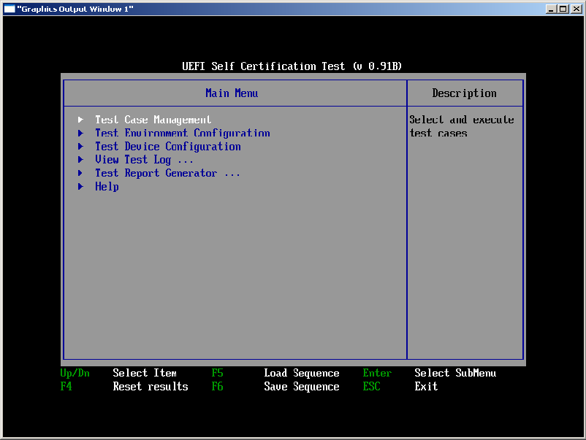

XTable 9X lists and describes the major items found in the Main Menu.

Table 9. Major Items in the Main Menu of the SCT

| Items | Description |
| --- | --- |
| Test Case Management | Selects and executes specific test cases |
| Test Environment Configuration | Sets the parameters for test execution, including the maximum run times for each test case, enabling/disabling screen output, etc. |
| Test Device Configuration | Selects the devices that should be tested. |
| Test Report Generator | Generates a test report in .CSV format. This test report can be opened by the Microsoft® Excel* or the other compatible utilities. |
| F4 (Reset Results) | Resets all test results. It is equivalent to invoking “SCT –r” in the command line. |
| F5 (Load Sequence) | Loads a test sequence file from the storage device. This function allows user to load, edit or execute an existing test sequence file. |
| F6 (Save Sequence) | Saves a user-specified test sequence into a file. This function allows the user to save selected test cases into a file that can then be used for later test execution via “SCT –s <seq>” from the command line. |

#### 65BManaging Test Cases

The UEFI compliance IHV SCT includes a set of test cases for UEFI Specification compliance testing. The method to manage the test cases and to specify test cases in the tree-like hierarchy is described in “UEFI SCT User Guide”.

In IHV SCT, only selecting the test cases in the tree-like menu is not enough to test. Selecting cases in tree-like menu just tells IHV SCT which cases should be run, in IHV SCT, users must choose which devices they want to test through “Test Device Configuration”(see section X4.2.2.3X).

#### 66BTest Device Configuration

The IHV SCT provides the utility of Test Device Configuration. This allows users to choose the devices for testing. The IHV SCT uses a configuration file to save a list of devices that users have chosen. During IHV SCT testing, it will only test the supported devices listed in the configuration file instead of all the supported devices in the system. In other words if the users only select the test cases through the tree-like menu but do not choose any device though the “Test Device configuration”, no checkpoints in the cases will be tested.

In the IHV SCT, selecting cases in tree-like menu tells IHV SCT which cases should be run; and choosing devices through the “Test Device Configuration” tells the IHV SCT which devices should be test. The usage of Test Device Configuration is shown in Figure 27.

Figure 27. Test Device Configuration

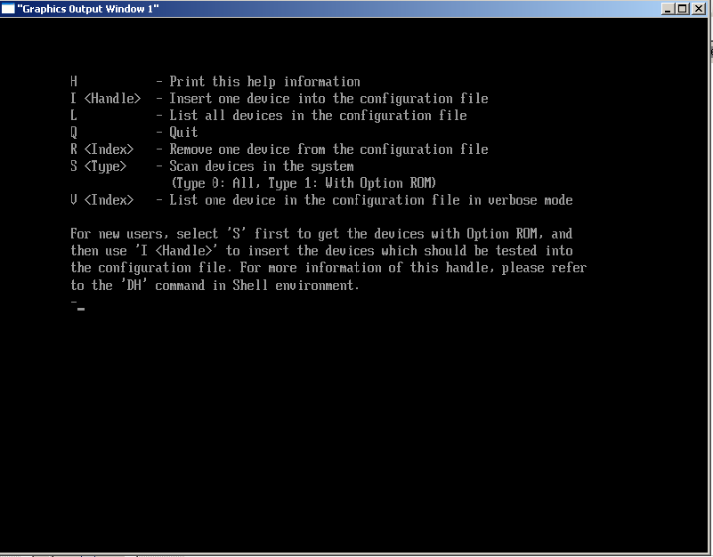

Table 10. The Items in the Menu of the Test Device Configuration

| Items | Description |
| --- | --- |
| H | Print the help information |
| I <Handle> | Insert one device into the configuration file |
| L | List all devices in the configuration file |
| R <Index> | Remove one device from the configuration file |
| S <Type> | Scan devices in the system (Type 0: All, Type 1: With Option ROM) |
| V <Index> | List one device in the configuration file in verbose mode |

In the IHV SCT, the usual way to test an add-in card as follows: The first thing users should do is let the SCT scan devices in the system by typing the command line “S 0” or “S 1” in the Test Device Configuration’s window. “S 0” means scan all devices, “S 1” means scan devices with option ROM. See Table 10.

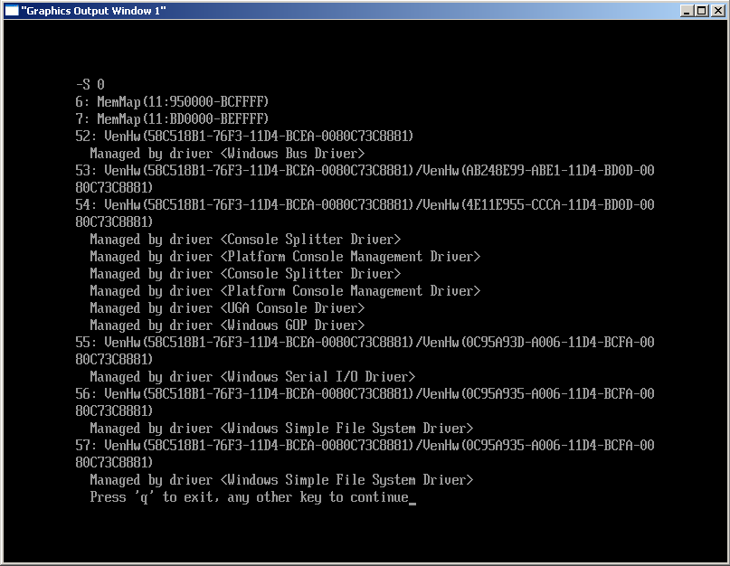

After SCT scan, the “Handle” of the device sought can be known, so users can insert the device sought into SCT’s configuration file by typing the command line ”I <Handle>”;

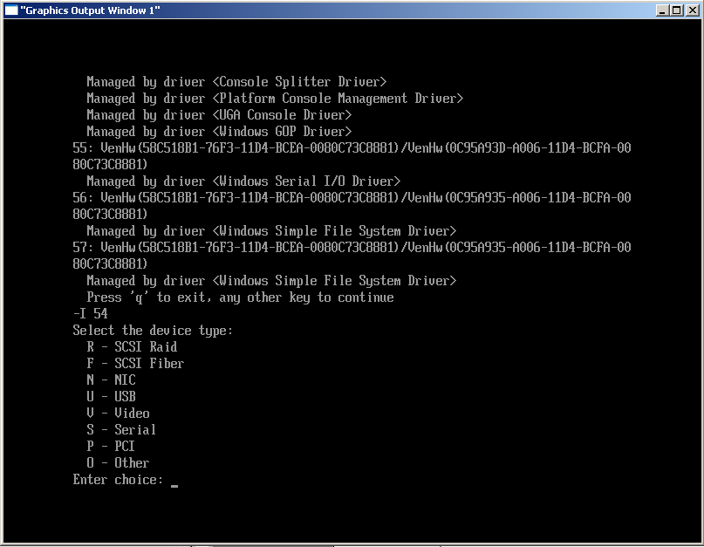

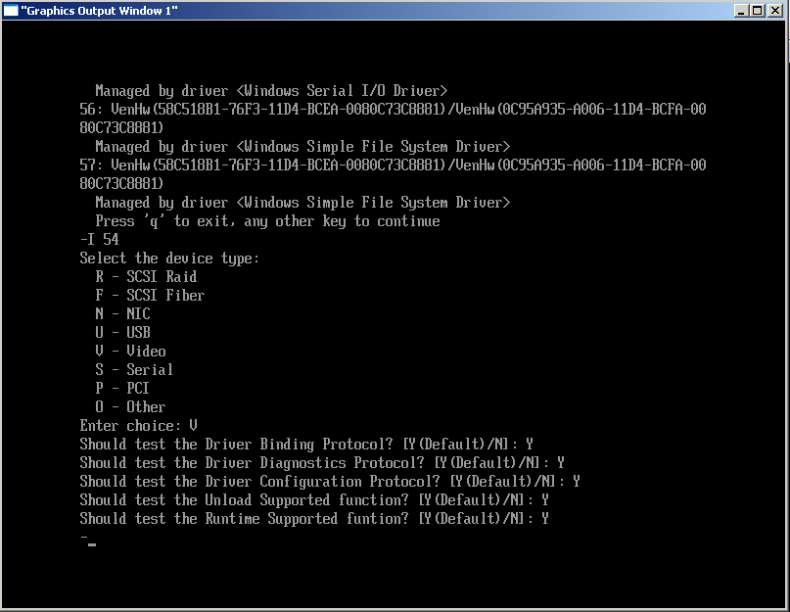

At this time, users can select test cases in the tree-like menu. The SCT can run the test only if all the operations of test device configuration are done.

***Note:*** *If users want to start a new test because the test device configuration has been changed, the “SCT -r” operation is suggested.*

# UEFI SCRT

## Introduction

This chapter introduces the Self-Certification Runtime Test (SCRT) Utility and focuses on how to use it.

As a supplement to SCT, SCRT is invoked under the EFI shell environment and used to validate UEFI Runtime Services implementations for compliance to the UEFI Specification. The source code of SCRT has been included in UEFI SCT release package and the binary of SCRT utility is generated automatically in the build process of UEFI SCT.

## The Usage of SCRT

### System Requirement

To ensure SCRT runs in the runtime environment without unexpected behavior, for targeted platforms the physical memory on the target machine is limited to the following rules:

* IA32 architecture-based platform: Physical memory <= 4G.
* X64 architecture-based platform: Physical memory <= 32G

### The location of SCRT Utility

After UEFI SCT is built successfully, the SCRT Utility is generated automatically and located at specified path below, including SCRTDRIVER.efi, SCRTAPP.efi, SCRT.conf:

UefiSct\Build\UefiSct\DEBUG_VS2008x86\SctPackageIA32\IA32\SCRT IA32 Version

UefiSct\Build\UefiSct\DEBUG_VS2008x86\SctPackageX64\X64\SCRT X64 Version

### Run SCRT Utility

SCRT is invoked under the EFI shell environment:

1. Copy SCRT Utility into discretionary directory in EFI shell environment.
2. Change execution path to the directory that SCRT Utility is located.
3. type ‘Load SCRTDRIVER.efi’
4. type ‘SCRTAPP –f SCRT.conf’

Figure 28. Run SCRT Utility with configure file

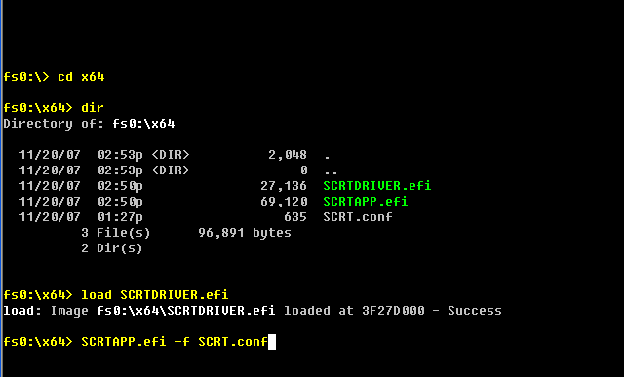

### Configuration File

Following is an example for the usage model of the configuration file named SCRT.conf. SCRT check points are divided into five groups, Variable Service, Time Service, Capsule Service, MonotonicCount Service, and Reset Service.

In SCRT.conf, FALSE means to disable a runtime service test, and TRUE means to enable a runtime service test.

With the help of this configuration file, SCRT obtains information regarding which runtime services are needed to test in the runtime environment.

#

# UEFI Runtime Test Utility SCRT Configuration file.

#

[variable]

SetVariable = TRUE

GetVariable = TRUE

GetNextVariableName = TRUE

QueryVariableInfo = FALSE

[time]

GetTime = TRUE

SetTime = TRUE

SetWakeupTime = TRUE

GetWakeupTime = TRUE

[capsule]

QueryCapsuleCapabilities = FALSE

UpdateCapsule = FALSE

[monotonicCount]

GetNextHighMonotonicCount = TRUE

[reset]

ColdReset = TRUE

WarmReset = FALSE

ShutDown = FALSE

**Note:** For three reset sub-items, only one item is allowed at a time.

### Analyze SCRT Test Result

Unlike SCT, SCRT cannot create a test log file automatically in a runtime environment because it lacks certain boot services. To solve this issue, SCRT records the results in a variable. After runtime test, user can run “SCRTAPP.efi –g SCRT.log” in shell environment to analyze the variable and generate a log file which is named as ‘SCRT.log’. It lists all requested test points and separate test results. From these messages, users can easily find which test point fails.

Besides this method, SCRT can send debug messages to Port 80 at the execution time. Using these messages, the user can analyze the failure reason.

#### Log File Overview

SCRT log file is divided into several groups:

Variable Services Test

Time Services Test

Capsule Service Test

Misc Services Test

Reset Services Test

The following is an example of the log file:

Sometimes the result of Reset Services Test is not correct. Please note the platform behavior to judge

********************Variable Test Group*******************

SetVariable Requested

SetVariable Pass

GetVariable Requested

GetVariable Pass

GetNextVariable Requested

GetNextVariable Pass

********************Time Test Group*******************

GetTime Requested

GetTime Pass

SetTime Requested

SetTime Pass

SetWakeupTime Requested

SetWakeupTime Pass

GetWakeupTime Requested

GetWakeupTime Fail

********************Capsule Test Group*******************

********************Misc Test Group*******************

GetNextCount Requested

GetNextCount Not Test

********************Reset Test Group*******************

ColdReset Requested

ColdReset Not Test

Please note the following”

* Requested means this test point is requested to test in runtime environment.
* Pass means this test point is tested successfully in runtime environment.
* Fail means this test point is failed during runtime test, usually it causes system hang.
* Not Test means this test point is not tested because some test point prior to it causes system hang.

#### Port 80 Display

If the target machine under test has Port 80, the hex number displayed with Port80 can be used to trace the test case workflow. For every checkpoint, Port 80 will display a unique hex number. Please refer to Appendix C for more details.

### System Hang

SCRT validates the Runtime Services implementation in the runtime environment. If some pointers are not converted, the system hangs. If the system hangs at Nth checkpoint, the SCRT records the (N-1)th information in the test log file and displays the corresponding hex number in Port 80. Using this relationship with the enabled checkpoint sequences, users can find which checkpoint hangs.

## How to Add SCRT Test Cases

SCRT is used to validate Runtime Services in a runtime environment. If a more detailed test case for runtime services is needed, users may develop the required test case, and add it to the SCRT infrastructure.

### The Framework of SCRT Utility

SCRTDriver in the SCRT utility is responsible for performing the test cases. In SCRTDriver module, GUID definition for the checkpoints is declared in Guid.h and Guid.c, and test cases are located in TestCase.c.

To extend the test coverage, the user can add the test cases in TestCase.c and add the new GUID definitions inGuid.h/Guid.c.

SCRTDriver\

|----Guid.h

|----Guid.c

|----TestCase.c

|----Debug.c

|----Print.c

    |----SCRTDriver.c

    |----SCRTDriver.h

    |----SCRTDriver.inf

|----ia32

|----Dump.c

|----Io.c

|----Io.h

|----IoAccess.asm

       |----Port80.asm

|----ipf

|----Dump.c

|----Io.c

|----Io.h

       |----Port80.c

|----x64

|----Dump.c

|----Io.c

|----Io.h

|----IoAccess.asm

       |----Port80.asm

**Note:** Guid.h/Guid.c declares GUID definition.

**Note:** TestCase.c consists of the test cases.

In TestCase.c, we allow for adding more checkpoints. For each new checkpoint, the user needs to create a new GUID for it and declare it in Guid.h/Guid.c.

### Example: Adding a Test Case

Because the call Runtime Service UpdateCapsule behaves differently for different platforms—for example, a system reset—this checkpoint is not included in TestCase.c as a common test case. Users can add a case in TestCase.c to verify the service, per the example shown below.

Following is sample code to add the checkpoint in EfiCapsuleTestVirtual(), TestCase.c:

Port80(xxx);

Status = VRT->UpdateCapsule (

xxxxx,

xxxxx,

xxxxx

);

RecordAssertion (

Status,

gSCRTAssertionGuidxxx,

"RT. UpdateCapsule – should be EFI_SUCCESS",

"%a:%d:Status - %r, Expected - %r",

__FILE__,

__LINE__,

Status,

EFI_SUCCESS

);

In addition, define gSCRTAssertionGuidxxx in Guide.h and Guide.c as shown below:

In Guide.c:

EFI_GUID gSCRTAssertionGuidxxx = EFI_TEST_SCRT_ASSERTION_xxx_GUID;

In Guide.h:

#define EFI_TEST_SCRT_ASSERTION_xxx_GUID \

{ xxxxxxxx, xxxx, xxxx, { xx, xx, xx, xx, xx, xx, xx, xx } }

extern EFI_GUID gSCRTAssertionGuidxxx;

* 1. Test Report Format

A summary of SCT test results is recorded into a test report file in CSV format. The output information includes the number of passed and failed test assertions for each executed test category, as well as detailed information for each executed test assertion, passed or failed.

Below are the contents of a sample test report file:

“Self Certification Test Report”

“Service/Protocol Name”,“Total”,“Failed”,“Passed”

“Boot Services Test\Event, Timer, and Task Priority Services Test”,“16”,“0”,“16”

“Boot Services Test\Image Services Test”,“121”,“1”,“120”

“Driver Model Test\Driver Binding Protocol Test”,“15”,“1”,“14”

“Total”,“152”,“2”,“150”

“Index”,“Instance”,“Iteration”,“Guid”,“Result”,“Title”,“Runtime Information”,“Case Revision”,“Case Guid”

“3.1.2.1”,“0”,“0”,“3D3BEE76-3BE8-40DD-BD34-C38AFE2BBDEB”,“FAIL”,“BS.LoadImage() – Load image fail via LOAD_FILE protocol”,“Status – Unsupported, TPL – 4”,“0x00010000”,“256456BC-D9E1-476c-B4AD-BE37E53F7940”

“3.1.2.2”,“0”,“0”,“3D3BEE76-3BE8-40DD-BD34-C38AFE2BBDEC”,“FAIL”,“BS.LoadImage() – Load image fail via Device and File path”,“Status – Not found, TPL – 8”,“0x00010000”,“256456BC-D9E1-476c-B4AD-BE37E53F7940”

“Index”,“Instance”,“Iteration”,“Guid”,“Result”,“Title”,“Runtime Information”,“Case Revision”,“Case Guid”

“3.1.1.1”,“0”,“0”,“3D3BEE76-3BE8-40DD-BD34-C38AFE2BBDEA”,“PASS”,“BS.CreateEvent() – Create event with invalid event type”,“Status – Invalid parameter”,“0x00010000”,“75634025-6B30-4cc4-AC5C-6D031AE4D74C”

When viewed in Microsoft Excel ®, the contents of the report file appear as shown in Figure 29**.**

Figure 29. Excel® File Containing Test Report in CSV Format

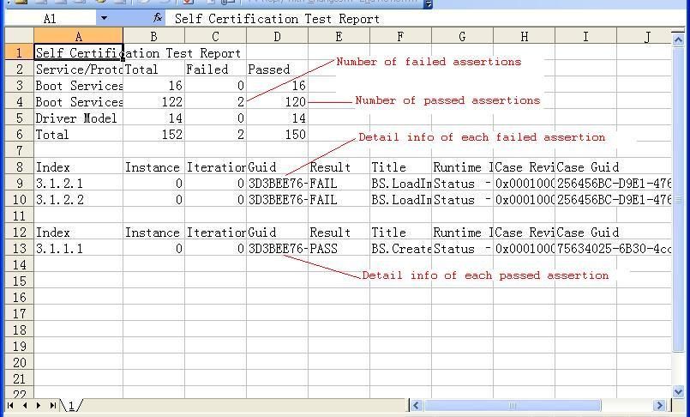

* 1. Test Category

Information on each test category that the EFI SCT Test Harness will need for execution is provided using a category file in INI format. This file is created in the Data subdirectory.

Below are the contents of a sample category file:

[Category Data]

Revision = 0x00010000

CategoryGuid = 7AB1E93F-B439-4e2e-B773-CA540CEBCFEF

InterfaceGuid = E9EF7553-F833-4e56-96E8-38AE679523CC

Name = Boot Services Test\Event, Timer, and Priority Services Test

Description = Event, Timer, and Priority Services Test. Related to EFI Spec 5.1.

[Category Data]

Revision = 0x00010000

CategoryGuid = CC129459-A197-4c8f-9422-2441E88C559A

InterfaceGuid = E9EF7553-F833-4e56-96E8-38AE679523CC

Name = Boot Services Test\Memory Allocation Services Test

Description = Memory Allocation Services Test. Related to EFI Spec 5.2.

The CategoryGuid is the GUID of a corresponding test file. For user-defined test cases, the GUID is defined when using the Black-Box or White-Box test interface. The InterfaceGuid is made up of EFI Protocol GUIDs that are currently in testing. For example, there are three GUIDs specially defined in the EFI 1.10 Specification for the EFI services.

Boot Services: E9EF7553-F833-4e56-96E8-38AE679523CC

Runtime Services: AFF115FB-387B-4c18-8C41-6AFC7F03BB90

Generic Services: 71652D04-BF38-434a-BCB8-6547D7FD8384

Using the category file, the list of test categories can be changed to suit your requirements. For example, the current UEFI SCT release provides test cases for testing protocol interfaces defined in the UEFI Specification. You can integrate additional test cases for these depending on the EFI implementation on the target platform. A sample category file is shown below. The highlighting marks the places where the file can be modified.

[Category Data]

Revision = 0x00010000

CategoryGuid = 7AB1E93F-B439-4e2e-B773-CA540CEBCFEF

InterfaceGuid = E9EF7553-F833-4e56-96E8-38AE679523CC

Name = EFI Spec\Boot Services Test\Event, Timer, and Priority Services Test

Description = Event, Timer, and Priority Services Test. Related to EFI Spec 5.1.

[Category Data]

Revision = 0x00010000

CategoryGuid = CC129459-A197-4c8f-9422-2441E88C559A

InterfaceGuid = E9EF7553-F833-4e56-96E8-38AE679523CC

Name = EFI Spec\Boot Services Test\Memory Allocation Services Test

Description = Memory Allocation Services Test. Related to EFI Spec 5.2.

[Category Data]

Revision = 0x00010000

CategoryGuid = {GUID of user-defined test}

InterfaceGuid = E9EF7553-F833-4e56-96E8-38AE679523CC

Name = User-defined\Boot Services Test\Event, Timer, and Priority Services Test

Description = Event, Timer, and Priority Services Test. Related to XXX design document.

[Category Data]

Revision = 0x00010000

CategoryGuid = {GUID of user-defined test}

InterfaceGuid = E9EF7553-F833-4e56-96E8-38AE679523CC

Name = User-defined\Boot Services Test\Memory Allocation Services Test

Description = Memory Allocation Services Test. Related to XXX design document.

* 1. SCRT Assertion Information

To accomplish a runtime service test, sometimes more than one step is required. For example, to test GetVariable service, set a certain variable first, and then get it to test. Encode the Port 80 number as XY. Here X stands for the runtime service sequence and Y stands for the step sequence in this service test. Corresponding to a unique Port 80 hex number, a unique GUID and the test description are printed out to COM1/COM2.The relationship is shown in Table 11.

Table 11 shows the detailed information for each assertion in the UEFI SCRT tests. It can be used by UEFI SCRT users as a case assertion reference.

Table 11. Test Case, Port 80 Display and Log file Relationship for Each Assertion

| Test Case | Port80 Display | GUID | Assertion | Test Description |
| --- | --- | --- | --- | --- |
| SetVariable | 11 | 0xbff7e548,  0xf13a,  0x497c,  0x8e, 0x21, 0xae, 0xc2, 0x37, 0xa6, 0xcc, 0xe3 | RT.SetVariable - Set a test variable named UEFIRuntimeVariable, should be EFI_SUCCESS | Call RT.SetVariable with the special name and Guid. And the variable is set with 8 Bytes data size. The return status should be EFI_SUCCESS. |
| 12 | 0xf556b5ad,  0xaace,  0x4bf0,  0xb7, 0x24, 0xe1, 0x29, 0xee, 0x0, 0xea, 0x37 | RT.SetVariable - Clear a test variable named UEFIRuntimeVariable, should be EFI_SUCCESS | Call RT.SetVariable to clear the test variable. The return status should be EFI_SUCCESS. |
| GetVariable | 21 | 0xd66e4a7f,  0x6d54,  0x4cc0,  0xb9, 0x3b, 0xf6, 0x2f, 0x48, 0x57, 0xa6, 0xff | RT.SetVariable - Set a test variable named UEFIRuntimeVariable, should be EFI_SUCCESS | Call RT.SetVariable with the special name and Guid. And the variable is set with 8 Bytes data size. The return status should be EFI_SUCCESS. |
| 22 | 0xaa5c5763,  0x36cd,  0x4f00,  0x84, 0x36, 0xf4, 0xa9, 0xd5, 0xaf, 0x12, 0xfb | RT.GetVariable - Get the test variable named UEFIRuntimeVariable, should be EFI_SUCCESS | Call RT.GetVariable to get the test variable. The return status should be EFI_SUCCESS |
| 23 | 0xbac20972,  0x9662,  0x4f24,  0x8a, 0xac, 0x66, 0x41, 0x42, 0xb5, 0x6d, 0xde | RT.SetVariable - Clear a test variable named UEFIRuntimeVariable, should be EFI_SUCCESS | Call RT.SetVariable to clear the test variable. The return status should be EFI_SUCCESS. |
| GetNextVariableName | 31 | 0x8bcda7a3,  0x2848,  0x413d,  0xbf, 0x5, 0x7, 0xe1, 0x9, 0x8d, 0x42, 0xd2 | RT.SetVariable - Set a test variable named UEFIRuntimeVariable, should be EFI_SUCCESS | Call RT.SetVariable with the special name and Guid. And the variable is set with 8 Bytes data size. The return status should be EFI_SUCCESS. |
| 32 | 0x67b4e72a,  0xc792,  0x4f74,  0x92, 0x1d, 0xea, 0xb3, 0x66, 0x4f, 0x95, 0x3b | RT.GetNextVariableName - Get the next variable name should be EFI_SUCCESS/EFI_NOT_FOUND | Loop call RT.GetNextVariableName get the next variable. The return status should be EFI_SUCCESS/EFI_NOT_FOUND. |
| 33 | 0xdbb5195f,  0x3584,  0x427d,  0xa1, 0x68, 0x3f, 0x5e, 0x1d, 0x24, 0x3b, 0xb9 | RT.SetVariable - Clear a test variable named UEFIRuntimeVariable, should be EFI_SUCCESS | Call RT.SetVariable to clear the test variable. The return status should be EFI_SUCCESS. |
| QueryVariableInfo | 41 | 0x8e75d9a9,  0x3c14,  0x4095,  0xbe, 0x76, 0xad, 0xcf, 0x55, 0xab, 0x8e, 0x6c | RT.QueryVariableInfo - Query Variable Information of the platform should be EFI_SUCCESS. | Call  RT.QueryVariableInfo to query variable information. The return status should be EFI_SUCCESS. |
| GetTime | 51 | 0xe8cd357a,  0xd254,  0x4f7b,  0x92, 0xc3, 0x23, 0xfd, 0x4d, 0xd6, 0xc0, 0xa3 | RT.GetTime - Get the current time and date information should be EFI_SUCCESS | Call RT.GetTime with NULL capabilities. The return status should be EFI_SUCCESS. |
| SetTime | 61 | 0x6417f479,  0xa174,  0x4614,  0x80, 0xcd, 0xe6, 0x96, 0x85, 0x8c, 0xd9, 0xfa | RT.GetTime - Get the current time and date information should be EFI_SUCCESS | Call RT.GetTime with NULL capabilities. The return status should be EFI_SUCCESS. |
| 62 | 0xd6a3c41a,  0xe6cf,  0x42fc,  0xa0, 0x39, 0x68, 0xf8, 0x39, 0xbb, 0xbf, 0xe3 | RT.SetTime – set the same time as just got. should be EFI_SUCCESS | Set time. The return status should be EFI_SUCCESS. |
| SetWakeupTime | 71 | 0xd6b952a9,  0x3d54,  0x4277,  0xbf, 0x60, 0xab, 0xfb, 0x3, 0x71, 0x5, 0xd5 | RT.GetTime - Get the current time and date information should be EFI_SUCCESS | Call RT.GetTime with NULL capabilities. The return status should be EFI_SUCCESS. |
| 72 | 0x3f65c680,  0xae51,  0x4830,  0xb3, 0xd1, 0xd7, 0xc9, 0x2a, 0xcd, 0x14, 0x8a | RT.SetWakeupTime - Set wakeup time in 1 hour later from now on, should be EFI_SUCCESS | Call RT.SetWakeupTime to set wake up time, the time is 1 hour later from now on. The return status should be EFI_SUCCESS. |
| GetWakeupTime | 81 | 0x4611524b,  0xbfd2,  0x42d4,  0x85, 0xa8, 0x9b, 0xf, 0xd1, 0xc6, 0x27, 0xd3 | RT.GetWakeupTime - Get the current wakeup alarm clock setting information, should be EFI_SUCCESS. | Call RT.GetWakeupTime to get the current wake up time. The return status should be EFI_SUCCESS. |
| QueryCapsuleCapabilities | 91 | 0x5c2cbd54,  0x1388,  0x4e87,  0xab, 0x11, 0x2c, 0x12, 0x3d, 0x24, 0x5, 0xbd | RT.QueryCapsuleCapabilities - Query the capsule capabilities with a NULL MaxCapsuleSize, should be EFI_INVALID_PARAMETER. | Call RT.QueryCapsuleCapabilities to query the capsule capabilities with a NULL MaxCapsuleSize. The return status should be EFI_INVALID_PARAMETER. |
| UpdateCapsule | A1 | 0x9e39a3e3,  0xcbb6,  0x4fcc,  0xb2, 0x21, 0x73, 0x24, 0x79, 0xf1, 0x21, 0x77 | RT.UpdateCapsule – Update Capsules with 0 CapsuleCount, should be EFI_INVALID_PARAMETER.  Because this case brings on some reset or update flash behavior, it is recommended disable as default. Users can enhance this test case for their own test platform. | Call RT.UpdateCapsule with 0 CapsuleCount. The return status should be EFI_INVALID_PARAMETER. |
| GetNextHighMonotonicCount | B1 | 0xda790c1e,  0xdcbf,  0x4c0e,  0xaf, 0xf7, 0x46, 0x3a, 0xc4, 0x47, 0xb0, 0x6e | RT.GetNextHighMonotonicCount - First get next high monotonic counter, should be EFI_SUCCESS. | Call RT.GetNextHighMonotonicCount to get next high monotonic counter. The return status should be EFI_SUCCESS. |
| ResetSystem | C1 | 0x1bc049bb,  0xc371, 0x46cc,  0x8d, 0x98  0xef, 0x56  0xc, 0x35  0x7f, 0x1 | RT.ResetSystem - Machine should have code reset! We should never come here. | RT.ResetSystem - Machine should have code reset! We should never come here. |
| C2 | 0x11a541a4,  0xf75d,  0x42e0,  0xa8, 0x97, 0xe7, 0x92, 0xd4, 0x37, 0xc2, 0xfc | RT.ResetSystem - Machine should have warm reset! We should never come here | RT.ResetSystem - Machine should have warm reset! We should never come here |
| C3 | 0xe5818568, 0x4723,  0x473f,  0xbc, 0x8f,  0xb5, 0x86,  0x2e, 0xd2,  0x5e, 0xb1 | RT.ResetSystem - Machine should have shut down! We should never come here | RT.ResetSystem - Machine should have shut down! We should never come here |